Worship Plan for Sunday, October 25, 2026
Reformation Sunday

The Holy Spirit calls us together as the people of God.
GATHERING

Prelude
Welcome/Announcements
Reflection - Preparing for Worship
Handbells - The Church’s One Foundation
Sing 2x

Please stand.
Confession and Forgiveness
All may make the sign of the cross, the sign that is marked at baptism, as the presiding minister begins.
Blessed be the holy Trinity, ☩ one God,
who pours love into our hearts
and healing upon the earth.
Amen.
Confident that God justifies us by grace through faith,
let us confess our sin.
Silence is kept for reflection.

Compassionate God,
we confess that we struggle to embody your goodness
in the world and in our own hearts.
Creation groans from overuse.
Jealousy and bitterness strain our relationships.
Indifference keeps us from seeking justice.
Divisions disrupt your call to show genuine love
to others.
Turn our hearts back to you.
Restore our world and reconcile us to one another.
Renew us to live as your holy people,
following the way of Jesus Christ.
Amen.
Hear this good news:
We have peace with God through ☩ Jesus Christ,
in whom there is no condemnation,
but only forgiveness and the promise of eternal life.
Receive freely this healing gift of grace.
Amen.

Gathering Song Built on a Rock ELW 652

Greeting
The grace of our Lord Jesus Christ, the love of God
and the communion of the Holy Spirit be with you all.
And also, with you.

Prayer of the Day
Let us pray.
Almighty God, gracious Lord, we thank you that your Holy Spirit renews the church in every age. Pour out your Holy Spirit on your faithful people. Keep them steadfast in your word, protect and comfort them in times of trial, defend them against all enemies of the gospel, and bestow on the church your saving peace, through Jesus Christ, our Savior and Lord, who lives and reigns with you and the Holy Spirit, one God, now and forever.
Amen.

Please be seated.
God speaks to us in scripture reading, preaching, and song.
WORD

First Reading: Jeremiah 31:31-34
A reading from Jeremiah.
³¹ The days are surely coming, says the Lord, when I will make a new covenant with the house of Israel and the house of Judah. ³² It will not be like the covenant that I made with their ancestors when I took them by the hand to bring them out of the land of Egypt—a covenant that they broke, though I was their husband, says the Lord. ³³ But this is the covenant that I will make with the house of Israel after those days, says the Lord: I will put my law within them, and I will write it on their hearts, and I will be their God, and they shall be my people. ³⁴ No longer shall they teach one another or say to each other, “Know the Lord,” for they shall all know me, from the least of them to the greatest, says the Lord, for I will forgive their iniquity and remember their sin no more.
The word of the Lord.
Thanks be to God.

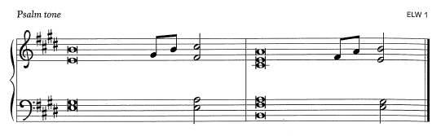
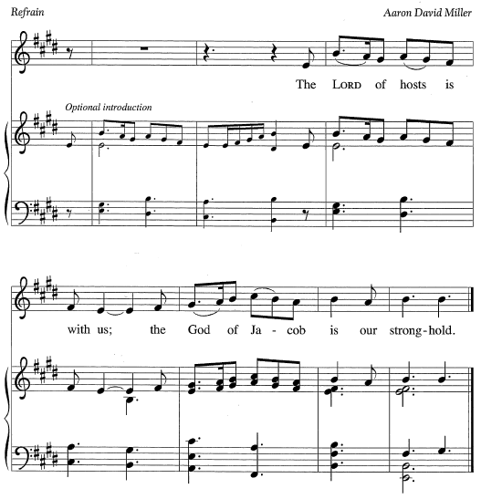
Psalm: Psalm 46
¹ God is our ref- | uge and strength,
a very present | help in trouble.
² Therefore we will not fear, though the | earth be moved,
and though the mountains shake in the depths | of the sea;
³ though its waters | rage and foam,
and though the mountains tremble | with its tumult.
⁴ There is a river whose streams make glad the cit- | y of God,
the holy habitation of | the Most High.
⁵ God is in the midst of the city; it shall | not be shaken;
God shall help it at the | break of day.
⁶ The nations rage, and the | kingdoms shake;
God speaks, and the earth | melts away. R
⁷ The Lord of | hosts is with us;
the God of Jacob | is our stronghold.
⁸ Come now, regard the works | of the Lord,
what desolations God has brought up- | on the earth;
⁹ behold the one who makes war to cease in | all the world;
who breaks the bow, and shatters the spear, and burns the | shields with fire.
¹⁰ “Be still, then, and know that | I am God;
I will be exalted among the nations; I will be exalted | in the earth.”
¹¹ The Lord of | hosts is with us;
the God of Jacob | is our stronghold. R

Second Reading: Romans 3:19-28
A reading from Romans.
¹⁹ Now we know that, whatever the law says, it speaks to those who are under the law, so that every mouth may be silenced and the whole world may be held accountable to God. ²⁰ For no human will be justified before him by deeds prescribed by the law, for through the law comes the knowledge of sin.
²¹ But now, apart from the law, the righteousness of God has been disclosed and is attested by the Law and the Prophets, ²² the righteousness of God through the faith of Jesus Christ for all who believe. For there is no distinction, ²³ since all have sinned and fall short of the glory of God; ²⁴ they are now justified by his grace as a gift, through the redemption that is in Christ Jesus, ²⁵ whom God put forward as a sacrifice of atonement by his blood, effective through faith. He did this to demonstrate his righteousness, because in his divine forbearance he had passed over the sins previously committed; ²⁶ it was to demonstrate at the present time his own righteousness, so that he is righteous and he justifies the one who has the faith of Jesus.
²⁷ Then what becomes of boasting? It is excluded. Through what kind of law? That of works? No, rather through the law of faith. ²⁸ For we hold that a person is justified by faith apart from works prescribed by the law.
The word of the Lord.
Thanks be to God.

Please stand.
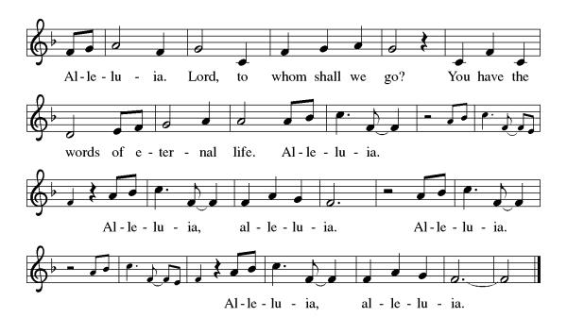
Gospel Acclamation
Gospel: John 8:31-36
The holy gospel according to John.
Glory to you, O Lord.
³¹ Jesus said to the Jews who had believed in him, “If you continue in my word, you are truly my disciples, ³² and you will know the truth, and the truth will make you free.” ³³ They answered him, “We are descendants of Abraham and have never been slaves to anyone. What do you mean by saying, ‘You will be made free’?”
³⁴ Jesus answered them, “Very truly, I tell you, everyone who commits sin is a slave to sin. ³⁵ The slave does not have a permanent place in the household; the son has a place there forever. ³⁶ So if the Son makes you free, you will be free indeed.”
The gospel of the Lord.
Praise to you, O Christ.

Please be seated.
Children’s Message
Sermon

Please stand
Hymn of the Day The Church’s One Foundation ELW 654

Apostles’ Creed
Let us confess our faith to the words of the Apostles’ Creed
I believe in God, the Father almighty,
creator of heaven and earth.
I believe in Jesus Christ, God's only Son, our Lord,
who was conceived by the Holy Spirit,
born of the Virgin Mary,
suffered under Pontius Pilate,
was crucified, died, and was buried;
he descended to the dead.
On the third day he rose again;
he ascended into heaven,
he is seated at the right hand of the Father,
and he will come to judge the living and the dead.
I believe in the Holy Spirit,
the holy catholic Church,
the communion of saints,
the forgiveness of sins,
the resurrection of the body,
and the life everlasting. Amen

Please sit or kneel.
Prayers of Intercession
Seeking the Spirit of God who makes all things new, we pray for the church and the world.
As we celebrate Reformation Sunday, we remember the witness of Martin Luther and the reformers of the church in every generation. Empower us to continue the work of reform and renewal in our own day. Hear us, O God.
Your mercy is great.
We pray for the healing of natural places despoiled by pollution and human greed (local places may be named). Give all living creatures access to safe land, water, and air. Hear us, O God.
Your mercy is great.
We pray for our criminal justice systems and all those whose lives are affected by them. Give wisdom and discernment to police, probation officers, judges, and attorneys; give courage and peace to prisoners and the formerly incarcerated. Hear us, O God.
Your mercy is great.
We ask your blessing upon all people who have been harmed by the church and its leaders, that the truth may make them free. We pray for the relief of all those who are sick or suffering (especially). Hear us, O God.
Your mercy is great.
We give thanks for those exploring or returning to a life of faith. Encourage and guide them, that they may find their hope in you. Hear us, O God.
Your mercy is great.
With gratitude, we remember those disciples who paved the way for us and all of our beloved dead. Hear us, O God.
Your mercy is great.
Trusting in your boundless grace, O God, we lift up these spoken prayers and those in our hearts; through Jesus Christ our Lord.
Amen.

Peace
The peace of Christ be with you always. And also, with you.

MEAL
God feeds us with the presence of Jesus Christ.

Please be seated.
Offering

Choir Music ~ Faithfulness Medley

Please stand.
Offertory Hymn Come, Bring Your Burdens to God ACS 1009
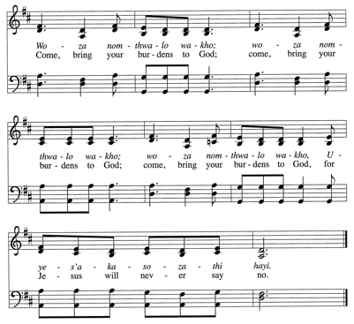
2x
Offertory Prayer
God of creation,
you send rain and the earth springs forth abundantly.
All blessings are from you;
make us generous with what we have.
Use our gifts, our abilities, and our hearts
in service to you and in love to our neighbors,
today and always.
Amen.

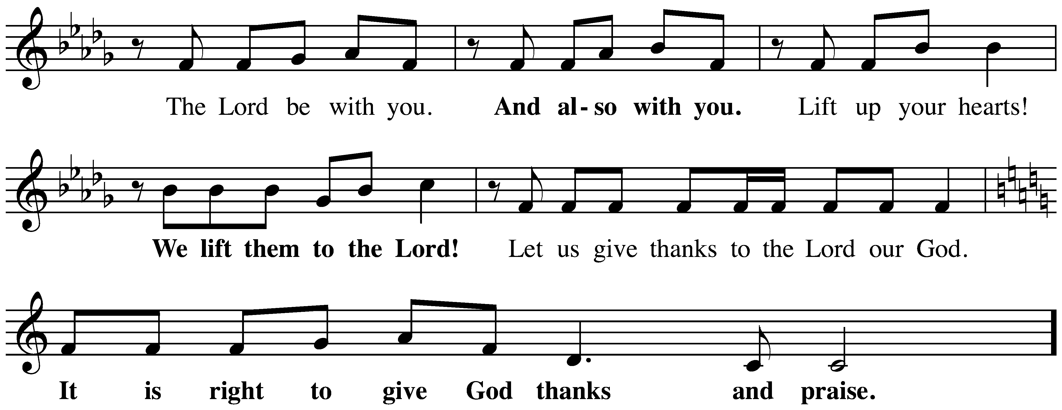
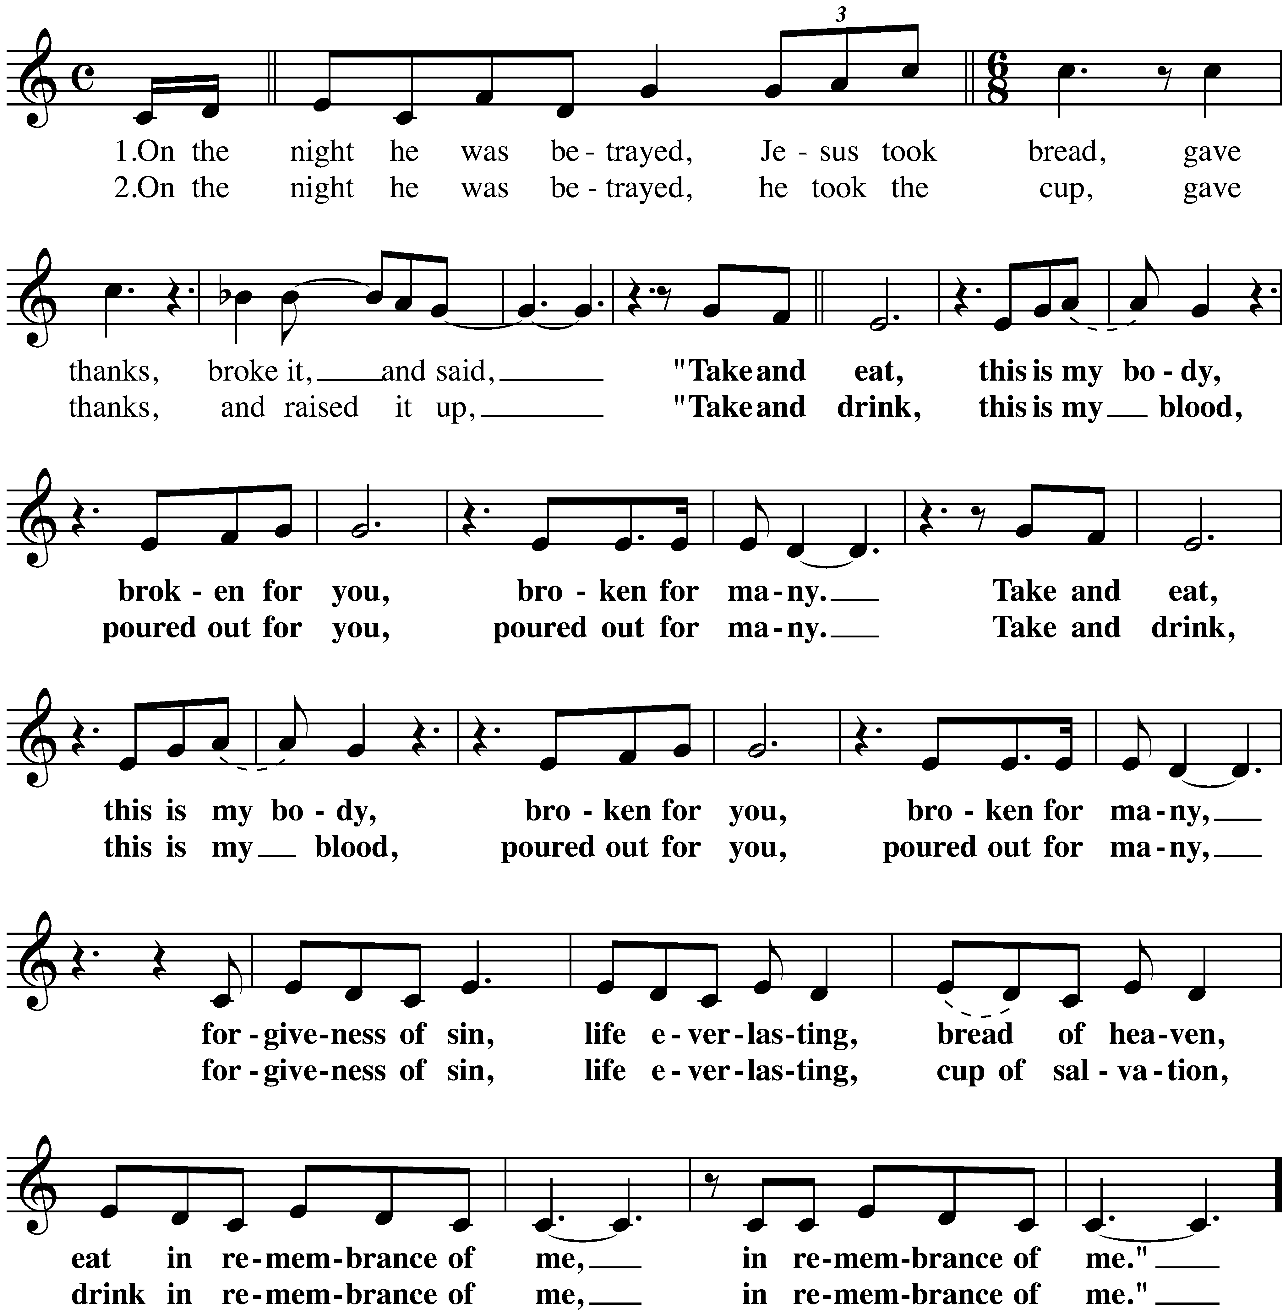
The Great Thanksgiving

The Lord’s Prayer
Our Father, who art in heaven,
hallowed be thy name, thy kingdom come,
thy will be done, on earth as it is in heaven.
Give us this day our daily bread;
and forgive us our trespasses, as we forgive those who trespass against us;
and lead us not into temptation but deliver us from evil.
For thine is the kingdom,
and the power, and the glory, forever and ever.
Amen.

Invitation to Communion
Christ invites you to this table.
All who are thirsty, all who are hungry, come!

Please be seated.
Communion Hymns
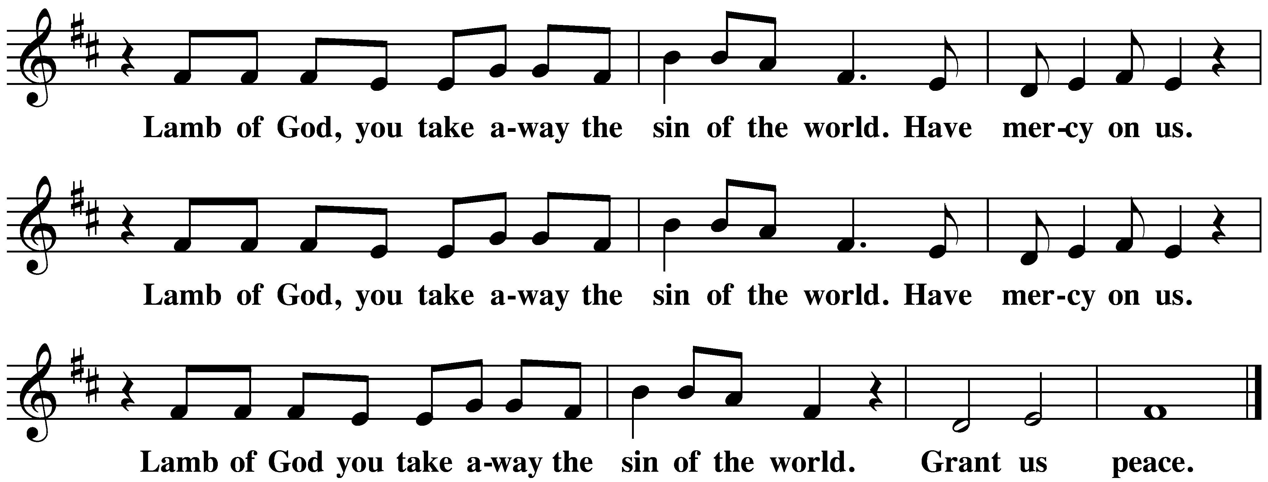
Great is Thy Faithfulness ELW 733

By Grace We Have Been Saved ACS 1006
Prayer after Communion
Sustaining God,
with this bread and cup,
you nourish us with mercy and abundant life.
By your Spirit, send us from this table to serve a needy world.
Make us living signs of your liberation, healing, and love,
following the way of Jesus, in whose name we pray.
Amen.
God blesses us and sends us in mission to the world.
SENDING

Blessing
The God of love
draw you into full accord and one mind,
in the body of Christ Jesus. Amen.
The God of hope
grant you strength and joy in all circumstances
through the interceding of the Spirit. Amen.
The God of grace
☩ bless you now and forever. Amen.

Sending Song A Mighty Fortress is Our God ELW 504

Dismissal
Go out in joy. Be led forth in peace.
Thanks be to God.

From sundaysandseasons.com.
Copyright © 2026 Augsburg Fortress. All rights reserved.
CCLI License 1553828

