Worship Plan for Sunday, May 31, 2026
The Holy Trinity

The Holy Spirit calls us together as the people of God.
GATHERING
Welcome & Announcements
Prelude
Reflection – Preparing for Worship

Spirit of the Living God

Please stand.
Confession and Forgiveness
All may make the sign of the cross, the sign that is marked at baptism, as the presiding minister begins.

Blessed be the holy Trinity,☩ one God,
whose compassion endures forever.
Amen.

Let us confess our sin to God.

Silence is kept for reflection.

Compassionate God,
we confess to you all our sins.
Our burden is heavy, and we cannot free ourselves.
In your mercy, call us back to you.
Your yoke is easy and your burden is light.
Restore us to dwell in your peace.
In Christ’s name we pray,
Amen.

Jesus says, “Come to me,
all you who are weary
and are carrying heavy burdens,
and I will give you rest.”
In the name of God,
Father, ☩ Son, and Holy Spirit,
your sins are forgiven.
Rest in God’s love.
Amen.

Gathering Song Holy God, We Praise Your Name (ELW 414)

Greeting
The grace of our Lord Jesus Christ, the love of God,
and the communion of the Holy Spirit be with you all.
And also with you.
Canticle of Praise

Prayer of the Day
Let us pray.
Almighty Creator and ever-living God: we worship your glory, eternal Three-in-One, and we praise your power, majestic One-in-Three. Keep us steadfast in this faith, defend us in all adversity, and bring us at last into your presence, where you live in endless joy and love, Father, Son, and Holy Spirit, one God, now and forever.
Amen.
God speaks to us in scripture reading, preaching, and song.
WORD

First Reading: Genesis 1:1—2:4a
A reading from Genesis.
¹ When God began to create the heavens and the earth, ² the earth was complete chaos, and darkness covered the face of the deep, while a wind from God swept over the face of the waters. ³ Then God said, “Let there be light,” and there was light. ⁴ And God saw that the light was good, and God separated the light from the darkness. ⁵ God called the light Day, and the darkness he called Night. And there was evening and there was morning, the first day.
⁶ And God said, “Let there be a dome in the midst of the waters, and let it separate the waters from the waters.” ⁷ So God made the dome and separated the waters that were under the dome from the waters that were above the dome. And it was so. ⁸ God called the dome Sky. And there was evening and there was morning, the second day.
⁹ And God said, “Let the waters under the sky be gathered together into one place, and let the dry land appear.” And it was so. ¹⁰ God called the dry land Earth, and the waters that were gathered together he called Seas. And God saw that it was good. ¹¹ Then God said, “Let the earth put forth vegetation: plants yielding seed and fruit trees of every kind on earth that bear fruit with the seed in it.” And it was so. ¹² The earth brought forth vegetation: plants yielding seed of every kind and trees of every kind bearing fruit with the seed in it. And God saw that it was good. ¹³ And there was evening and there was morning, the third day.
¹⁴ And God said, “Let there be lights in the dome of the sky to separate the day from the night, and let them be for signs and for seasons and for days and years, ¹⁵ and let them be lights in the dome of the sky to give light upon the earth.” And it was so. ¹⁶ God made the two great lights—the greater light to rule the day and the lesser light to rule the night—and the stars. ¹⁷ God set them in the dome of the sky to give light upon the earth, ¹⁸ to rule over the day and over the night, and to separate the light from the darkness. And God saw that it was good. ¹⁹ And there was evening and there was morning, the fourth day.
²⁰ And God said, “Let the waters bring forth swarms of living creatures, and let birds fly above the earth across the dome of the sky.” ²¹ So God created the great sea monsters and every living creature that moves, of every kind, with which the waters swarm and every winged bird of every kind. And God saw that it was good. ²² God blessed them, saying, “Be fruitful and multiply and fill the waters in the seas, and let birds multiply on the earth.” ²³ And there was evening and there was morning, the fifth day.
²⁴ And God said, “Let the earth bring forth living creatures of every kind: cattle and creeping things and wild animals of the earth of every kind.” And it was so. ²⁵ God made the wild animals of the earth of every kind and the cattle of every kind and everything that creeps upon the ground of every kind. And God saw that it was good.
²⁶ Then God said, “Let us make humans in our image, according to our likeness, and let them have dominion over the fish of the sea and over the birds of the air and over the cattle and over all the wild animals of the earth and over every creeping thing that creeps upon the earth.”
²⁷ So God created humans in his image,
in the image of God he created them;
male and female he created them.
²⁸ God blessed them, and God said to them, “Be fruitful and multiply and fill the earth and subdue it and have dominion over the fish of the sea and over the birds of the air and over every living thing that moves upon the earth.” ²⁹ God said, “See, I have given you every plant yielding seed that is upon the face of all the earth and every tree with seed in its fruit; you shall have them for food. ³⁰ And to every beast of the earth and to every bird of the air and to everything that creeps on the earth, everything that has the breath of life, I have given every green plant for food.” And it was so. ³¹ God saw everything that he had made, and indeed, it was very good. And there was evening and there was morning, the sixth day.
^{2:1} Thus the heavens and the earth were finished and all their multitude. ² On the sixth day God finished the work that he had done, and he rested on the seventh day from all the work that he had done. ³ So God blessed the seventh day and hallowed it, because on it God rested from all the work that he had done in creation.
^{4a} These are the generations of the heavens and the earth when they were created.
The word of the Lord.
Thanks be to God.
Psalm: Psalm 8
¹ O | Lord our Lord,
how majestic is your name in | all the earth!—
² you whose glory is chanted above the heavens out of the mouths of in- | fants and children;
you have set up a fortress against your enemies, to silence the foe | and avenger.
³ When I consider your heavens, the work | of your fingers,
the moon and the stars you have set | in their courses,
⁴ what are mere mortals that you should be mind- | ful of them,
human beings that you should | care for them? R
⁵ Yet you have made them little less | than divine;
with glory and hon- | or you crown them.
⁶ You have made them rule over the works | of your hands;
you have put all things un- | der their feet:
⁷ all | flocks and cattle,
even the wild beasts | of the field,
⁸ the birds of the air, the fish | of the sea,
and whatever passes along the paths | of the sea.
⁹ O | Lord our Lord,
how majestic is your name in | all the earth! R

Second Reading: 2 Corinthians 13:11-13
A reading from 2 Corinthians.
[Paul writes:] ¹¹ Finally, brothers and sisters, farewell. Be restored; listen to my appeal; agree with one another; live in peace; and the God of love and peace will be with you. ¹² Greet one another with a holy kiss. All the saints greet you.
¹³ The grace of the Lord Jesus Christ, the love of God, and the communion of the Holy Spirit be with all of you.
The word of the Lord.
Thanks be to God.

Pleas Stand.
Gospel: Matthew 28:16-20
The holy gospel according to Matthew.
Glory to you, O Lord.
¹⁶ Now the eleven disciples went to Galilee, to the mountain to which Jesus had directed them. ¹⁷ When they saw him, they worshiped him, but they doubted. ¹⁸ And Jesus came and said to them, “All authority in heaven and on earth has been given to me. ¹⁹ Go therefore and make disciples of all nations, baptizing them in the name of the Father and of the Son and of the Holy Spirit ²⁰ and teaching them to obey everything that I have commanded you. And remember, I am with you always, to the end of the age.”
The gospel of the Lord.
Praise to you, O Christ.
Please be seated.
Children’s Message

Sermon

Hymn of the Day God, Whose Almighty Word ELW 673

Apostles’ Creed
I believe in God, the Father almighty,
creator of heaven and earth.
I believe in Jesus Christ, God’s only Son, our Lord,
who was conceived by the Holy Spirit,
born of the virgin Mary,
suffered under Pontius Pilate,
was crucified, died, and was buried;
he descended to the dead.*
On the third day he rose again;
he ascended into heaven,
he is seated at the right hand of the Father,
and he will come to judge the living and the dead.
I believe in the Holy Spirit,
the holy catholic church,
the communion of saints,
the forgiveness of sins,
the resurrection of the body,
and the life everlasting. Amen.

Prayers of Intercession
Gathered together by the Holy Spirit, let us pray for the church and the needs of the world.
Holy God, we are in awe of your creative work. Continue that work in your church, making us a new creation that proclaims your presence and love. God of grace,
hear our prayer.
Creator God, nature reveals your power and glory. Protect water sources, vegetation, and wildlife as reminders of who you are. God of grace,
hear our prayer.
Redeemer God, you call us to pray for those in authority. Guide our leaders to pursue the work of fostering peace and community. God of grace,
hear our prayer.
Sustaining God, you are mindful of your people in every circumstance. Heal those who are sick. Provide for all who hunger. Protect those in harm’s way. Comfort any experiencing hardship (especially). God of grace,
hear our prayer.
Gracious God, we pray for the children of our church and community. Provide for their needs. Support their caregivers. Nurture their faith. God of grace,
hear our prayer.
Loving God, we give thanks for those who have died and claimed their baptismal promises (especially). Strengthen us to live as they did in communion with you. God of grace,
hear our prayer.
Trusting you receive all our prayers, we commend our spoken and unspoken prayers to you, O God, through Jesus our Savior.
Amen.

Peace
The peace of Christ be with you always. And also with you.

MEAL
God feeds us with the presence of Jesus Christ.

Special Music – Chase Hatmaker

Please stand.
Offertory Hymn Lord, Let My Heart Be Good Soil

Offering Prayer
Loving God,
we offer at your table the gifts of our hearts.
Help us take heart in you and share freely of your love,
so that all creation can taste your abundance.
We ask this in the name of Jesus,
through the Spirit abiding with us now and forever.
Amen.
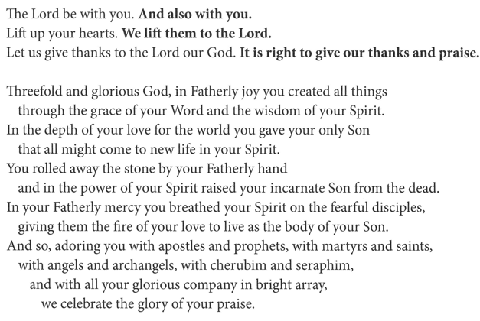
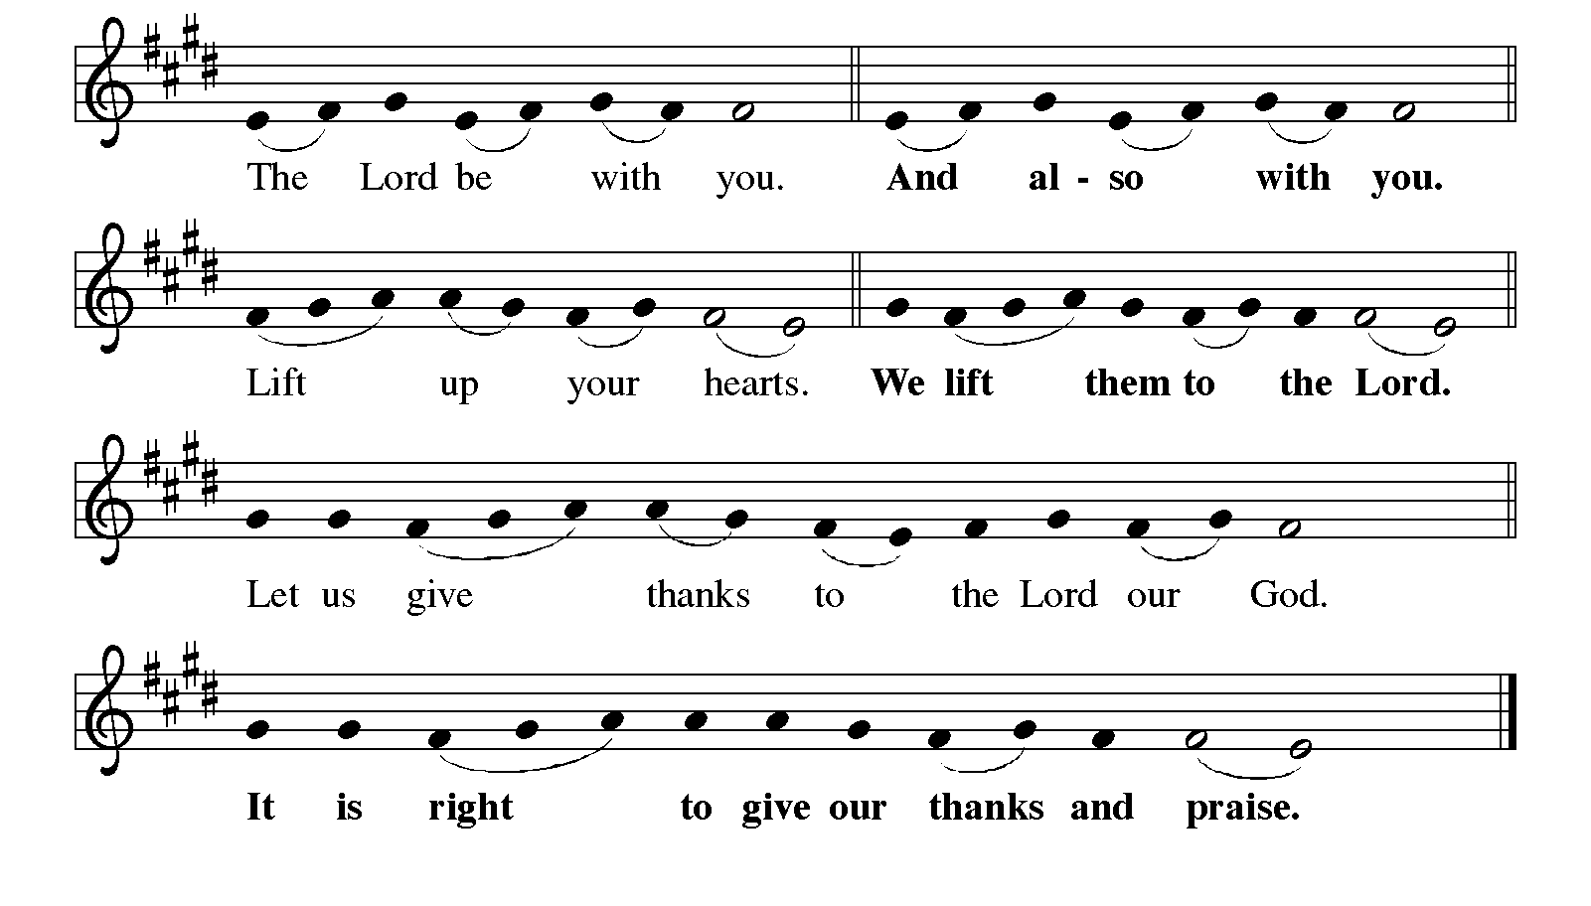
Great Thanksgiving

Eucharistic Prayer
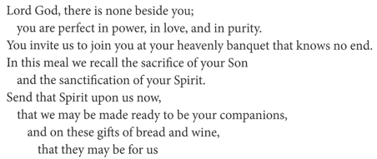
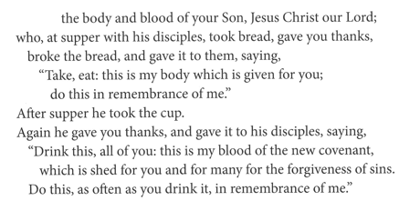

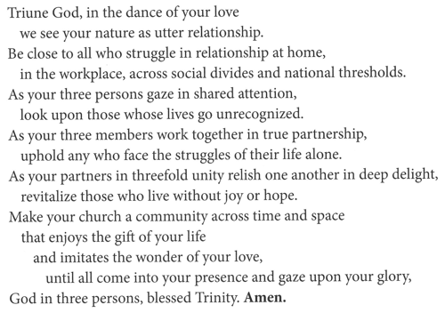
Lord’s Prayer
Our Father, who art in heaven,
hallowed be thy name, thy kingdom come,
thy will be done, on earth as it is in heaven.
Give us this day our daily bread;
and forgive us our trespasses, as we forgive those who trespass against us;
and lead us not into temptation but deliver us from evil.
For thine is the kingdom,
and the power, and the glory, forever and ever.
Amen.

Invitation to Communion
Heaven has come near.
Come, share in the feast!
Communion

Communion Songs Come, Join the Dance of Trinity ELW 412

Mothering God, You Gave Me Birth ELW 735

Prayer after Communion
Compassionate God,
through the gifts of bread and wine
our hearts are filled with the abundance of your love.
Strengthen us that we, through this holy meal,
may share your love freely, as you have shared with us.
We ask this in the name of Jesus,
through the Spirit nourishing us now and forever.
Amen.

SENDING
God blesses us and sends us in mission to the world.

Blessing
Creator, Redeemer, Sustainer,
☩ one God,
bless, heal, and hold you
today and always.
Amen.

Sending Song Holy, Holy, Holy, Lord God Almighty! ELW 413

Dismissal
Heaven has come near. Go, share the good news!
Thanks be to God.

From sundaysandseasons.com.
Copyright © 2026 Augsburg Fortress. All rights reserved.

