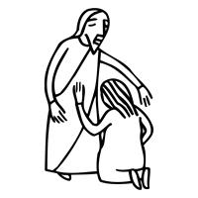
Worship Plan for Sunday, August 16, 2026
12th Sunday After Pentecost

The Holy Spirit calls us together as the people of God.
GATHERING

Prelude
Welcome/Announcements
Reflection - Preparing for Worship
Sing 3X

Please stand.
Confession and Forgiveness
All may make the sign of the cross, the sign that is marked at baptism, as the presiding minister begins.

Blessed be the holy Trinity,☩ one God,
whose compassion endures forever.
Amen.

Let us confess our sin to God.
Silence is kept for reflection.

Compassionate God,
we confess to you all our sins.
Our burden is heavy, and we cannot free ourselves.
In your mercy, call us back to you.
Your yoke is easy and your burden is light.
Restore us to dwell in your peace.
In Christ’s name we pray,
Amen.

Jesus says, “Come to me,
all you who are weary
and are carrying heavy burdens,
and I will give you rest.”
In the name of God,
Father, ☩ Son, and Holy Spirit,
your sins are forgiven.
Rest in God’s love.
Amen.

Gathering Song Oh, for a Thousand Tounges to Sing ELW 886

Greeting
The grace of our Lord Jesus Christ, the love of God
and the communion of the Holy Spirit be with you all.
And also, with you.

Hymn of Praise
Prayer of the Day
Let us pray.
God of all peoples, your arms reach out to embrace all those who call upon you. Teach us as disciples of your Son to love the world with compassion and constancy, that your name may be known throughout the earth, through Jesus Christ, our Savior and Lord.
Amen.

Please be seated.
God speaks to us in scripture reading, preaching, and song.
WORD

First Reading: Isaiah 56:1, 6-8
A reading from Isaiah.
¹ Thus says the Lord:
Maintain justice, and do what is right,
for soon my salvation will come
and my deliverance be revealed.
⁶ And the foreigners who join themselves to the Lord,
to minister to him, to love the name of the Lord,
and to be his servants,
all who keep the Sabbath and do not profane it
and hold fast my covenant—
⁷ these I will bring to my holy mountain
and make them joyful in my house of prayer;
their burnt offerings and their sacrifices
will be accepted on my altar,
for my house shall be called a house of prayer
for all peoples.
⁸ Thus says the Lord God,
who gathers the outcasts of Israel:
I will gather others to them
besides those already gathered.
The word of the Lord.
Thanks be to God.

Psalm: Psalm 67
¹ May God be merciful to | us and bless us;
may the light of God’s face | shine upon us.
² Let your way be known | upon earth,
your saving health a- | mong all nations.
³ Let the peoples praise | you, O God;
let all the | peoples praise you.
⁴ Let the nations be glad and | sing for joy,
for you judge the peoples with equity and guide all the na- | tions on earth. R
⁵ Let the peoples praise | you, O God;
let all the | peoples praise you.
⁶ The earth has brought | forth its increase;
God, our own | God, has blessed us.
⁷ May God | give us blessing,
and may all the ends of the earth | stand in awe. R

Second Reading: Romans 11:1-2a, 29-32
A reading from Romans.
[Paul writes:] ¹ I ask, then, has God rejected his people? By no means! I myself am an Israelite, a descendant of Abraham, a member of the tribe of Benjamin. ^{2a} God has not rejected his people whom he foreknew.
²⁹ For the gifts and the calling of God are irrevocable. ³⁰ Just as you were once disobedient to God but have now received mercy because of their disobedience, ³¹ so also they have now been disobedient in order that, by the mercy shown to you, they also may now receive mercy. ³² For God has imprisoned all in disobedience so that he may be merciful to all.
The word of the Lord.
Thanks be to God.

Please stand.
Gospel Acclamation
Gospel: Matthew 15:[10-20] 21-28
The holy gospel according to Matthew.
Glory to you, O Lord.
[¹⁰ [Jesus] called the crowd to him and said to them, “Listen and understand:¹¹ it is not what goes into the mouth that defiles a person, but it is what comes out of the mouth that defiles.” ¹² Then the disciples approached and said to him, “Do you know that the Pharisees took offense when they heard what you said?” ¹³ He answered, “Every plant that my heavenly Father has not planted will be uprooted. ¹⁴ Let them alone; they are blind guides of the blind. And if one blind person guides another, both will fall into a pit.” ¹⁵ But Peter said to him, “Explain this parable to us.” ¹⁶ Then he said, “Are you also still without understanding? ¹⁷ Do you not see that whatever goes into the mouth enters the stomach and goes out into the sewer? ¹⁸ But what comes out of the mouth proceeds from the heart, and this is what defiles. ¹⁹ For out of the heart come evil intentions, murder, adultery, sexual immorality, theft, false witness, slander. ²⁰ These are what defile a person, but to eat with unwashed hands does not defile.”]
²¹ Jesus left that place and went away to the district of Tyre and Sidon. ²² Just then a Canaanite woman from that region came out and started shouting, “Have mercy on me, Lord, Son of David; my daughter is tormented by a demon.” ²³ But he did not answer her at all. And his disciples came and urged him, saying, “Send her away, for she keeps shouting after us.” ²⁴ He answered, “I was sent only to the lost sheep of the house of Israel.” ²⁵ But she came and knelt before him, saying, “Lord, help me.” ²⁶ He answered, “It is not fair to take the children’s food and throw it to the dogs.” ²⁷ She said, “Yes, Lord, yet even the dogs eat the crumbs that fall from their masters’ table.” ²⁸ Then Jesus answered her, “Woman, great is your faith! Let it be done for you as you wish.” And her daughter was healed from that moment.
The gospel of the Lord.
Praise to you, O Christ.

Please be seated.
Children’s Message

Sermon

Please stand
Hymn of the Day In Christ There is No East or West ELW 650

Apostles’ Creed
Let us confess our faith to the words of the Apostles’ Creed
I believe in God, the Father almighty,
creator of heaven and earth.
I believe in Jesus Christ, God's only Son, our Lord,
who was conceived by the Holy Spirit,
born of the Virgin Mary,
suffered under Pontius Pilate,
was crucified, died, and was buried;
he descended to the dead.
On the third day he rose again;
he ascended into heaven,
he is seated at the right hand of the Father,
and he will come to judge the living and the dead.
I believe in the Holy Spirit,
the holy catholic Church,
the communion of saints,
the forgiveness of sins,
the resurrection of the body,
and the life everlasting. Amen

Please sit or kneel.
Prayers of Intercession
With bold trust in God’s unfailing provision, we pray for the church, those in need, and all of God’s creation.
For believers around the world who stream to your holy mountain, that all be united in faith and harmony in the body of Christ. Let your church on earth be a witness to the beloved community of your heavenly kingdom. Merciful God,
receive our prayer.
For your wondrous creation, that it thrives and flourishes as you intend. Raise up wise stewards to defend the natural world against carelessness and destruction. Safeguard endangered species and their habitats (especially). Merciful God,
receive our prayer.
For the nations of the world and all in authority, that they heed the cry of the outcast and ensure care for the most vulnerable. Give wisdom to leaders of countries, congregations, and communities, that they lead and serve justly. Merciful God,
receive our prayer.
For all who are lonely, grieving, or struggling with chronic pain, that they find comfort, community, and hope. Send relief to all who struggle with illness of any kind (especially). Merciful God,
receive our prayer.
For this congregation, for visitors and those new to this faith community, that all may recognize the presence of Christ in each new face. Draw this community together in love and strengthen it in unwavering faith. Merciful God,
receive our prayer.
For the saints before us whose work is done, that their faithful example continues to direct your church. May their witness remind us that your gifts and calling are irrevocable, whether in life or death. Merciful God,
receive our prayer.
Receive our prayers and answer, O God, as you have promised. All this we ask in the name of your Son, Jesus Christ our Lord.
Amen.

Peace
The peace of Christ be with you always. And also, with you.

MEAL
God feeds us with the presence of Jesus Christ.

Please be seated.
Offering

Special Music Suzanne & Brian Walters

Please stand.
Offertory Hymn Here on Jesus Christ I will Stand ACS 1024

Offertory Prayer
Lord of the harvest,
we return to you a portion of what you have given to us.
Turn us to set our hope not on the uncertainty of riches,
but on you, who richly provides for us.
Multiply what we have gathered
to bless all who are suffering and in need,
through Jesus Christ our Lord.
Amen.

The Great Thanksgiving
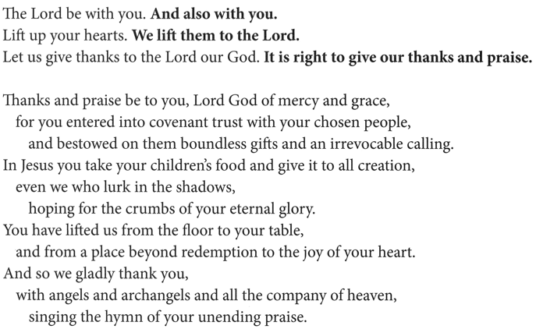

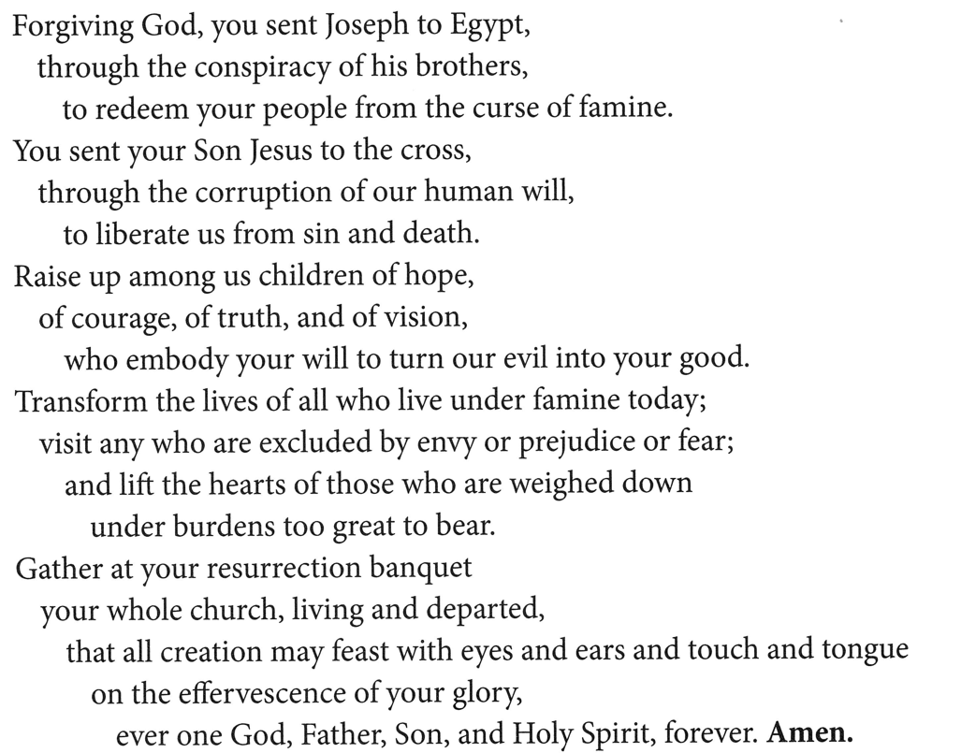
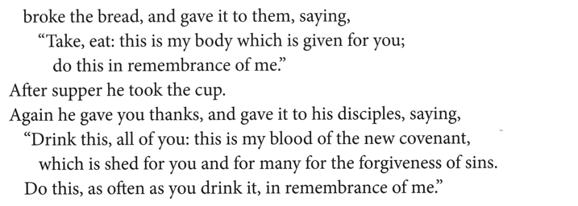
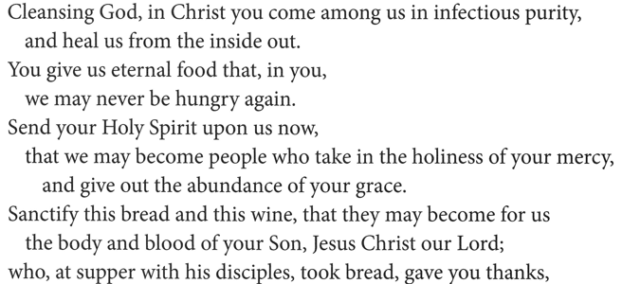

The Lord’s Prayer
Our Father, who art in heaven,
hallowed be thy name, thy kingdom come,
thy will be done, on earth as it is in heaven.
Give us this day our daily bread;
and forgive us our trespasses, as we forgive those who trespass against us;
and lead us not into temptation but deliver us from evil.
For thine is the kingdom,
and the power, and the glory, forever and ever.
Amen.

Invitation to Communion
Heaven has come near.
Come, share in the feast!

Please be seated.
Communion Hymns

Build a Longer Table ACS 1062

Healer of Our Every Ill ELW 612

Prayer after Communion
Compassionate God,
through the gifts of bread and wine
our hearts are filled with the abundance of your love.
Strengthen us that we, through this holy meal,
may share your love freely, as you have shared with us.
We ask this in the name of Jesus,
through the Spirit nourishing us now and forever.
Amen.

God blesses us and sends us in mission to the world.
SENDING

Blessing
Creator, Redeemer, Sustainer,
☩ one God,
bless, heal, and hold you
today and always.
Amen.

Sending Song Jesus Shall Reign ELW 434

Dismissal
Heaven has come near. Go, share the good news!
Thanks be to God.

From sundaysandseasons.com.
Copyright © 2026 Augsburg Fortress. All rights reserved.

