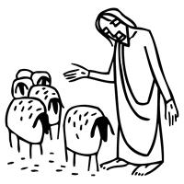
Worship Plan for Sunday, May 3, 2026
Fifth Sunday of Easter

The Holy Spirit calls us together as the people of God.
GATHERING
Welcome & Announcements
Prelude
Reflection – Preparing for Worship

Please stand.
Confession and Forgiveness
The assembly stands. All may make the sign of the cross, the sign that is marked at baptism, as the presiding minister begins.

In the name of the Father,
and of the ☩ Son,
and of the Holy Spirit.
Amen.

God of all mercy and consolation, come to the help of your people, turning us from our sin to live for you alone. Give us the power of your Holy Spirit that we may confess our sin, receive your forgiveness, and grow into the fullness of Jesus Christ, our Savior and Lord.
Amen.

Let us confess our sin in the presence of God and of one another.
The assembly kneels or stands. Silence is kept for reflection.

Most merciful God,
we confess that we are captive to sin and cannot free ourselves. We have sinned against you in thought, word, and deed, by what we have done and by what we have left undone. We have not loved you with our whole heart; we have not loved our neighbors as ourselves. For the sake of your Son, Jesus Christ, have mercy on us. Forgive us, renew us, and lead us, so that we may delight in your will and walk in your ways, to the glory of your holy name.
Amen.

In the mercy of almighty God, Jesus Christ was given to die for us, and for his sake God forgives us all our sins. As a called and ordained minister of the church of Christ, and by his authority, I therefore declare to you the entire forgiveness of all your sins, in the name of the Father, and of the ☩ Son, and of the Holy Spirit.
Amen.

Gathering Song Lord God, We Praise You ELW 558

Greeting
The grace of our Lord Jesus Christ, the love of God,
and the communion of the Holy Spirit be with you all.
And also with you.

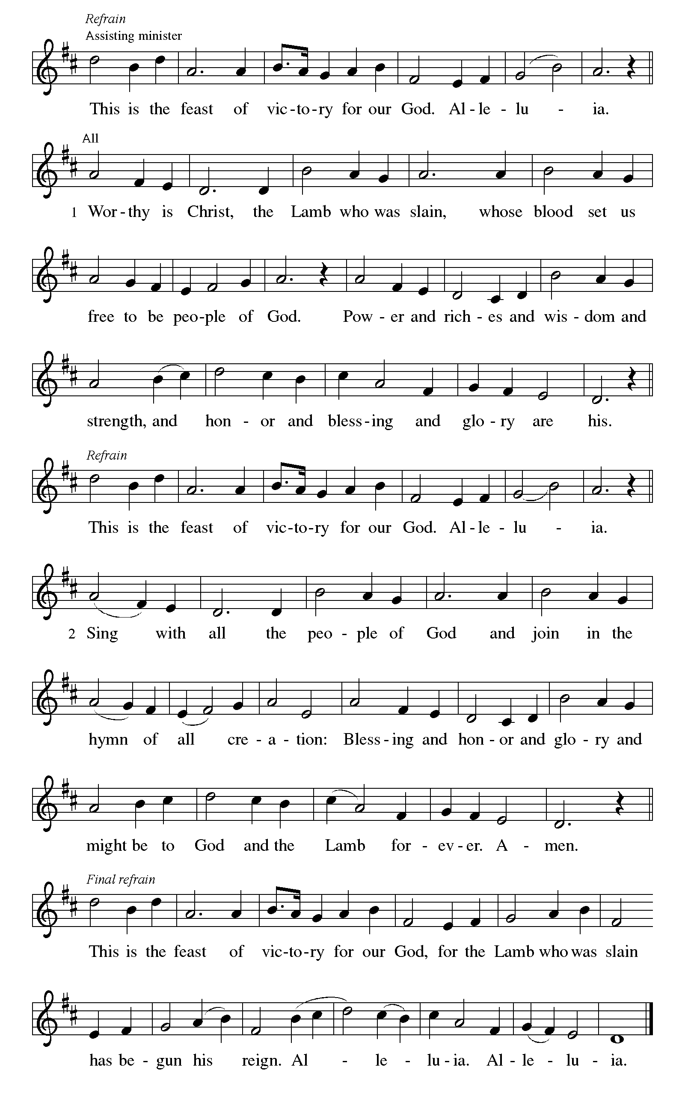
Canticle of Praise

Prayer of the Day
Let us pray.
Almighty God, your Son Jesus Christ is the way, the truth, and the life. Give us grace to love one another, to follow in the way of his commandments, and to share his risen life with all the world, for he lives and reigns with you and the Holy Spirit, one God, now and forever.
Amen.
God speaks to us in scripture reading, preaching, and song.
WORD
First Reading: Acts 7:55-60
A reading from Acts.
⁵⁵ Filled with the Holy Spirit, [Stephen] gazed into heaven and saw the glory of God and Jesus standing at the right hand of God. ⁵⁶ “Look,” he said, “I see the heavens opened and the Son of Man standing at the right hand of God!” ⁵⁷ But they covered their ears, and with a loud shout all rushed together against him. ⁵⁸ Then they dragged him out of the city and began to stone him, and the witnesses laid their coats at the feet of a young man named Saul. ⁵⁹ While they were stoning Stephen, he prayed, “Lord Jesus, receive my spirit.” ⁶⁰ Then he knelt down and cried out in a loud voice, “Lord, do not hold this sin against them.” When he had said this, he died.
The word of the Lord.
Thanks be to God.

Psalm: Psalm 31:1-5, 15-16
¹ In you, O Lord, have I taken refuge; let me never be | put to shame;
deliver me | in your righteousness.
² Incline your | ear to me;
make haste to de- | liver me.
³ Be my strong rock, a castle to keep me safe, for you are my crag | and my stronghold;
for the sake of your name, lead | me and guide me.
⁴ Take me out of the net that they have secretly | set for me,
for you are my tow- | er of strength. R
⁵ Into your hands I com- | mend my spirit,
for you have redeemed me, O Lord, | God of truth.
¹⁵ My times are | in your hand;
rescue me from the hand of my enemies, and from those who | persecute me.
¹⁶ Let your face shine up- | on your servant;
save me in your | steadfast love.” R

Second Reading: 1 Peter 2:2-10
A reading from 1 Peter.
² Like newborn infants, long for the pure, spiritual milk, so that by it you may grow into salvation ³ if indeed you have tasted that the Lord is good.
⁴ Come to him, a living stone, though rejected by mortals yet chosen and precious in God’s sight, and ⁵ like living stones let yourselves be built into a spiritual house, to be a holy priesthood, to offer spiritual sacrifices acceptable to God through Jesus Christ. ⁶ For it stands in scripture:
“See, I am laying in Zion a stone,
a cornerstone chosen and precious,
and whoever believes in him will not be put to shame.”
⁷ This honor, then, is for you who believe, but for those who do not believe,
“The stone that the builders rejected
has become the very head of the corner,”
⁸ and
“A stone that makes them stumble
and a rock that makes them fall.”
They stumble because they disobey the word, as they were destined to do.
⁹ But you are a chosen people, a royal priesthood, a holy nation, God’s own people, in order that you may proclaim the excellence of him who called you out of darkness into his marvelous light.
¹⁰ Once you were not a people,
but now you are God’s people;
once you had not received mercy,
but now you have received mercy.
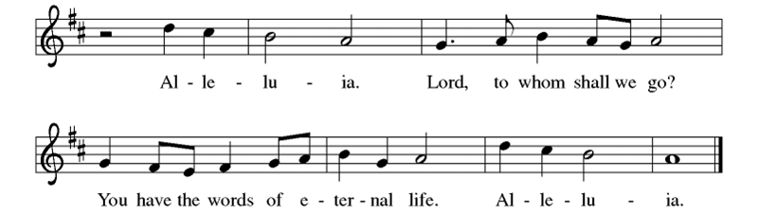
The word of the Lord.
Thanks be to God.
Gospel: John 14:1-14
The holy gospel according to John.
Glory to you, O Lord.
[Jesus said to the disciples:] ¹ “Do not let your hearts be troubled. Believe in God; believe also in me. ² In my Father’s house there are many dwelling places. If it were not so, would I have told you that I go to prepare a place for you? ³ And if I go and prepare a place for you, I will come again and will take you to myself, so that where I am, there you may be also. ⁴ And you know the way to the place where I am going.” ⁵ Thomas said to him, “Lord, we do not know where you are going. How can we know the way?” ⁶ Jesus said to him, “I am the way and the truth and the life. No one comes to the Father except through me. ⁷ If you know me, you will know my Father also. From now on you do know him and have seen him.”
⁸ Philip said to him, “Lord, show us the Father, and we will be satisfied.” ⁹ Jesus said to him, “Have I been with you all this time, Philip, and you still do not know me? Whoever has seen me has seen the Father. How can you say, ‘Show us the Father’? ¹⁰ Do you not believe that I am in the Father and the Father is in me? The words that I say to you I do not speak on my own, but the Father who dwells in me does his works. ¹¹ Believe me that I am in the Father and the Father is in me, but if you do not, then believe because of the works themselves. ¹² Very truly, I tell you, the one who believes in me will also do the works that I do and, in fact, will do greater works than these, because I am going to the Father. ¹³ I will do whatever you ask in my name, so that the Father may be glorified in the Son. ¹⁴ If in my name you ask me for anything, I will do it.”
The gospel of the Lord. Praise to you, O Christ.
Please be seated.
Children’s Message

Sermon
Hymn of the Day O Jesus, I Have Promised ELW 810

Nicene Creed
A: Let us profess our faith to the words of the Nicene creed
We believe in one God,
the Father, the Almighty,
maker of heaven and earth,
of all that is, seen and unseen.
We believe in one Lord, Jesus Christ,
the only Son of God,
eternally begotten of the Father,
God from God, Light from Light,
true God from true God,
begotten, not made,
of one Being with the Father;
through him all things were made.
For us and for our salvation
he came down from heaven,
was incarnate of the Holy Spirit and the virgin Mary
and became truly human.
For our sake he was crucified under Pontius Pilate;
he suffered death and was buried.
On the third day he rose again
in accordance with the scriptures;
he ascended into heaven
and is seated at the right hand of the Father.
He will come again in glory to judge the living and the dead,
and his kingdom will have no end.
We believe in the Holy Spirit, the Lord, the giver of life,
who proceeds from the Father and the Son,*
who with the Father and the Son is worshiped and glorified,
who has spoken through the prophets.
We believe in one holy catholic and apostolic church.
We acknowledge one baptism for the forgiveness of sins.
We look for the resurrection of the dead,
and the life of the world to come. Amen.

Prayers of Intercession
Trusting in the power of Christ’s resurrection to heal and redeem our broken world, let us pray for the needs of all creation.
God of glory, you have built your church on Christ the cornerstone. Inspire lay leaders, deacons, pastors, and bishops to proclaim forgiveness and your steadfast love to all whom they encounter. Merciful God,
receive our prayer.
God of majesty, you bring forth plants and animals, skies and seas, mountains and valleys. Protect all you have made from the ravages of pollution and climate disaster. Merciful God,
receive our prayer.
God of mercy, you intend governments and social service agencies to be instruments of peace and justice. Guide political leaders and organizations to be agents of compassion, and raise up advocates for those who seek refuge and assistance. Merciful God,
receive our prayer.
God of well-being, you soothe those in distress, console all who grieve, provide for any in need, and comfort those who are sick (especially). Instill caregivers with a sense of purpose to be your healing hands in this world. Merciful God,
receive our prayer.
God of community, you call us together as your people for mutual support and to witness to your love in the world. Make your presence known among those unable to attend worship today. Merciful God,
receive our prayer.
God of eternal life, you have prepared dwelling places for your people, so that we are never separated from you. We give you thanks for the faithful departed who witnessed to your mighty acts in word and deed. Merciful God,
receive our prayer.
God of resurrection power, use us and these prayers to proclaim the good news of new life to all the world, through Jesus Christ, our risen Savior.
Amen.

Peace
The peace of Christ be with you always. And also with you.

MEAL
God feeds us with the presence of Jesus Christ.

Choral Anthem – How Great Thou Art

Please stand.
Offertory Hymn Give Thanks

Offering Prayer
Merciful God,
accept the fruits of our labor, gathered to give you glory.
You have set a table before us, a glimpse of that great day
when we will hunger and thirst no more.
Nourish us with the body and blood of Jesus,
that goodness and mercy may follow us
and bless the world you love.
In the name of Jesus,
Amen.

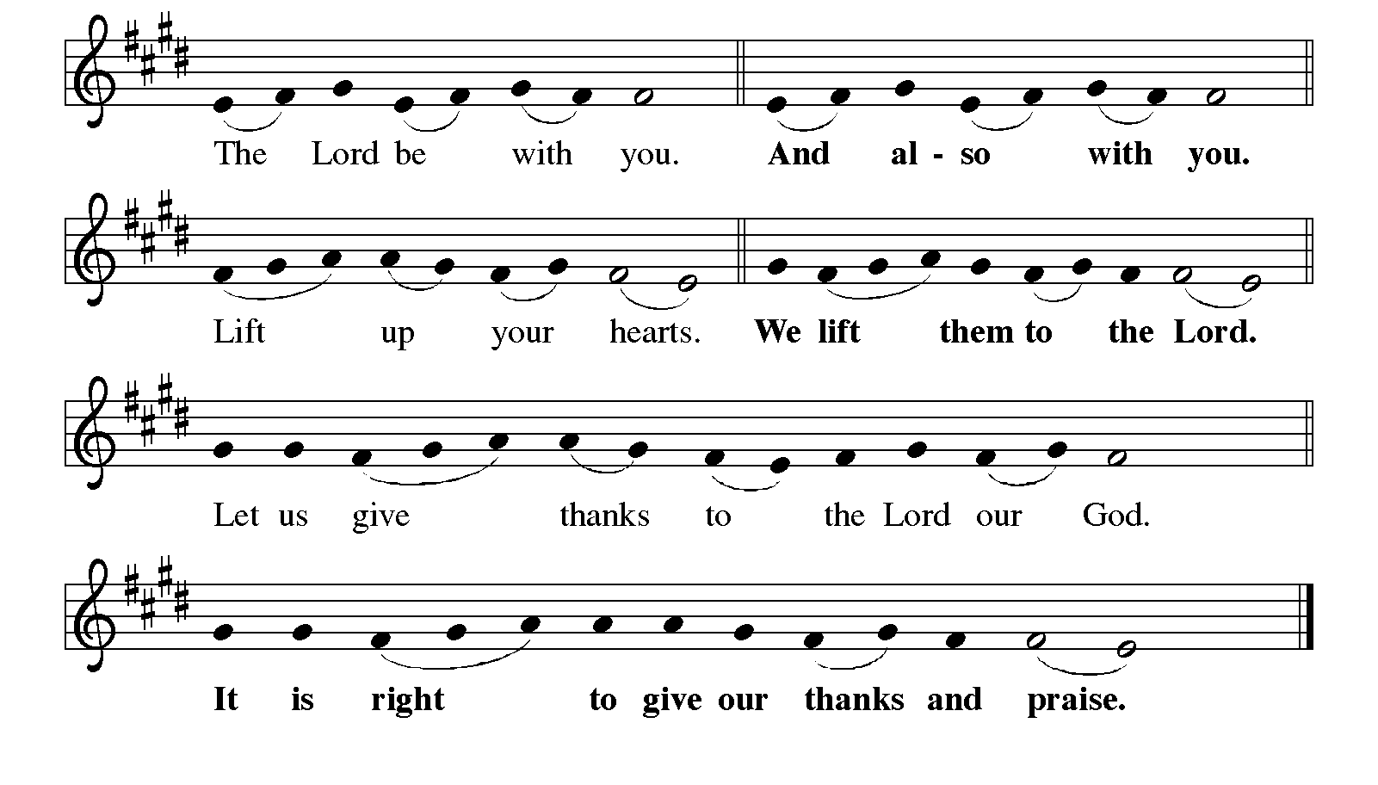
Great Thanksgiving
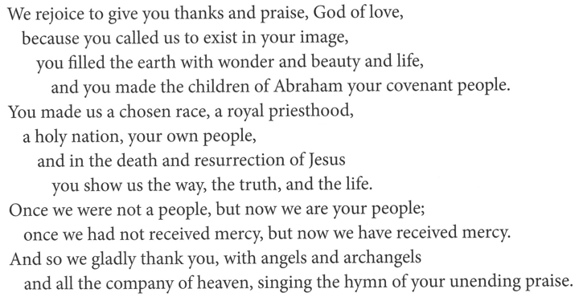

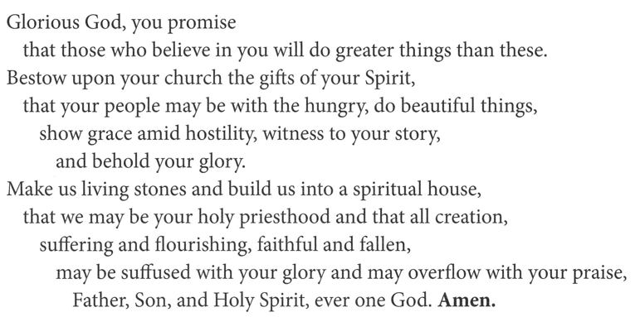
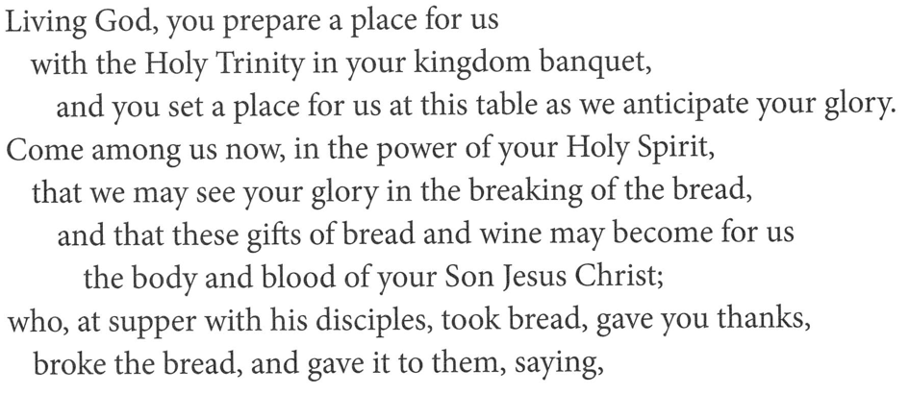
Eucharistic Prayer
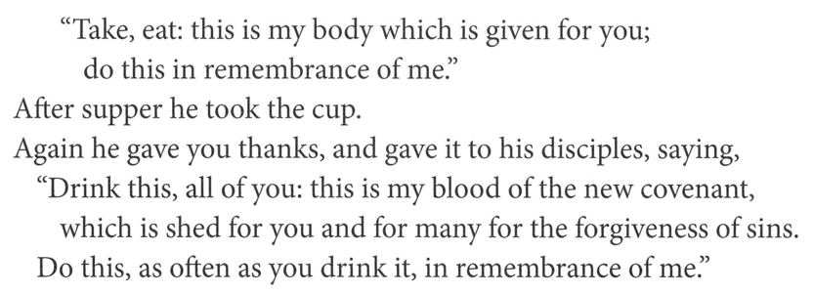
Lord’s Prayer
Our Father, who art in heaven,
hallowed be thy name, thy kingdom come,
thy will be done, on earth as it is in heaven.
Give us this day our daily bread;
and forgive us our trespasses, as we forgive those who trespass against us;
and lead us not into temptation but deliver us from evil.
For thine is the kingdom,
and the power, and the glory, forever and ever.
Amen.
Invitation to Communion
Come to the table of new life.
Receive the risen Lord.

Communion

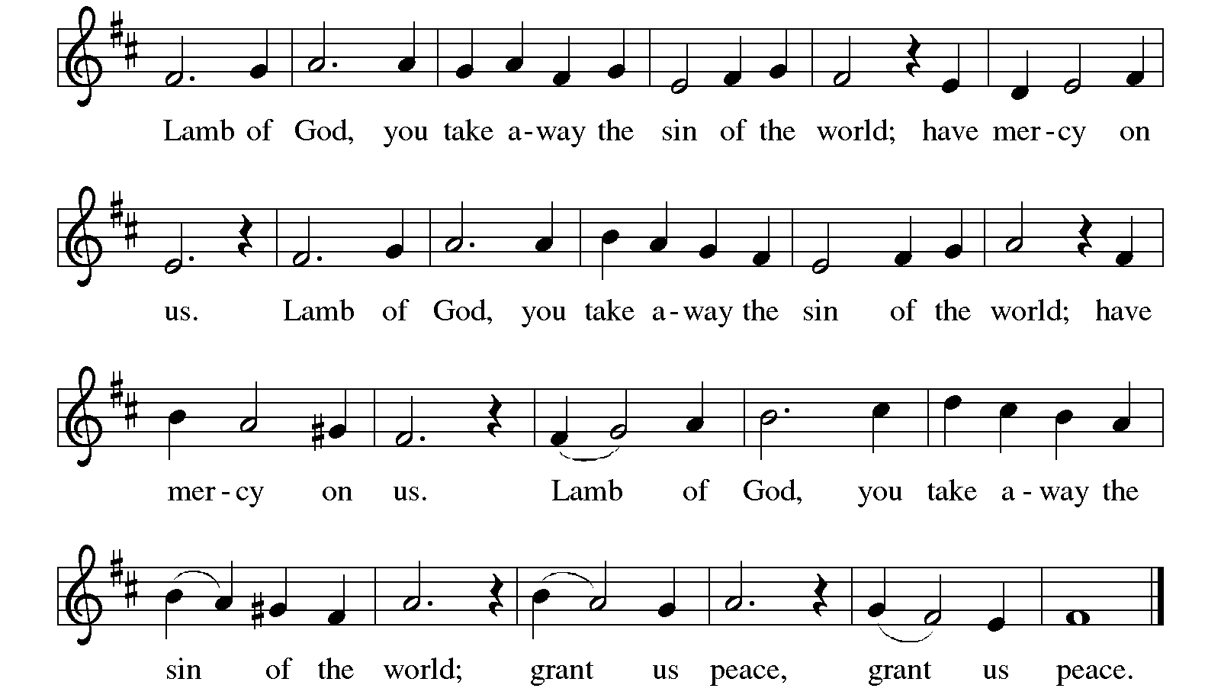

Communion Songs I Received the Living God ELW 477

Bring Many Names ACS 1094

Prayer after Communion
Holy One,
through this meal you have made your home among us
and are making all things new.
Send us now to speak peace to anxious hearts,
to love our enemies,
and to bring your healing to the nations.
In the name of Jesus, Amen.

SENDING
God blesses us and sends us in mission to the world.

Blessing
God Almighty, who is the beginning and the end,
Jesus Christ, the firstborn of the dead,
and the Spirit, our advocate and peace,
☩ bless you now and forever.
Amen.
Sending Song Christ Is Alive! Let Christians Sing ELW 389

Dismissal
Go in peace. Praise the Lord. Alleluia!
Thanks be to God. Alleluia!

From sundaysandseasons.com.

Copyright © 2026 Augsburg Fortress. All rights reserved.

