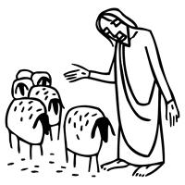
Worship Plan for Sunday, April 26, 2026
Fourth Sunday of Easter

The Holy Spirit calls us together as the people of God.
GATHERING
Welcome & Announcements
Prelude
Reflection – Preparing for Worship

Please stand.
Confession and Forgiveness
The assembly stands. All may make the sign of the cross, the sign that is marked at baptism, as the presiding minister begins.

In the name of the Father,
and of the ☩ Son,
and of the Holy Spirit.
Amen.

God of all mercy and consolation, come to the help of your people, turning us from our sin to live for you alone. Give us the power of your Holy Spirit that we may confess our sin, receive your forgiveness, and grow into the fullness of Jesus Christ, our Savior and Lord.
Amen.

Let us confess our sin in the presence of God and of one another.
The assembly kneels or stands. Silence is kept for reflection.

Most merciful God,
we confess that we are captive to sin and cannot free ourselves. We have sinned against you in thought, word, and deed, by what we have done and by what we have left undone. We have not loved you with our whole heart; we have not loved our neighbors as ourselves. For the sake of your Son, Jesus Christ, have mercy on us. Forgive us, renew us, and lead us, so that we may delight in your will and walk in your ways, to the glory of your holy name.
Amen.

In the mercy of almighty God, Jesus Christ was given to die for us, and for his sake God forgives us all our sins. As a called and ordained minister of the church of Christ, and by his authority, I therefore declare to you the entire forgiveness of all your sins, in the name of the Father, and of the ☩ Son, and of the Holy Spirit.
Amen.

Gathering Song Come, Thou Fount of Every Blessing ELW 807

Greeting
The grace of our Lord Jesus Christ, the love of God,
and the communion of the Holy Spirit be with you all.
And also with you.

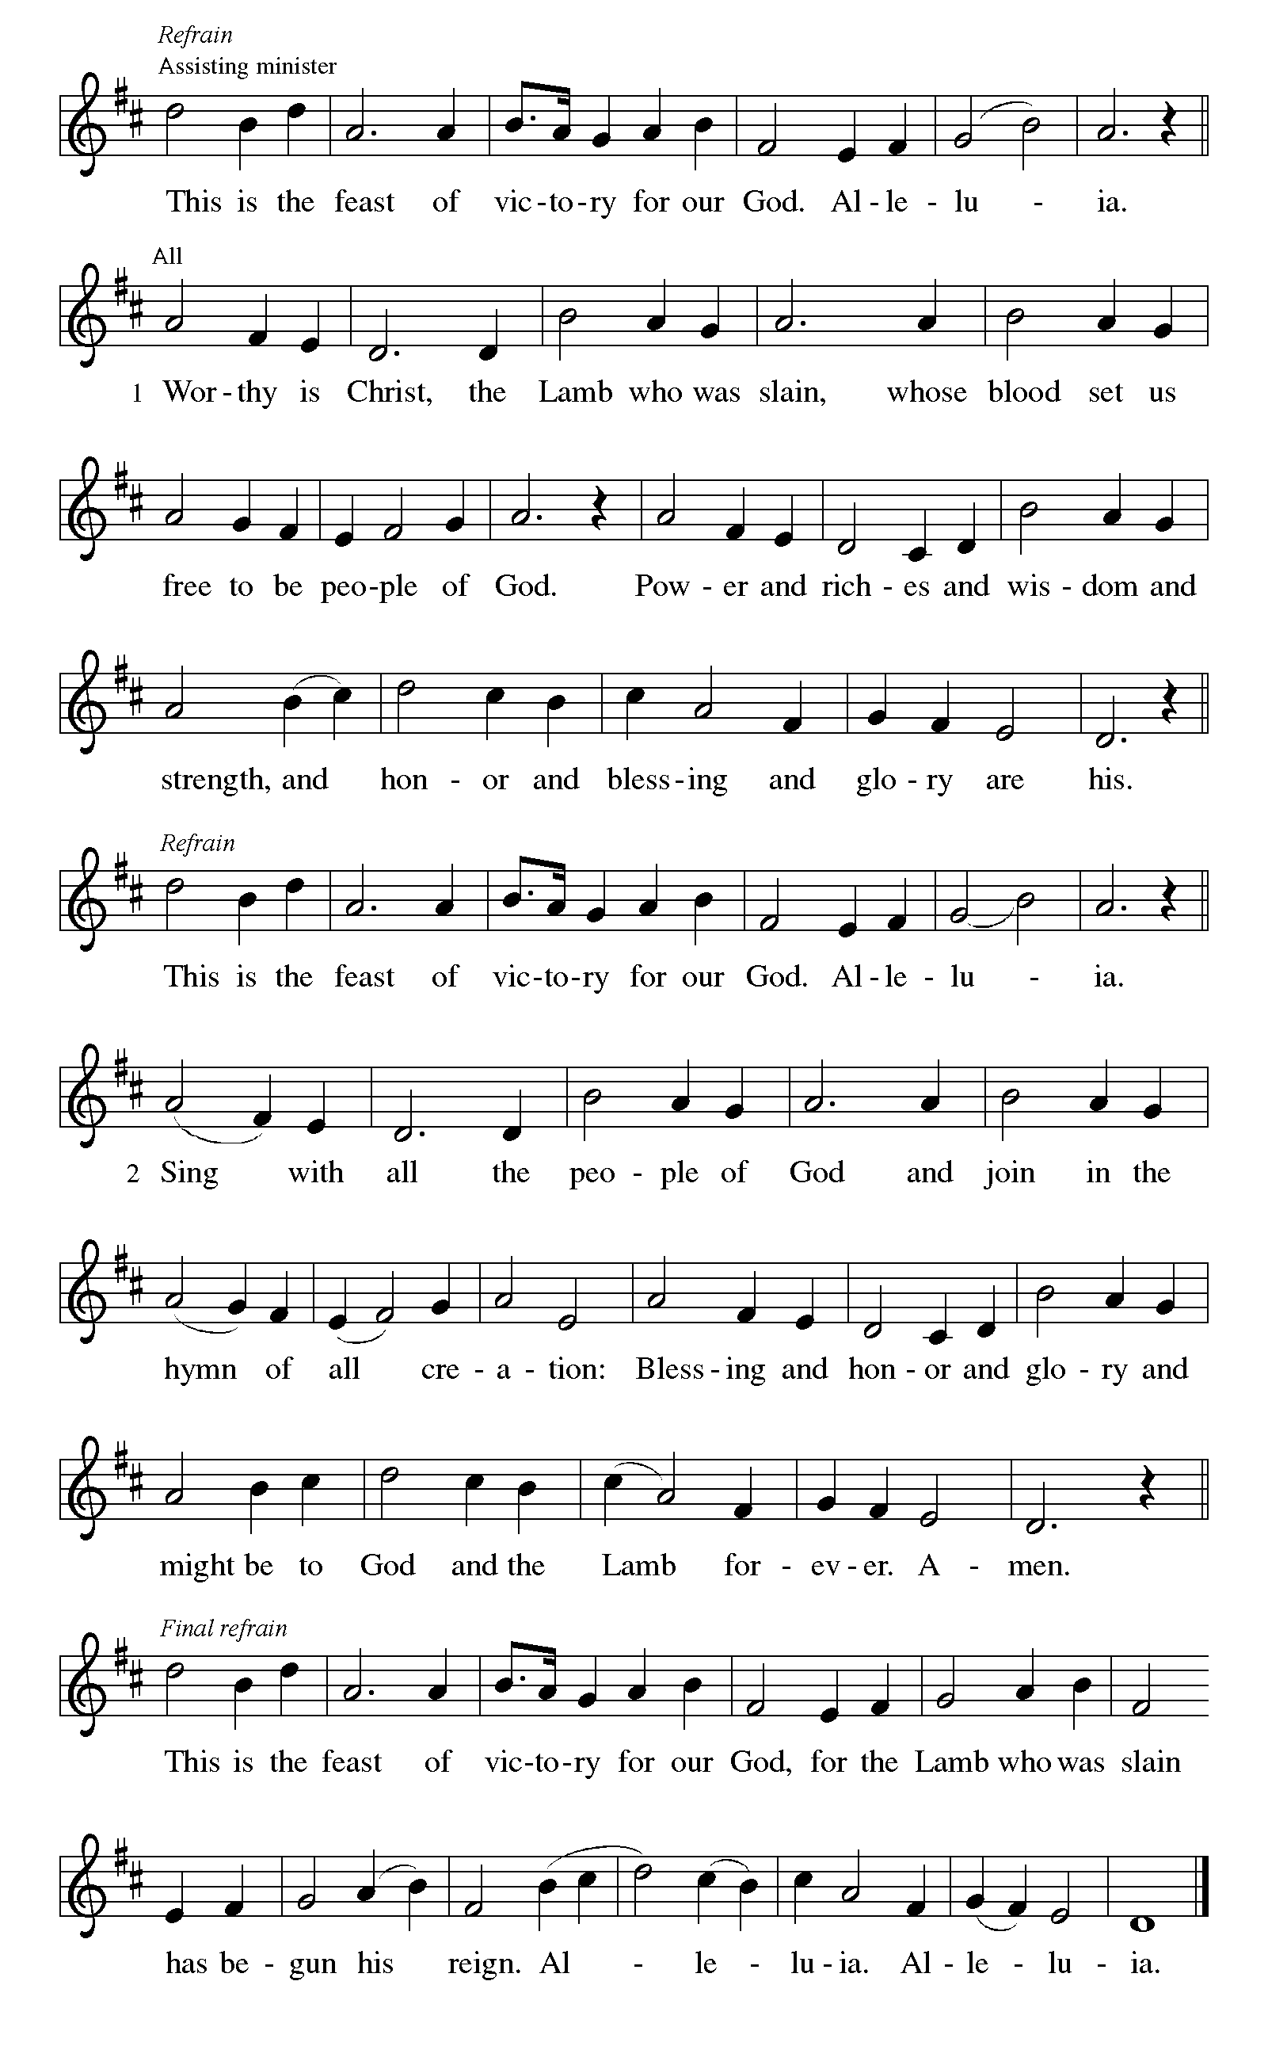
Canticle of Praise

Prayer of the Day
Let us pray.
O God our shepherd, you know your sheep by name and lead us to safety through the valleys of death. Guide us by your voice, that we may walk in certainty and security to the joyous feast prepared in your house, through Jesus Christ, our Savior and Lord, who lives and reigns with you and the Holy Spirit, one God, now and forever.
Amen.
God speaks to us in scripture reading, preaching, and song.
WORD
First Reading: Acts 2:42-47
A reading from Acts.
⁴² [The baptized] devoted themselves to the apostles’ teaching and fellowship, to the breaking of bread and the prayers.
⁴³ Awe came upon everyone because many wonders and signs were being done through the apostles. ⁴⁴ All who believed were together and had all things in common; ⁴⁵ they would sell their possessions and goods and distribute the proceeds to all, as any had need. ⁴⁶ Day by day, as they spent much time together in the temple, they broke bread at home and ate their food with glad and generous hearts, ⁴⁷ praising God and having the goodwill of all the people. And day by day the Lord added to their number those who were being saved.
The word of the Lord.
Thanks be to God.

Psalm: Psalm 23
¹ The Lord | is my shepherd;
I shall not | be in want.
² The Lord makes me lie down | in green pastures
and leads me be- | side still waters.
³ You restore my | soul, O Lord,
and guide me along right pathways | for your name’s sake.
⁴ Though I walk through the valley of the shadow of death, I shall | fear no evil;
for you are with me; your rod and your staff, they | comfort me. R
⁵ You prepare a table before me in the presence | of my enemies;
you anoint my head with oil, and my cup is | running over.
⁶ Surely goodness and mercy shall follow me all the days | of my life,
and I will dwell in the house of the | Lord forever. R

Second Reading: 1 Peter 2:19-25
A reading from 1 Peter.
¹⁹ It is a commendable thing if, being aware of God, a person endures pain while suffering unjustly. ²⁰ If you endure when you are beaten for doing wrong, what credit is that? But if you endure when you do good and suffer for it, this is a commendable thing before God. ²¹ For to this you have been called, because Christ also suffered for you, leaving you an example, so that you should follow in his steps.
²² “He committed no sin,
and no deceit was found in his mouth.”
²³ When he was abused, he did not return abuse; when he suffered, he did not threaten, but he entrusted himself to the one who judges justly. ²⁴ He himself bore our sins in his body on the cross, so that, having died to sins, we might live for righteousness; by his wounds you have been healed. ²⁵ For you were going astray like sheep, but now you have returned to the shepherd and guardian of your souls.
The word of the Lord.
Thanks be to God.

Gospel: John 10:1-10
The holy gospel according to John.
Glory to you, O Lord.
[Jesus said:] ¹ “Very truly, I tell you, anyone who does not enter the sheepfold by the gate but climbs in by another way is a thief and a bandit. ² The one who enters by the gate is the shepherd of the sheep. ³ The gatekeeper opens the gate for him, and the sheep hear his voice. He calls his own sheep by name and leads them out. ⁴ When he has brought out all his own, he goes ahead of them, and the sheep follow him because they know his voice. ⁵ They will not follow a stranger, but they will run from him because they do not know the voice of strangers.” ⁶ Jesus used this figure of speech with them, but they did not understand what he was saying to them.
⁷ So again Jesus said to them, “Very truly, I tell you, I am the gate for the sheep. ⁸ All who came before me are thieves and bandits, but the sheep did not listen to them. ⁹ I am the gate. Whoever enters by me will be saved and will come in and go out and find pasture. ¹⁰ The thief comes only to steal and kill and destroy. I came that they may have life and have it abundantly.”
The gospel of the Lord.
Praise to you, O Christ.

Please be seated.
Children’s Message

Sermon

Hymn of the Day The Lord’s My Shepherd ELW 778

Nicene Creed
A: Let us profess our faith to the words of the Nicene creed
We believe in one God,
the Father, the Almighty,
maker of heaven and earth,
of all that is, seen and unseen.
We believe in one Lord, Jesus Christ,
the only Son of God,
eternally begotten of the Father,
God from God, Light from Light,
true God from true God,
begotten, not made,
of one Being with the Father;
through him all things were made.
For us and for our salvation
he came down from heaven,
was incarnate of the Holy Spirit and the virgin Mary
and became truly human.
For our sake he was crucified under Pontius Pilate;
he suffered death and was buried.
On the third day he rose again
in accordance with the scriptures;
he ascended into heaven
and is seated at the right hand of the Father.
He will come again in glory to judge the living and the dead,
and his kingdom will have no end.
We believe in the Holy Spirit, the Lord, the giver of life,
who proceeds from the Father and the Son,*
who with the Father and the Son is worshiped and glorified,
who has spoken through the prophets.
We believe in one holy catholic and apostolic church.
We acknowledge one baptism for the forgiveness of sins.
We look for the resurrection of the dead,
and the life of the world to come. Amen.

Prayers of Intercession
Trusting in the power of Christ’s resurrection to heal and redeem our broken world, let us pray for the needs of all creation.
Shepherding God, draw all people to yourself and lead them in paths of righteousness. Embolden your church to enter the valleys of the world and guide us beside the still waters of your grace. We pray for military and prison chaplains serving near and far. Merciful God,
receive our prayer.
Creator God, by the resurrection of your Son, show us your steadfast love and instruct our hearts in your ways. Help us to revere and protect the wonders of your creation. Merciful God,
receive our prayer.
Righteous Judge, strengthen and uphold those who work for justice and advocate for human rights. Bring an end to oppression and save us from the temptation of violence or vengeance. Merciful God,
receive our prayer.
Great Physician, walk with those who are grieving, and anoint those who are ill or injured (especially). Restore them to health of body, mind, and spirit. Merciful God,
receive our prayer.
Good Shepherd, continually seek us out as lambs of your flock, and form us into a community where all are honored and cared for. Spread a feast before us and fill our cups to overflowing. Merciful God,
receive our prayer.
Living God, we praise you for the saints who have died in faith and now dwell in your love. At our end, bring us, with them, to our heavenly home. Merciful God,
receive our prayer.
God of resurrection power, use us and these prayers to proclaim the good news of new life to all the world, through Jesus Christ, our risen Savior.
Amen.

Peace
The peace of Christ be with you always. And also with you.

MEAL
God feeds us with the presence of Jesus Christ.

Choral Anthem – Shine On Us

Please stand.
Offertory Hymn Give Thanks

Offering Prayer
Merciful God,
accept the fruits of our labor, gathered to give you glory.
You have set a table before us, a glimpse of that great day
when we will hunger and thirst no more.
Nourish us with the body and blood of Jesus,
that goodness and mercy may follow us
and bless the world you love.
In the name of Jesus,
Amen.

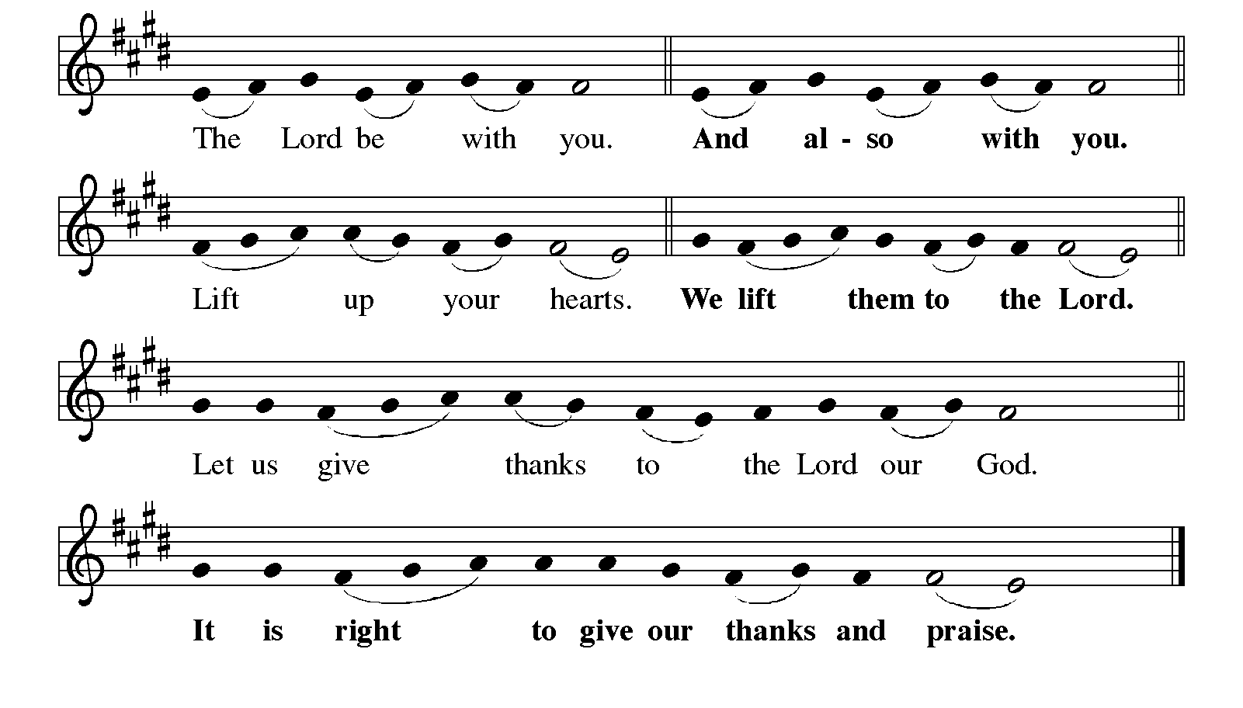
Great Thanksgiving

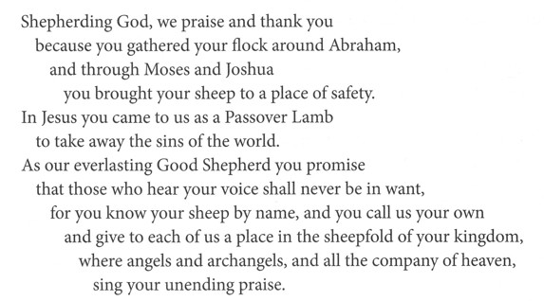

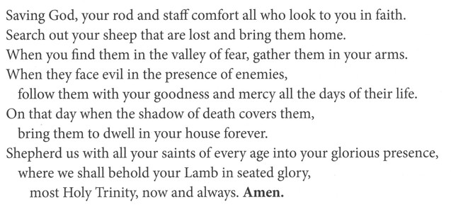
Eucharistic Prayer
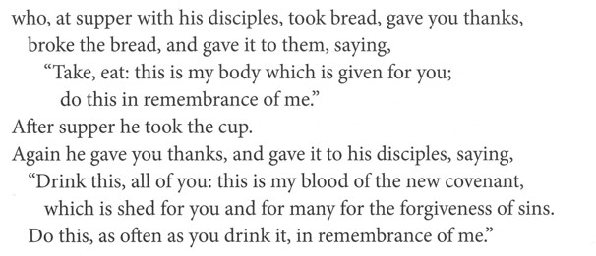
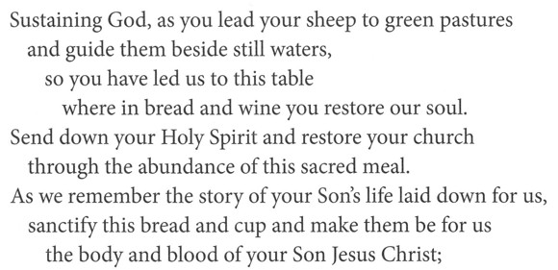
Lord’s Prayer
Our Father, who art in heaven,
hallowed be thy name, thy kingdom come,
thy will be done, on earth as it is in heaven.
Give us this day our daily bread;
and forgive us our trespasses, as we forgive those who trespass against us;
and lead us not into temptation but deliver us from evil.
For thine is the kingdom,
and the power, and the glory, forever and ever.
Amen.

Invitation to Communion
Come to the table of new life.
Receive the risen Lord.

Communion

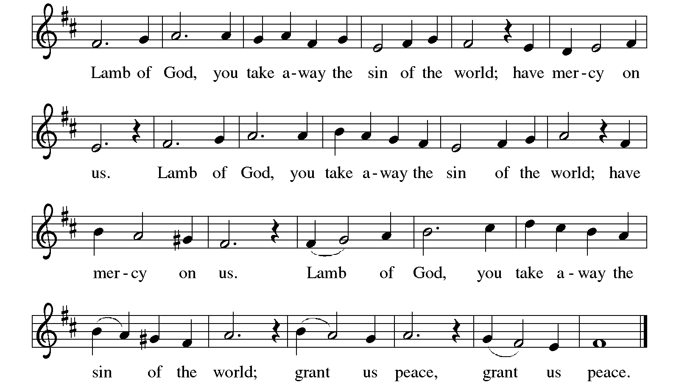

Communion Songs Savior, like a Shepherd Lead Us ELW 789

The King of Love My Shepherd ELW 502
Prayer after Communion
Holy One,
through this meal you have made your home among us
and are making all things new.
Send us now to speak peace to anxious hearts,
to love our enemies,
and to bring your healing to the nations.
In the name of Jesus, Amen.
SENDING
God blesses us and sends us in mission to the world.

Blessing
God Almighty, who is the beginning and the end,
Jesus Christ, the firstborn of the dead,
and the Spirit, our advocate and peace,
☩ bless you now and forever.
Amen.
Sending Song What a Fellowship, What a Joy Devine ELW 774
Leaning on the Everlasting Arms

Dismissal
Go in peace. Praise the Lord. Alleluia!
Thanks be to God. Alleluia!

From sundaysandseasons.com.

Copyright © 2026 Augsburg Fortress. All rights reserved.

