
Worship Plan for Sunday, February 15, 2026
Transfiguration of Our Lord
Last Sunday after Epiphany

The Holy Spirit calls us together as the people of God.
GATHERING

Prelude
Welcome & Announcements
Reflection – Preparing for Worship
Sing 2x

Please stand.

Confession and Forgiveness

All may make the sign of the cross, the sign that is marked at baptism, as the presiding minister begins.

Blessed be the holy Trinity, ☩ one God,
the God of manna,
the God of miracles,
the God of mercy.
Amen.

Drawn to Christ and seeking God’s abundance,
let us confess our sin.

Silence is kept for reflection.

God, our provider,
help us.
It is hard to believe there is enough to share.
We question your ways when they differ from the ways
of the world in which we live.
We turn to our own understanding
rather than trusting in you.
We take offense at your teachings and your ways.
Turn us again to you.
Where else can we turn?
Share with us the words of eternal life
and feed us for life in the world.
Amen.
Beloved people of God:
in Jesus, the manna from heaven,
you are fed and nourished.
By Jesus, the worker of miracles,
there is always more than enough.
Through Jesus, ☩ the bread of life,
you are shown God’s mercy:
you are forgiven and loved into abundant life.
Amen.

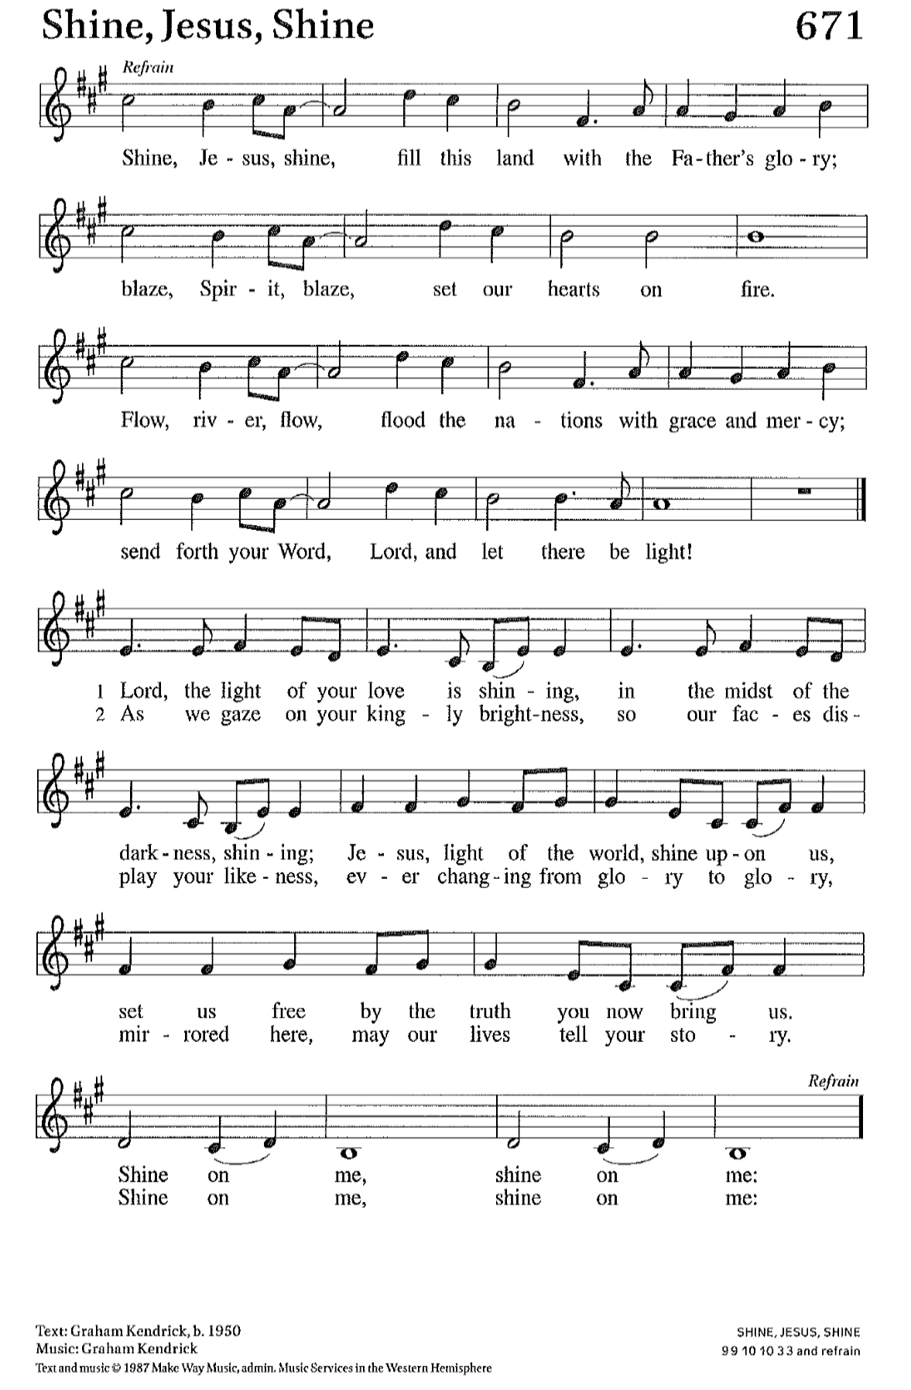
Gathering Song Shine, Jesus, Shine ELW 671

Greeting
The grace of our Lord Jesus Christ, the love of God,
and the communion of the Holy Spirit be with you all.
And also with you.

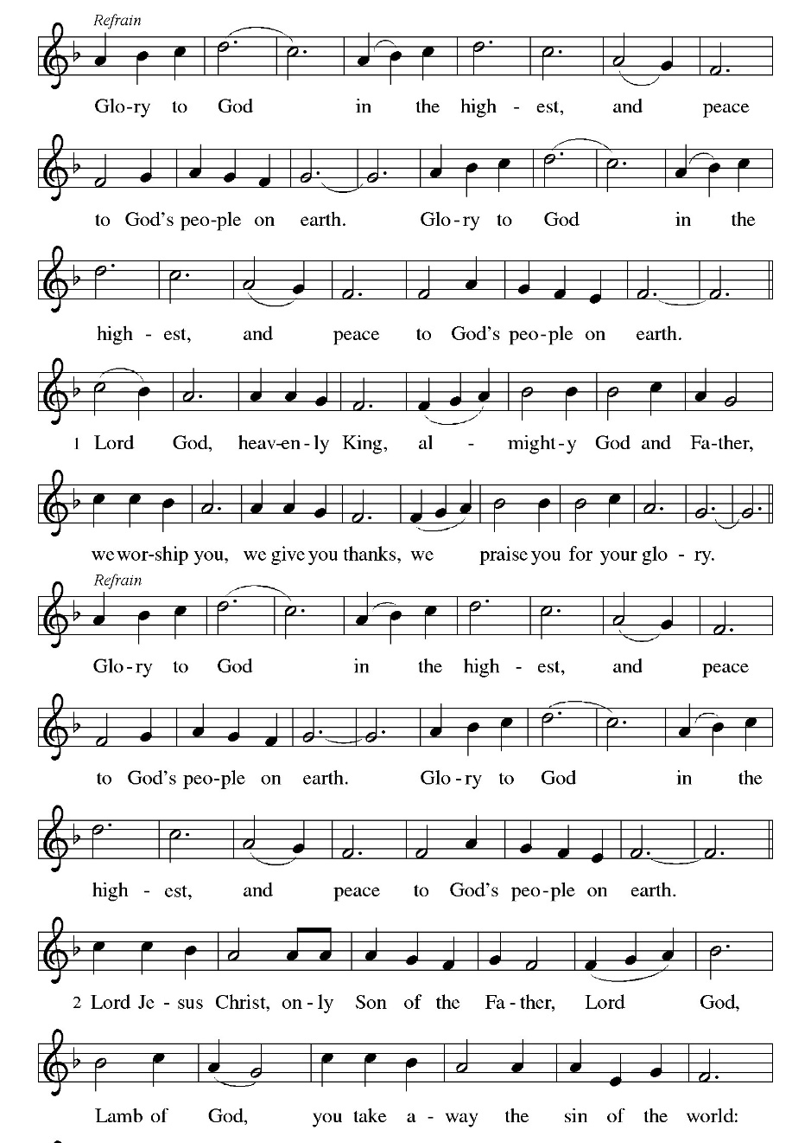
Hymn of Praise Glory to God

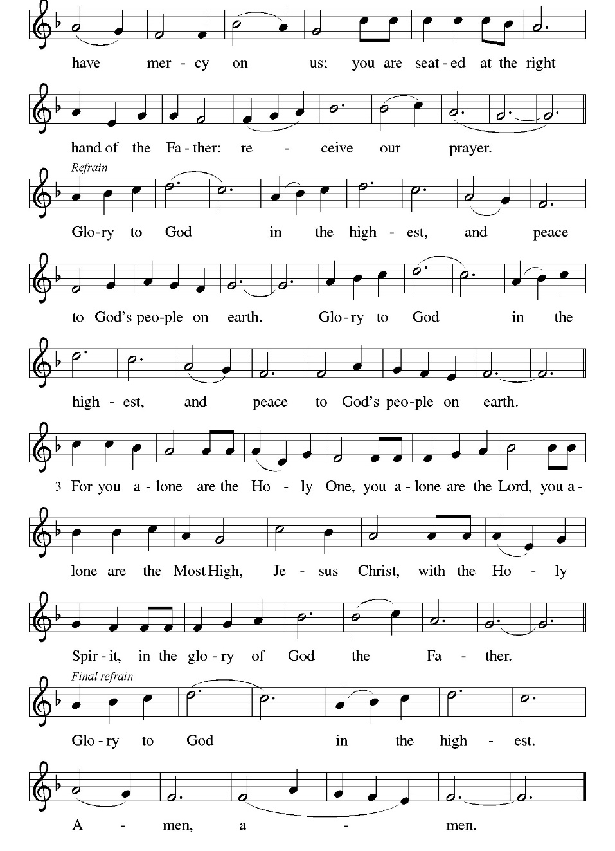

Prayer of the Day
Let us pray.
O God, in the transfiguration of your Son you confirmed the mysteries of the faith by the witness of Moses and Elijah, and in the voice from the bright cloud declaring Jesus your beloved Son, you foreshadowed our adoption as your children. Make us heirs with Christ of your glory, and bring us to enjoy its fullness, through Jesus Christ, our Savior and Lord, who lives and reigns with you and the Holy Spirit, one God, now and forever.
Amen.

God speaks to us in scripture reading, preaching, and song.
WORD

First Reading: Exodus 24:12-18
A reading from Exodus.
¹² The Lord said to Moses, “Come up to me on the mountain and wait there; I will give you the tablets of stone, with the law and the commandment, which I have written for their instruction.” ¹³ So Moses set out with his assistant Joshua, and Moses went up onto the mountain of God. ¹⁴ To the elders he had said, “Wait here for us, until we come back to you. Look, Aaron and Hur are with you; whoever has a dispute may go to them.”
¹⁵ Then Moses went up on the mountain, and the cloud covered the mountain. ¹⁶ The glory of the Lord settled on Mount Sinai, and the cloud covered it for six days; on the seventh day he called to Moses out of the cloud. ¹⁷ Now the appearance of the glory of the Lord was like a devouring fire on the top of the mountain in the sight of the Israelites. ¹⁸ Moses entered the cloud and went up on the mountain. Moses was on the mountain for forty days and forty nights.
The word of the Lord.
Thanks be to God.

Psalm: Psalm 2
¹ Why are the nations | in an uproar?
Why do the peoples mutter | empty threats?
² Why do the kings of the earth rise up in revolt, and the princes | plot together,
against the Lord and against the | Lord’s anointed?
³ “Let us break their | yoke,” they say;
“let us cast off their | bonds from us.”
⁴ God whose throne is in heav- | en is laughing;
the Lord holds them | in derision. R
⁵ Then in wrath God | speaks to them,
and in rage fills | them with terror.
⁶ “As for me, I have anoint- | ed my king
upon Zion, my | holy mountain.”
⁷ Let me announce the decree | of the Lord,
who said to me, “You are my son; this day have I be- | gotten you.
⁸ Ask of me, and I will give you the nations for | your inheritance
and the ends of the earth for | your possession. R
⁹ You shall crush them with an | iron rod
and shatter them like a | piece of pottery.”
¹⁰ And now, you | kings, be wise;
be warned, you rulers | of the earth.
¹¹ Submit to the | Lord with fear,
and with trembling | bow in worship;
¹² lest the Lord be angry, and you perish in a sudden | blaze of wrath.
Happy are all who take ref- | uge in God! R

Second Reading: 2 Peter 1:16-21
A reading from 2 Peter.
¹⁶ We did not follow cleverly devised myths when we made known to you the power and coming of our Lord Jesus Christ, but we had been eyewitnesses of his majesty. ¹⁷ For he received honor and glory from God the Father when that voice was conveyed to him by the Majestic Glory, saying, “This is my Son, my Beloved, with whom I am well pleased.” ¹⁸ We ourselves heard this voice come from heaven, while we were with him on the holy mountain.
¹⁹ So we have the prophetic message more fully confirmed. You will do well to be attentive to this as to a lamp shining in a dark place, until the day dawns and the morning star rises in your hearts. ²⁰ First of all you must understand this, that no prophecy of scripture is a matter of one’s own interpretation, ²¹ because no prophecy ever came by human will, but men and women moved by the Holy Spirit spoke from God.
The word of the Lord.
Thanks be to God.

Please Stand
Gospel Acclamation
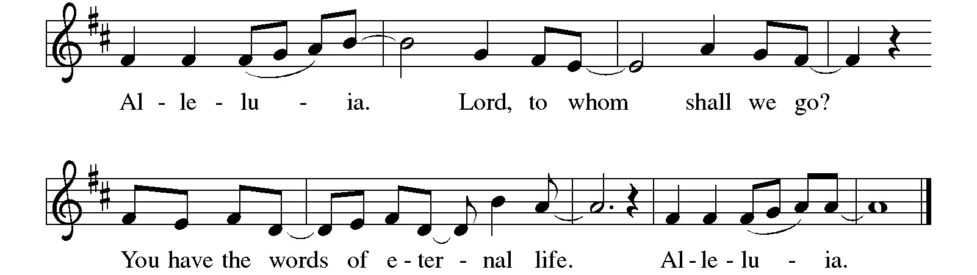
Gospel: Matthew 17:1-9
The holy gospel according to Matthew.
Glory to you, O Lord.
¹ Six days later, Jesus took with him Peter and James and his brother John and led them up a high mountain, by themselves. ² And he was transfigured before them, and his face shone like the sun, and his clothes became bright as light. ³ Suddenly there appeared to them Moses and Elijah, talking with him. ⁴ Then Peter said to Jesus, “Lord, it is good for us to be here; if you wish, I will set up three tents here, one for you, one for Moses, and one for Elijah.” ⁵ While he was still speaking, suddenly a bright cloud overshadowed them, and a voice from the cloud said, “This is my Son, the Beloved; with him I am well pleased; listen to him!” ⁶ When the disciples heard this, they fell to the ground and were overcome by fear. ⁷ But Jesus came and touched them, saying, “Get up and do not be afraid.” ⁸ And when they raised their eyes, they saw no one except Jesus himself alone.
⁹ As they were coming down the mountain, Jesus ordered them, “Tell no one about the vision until after the Son of Man has been raised from the dead.”
The gospel of the Lord.
Praise to you, O Christ.

Please be seated.
Children’s Message

Sermon

Please stand
HYMN OF THE DAY

Apostles’ Creed
Let us confess our faith through the words of the Apostles’ Creed
I believe in God, the Father almighty, creator of heaven and earth.
I believe in Jesus Christ, God's only Son, our Lord,
who was conceived by the Holy Spirit,
born of the virgin Mary,
suffered under Pontius Pilate,
was crucified, died, and was buried;
he descended to the dead
On the third day he rose again;
he ascended into heaven,
he is seated at the right hand of the Father,
and he will come to judge the living and the dead.
I believe in the Holy Spirit,
the holy catholic church, the communion of saints,
the forgiveness of sins, the resurrection of the body,
and the life everlasting. Amen.

Prayers of Intercession
As God’s beloved children united in Christ, let us pray for the church, the whole human community, and the well-being of the earth, our home.
Revealing God, your Spirit sustains the church. Strengthen the faithful with the revelation of Christ transfigured, that we may joyfully follow him in the way of the cross. Merciful God,
receive our prayer.
Life-giving God, creation is full of your majesty. Nurture in us a deep respect for the interdependence of all life, and make us wise and vigilant stewards of your good earth. Merciful God,
receive our prayer.
Peacemaking God, the nations are in turmoil. We pray for an end to violent conflict (regions at war may be named). Give wisdom to negotiators and sanctuary to refugees. Defend any who are in danger. Merciful God,
receive our prayer.
Healing God, you desire wholeness for all people. Bring healing to any who are experiencing illness, chronic pain, or mental anguish. Comfort the dying and those who grieve (especially). Merciful God,
receive our prayer.
Holy God, in our worship we glimpse your glory, hear your voice, and receive assurance of your love. Inspire all who prepare, lead, and participate in worship to serve you with reverence and joy. Merciful God,
receive our prayer.
Transforming God, you bring life from death. We give thanks for the witness of those who have died in faith, and we praise you for the hope we have in Christ, our Morning Star. Merciful God,
receive our prayer.
Confident that the Holy Spirit receives our prayers and answers us, we commend all for whom we pray to God’s loving-kindness made known to us in Christ Jesus our Savior.
Amen.

Peace
The peace of Christ be with you always. And also with you.

God feeds us with the presence of Jesus Christ.
MEAL

Please be seated.
Offering

Choral Anthem Agnus Dei

Please Stand
Offertory Hymn Thank You Lord ACS 1092

Offertory Prayer
God of majesty,
no eye has seen, no ear has heard
what you have prepared for those who love you,
yet in this meal you reveal the wideness of your mercy.
Use what we have gathered
to feed us with the reign of God come near,
Jesus Christ, our Savior and Lord.
Amen.

The Great Thanksgiving

The Lord be with you.
And also with you.
Lift up your hearts.
We lift them to the Lord.
Let us give thanks to the Lord our God.
It is right to give our thanks and praise.

Creating and liberating God…
… singing the hymn of your unending praise.

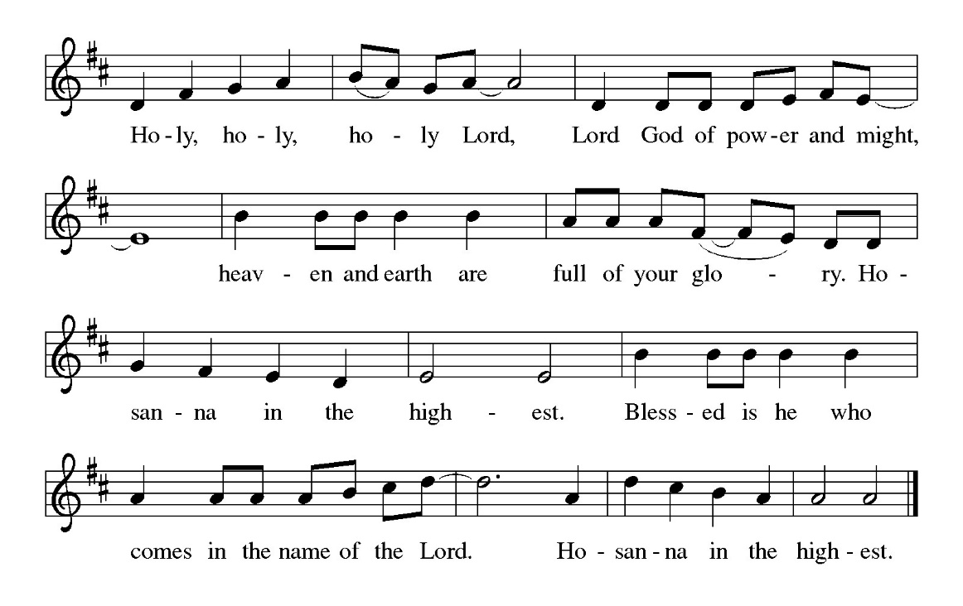

Dazzling God…
…ever one God, Father, Son, and Holy Spirit. Amen.

The Lord’s Prayer
Our Father, who art in heaven, hallowed be thy name,
thy kingdom come, thy will be done,
on earth as it is in heaven.
Give us this day our daily bread;
and forgive us our trespasses,
as we forgive those who trespass against us;
and lead us not into temptation but deliver us from evil.
For thine is the kingdom, and the power, and the glory,
forever and ever. Amen.

Invitation to Communion
Here is the Lamb of God who takes away the sin of the world!
Come to the table; taste and see.

Please be seated.
Communion Hymns
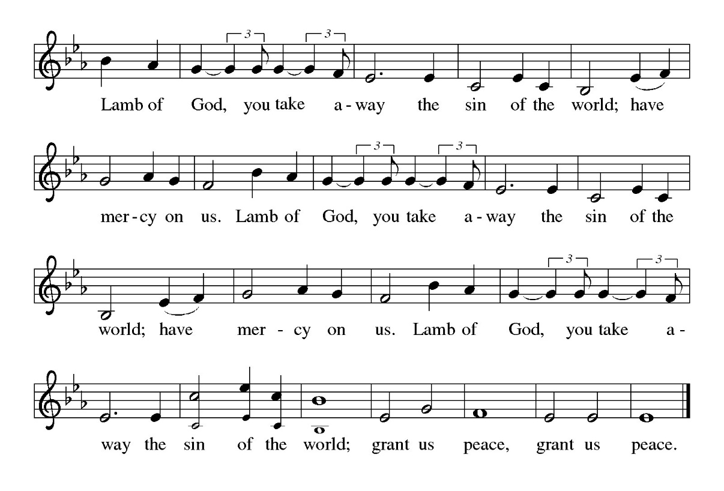

Beautiful Savior ELW 838

I Love to Tell the Story ELW 661

Please stand
Prayer After Communion
Radiant God,
we have seen your glory in the face of Jesus Christ.
In the sacrament of his body and blood
you have drawn us to your heart.
Send us from this table with delight,
that our lives may reflect the beauty of your love,
and bear witness to all we have seen and heard,
through Jesus Christ, our Savior and Lord.
Amen.
God blesses us and sends us in mission to the world.
SENDING

Blessing
May the triune God,
who has put a new song in your mouth
and tuned your heart for praise
☩ bless you now and forever.
Amen.

Sending Song Alleluia, Song of Gladness ELW 318

Dismissal
Go in peace. Do Justice. Love Mercy.
Thanks be to God.
From sundaysandseasons.com. Copyright © 2026 Augsburg Fortress. All rights reserved

