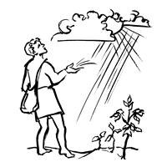
Worship Plan for Sunday, July 12, 2026
7th Sunday After Pentecost

The Holy Spirit calls us together as the people of God.
GATHERING

Prelude
Welcome/Announcements
Reflection - Preparing for Worship
Sing 2X

Please stand.
Confession and Forgiveness
All may make the sign of the cross, the sign that is marked at baptism, as the presiding minister begins.

Blessed be the holy Trinity,☩ one God,
whose compassion endures forever.
Amen.

Let us confess our sin to God.
Silence is kept for reflection.

Compassionate God,
we confess to you all our sins.
Our burden is heavy, and we cannot free ourselves.
In your mercy, call us back to you.
Your yoke is easy and your burden is light.
Restore us to dwell in your peace.
In Christ’s name we pray,
Amen.

Jesus says, “Come to me,
all you who are weary
and are carrying heavy burdens,
and I will give you rest.”
In the name of God,
Father, ☩ Son, and Holy Spirit,
your sins are forgiven.
Rest in God’s love.
Amen.

Gathering Song Open Now Thy Gates of Beauty ELW 533

Greeting
The grace of our Lord Jesus Christ, the love of God
and the communion of the Holy Spirit be with you all.
And also, with you.

Hymn of Praise
Prayer of the Day
Let us pray.
Almighty God, we thank you for planting in us the seed of your word. By your Holy Spirit help us to receive it with joy, live according to it, and grow in faith and hope and love, through Jesus Christ, our Savior and Lord.
Amen.

Please be seated.
God speaks to us in scripture reading, preaching, and song.
WORD

First Reading: Isaiah 55:10-13
A reading from Isaiah.
¹⁰ For as the rain and the snow come down from heaven
and do not return there until they have watered the earth,
making it bring forth and sprout,
giving seed to the sower and bread to the eater,
¹¹ so shall my word be that goes out from my mouth;
it shall not return to me empty,
but it shall accomplish that which I purpose
and succeed in the thing for which I sent it.
¹² For you shall go out in joy
and be led back in peace;
the mountains and the hills before you
shall burst into song,
and all the trees of the field shall clap their hands.
¹³ Instead of the thorn shall come up the cypress;
instead of the brier shall come up the myrtle,
and it shall be to the Lord for a memorial,
for an everlasting sign that shall not be cut off.
The word of the Lord.
Thanks be to God.

Psalm: Psalm 65:[1-8] 9-13
⁹ You visit the earth and water it abundantly; you make it very plenteous; the river of God is | full of water.
You prepare the grain, for so you provide | for the earth.
¹⁰ You drench the furrows and smooth | out the ridges;
with heavy rain you soften the ground and | bless its increase.
¹¹ You crown the year | with your goodness,
and your paths over- | flow with plenty.
¹² May the fields of the wilderness be | rich for grazing,
and the hills be | clothed with joy.
¹³ May the meadows cover themselves with flocks, and the valleys cloak them- | selves with grain;
let them shout for | joy and sing. R

Second Reading: Romans 8:1-11
A reading from Romans.
¹ Therefore there is now no condemnation for those who are in Christ Jesus. ² For the law of the Spirit of life in Christ Jesus has set you free from the law of sin and of death. ³ For God has done what the law, weakened by the flesh, could not do: by sending his own Son in the likeness of sinful flesh and to deal with sin, he condemned sin in the flesh, ⁴ so that the just requirement of the law might be fulfilled in us, who walk not according to the flesh but according to the Spirit. ⁵ For those who live according to the flesh set their minds on the things of the flesh, but those who live according to the Spirit set their minds on the things of the Spirit. ⁶ To set the mind on the flesh is death, but to set the mind on the Spirit is life and peace. ⁷ For this reason the mind that is set on the flesh is hostile to God; it does not submit to God’s law—indeed, it cannot, ⁸ and those who are in the flesh cannot please God.
⁹ But you are not in the flesh; you are in the Spirit, since the Spirit of God dwells in you. Anyone who does not have the Spirit of Christ does not belong to him. ¹⁰ But if Christ is in you, then the body is dead because of sin, but the Spirit is life because of righteousness. ¹¹ If the Spirit of him who raised Jesus from the dead dwells in you, he who raised Christ Jesus from the dead will give life to your mortal bodies also through his Spirit that dwells in you.
The word of the Lord.
Thanks be to God.
Please stand.
Gospel Acclamation
Gospel: Matthew 13:1-9, 18-23
The holy gospel according to Matthew.
Glory to you, O Lord.
¹ That same day Jesus went out of the house and sat beside the sea. ² Such great crowds gathered around him that he got into a boat and sat there, while the whole crowd stood on the beach. ³ And he told them many things in parables, saying: “Listen! A sower went out to sow. ⁴ And as he sowed, some seeds fell on a path, and the birds came and ate them up. ⁵ Other seeds fell on rocky ground, where they did not have much soil, and they sprang up quickly, since they had no depth of soil. ⁶ But when the sun rose, they were scorched, and since they had no root, they withered away. ⁷ Other seeds fell among thorns, and the thorns grew up and choked them. ⁸ Other seeds fell on good soil and brought forth grain, some a hundredfold, some sixty, some thirty. ⁹ If you have ears, hear!”
¹⁸ “Hear, then, the parable of the sower. ¹⁹ When anyone hears the word of the kingdom and does not understand it, the evil one comes and snatches away what is sown in the heart; this is what was sown on the path. ²⁰ As for what was sown on rocky ground, this is the one who hears the word and immediately receives it with joy, ²¹ yet such a person has no root but endures only for a while, and when trouble or persecution arises on account of the word, that person immediately falls away. ²² As for what was sown among thorns, this is the one who hears the word, but the cares of this age and the lure of wealth choke the word, and it yields nothing. ²³ But as for what was sown on good soil, this is the one who hears the word and understands it, who indeed bears fruit and yields in one case a hundredfold, in another sixty, and in another thirty.”
The gospel of the Lord.
Praise to you, O Christ.

Please be seated.
Children’s Message

Sermon

Please stand.

Hymn of the Day O God, Whose Word Wel-Planted ACS 975

Apostles’ Creed
Let us confess our faith to the words of the Apostles’ Creed
I believe in God, the Father almighty,
creator of heaven and earth.
I believe in Jesus Christ, God's only Son, our Lord,
who was conceived by the Holy Spirit,
born of the Virgin Mary,
suffered under Pontius Pilate,
was crucified, died, and was buried;
he descended to the dead.
On the third day he rose again;
he ascended into heaven,
he is seated at the right hand of the Father,
and he will come to judge the living and the dead.
I believe in the Holy Spirit,
the holy catholic Church,
the communion of saints,
the forgiveness of sins,
the resurrection of the body,
and the life everlasting. Amen

Please sit or kneel.
Prayers of Intercession
Trusting in God’s steadfast love for all God has made, let us pray for the church, the world, and all of creation.
God our gardener, you scatter grace like seed across the world. Continue to cultivate the garden of your church with your abundant Spirit. God of grace,
hear our prayer.
God our joy, your bountiful creation reflects your commitment to life despite our actions disregarding its wonder. We look toward Isaiah’s vision, when all creation rejoices, and the trees will clap for joy at your salvation. God of grace,
hear our prayer.
God our life, you give us the same Spirit by which you raised Christ from the dead. Set our minds on that Spirit whenever fear or condemnation overwhelm throughout the world (global concerns may be named). God of grace,
hear our prayer.
God our host and table, we pray for children who hunger and rely on school meals, for all who toil under the hot sun without refreshment, for the chronically ill who have exhausted their resources, and for local concerns (especially). God of grace,
hear our prayer.
God our source, tend this assembly with your grace throughout this summer season. May those who travel for work or recreation do so safely, and may visitors find refreshment among us. God of grace,
hear our prayer.
We give you thanks that the roots of your goodness run deep throughout history. We remember those saints who have gone before us in faith (especially Bishop Nathan Söderblom, whom the church commemorates today). God of grace,
hear our prayer.
Grateful for your abundant provision and trusting in your goodness, we cast all our cares upon you, through the abundant grace of Christ Jesus.
Amen.

Peace
The peace of Christ be with you always. And also, with you.

MEAL
God feeds us with the presence of Jesus Christ.

Please be seated.
Offering

Special Music Andy Feldt, Art Hafner, Bob Legg, Brian Walters and Chase Hatmaker

Please stand.
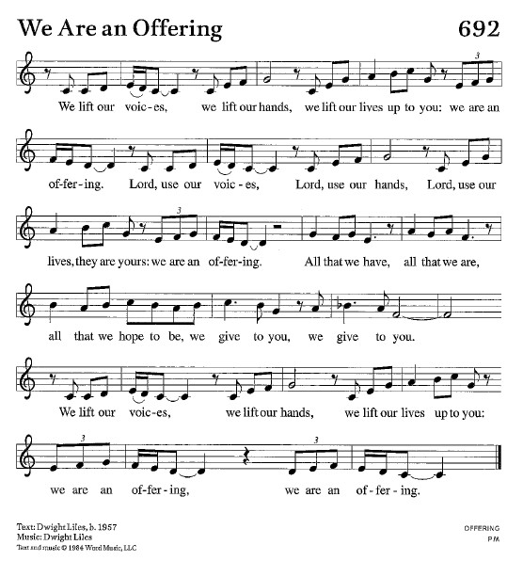
Offertory Hymn We Are An Offering ELW 692
Offertory Prayer
Lord of the harvest,
we return to you a portion of what you have given to us.
Turn us to set our hope not on the uncertainty of riches,
but on you, who richly provides for us.
Multiply what we have gathered
to bless all who are suffering and in need,
through Jesus Christ our Lord.
Amen.

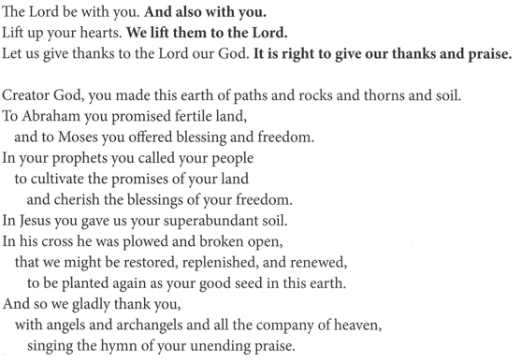
The Great Thanksgiving

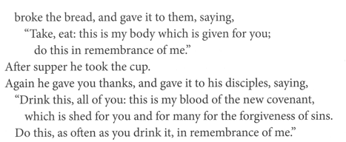
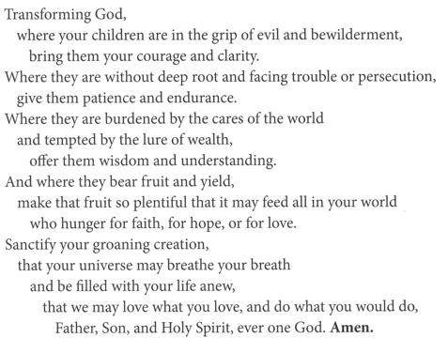
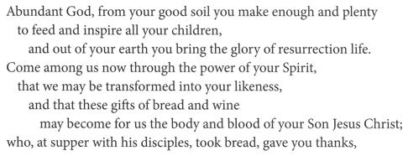

The Lord’s Prayer
Our Father, who art in heaven,
hallowed be thy name, thy kingdom come,
thy will be done, on earth as it is in heaven.
Give us this day our daily bread;
and forgive us our trespasses, as we forgive those who trespass against us;
and lead us not into temptation but deliver us from evil.
For thine is the kingdom,
and the power, and the glory, forever and ever.
Amen.

Invitation to Communion
Heaven has come near.
Come, share in the feast!

Please be seated.
Communion Hymns

As Rain from the Clouds ELW 508
(Continued on next page)

For the Fruit of All Creation ELW 679
Prayer after Communion
Compassionate God,
through the gifts of bread and wine
our hearts are filled with the abundance of your love.
Strengthen us that we, through this holy meal,
may share your love freely, as you have shared with us.
We ask this in the name of Jesus,
through the Spirit nourishing us now and forever.
Amen.

God blesses us and sends us in mission to the world.
SENDING

Blessing
Creator, Redeemer, Sustainer,
☩ one God,
bless, heal, and hold you
today and always.
Amen.

Sending Song Sent Forth by God’s Blessing ELW 547

Dismissal
Heaven has come near. Go, share the good news!
Thanks be to God.

From sundaysandseasons.com.
Copyright © 2026 Augsburg Fortress. All rights reserved.

