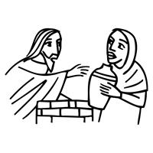
Worship Plan for Sunday, March 8, 2026
Third Sunday in Lent

The Holy Spirit calls us together as the people of God.
GATHERING

Prelude
Welcome/Announcements
Reflection - Preparing for Worship
Sing 2x

Please stand.
Confession and Forgiveness
All make the sign of the cross, the sign that is marked at baptism, as the presiding minister begins.
Blessed be the holy Trinity, ☩ one God,
who forgives all our sin,
whose mercy endures forever.
Amen.

Let us return to God, confessing our sin in the assurance of God’s abiding love.
Silence is kept for reflection.

Compassionate One,
you are slow to anger and abounding in steadfast love,
but our lives do not always reflect you
and your love for the world.
We do not show others the tender compassion
you have shown to us.
We do not welcome others with the radical hospitality
you grant to all people.
We oppress others,
even though you have set us free again and again.
We squander the abundant gifts of the earth.
Transform our lives
and guide us again in the way of the cross.
Amen.

Beloved in Christ,
God’s arms are always stretched open wide
to welcome the wandering ones home.
In ☩ Christ your sins are forgiven.
You have a place in God’s house forever.
Amen.

Gathering Song Come to Me, All Pilgrims Thirsty ELW 777

Greeting
The grace of our Lord Jesus Christ, the love of God
and the communion of the Holy Spirit be with you all.
And also, with you.

Kyrie

Your Heart, O God is Grieved

Prayer of the Day
Let us pray.
Merciful God, the fountain of living water, you quench our thirst and wash away our sin. Give us this water always. Bring us to drink from the well that flows with the beauty of your truth through Jesus Christ, our Savior and Lord, who lives and reigns with you and the Holy Spirit, one God, now and forever.
Amen.
Please be seated.
God speaks to us in scripture reading, preaching, and song.
WORD

First Reading: Exodus 17:1-7
A reading from Exodus.
¹ From the wilderness of Sin the whole congregation of the Israelites journeyed by stages, as the Lord commanded. They camped at Rephidim, but there was no water for the people to drink. ² The people quarreled with Moses and said, “Give us water to drink.” Moses said to them, “Why do you quarrel with me? Why do you test the Lord?” ³ But the people thirsted there for water, and the people complained against Moses and said, “Why did you bring us out of Egypt, to kill us and our children and livestock with thirst?” ⁴ So Moses cried out to the Lord, “What shall I do for this people? They are almost ready to stone me.” ⁵ The Lord said to Moses, “Go on ahead of the people and take some of the elders of Israel with you; take in your hand the staff with which you struck the Nile and go. ⁶ I will be standing there in front of you on the rock at Horeb. Strike the rock, and water will come out of it, so that the people may drink.” Moses did so, in the sight of the elders of Israel. ⁷ He called the place Massah and Meribah, because the Israelites quarreled and tested the Lord, saying, “Is the Lord among us or not?”
The word of the Lord.
Thanks be to God.

Psalm: Psalm 95
¹ Come, let us sing | to the Lord;
let us shout for joy to the rock of | our salvation.
² Let us come before God’s presence | with thanksgiving
and raise a loud shout to the | Lord with psalms.
³ For you, Lord, | are a great God,
and a great ruler a- | bove all gods.
⁴ In your hand are the caverns | of the earth;
the heights of the hills are | also yours.
⁵ The sea is yours, | for you made it,
and your hands have molded | the dry land.
⁶ Come, let us worship | and bow down,
let us kneel before the | Lord our maker. R
⁷ For the Lord is our God, and we are the people of God’s pasture and the sheep | of God’s hand.
Oh, that today you would | hear God’s voice!
⁸ “Harden | not your hearts,
as at Meribah, as on that day at Massah | in the desert.
⁹ There your ancestors | tested me,
they put me to the test, though they had | seen my works.
¹⁰ Forty years I loathed that gener- | ation, saying,
‘The heart of this people goes astray; they do not | know my ways.’
¹¹ Indeed I swore | in my anger,
‘They shall never come | to my rest.’ ” R

Second Reading: Romans 5:1-11
A reading from Romans.
¹ Since we are justified by faith, we have peace with God through our Lord Jesus Christ, ² through whom we have obtained access to this grace in which we stand, and we boast in our hope of sharing the glory of God. ³ And not only that, but we also boast in our afflictions, knowing that affliction produces endurance, ⁴ and endurance produces character, and character produces hope, ⁵ and hope does not put us to shame, because God’s love has been poured into our hearts through the Holy Spirit that has been given to us.
⁶ For while we were still weak, at the right time Christ died for the ungodly. ⁷ Indeed, rarely will anyone die for a righteous person—though perhaps for a good person someone might actually dare to die. ⁸ But God proves his love for us in that while we still were sinners Christ died for us. ⁹ Much more surely, therefore, since we have now been justified by his blood, will we be saved through him from the wrath of God. ¹⁰ For if while we were enemies we were reconciled to God through the death of his Son, much more surely, having been reconciled, will we be saved by his life. ¹¹ But more than that, we even boast in God through our Lord Jesus Christ, through whom we have now received reconciliation.
The word of the Lord.
Thanks be to God.
Please stand.
Gospel: John 4:5-42
The holy gospel according to John.
Glory to you, O Lord.
⁵ [Jesus] came to a Samaritan city called Sychar, near the plot of ground that Jacob had given to his son Joseph.⁶ Jacob’s well was there, and Jesus, tired out by his journey, was sitting by the well. It was about noon.
⁷ A Samaritan woman came to draw water, and Jesus said to her, “Give me a drink.” ⁸ (His disciples had gone to the city to buy food.) ⁹ The Samaritan woman said to him, “How is it that you, a Jew, ask a drink of me, a woman of Samaria?” (Jews do not share things in common with Samaritans.) ¹⁰ Jesus answered her, “If you knew the gift of God and who it is that is saying to you, ‘Give me a drink,’ you would have asked him, and he would have given you living water.” ¹¹ The woman said to him, “Sir, you have no bucket, and the well is deep. Where do you get that living water? ¹² Are you greater than our ancestor Jacob, who gave us the well and with his sons and his flocks drank from it?” ¹³ Jesus said to her, “Everyone who drinks of this water will be thirsty again, ¹⁴ but those who drink of the water that I will give them will never be thirsty. The water that I will give will become in them a spring of water gushing up to eternal life.” ¹⁵ The woman said to him, “Sir, give me this water, so that I may never be thirsty or have to keep coming here to draw water.”
¹⁶ Jesus said to her, “Go, call your husband, and come back.” ¹⁷ The woman answered him, “I have no husband.” Jesus said to her, “You are right in saying, ‘I have no husband,’ ¹⁸ for you have had five husbands, and the one you have now is not your husband. What you have said is true!” ¹⁹ The woman said to him, “Sir, I see that you are a prophet. ²⁰ Our ancestors worshiped on this mountain, but you say that the place where people must worship is in Jerusalem.” ²¹ Jesus said to her, “Woman, believe me, the hour is coming when you will worship the Father neither on this mountain nor in Jerusalem. ²² You worship what you do not know; we worship what we know, for salvation is from the Jews. ²³ But the hour is coming and is now here when the true worshipers will worship the Father in spirit and truth, for the Father seeks such as these to worship him. ²⁴ God is spirit, and those who worship him must worship in spirit and truth.” ²⁵ The woman said to him, “I know that Messiah is coming” (who is called Christ). “When he comes, he will proclaim all things to us.” ²⁶ Jesus said to her, “I am he, the one who is speaking to you.”
²⁷ Just then his disciples came. They were astonished that he was speaking with a woman, but no one said, “What do you want?” or, “Why are you speaking with her?” ²⁸ Then the woman left her water jar and went back to the city. She said to the people, ²⁹ “Come and see a man who told me everything I have ever done! He cannot be the Messiah, can he?” ³⁰ They left the city and were on their way to him.
³¹ Meanwhile the disciples were urging him, “Rabbi, eat something.” ³² But he said to them, “I have food to eat that you do not know about.” ³³ So the disciples said to one another, “Surely no one has brought him something to eat?” ³⁴ Jesus said to them, “My food is to do the will of him who sent me and to complete his work. ³⁵ Do you not say, ‘Four months more, then comes the harvest’? But I tell you, look around you, and see how the fields are ripe for harvesting. ³⁶ The reaper is already receiving wages and is gathering fruit for eternal life, so that sower and reaper may rejoice together. ³⁷ For here the saying holds true, ‘One sows and another reaps.’ ³⁸ I sent you to reap that for which you did not labor. Others have labored, and you have entered into their labor.”
³⁹ Many Samaritans from that city believed in him because of the woman’s testimony, “He told me everything I have ever done.” ⁴⁰ So when the Samaritans came to him, they asked him to stay with them, and he stayed there two days. ⁴¹ And many more believed because of his word. ⁴² They said to the woman, “It is no longer because of what you said that we believe, for we have heard for ourselves, and we know that this is truly the Savior of the world.”
The gospel of the Lord.
Praise to you, O Christ.
Please be seated.
Children’s Message

Sermon

Please stand
Hymn of the Day Jesus, Keep Me Near the Cross ELW 335

Apostles’ Creed
Let us confess our faith to the words of the Apostles’ Creed
I believe in God, the Father almighty,
creator of heaven and earth.
I believe in Jesus Christ, God’s only Son, our Lord,
who was conceived by the Holy Spirit,
born of the virgin Mary,
suffered under Pontius Pilate,
was crucified, died, and was buried;
he descended to the dead.*
On the third day he rose again;
he ascended into heaven,
he is seated at the right hand of the Father,
and he will come to judge the living and the dead.
I believe in the Holy Spirit,
the holy catholic church,
the communion of saints,
the forgiveness of sins,
the resurrection of the body,
and the life everlasting. Amen.

Please sit or kneel.
Prayers of Intercession
Reconciled by God’s mercy and sustained by God’s presence, let us pray for the world and its needs.
O God, when suffering arises, preserve your church. Give to pastors, deacons, bishops, and all servants of your gospel the endurance that produces character and the hope that will never disappoint. Hear us, O God.
Your mercy is great.
When the waters run dry, sustain this earth. Send water to places languishing with drought (especially), and bring relief to places damaged by floods (especially). Hear us, O God.
Your mercy is great.
When quarrels ensue, soften our hearts. Quell hostilities between nations and peoples, and reconcile all humans across the lines of race, class, nationality, moral conviction, religion, and all else that divides or oppresses. Hear us, O God.
Your mercy is great.
When your people thirst, satisfy their needs. Send water and food to all who need nourishment. Grant welcome to all who are excluded. Show your mercy to any in need (especially). Hear us, O God.
Your mercy is great.
When we gather to worship, send us your Spirit. Renew our hearts through the joyful noise we make and bless the work of our church musicians and musical ensembles (especially). Hear us, O God.
Your mercy is great.
O God, when death draws near, we rejoice in the promise of life with you. We remember all who have entered eternal rest, and we pray that you bring us the hope of sharing in your glory. Hear us, O God.
Your mercy is great.
Receive our prayers, O God, through Jesus Christ, our strength and salvation.
Amen.

Peace
The peace of Christ be with you always.
And also, with you.

God feeds us with the presence of Jesus Christ.
MEAL

Please be seated.
Offering

Choir – How Beautiful

Please stand.
Offertory Hymn Come, Bring Your Burdens ACS 1009

Offertory Prayer
Let us pray
Gracious Provider,
you set your immense treasures among us,
opening your heart to the world.
As we prepare to feast on your bountiful love,
deepen our commitment to sharing those
treasures with others,
through our Savior, Jesus Christ.
Amen.

The Great Thanksgiving

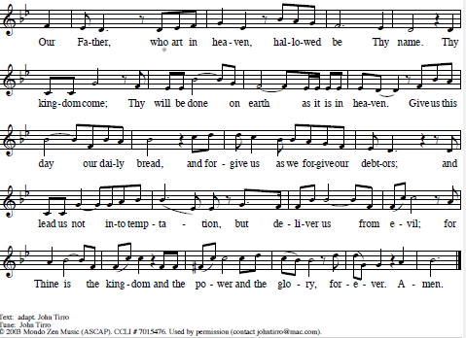
The Lord’s Prayer

Invitation to Communion
All who are hungry, come!
The feast of grace is spread.
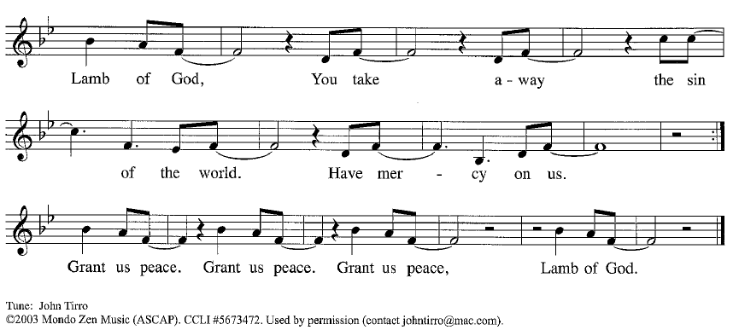
Please be seated
Communion Hymns O Blessed Spring ELW 447

O Living Bread from Heaven ELW 542

Prayer After Communion
Generous Host,
you have shared your feast with us and made us new.
Send us now to set tables of love and grace in our communities,
that your liberating love might nourish the world into freedom,
in the name of the crucified one, Jesus Christ our Lord. Amen.

God blesses us and sends us in mission to the world.
SENDING

Blessing
God our tender parent,
God the crucified one,
God the reconciling Spirit,
☩ bless you now and forever. Amen.

Sending Song Guide Me Ever, Great Redeemer ELW 618

Dismissal
Go in peace. Care for others as God cares for you.
Thanks be to God.

