
Worship Plan for Sunday, May 10, 2026
Sixth Sunday of Easter

The Holy Spirit calls us together as the people of God.
GATHERING
Welcome & Announcements
Prelude
Reflection – Preparing for Worship

Please stand.
Confession and Forgiveness
The assembly stands. All may make the sign of the cross, the sign that is marked at baptism, as the presiding minister begins.

In the name of the Father,
and of the ☩ Son,
and of the Holy Spirit.
Amen.

God of all mercy and consolation, come to the help of your people, turning us from our sin to live for you alone. Give us the power of your Holy Spirit that we may confess our sin, receive your forgiveness, and grow into the fullness of Jesus Christ, our Savior and Lord.
Amen.

Let us confess our sin in the presence of God and of one another.
The assembly kneels or stands. Silence is kept for reflection.

Most merciful God,
we confess that we are captive to sin and cannot free ourselves. We have sinned against you in thought, word, and deed, by what we have done and by what we have left undone. We have not loved you with our whole heart; we have not loved our neighbors as ourselves. For the sake of your Son, Jesus Christ, have mercy on us. Forgive us, renew us, and lead us, so that we may delight in your will and walk in your ways, to the glory of your holy name.
Amen.

In the mercy of almighty God, Jesus Christ was given to die for us, and for his sake God forgives us all our sins. As a called and ordained minister of the church of Christ, and by his authority, I therefore declare to you the entire forgiveness of all your sins, in the name of the Father, and of the ☩ Son, and of the Holy Spirit.
Amen.

Gathering Song Come, Thou Almighty King ELW 408

Greeting
The grace of our Lord Jesus Christ, the love of God,
and the communion of the Holy Spirit be with you all.
And also with you.

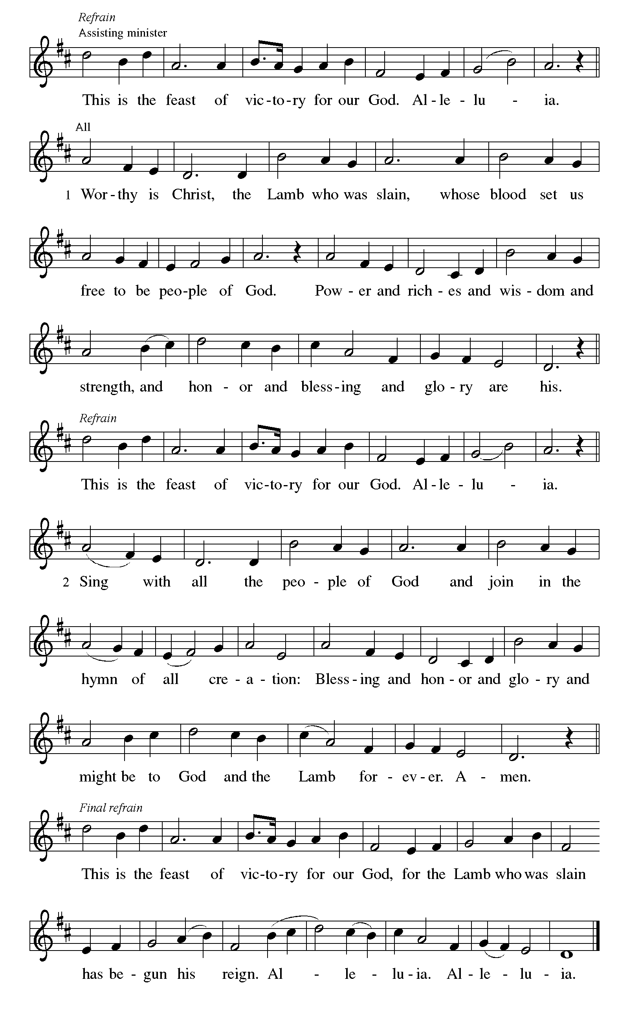
Canticle of Praise

Prayer of the Day
Let us pray.
Almighty and ever-living God, you hold together all things in heaven and on earth. In your great mercy receive the prayers of all your children, and give to all the world the Spirit of your truth and peace, through Jesus Christ, our Savior and Lord, who lives and reigns with you and the Holy Spirit, one God, now and forever.
Amen.
God speaks to us in scripture reading, preaching, and song.
WORD
First Reading: Acts 17:22-31
A reading from Acts.
²² Paul stood in front of the Areopagus and said, “Athenians, I see how extremely spiritual you are in every way. ²³ For as I went through the city and looked carefully at the objects of your worship, I found among them an altar with the inscription, ‘To an unknown god.’ What therefore you worship as unknown, this I proclaim to you. ²⁴ The God who made the world and everything in it, he who is Lord of heaven and earth, does not live in shrines made by human hands, ²⁵ nor is he served by human hands, as though he needed anything, since he himself gives to all mortals life and breath and all things. ²⁶ From one ancestor he made all peoples to inhabit the whole earth, and he allotted the times of their existence and the boundaries of the places where they would live, ²⁷ so that they would search for God and perhaps fumble about for him and find him—though indeed he is not far from each one of us. ²⁸ For ‘In him we live and move and have our being’; as even some of your own poets have said,
‘For we, too, are his offspring.’
²⁹ “Since we are God’s offspring, we ought not to think that the deity is like gold or silver or stone, an image formed by the art and imagination of mortals. ³⁰ While God has overlooked the times of human ignorance, now he commands all people everywhere to repent, ³¹ because he has fixed a day on which he will have the world judged in righteousness by a man whom he has appointed, and of this he has given assurance to all by raising him from the dead.”
The word of the Lord.
Thanks be to God.

Psalm: Psalm 66:8-20
⁸ Bless our | God, you peoples;
let the sound of | praise be heard.
⁹ Our God has kept us a- | mong the living
and has not allowed our | feet to slip. R
¹⁰ For you, O God, have | tested us;
you have tried us just as sil- | ver is tried.
¹¹ You brought us in- | to the net;
you laid heavy burdens up- | on our backs.
¹² You let people ride over our heads; we went through | fire and water,
but you brought us out into a place | of refreshment.
¹³ I will enter your house | with burnt offerings
and will pay | you my vows—
¹⁴ those that I promised | with my lips
and spoke with my mouth when I | was in trouble.
¹⁵ I will offer you burnt offerings of fatlings with the | smoke of rams;
I will give you ox- | en and goats. R
¹⁶ Come and listen, all you | who believe,
and I will tell you what God has | done for me.
¹⁷ I called out to God | with my mouth,
and praised the Lord | with my tongue.
¹⁸ If I had cherished evil | in my heart,
the Lord would | not have heard me;
¹⁹ but in truth | God has heard me
and has attended to the sound | of my prayer.
²⁰ Blessed be God, who has not reject- | ed my prayer,
nor withheld unfailing | love from me. R

Second Reading: 1 Peter 3:13-22
A reading from 1 Peter.
¹³ Now who will harm you if you are eager to do what is good? ¹⁴ But even if you do suffer for doing what is right, you are blessed. Do not fear what they fear, and do not be intimidated, ¹⁵ but in your hearts sanctify Christ as Lord. Always be ready to make your defense to anyone who demands from you an accounting for the hope that is in you, ¹⁶ yet do it with gentleness and respect. Maintain a good conscience so that, when you are maligned, those who abuse you for your good conduct in Christ may be put to shame. ¹⁷ For it is better to suffer for doing good, if suffering should be God’s will, than to suffer for doing evil. ¹⁸ For Christ also suffered for sins once for all, the righteous for the unrighteous, in order to bring you to God. He was put to death in the flesh but made alive in the spirit, ¹⁹ in which also he went and made a proclamation to the spirits in prison, ²⁰ who in former times did not obey, when God waited patiently in the days of Noah, during the building of the ark, in which a few, that is, eight lives, were saved through water. ²¹ And baptism, which this prefigured, now saves you—not as a removal of dirt from the body but as an appeal to God for a good conscience, through the resurrection of Jesus Christ, ²² who has gone into heaven and is at the right hand of God, with angels, authorities, and powers made subject to him.
The word of the Lord.
Thanks be to God.
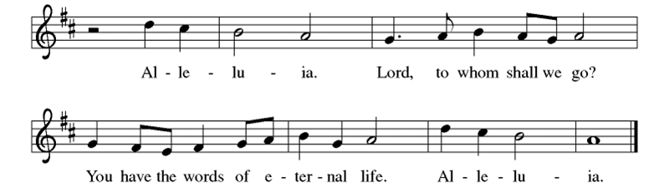

Gospel: John 14:15-21
The holy gospel according to John.
Glory to you, O Lord.
[Jesus said to the disciples:] ¹⁵ “If you love me, you will keep my commandments. ¹⁶ And I will ask the Father, and he will give you another Advocate, to be with you forever. ¹⁷ This is the Spirit of truth, whom the world cannot receive because it neither sees him nor knows him. You know him because he abides with you, and he will be in you.
¹⁸ “I will not leave you orphaned; I am coming to you. ¹⁹ In a little while the world will no longer see me, but you will see me; because I live, you also will live. ²⁰ On that day you will know that I am in my Father, and you in me, and I in you. ²¹ They who have my commandments and keep them are those who love me, and those who love me will be loved by my Father, and I will love them and reveal myself to them.”
The gospel of the Lord.
Praise to you, O Christ.
Please be seated.
Children’s Message

Sermon

Hymn of the Day Loving Spirit WOV 683

Nicene Creed
A: Let us profess our faith to the words of the Nicene creed
We believe in one God,
the Father, the Almighty,
maker of heaven and earth,
of all that is, seen and unseen.
We believe in one Lord, Jesus Christ,
the only Son of God,
eternally begotten of the Father,
God from God, Light from Light,
true God from true God,
begotten, not made,
of one Being with the Father;
through him all things were made.
For us and for our salvation
he came down from heaven,
was incarnate of the Holy Spirit and the virgin Mary
and became truly human.
For our sake he was crucified under Pontius Pilate;
he suffered death and was buried.
On the third day he rose again
in accordance with the scriptures;
he ascended into heaven
and is seated at the right hand of the Father.
He will come again in glory to judge the living and the dead,
and his kingdom will have no end.
We believe in the Holy Spirit, the Lord, the giver of life,
who proceeds from the Father and the Son,*
who with the Father and the Son is worshiped and glorified,
who has spoken through the prophets.
We believe in one holy catholic and apostolic church.
We acknowledge one baptism for the forgiveness of sins.
We look for the resurrection of the dead,
and the life of the world to come. Amen.

Prayers of Intercession
Trusting in the power of Christ’s resurrection to heal and redeem our broken world, let us pray for the needs of all creation.
God of new life, you call us through the waters of baptism to be in relationship with you and one another. Guide the church and its leaders to proclaim Christ’s righteousness throughout the world. Merciful God,
receive our prayer.
You create the world and all that is in it. Shelter budding plants and young animals, provide unpolluted habitats and clean water, and raise up stewards for the environment. Merciful God,
receive our prayer.
You set civil servants in the places where we live. Instill truth and equity among judges and lawyers, gentleness and courage among first responders, and peace among leaders of towns and nations. Merciful God,
receive our prayer.
You provide comfort in times of trouble. Heal those who are sick, shelter any who are unhoused, feed those undernourished, and accompany and console all who are lonely, bereaved, anxious, or ill (especially). Merciful God,
receive our prayer.
You are love and you desire that we love one another. As a mother hen cares for her chicks, bless all who provide motherly care in our lives, and inspire us to care for one another. Merciful God,
receive our prayer.
God of new life, your steadfast love endures forever. Inspire us by the example of the faithful departed, who clung to your promises of life, forgiveness of sins, and salvation. Merciful God,
receive our prayer.
God of resurrection power, use us and these prayers to proclaim the good news of new life to all the world, through Jesus Christ, our risen Savior.
Amen.

Peace
The peace of Christ be with you always. And also with you.

MEAL
God feeds us with the presence of Jesus Christ.

Choral Anthem – Living Hope

Please stand.
Offertory Hymn Give Thanks

Offering Prayer
Merciful God,
accept the fruits of our labor, gathered to give you glory.
You have set a table before us, a glimpse of that great day
when we will hunger and thirst no more.
Nourish us with the body and blood of Jesus,
that goodness and mercy may follow us
and bless the world you love.
In the name of Jesus,
Amen.

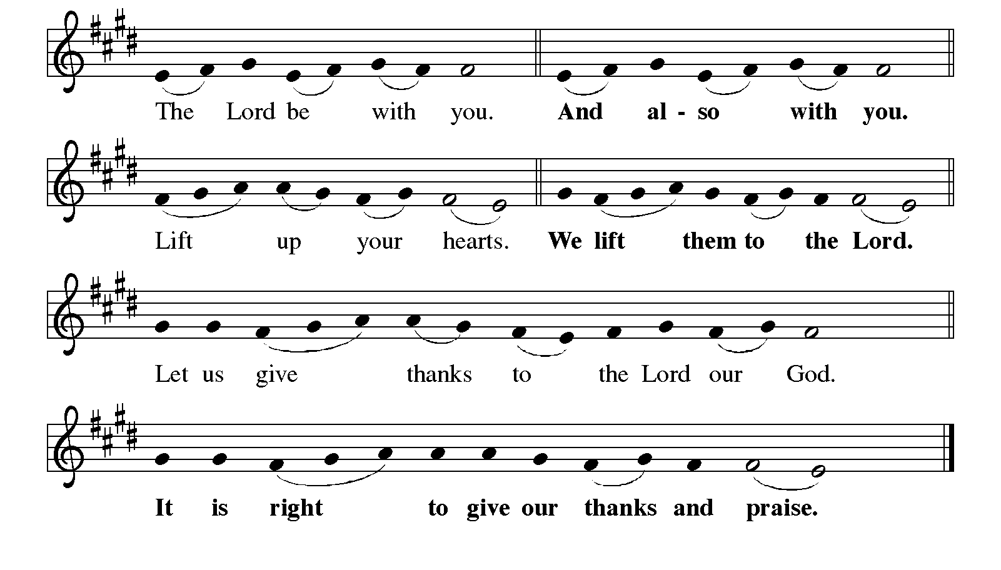
Great Thanksgiving
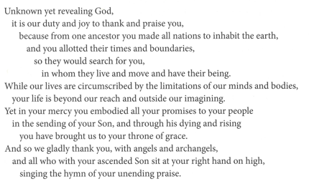

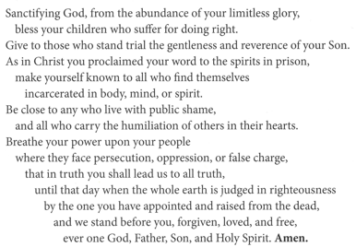
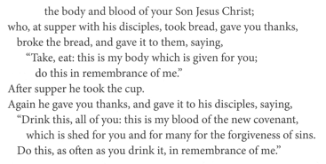
Eucharistic Prayer
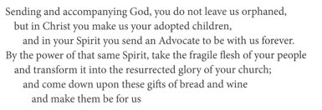

Lord’s Prayer
Our Father, who art in heaven,
hallowed be thy name, thy kingdom come,
thy will be done, on earth as it is in heaven.
Give us this day our daily bread;
and forgive us our trespasses, as we forgive those who trespass against us;
and lead us not into temptation but deliver us from evil.
For thine is the kingdom,
and the power, and the glory, forever and ever.
Amen.

Invitation to Communion
Come to the table of new life.
Receive the risen Lord.

Communion

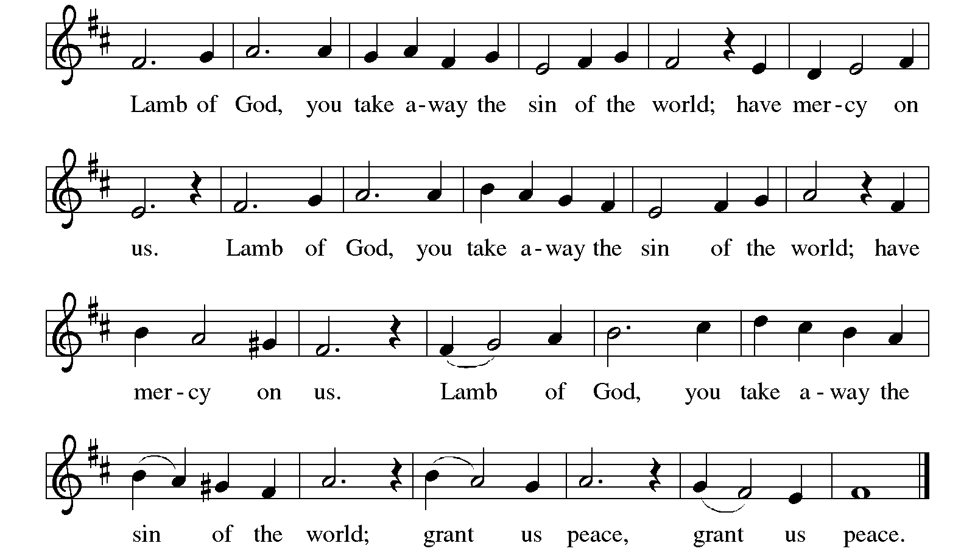

Communion Songs Children of the Heavenly Father ELW 781

For All the Faithful Women ELW 419
Verses 1, 2, 3, 4 & Last

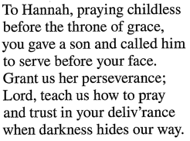
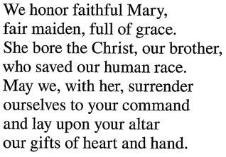
3 Hannah 4 Mary, Mother of Our Lord

Prayer after Communion
Holy One,
through this meal you have made your home among us
and are making all things new.
Send us now to speak peace to anxious hearts,
to love our enemies,
and to bring your healing to the nations.
In the name of Jesus, Amen.

SENDING
God blesses us and sends us in mission to the world.

Blessing
God Almighty, who is the beginning and the end,
Jesus Christ, the firstborn of the dead,
and the Spirit, our advocate and peace,
☩ bless you now and forever.
Amen.
Sending Song Alleluia! Sing to Jesus ELW 392

Dismissal
Go in peace. Praise the Lord. Alleluia!
Thanks be to God. Alleluia!

From sundaysandseasons.com.

Copyright © 2026 Augsburg Fortress. All rights reserved.

