Worship Plan for Sunday, February 22, 2026
First Sunday in Lent

The Holy Spirit calls us together as the people of God.
GATHERING

Prelude
Welcome/Announcements
Reflection - Preparing for Worship
Sing 2x

Please stand.
Confession and Forgiveness
All make the sign of the cross, the sign that is marked at baptism, as the presiding minister begins.
Blessed be the holy Trinity, ☩ one God,
who forgives all our sin,
whose mercy endures forever.
Amen.

Let us return to God, confessing our sin in the assurance of God’s abiding love.
Silence is kept for reflection.

Compassionate One,
you are slow to anger and abounding in steadfast love,
but our lives do not always reflect you
and your love for the world.
We do not show others the tender compassion
you have shown to us.
We do not welcome others with the radical hospitality
you grant to all people.
We oppress others,
even though you have set us free again and again.
We squander the abundant gifts of the earth.
Transform our lives
and guide us again in the way of the cross.
Amen.

Beloved in Christ,
God’s arms are always stretched open wide
to welcome the wandering ones home.
In ☩ Christ your sins are forgiven.
You have a place in God’s house forever.
Amen.

Gathering Song Rejoice, Ye Pure in Heart! ELW 873

Greeting
The grace of our Lord Jesus Christ, the love of God
and the communion of the Holy Spirit be with you all.
And also, with you.

Kyrie

Your Heart, O God is Grieved

Prayer of the Day
Let us pray.
Lord God, our strength, the struggle between good and evil rages within and around us, and the devil and all the forces that defy you tempt us with empty promises. Keep us steadfast in your word, and when we fall, raise us again and restore us through your Son, Jesus Christ, our Savior and Lord, who lives and reigns with you and the Holy Spirit, one God, now and forever.
Amen.

Please be seated.
God speaks to us in scripture reading, preaching, and song.
WORD

First Reading: Genesis 2:15-17; 3:1-7
A reading from Genesis.
¹⁵ The Lord God took the man and put him in the garden of Eden to till it and keep it. ¹⁶ And the Lord God commanded the man, “You may freely eat of every tree of the garden, ¹⁷ but of the tree of the knowledge of good and evil you shall not eat, for in the day that you eat of it you shall die.”
^{3:1} Now the serpent was more crafty than any other wild animal that the Lord God had made. He said to the woman, “Did God say, ‘You shall not eat from any tree in the garden’?” ² The woman said to the serpent, “We may eat of the fruit of the trees in the garden, ³ but God said, ‘You shall not eat of the fruit of the tree that is in the middle of the garden, nor shall you touch it, or you shall die.’ ” ⁴ But the serpent said to the woman, “You will not die, ⁵ for God knows that when you eat of it your eyes will be opened, and you will be like God, knowing good and evil.” ⁶ So when the woman saw that the tree was good for food and that it was a delight to the eyes and that the tree was to be desired to make one wise, she took of its fruit and ate, and she also gave some to her husband, who was with her, and he ate. ⁷ Then the eyes of both were opened, and they knew that they were naked, and they sewed fig leaves together and made loincloths for themselves.
The word of the Lord.
Thanks be to God.
Psalm: Psalm 32
¹ Happy are they whose transgressions | are forgiven,
and whose sin is | put away!
² Happy are they to whom the Lord im- | putes no guilt,
and in whose spirit there | is no guile!
³ While I held my tongue, my bones with- | ered away,
because of my groaning | all day long.
⁴ For your hand was heavy upon me | day and night;
my moisture was dried up as in the | heat of summer. R
⁵ Then I acknowledged my sin to you, and did not con- | ceal my guilt.
I said, “I will confess my transgressions to the Lord.” Then you forgave me the guilt | of my sin.
⁶ Therefore all the faithful will make their prayers to you in | time of trouble;
when the great waters overflow, they | shall not reach them.
⁷ You are my hiding-place; you preserve | me from trouble;
you surround me with shouts | of deliverance.
⁸ “I will instruct you and teach you in the way that | you should go;
I will guide you | with my eye. R
⁹ Do not be like horse or mule, which have no | understanding;
who must be fitted with bit and bridle, or else they will | not stay near you.”
¹⁰ Great are the tribulations | of the wicked;
but mercy embraces those who trust | in the Lord.
¹¹ Be glad, you righteous, and rejoice | in the Lord;
shout for joy, all who are | true of heart. R

Second Reading: Romans 5:12-19
A reading from Romans.
¹² Just as sin came into the world through one man, and death came through sin, and so death spread to all because all have sinned ¹³ for sin was indeed in the world before the law, but sin is not reckoned when there is no law. ¹⁴ Yet death reigned from Adam to Moses, even over those who did not sin in the likeness of Adam, who is a pattern of the one who was to come.
¹⁵ But the free gift is not like the trespass. For if the many died through the one man’s trespass, much more surely have the grace of God and the gift in the grace of the one man, Jesus Christ, abounded for the many. ¹⁶ And the gift is not like the effect of the one man’s sin. For the judgment following one trespass brought condemnation, but the gift following many trespasses brings justification. ¹⁷ If, because of the one man’s trespass, death reigned through that one, much more surely will those who receive the abundance of grace and the gift of righteousness reign in life through the one man, Jesus Christ.
¹⁸ Therefore just as one man’s trespass led to condemnation for all, so one man’s act of righteousness leads to justification and life for all. ¹⁹ For just as through the one man’s disobedience the many were made sinners, so through the one man’s obedience the many will be made righteous.
The word of the Lord.
Thanks be to God.
Please stand.

Gospel: Matthew 4:1-11
The holy gospel according to Matthew.
Glory to you, O Lord.
¹ Jesus was led up by the Spirit into the wilderness to be tested by the devil. ² He fasted forty days and forty nights, and afterward he was famished. ³ The tempter came and said to him, “If you are the Son of God, command these stones to become loaves of bread.” ⁴ But he answered, “It is written,
‘One does not live by bread alone,
but by every word that comes from the mouth of God.’ ”
⁵ Then the devil took him to the holy city and placed him on the pinnacle of the temple, ⁶ saying to him, “If you are the Son of God, throw yourself down, for it is written,
‘He will command his angels concerning you,’
and ‘On their hands they will bear you up,
so that you will not dash your foot against a stone.’ ”
⁷ Jesus said to him, “Again it is written, ‘Do not put the Lord your God to the test.’ ”
⁸ Again, the devil took him to a very high mountain and showed him all the kingdoms of the world and their glory, ⁹ and he said to him, “All these I will give you, if you will fall down and worship me.” ¹⁰ Then Jesus said to him, “Away with you, Satan! for it is written,
‘Worship the Lord your God,
and serve only him.’ ”
¹¹ Then the devil left him, and suddenly angels came and waited on him.
The gospel of the Lord.
Praise to you, O Christ.

Please be seated.

Children’s Message

Sermon

Please stand.
Hymn of the Day When the Poor Ones ELW 725
Cuando el pobre

Apostles’ Creed
Let us confess our faith to the words of the Apostles’ Creed
I believe in God, the Father almighty,
creator of heaven and earth.
I believe in Jesus Christ, God’s only Son, our Lord,
who was conceived by the Holy Spirit,
born of the virgin Mary,
suffered under Pontius Pilate,
was crucified, died, and was buried;
he descended to the dead.*
On the third day he rose again;
he ascended into heaven,
he is seated at the right hand of the Father,
and he will come to judge the living and the dead.
I believe in the Holy Spirit,
the holy catholic church,
the communion of saints,
the forgiveness of sins,
the resurrection of the body,
and the life everlasting. Amen.

Please sit or kneel.
Prayers of Intercession
Reconciled by God’s mercy and sustained by God’s presence, let us pray for the world and its needs.
God of all grace, grant faith to your church. Give to all the baptized the will to resist temptation and to worship and serve you alone. Hear us, O God.
Your mercy is great.
God of all creation, tend this earth. When human greed and disobedience threaten this planet and the life it contains, lead us by your Spirit into ways of reverence, awe, and gentleness. Hear us, O God.
Your mercy is great.
God of all nations, preserve us from trouble. Surround all living in places of violence with your steadfast love and give resilience to all who work for peace. Grant courage to those who challenge, especially around issues of racism and systemic oppression. Hear us, O God.
Your mercy is great.
God of all healing, mend our wounds. Bring wholeness to all who are sick, give peace to all who groan in grief, and send companions to all who are lonely or isolated. (Especially we pray for . . .) Hear us, O God.
Your mercy is great.
God of all people, provide for our community. For any among us who hunger for bread, bring nourishment. For any among us who hunger for truth, speak your life-giving word. Hear us, O God.
Your mercy is great.
God of all life, bring us to you. We thank you for your free and abounding grace, and for those who, by that same grace, now rest eternally in you (especially). Hear us, O God.
Your mercy is great.
Receive our prayers, O God, through Jesus Christ, our strength and salvation.
Amen

Peace
The peace of Christ be with you always.
And also, with you.

God feeds us with the presence of Jesus Christ.
MEAL

Please be seated.
Offering

Choir – If You Love Me

Please stand.
Offertory Hymn Come, Bring Your Burdens ACS 1009

Offertory Prayer
Let us pray
Gracious Provider,
you set your immense treasures among us,
opening your heart to the world.
As we prepare to feast on your bountiful love,
deepen our commitment to sharing those
treasures with others,
through our Savior, Jesus Christ.
Amen.

The Great Thanksgiving

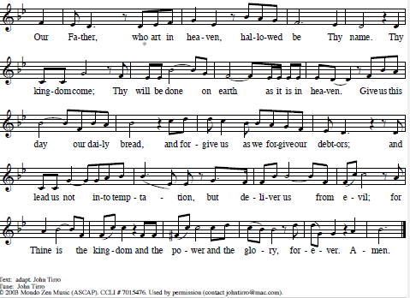
The Lord’s Prayer

Invitation to Communion
All who are hungry, come!
The feast of grace is spread.
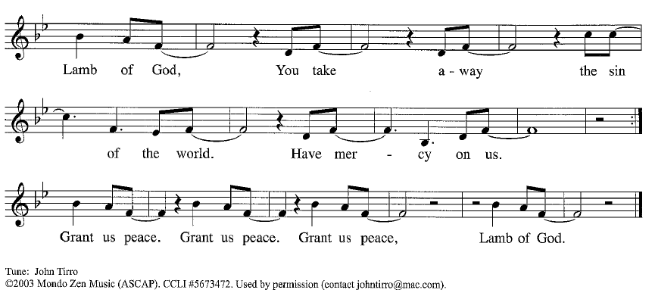
Please be seated.
Communion Hymns As We Gather At Your Table ELW 522

O God of Mercy, God of Light ELW 714

Prayer After Communion
Generous Host,
you have shared your feast with us and made us new.
Send us now to set tables of love and grace in our communities,
that your liberating love might nourish the world into freedom,
in the name of the crucified one, Jesus Christ our Lord. Amen.

God blesses us and sends us in mission to the world.
SENDING

Blessing
God our tender parent,
God the crucified one,
God the reconciling Spirit,
☩ bless you now and forever. Amen.

Sending Song The Spirit Sends Us Forth to Serve ELW 551

Dismissal
Go in peace. Care for others as God cares for you.
Thanks be to God.

