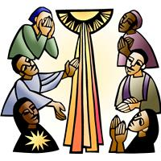
Worship Plan for Sunday, February 1, 2026
Forth Sunday after Epiphany

The Holy Spirit calls us together as the people of God.
GATHERING

Prelude
Welcome & Announcements
Handbells ~ A Time for Joy
Reflection – Preparing for Worship
Sing 2x

Please stand.

Confession and Forgiveness

All may make the sign of the cross, the sign that is marked at baptism, as the presiding minister begins.

Blessed be the holy Trinity, ☩ one God,
the God of manna,
the God of miracles,
the God of mercy.
Amen.

Drawn to Christ and seeking God’s abundance,
let us confess our sin.

Silence is kept for reflection.

God, our provider,
help us.
It is hard to believe there is enough to share.
We question your ways when they differ from the ways
of the world in which we live.
We turn to our own understanding
rather than trusting in you.
We take offense at your teachings and your ways.
Turn us again to you.
Where else can we turn?
Share with us the words of eternal life
and feed us for life in the world.
Amen.
Beloved people of God:
in Jesus, the manna from heaven,
you are fed and nourished.
By Jesus, the worker of miracles,
there is always more than enough.
Through Jesus, ☩ the bread of life,
you are shown God’s mercy:
you are forgiven and loved into abundant life.
Amen.

Gathering Song Rejoice, Ye Pure in Heart! ELW 873

Greeting
The grace of our Lord Jesus Christ, the love of God,
and the communion of the Holy Spirit be with you all.
And also with you.

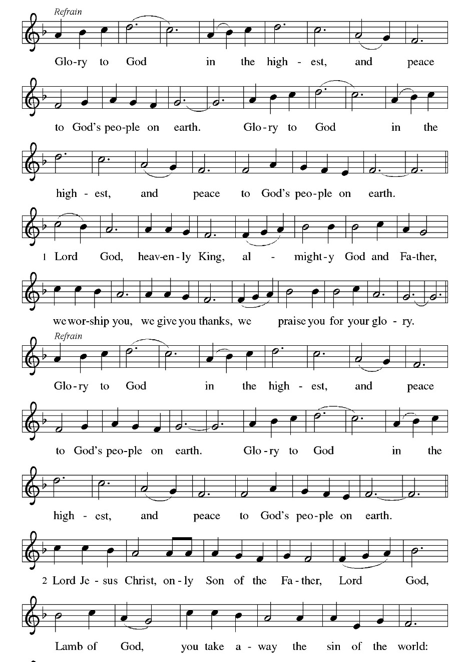
Hymn of Praise Glory to God

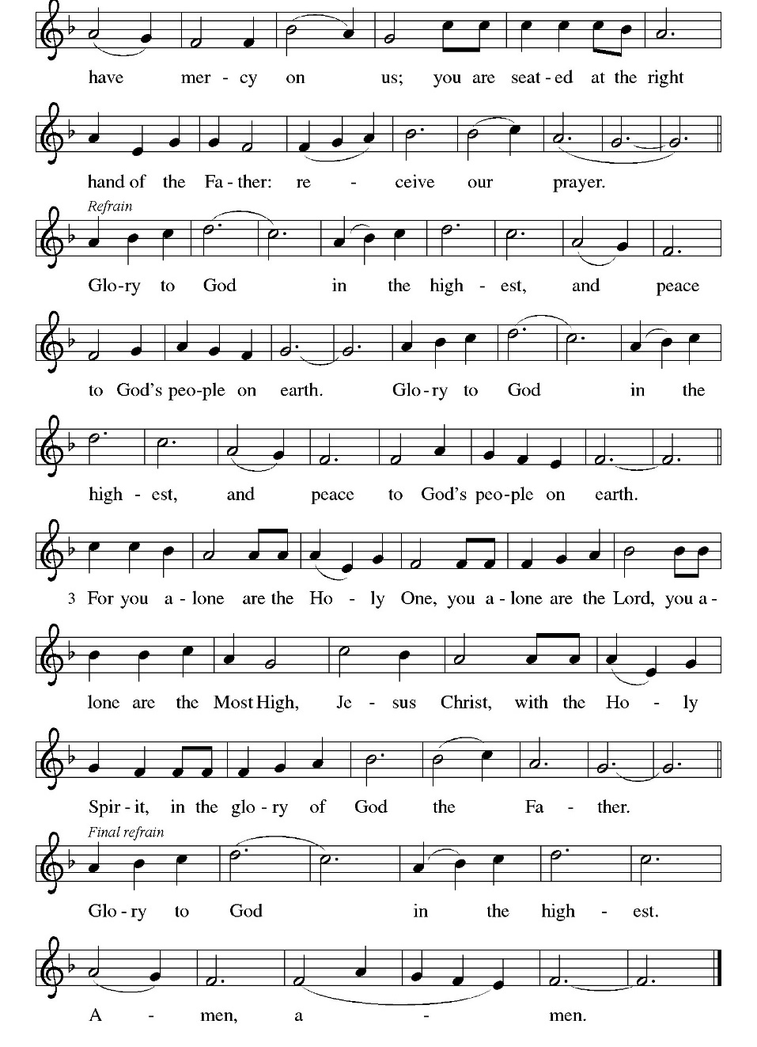

Prayer of the Day
Let us pray.
Holy God, you confound the world’s wisdom in giving your kingdom to the lowly and the pure in heart. Give us such a hunger and thirst for justice, and perseverance in striving for peace, that in our words and deeds the world may see the life of your Son, Jesus Christ, our Savior and Lord.
Amen.

God speaks to us in scripture reading, preaching, and song.
WORD

First Reading: Micah 6:1-8
A reading from Micah.
¹ Hear what the Lord says:
Rise, plead your case before the mountains,
and let the hills hear your voice.
² Hear, you mountains, the case of the Lord,
and you enduring foundations of the earth,
for the Lord has a case against his people,
and he will contend with Israel.
³ “O my people, what have I done to you?
In what have I wearied you? Answer me!
⁴ For I brought you up from the land of Egypt
and redeemed you from the house of slavery,
and I sent before you Moses,
Aaron, and Miriam.
⁵ O my people, remember now what King Balak of Moab devised,
what Balaam son of Beor answered him,
and what happened from Shittim to Gilgal,
that you may know the saving acts of the Lord.”
⁶ “With what shall I come before the Lord
and bow myself before God on high?
Shall I come before him with burnt offerings,
with calves a year old?
⁷ Will the Lord be pleased with thousands of rams,
with ten thousands of rivers of oil?
Shall I give my firstborn for my transgression,
the fruit of my body for the sin of my soul?”
⁸ He has told you, O mortal, what is good,
and what does the Lord require of you
but to do justice and to love kindness
and to walk humbly with your God?
The word of the Lord.
Thanks be to God.

Psalm: Psalm 15
¹ Lord, who may dwell in your | tabernacle?
Who may abide upon your | holy hill?
² Those who lead a blameless life and do | what is right,
who speak the truth | from their heart; R
³ they do not slander with the tongue, they do no evil | to their friends;
they do not cast discredit up- | on a neighbor.
⁴ In their sight the wicked are rejected, but they honor those who | fear the Lord.
They have sworn upon their health and do not take | back their word.
⁵ They do not give their money in hope of gain, nor do they take bribes a- | gainst the innocent.
Those who do these things shall never be | overthrown. R

Second Reading: 1 Corinthians 1:18-31
A reading from 1 Corinthians.
¹⁸ The message about the cross is foolishness to those who are perishing, but to us who are being saved it is the power of God. ¹⁹ For it is written,
“I will destroy the wisdom of the wise,
and the discernment of the discerning I will thwart.”
²⁰ Where is the one who is wise? Where is the scholar? Where is the debater of this age? Has not God made foolish the wisdom of the world? ²¹ For since, in the wisdom of God, the world did not know God through wisdom, God decided, through the foolishness of the proclamation, to save those who believe. ²² For Jews ask for signs and Greeks desire wisdom, ²³ but we proclaim Christ crucified, a stumbling block to Jews and foolishness to gentiles, ²⁴ but to those who are the called, both Jews and Greeks, Christ the power of God and the wisdom of God. ²⁵ For God’s foolishness is wiser than human wisdom, and God’s weakness is stronger than human strength.
²⁶ Consider your own call, brothers and sisters: not many of you were wise by human standards, not many were powerful, not many were of noble birth. ²⁷ But God chose what is foolish in the world to shame the wise; God chose what is weak in the world to shame the strong; ²⁸ God chose what is low and despised in the world, things that are not, to abolish things that are, ²⁹ so that no one might boast in the presence of God. ³⁰ In contrast, God is why you are in Christ Jesus, who became for us wisdom from God, and righteousness and sanctification and redemption, ³¹ in order that, as it is written, “Let the one who boasts, boast in the Lord.”
The word of the Lord.
Thanks be to God.

Please Stand
Gospel Acclamation
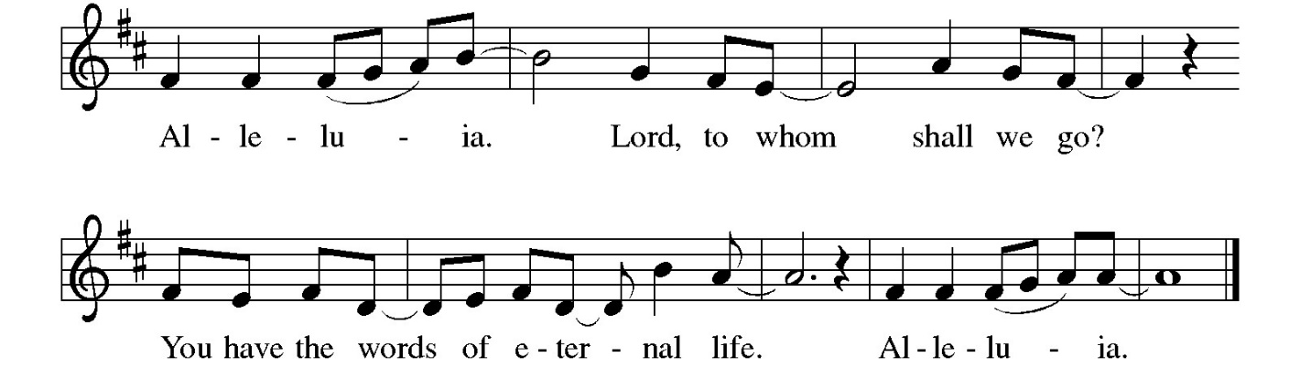
Gospel: Matthew 5:1-12
The holy gospel according to Matthew.
Glory to you, O Lord.
¹ When Jesus saw the crowds, he went up the mountain, and after he sat down, his disciples came to him. ² And he began to speak and taught them, saying:
³ “Blessed are the poor in spirit, for theirs is the kingdom of heaven.
⁴ “Blessed are those who mourn, for they will be comforted.
⁵ “Blessed are the meek, for they will inherit the earth.
⁶ “Blessed are those who hunger and thirst for righteousness, for they will be filled.
⁷ “Blessed are the merciful, for they will receive mercy.
⁸ “Blessed are the pure in heart, for they will see God.
⁹ “Blessed are the peacemakers, for they will be called children of God.
¹⁰ “Blessed are those who are persecuted for the sake of righteousness, for theirs is the kingdom of heaven.
¹¹ “Blessed are you when people revile you and persecute you and utter all kinds of evil against you falsely on my account. ¹² Rejoice and be glad, for your reward is great in heaven, for in the same way they persecuted the prophets who were before you.”
The gospel of the Lord.
Praise to you, O Christ.

Please be seated.
Children’s Message

Sermon

Please stand
Hymn of the Day When the Poor Ones ELW 725
Cuando el pobre

Apostles’ Creed
Let us confess our faith through the words of the Apostles’ Creed
I believe in God, the Father almighty, creator of heaven and earth.
I believe in Jesus Christ, God's only Son, our Lord,
who was conceived by the Holy Spirit,
born of the virgin Mary,
suffered under Pontius Pilate,
was crucified, died, and was buried;
he descended to the dead
On the third day he rose again;
he ascended into heaven,
he is seated at the right hand of the Father,
and he will come to judge the living and the dead.
I believe in the Holy Spirit,
the holy catholic church, the communion of saints,
the forgiveness of sins, the resurrection of the body,
and the life everlasting. Amen.

Prayers of Intercession
As God’s beloved children united in Christ, let us pray for the church, the whole human community, and the well-being of the earth, our home.
God our wisdom, renew the church in the power of the Spirit, that it may do justice, love kindness, live humbly, and boldly proclaim Christ crucified. We pray for social justice and humanitarian aid ministries (faith-based organizations may be named). Merciful God,
receive our prayer.
God our source, we honor you by caring wisely for your creation. We pray for the health of old growth forests, ice caps, and ocean currents. Preserve the diversity of life on earth. Merciful God,
receive our prayer.
God our righteousness, raise up visionary leaders who serve with integrity and respect human rights. Increase freedom in every nation. Protect educators, journalists, artists, and religious activists who are reviled for speaking truth. Merciful God,
receive our prayer.
God our advocate, you give hope to all who suffer because of persecution, poverty, or war. Reunite separated families and bring orphaned children to safety. Comfort any who grieve or suffer in any way (especially). Merciful God,
receive our prayer.
God our blessing, we pray for the children and youth of this congregation, and for parents, grandparents, mentors, teachers, and youth ministers who model love for their neighbor and care for others. Merciful God,
receive our prayer.
God our joy, we give thanks for the lives of those before us who journeyed humbly with you. Merciful God,
receive our prayer.
Confident that the Holy Spirit receives our prayers and answers us, we commend all for whom we pray to God’s loving-kindness made known to us in Christ Jesus our Savior.
Amen.

Peace
The peace of Christ be with you always. And also with you.

God feeds us with the presence of Jesus Christ.
MEAL

Please be seated.
Offering

Choral Anthem Shine on Us

Please Stand
Offertory Hymn Thank You Lord ACS 1092

Offertory Prayer
God of majesty,
no eye has seen, no ear has heard
what you have prepared for those who love you,
yet in this meal you reveal the wideness of your mercy.
Use what we have gathered
to feed us with the reign of God come near,
Jesus Christ, our Savior and Lord.
Amen.

The Great Thanksgiving

The Lord be with you.
And also with you.
Lift up your hearts.
We lift them to the Lord.
Let us give thanks to the Lord our God.
It is right to give our thanks and praise.

Blessed are you, Lord God…
… singing the hymn of your unending praise.

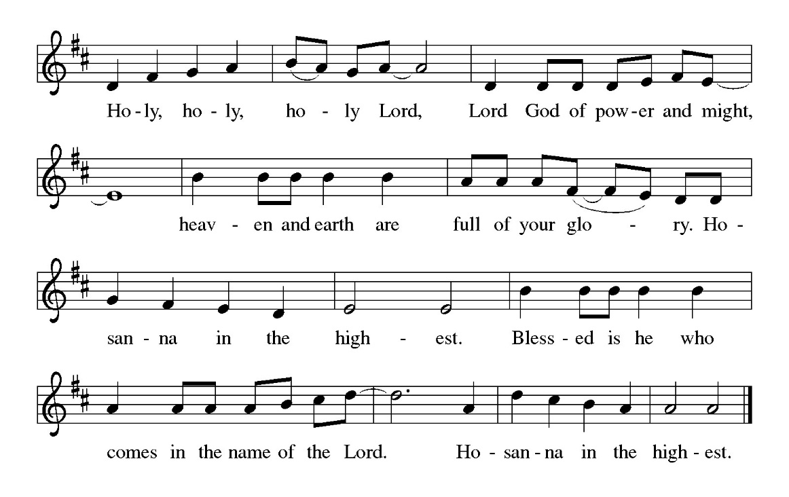

God our companion…
…Father, Son, and Holy Spirit, ever one God. Amen.

The Lord’s Prayer
Our Father, who art in heaven, hallowed be thy name,
thy kingdom come, thy will be done,
on earth as it is in heaven.
Give us this day our daily bread;
and forgive us our trespasses,
as we forgive those who trespass against us;
and lead us not into temptation but deliver us from evil.
For thine is the kingdom, and the power, and the glory,
forever and ever. Amen.

Invitation to Communion
Here is the Lamb of God who takes away the sin of the world!
Come to the table; taste and see.

Please be seated.
Communion Hymns
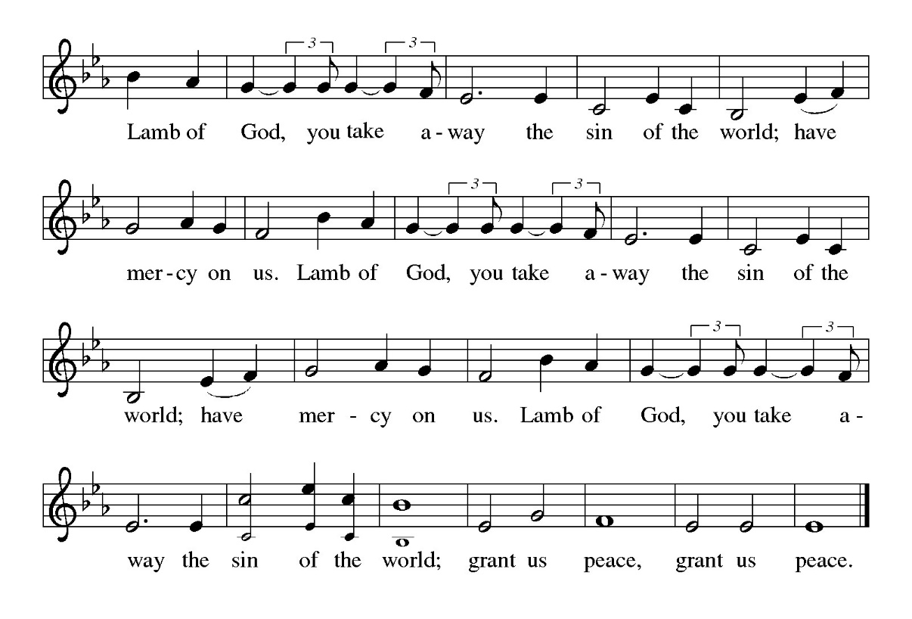

As We Gather at Your Table ELW 522

O God of Mercy, God of Light ELW 714

Please stand
Prayer After Communion
Radiant God,
we have seen your glory in the face of Jesus Christ.
In the sacrament of his body and blood
you have drawn us to your heart.
Send us from this table with delight,
that our lives may reflect the beauty of your love,
and bear witness to all we have seen and heard,
through Jesus Christ, our Savior and Lord.
Amen.
God blesses us and sends us in mission to the world.
SENDING

Blessing
May the triune God,
who has put a new song in your mouth
and tuned your heart for praise
☩ bless you now and forever.
Amen.

Sending Song The Spirit Sends Us Forth to Serve ELW 551
Dismissal
Go in peace. Do Justice. Love Mercy.
Thanks be to God.
From sundaysandseasons.com. Copyright © 2026 Augsburg Fortress. All rights reserved

