Worship Plan for Sunday, November 1, 2026
All Saints Day

The Holy Spirit calls us together as the people of God.
GATHERING

Prelude
Welcome/Announcements
Reflection - Preparing for Worship
Sing 2x

Please stand.

Confession and Forgiveness
All may make the sign of the cross, the sign that is marked at baptism, as the presiding minister begins.
Blessed be the holy Trinity, ☩ one God,
our dwelling place for all generations,
whose compassion never slumbers.
Amen.
Let us confess our sin in the presence of God
and of one another.

Silence is kept for reflection.

Holy God,
we confess that we have trusted in our preparation
instead of your invitation.
We prioritize our piety over care for your beloved.
We trust the voice of our shame and fear,
which keeps us from entering fully
into relationship with you and others.
We are not awake to the coming of your reign.
Rouse us and rescue us,
that we may enter into your joy.
Amen.
Inherit the riches of God’s grace.
☩ Jesus, the good shepherd, feeds you with his mercy.
You are forgiven.
Blessed are you.
Amen.

Page intentaly left blank
Gathering Song For All the Saints ELW 422
(continued on next page)

Greeting
The grace of our Lord Jesus Christ, the love of God
and the communion of the Holy Spirit be with you all.
And also, with you.

Prayer of the Day
Let us pray.
Almighty God, you have knit your people together in one communion in the mystical body of your Son, Jesus Christ our Lord. Grant us grace to follow your blessed saints in lives of faith and commitment, and to know the inexpressible joys you have prepared for those who love you, through Jesus Christ, our Savior and Lord, who lives and reigns with you and the Holy Spirit, one God, now and forever.
Amen.

Please be seated.
God speaks to us in scripture reading, preaching, and song.
WORD

First Reading: Revelation 7:9-17
A reading from Revelation.
⁹ After this I looked, and there was a great multitude that no one could count, from every nation, from all tribes and peoples and languages, standing before the throne and before the Lamb, robed in white, with palm branches in their hands. ¹⁰ They cried out in a loud voice, saying,
“Salvation belongs to our God who is seated on the throne and to the Lamb!”
¹¹ And all the angels stood around the throne and around the elders and the four living creatures, and they fell on their faces before the throne and worshiped God, ¹² singing,
“Amen! Blessing and glory and wisdom
and thanksgiving and honor
and power and might
be to our God forever and ever! Amen.”
¹³ Then one of the elders addressed me, saying, “Who are these, robed in white, and where have they come from?” ¹⁴ I said to him, “Sir, you are the one who knows.” Then he said to me, “These are they who have come out of the great ordeal; they have washed their robes and made them white in the blood of the Lamb.
¹⁵ For this reason they are before the throne of God
and worship him day and night within his temple,
and the one who is seated on the throne will shelter them.
¹⁶ They will hunger no more and thirst no more;
the sun will not strike them,
nor any scorching heat,
¹⁷ for the Lamb at the center of the throne will be their shepherd,
and he will guide them to springs of the water of life,
and God will wipe away every tear from their eyes.”
The word of the Lord.
Thanks be to God.

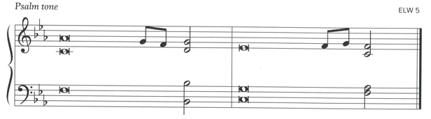
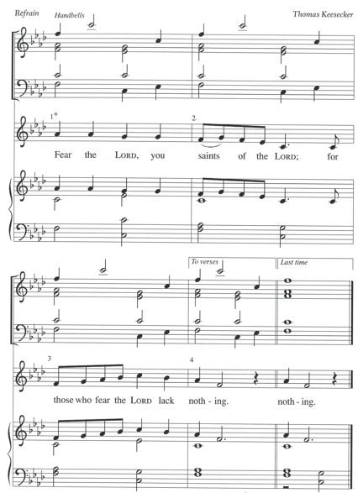

Psalm: Psalm 34:1-10, 22
¹ I will bless the Lord | at all times;
the praise of God shall ever be | in my mouth.
² I will glory | in the Lord;
let the lowly hear | and rejoice. R
³ Proclaim with me the greatness | of the Lord;
let us exalt God’s | name together.
⁴ I sought the Lord, who | answered me
and delivered me from | all my terrors.
⁵ Look upon the Lord | and be radiant,
and let not your faces | be ashamed.
⁶ I called in my affliction, and | the Lord heard me
and saved me from | all my troubles. R
⁷ The angel of the Lord encamps around those who | fear the Lord
and de- | livers them.
⁸ Taste and see that the | Lord is good;
happy are they who take ref- | uge in God!
⁹ Fear the Lord, you saints | of the Lord,
for those who fear the | Lord lack nothing.
¹⁰ The lions are in want and | suffer hunger,
but those who seek the Lord lack nothing | that is good.
²² O Lord, you redeem the life | of your servants,
and those who put their trust in you will | not be punished. R

Second Reading: 1 John 3:1-3
A reading from 1 John.
¹ See what love the Father has given us, that we should be called children of God, and that is what we are. The reason the world does not know us is that it did not know him. ² Beloved, we are God’s children now; what we will be has not yet been revealed. What we do know is this: when he is revealed, we will be like him, for we will see him as he is. ³ And all who have this hope in him purify themselves, just as he is pure.
The word of the Lord.
Thanks be to God.

Please stand.
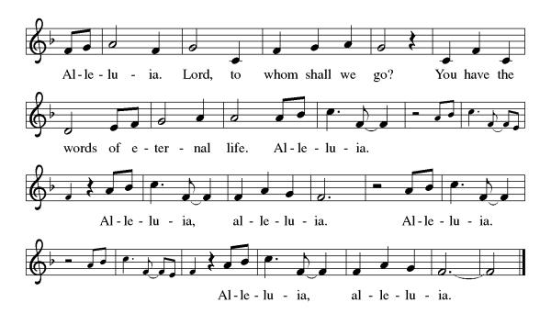
Gospel Acclamation

Gospel: Matthew 5:1-12
The holy gospel according to Matthew.
Glory to you, O Lord.
¹ When Jesus saw the crowds, he went up the mountain, and after he sat down, his disciples came to him. ² And he began to speak and taught them, saying:
³ “Blessed are the poor in spirit, for theirs is the kingdom of heaven.
⁴ “Blessed are those who mourn, for they will be comforted.
⁵ “Blessed are the meek, for they will inherit the earth.
⁶ “Blessed are those who hunger and thirst for righteousness, for they will be filled.
⁷ “Blessed are the merciful, for they will receive mercy.
⁸ “Blessed are the pure in heart, for they will see God.
⁹ “Blessed are the peacemakers, for they will be called children of God.
¹⁰ “Blessed are those who are persecuted for the sake of righteousness, for theirs is the kingdom of heaven.
¹¹ “Blessed are you when people revile you and persecute you and utter all kinds of evil against you falsely on my account. ¹² Rejoice and be glad, for your reward is great in heaven, for in the same way they persecuted the prophets who were before you.”
The gospel of the Lord.
Praise to you, O Christ.

Please be seated.
Children’s Message
Sermon

Please stand
Hymn of the Day Shall We Gather at the River ELW 423

Apostles’ Creed
Let us confess our faith to the words of the Apostles’ Creed
I believe in God, the Father almighty,
creator of heaven and earth.
I believe in Jesus Christ, God's only Son, our Lord,
who was conceived by the Holy Spirit,
born of the Virgin Mary,
suffered under Pontius Pilate,
was crucified, died, and was buried;
he descended to the dead.
On the third day he rose again;
he ascended into heaven,
he is seated at the right hand of the Father,
and he will come to judge the living and the dead.
I believe in the Holy Spirit,
the holy catholic Church,
the communion of saints,
the forgiveness of sins,
the resurrection of the body,
and the life everlasting. Amen

Please sit or kneel.
Prayers of Intercession
United with the great cloud of witnesses, we offer our prayers for the church, the world, and all of creation.
Fill your church with mercy and humility as we proclaim the gospel in our worship and witness in the world. Renew and inspire all who preach and teach among us. God, in your mercy,
hear our prayer.
Restore all lands suffering from ecological degradation. Protect soils and waterways (local places may be named). Point us toward innovative ways of living in harmony and joy with creation. God, in your mercy,
hear our prayer.
Unite the nations in their actions toward justice and peace. Raise up leaders who listen deeply for the needs of their communities, and surround the election process with wisdom and discernment. God, in your mercy,
hear our prayer.
Bring comfort and care to all who are in need, especially all who mourn this day. Sustain any who are weary, experiencing loneliness, or struggling with chronic illness (especially). God, in your mercy,
hear our prayer.
Nurture programs and communities that support elders and those who are homebound. Bless caregivers, nurses, chaplains, social workers, and hospice staff. Guide this congregation’s ministry with seniors and their families. God, in your mercy,
hear our prayer.
With grateful hearts we remember all who have died and now rest from their labors (those who have died in the past year may be named). Fill us with songs of praise until we too are gathered at your side. God, in your mercy,
hear our prayer.
Into your steadfast love, faithful God, we entrust all for whom we pray, in the name of Jesus, your beloved.
Amen.

Peace
The peace of Christ be with you always. And also, with you.

MEAL
God feeds us with the presence of Jesus Christ.

Please be seated.
Offering

Choir Music ~ Spirit of Joy

Please stand.
Offertory Hymn Give Thanks
Offertory Prayer
Eternal God,
our time, talents, and treasures are gifts from you.
Receive what we offer,
and all that you entrust to us,
until hungry no more, all the world is fed,
through Jesus Christ, our Savior and Lord. Amen.

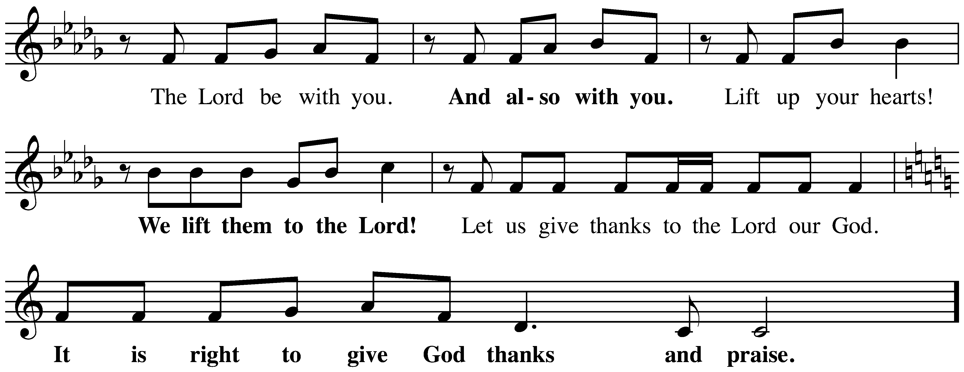
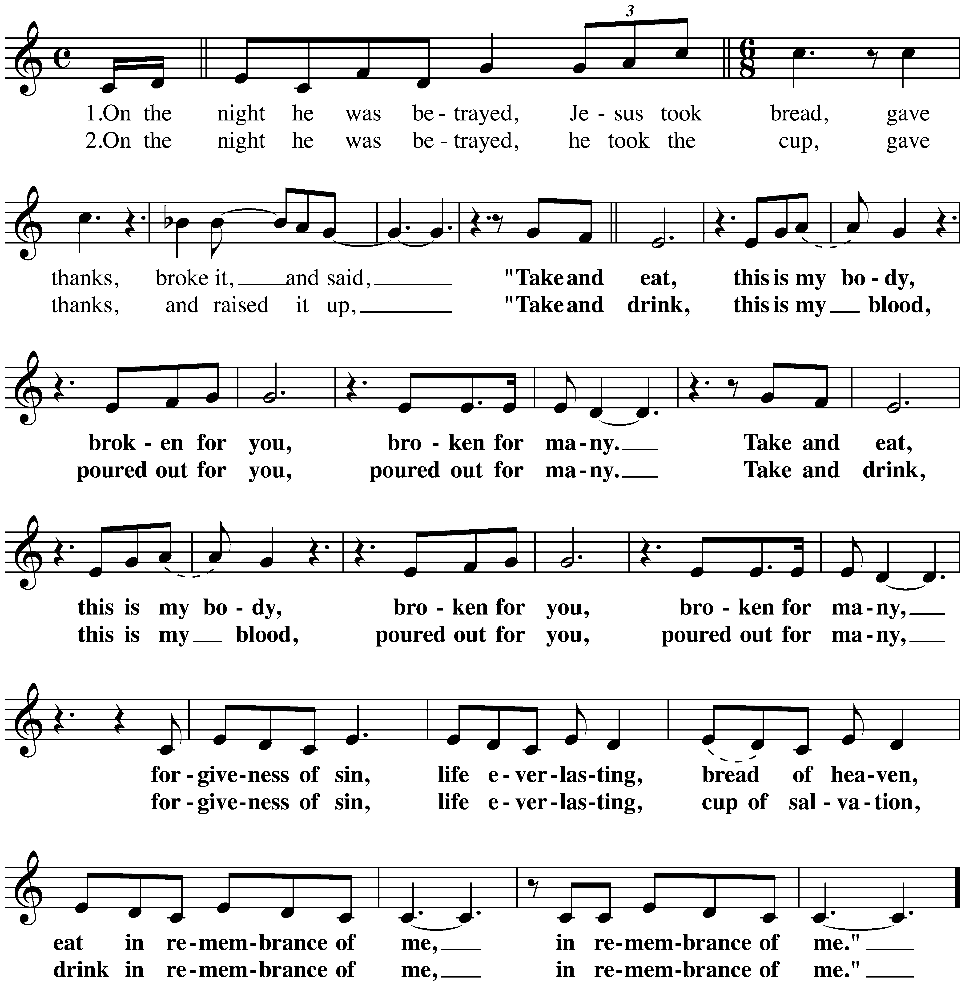
The Great Thanksgiving
The Lord’s Prayer
Our Father, who art in heaven,
hallowed be thy name, thy kingdom come,
thy will be done, on earth as it is in heaven.
Give us this day our daily bread;
and forgive us our trespasses, as we forgive those who trespass against us;
and lead us not into temptation but deliver us from evil.
For thine is the kingdom,
and the power, and the glory, forever and ever.
Amen.

Invitation to Communion
In bread and cup the reign of Christ is breaking in.
Come, receive what Christ has prepared.

Please be seated.
Communion Hymns
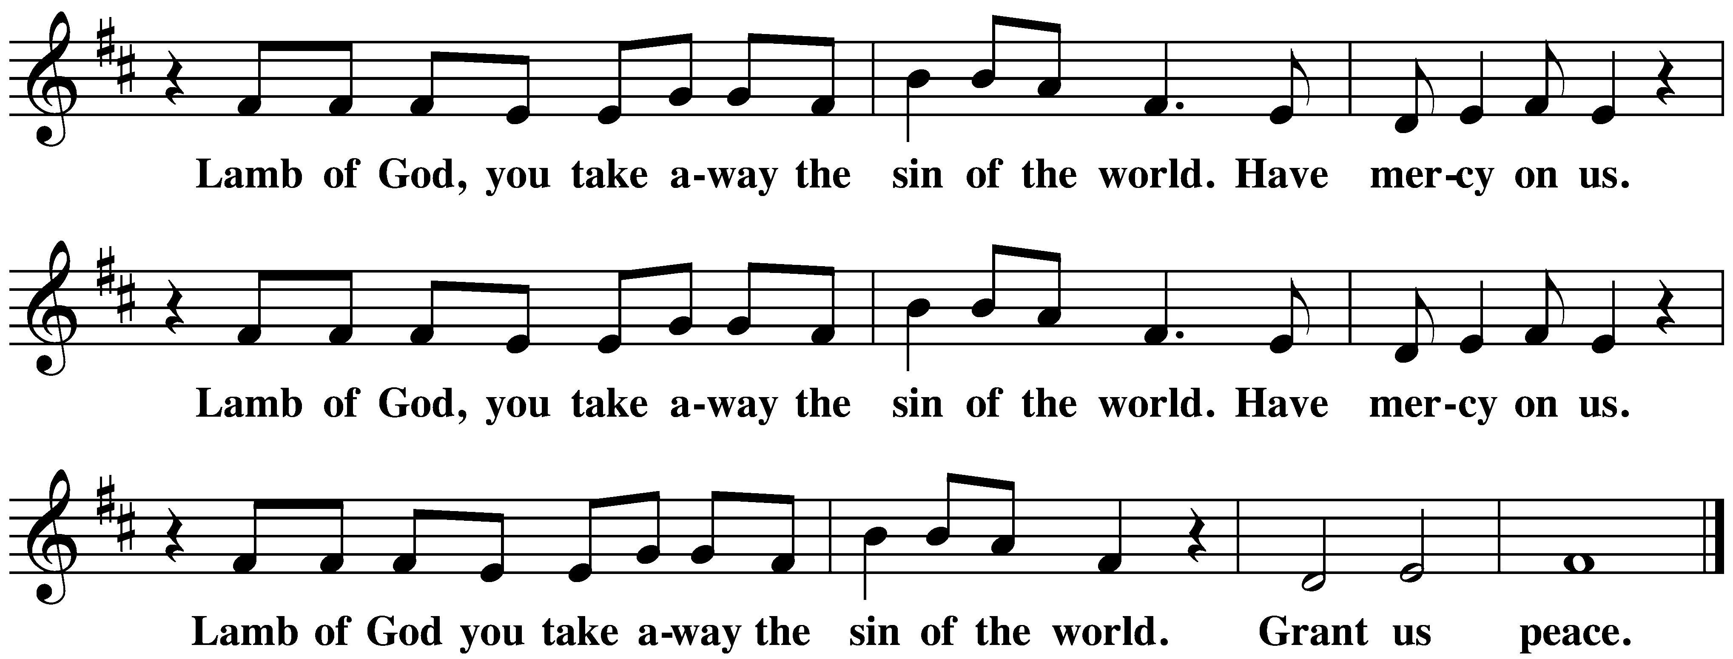
Jerusalem, My Happy Home ELW 628

Sing with All the Saints in Glory ELW 426
Prayer after Communion
Holy God,
we have received your never-ending mercy in this meal.
You continuously seek the lost,
bind the injured,
and feed your people abundantly.
Now send us out,
awake to your presence,
now and forever.
Amen.
God blesses us and sends us in mission to the world.
SENDING

Blessing
The holy Trinity,
Father, ☩ Son, and Holy Spirit,
bless you with wisdom to welcome the reign of God,
today and always.
Amen.

Sending Song Oh, When the Saints Go Marching In ACS 950

Dismissal
Go in peace. Encourage one another.
Thanks be to God.

From sundaysandseasons.com.
Copyright © 2026 Augsburg Fortress. All rights reserved.
CCLI License 1553828

