
Worship Plan for Sunday, December 14, 2025
Third Sunday of Advent

The Holy Spirit calls us together as the people of God.
GATHERING
Prelude
Welcome & Announcements

We Are Waiting for Jesus ACS#905
Confession and Forgiveness
Blessed be the holy Trinity, ☩ one God,
alive in the world,
reviving creation,
arriving soon.
Amen.

Let us confess our sin in the presence of God
and of one another

Silence is kept for reflection.

God of mercy,
we confess that we have sinned.
We trust earthly powers and human authority alone.
We grow fearful. We cling to false comforts.

God of might,
we confess that we have sinned.
We have turned away from our neighbors.
We have trusted false promises.

God in our midst,
we confess that we have sinned.
We plead; come to us.
Bring your mercy to birth in us.

A righteous branch springs forth:
it is Christ the Lord, our Savior,
in whom we have forgiveness, life, and mercy.
By the power of the Holy Spirit,
receive the grace and forgiveness of God
through ☩ Christ Jesus,
whose day draws near.
Amen.

Gathering Song Awake! Awake, and Greet the New Morn ELW#242

Greeting
The grace of our Lord Jesus Christ, the love of God,
and the communion of the Holy Spirit be with you all.
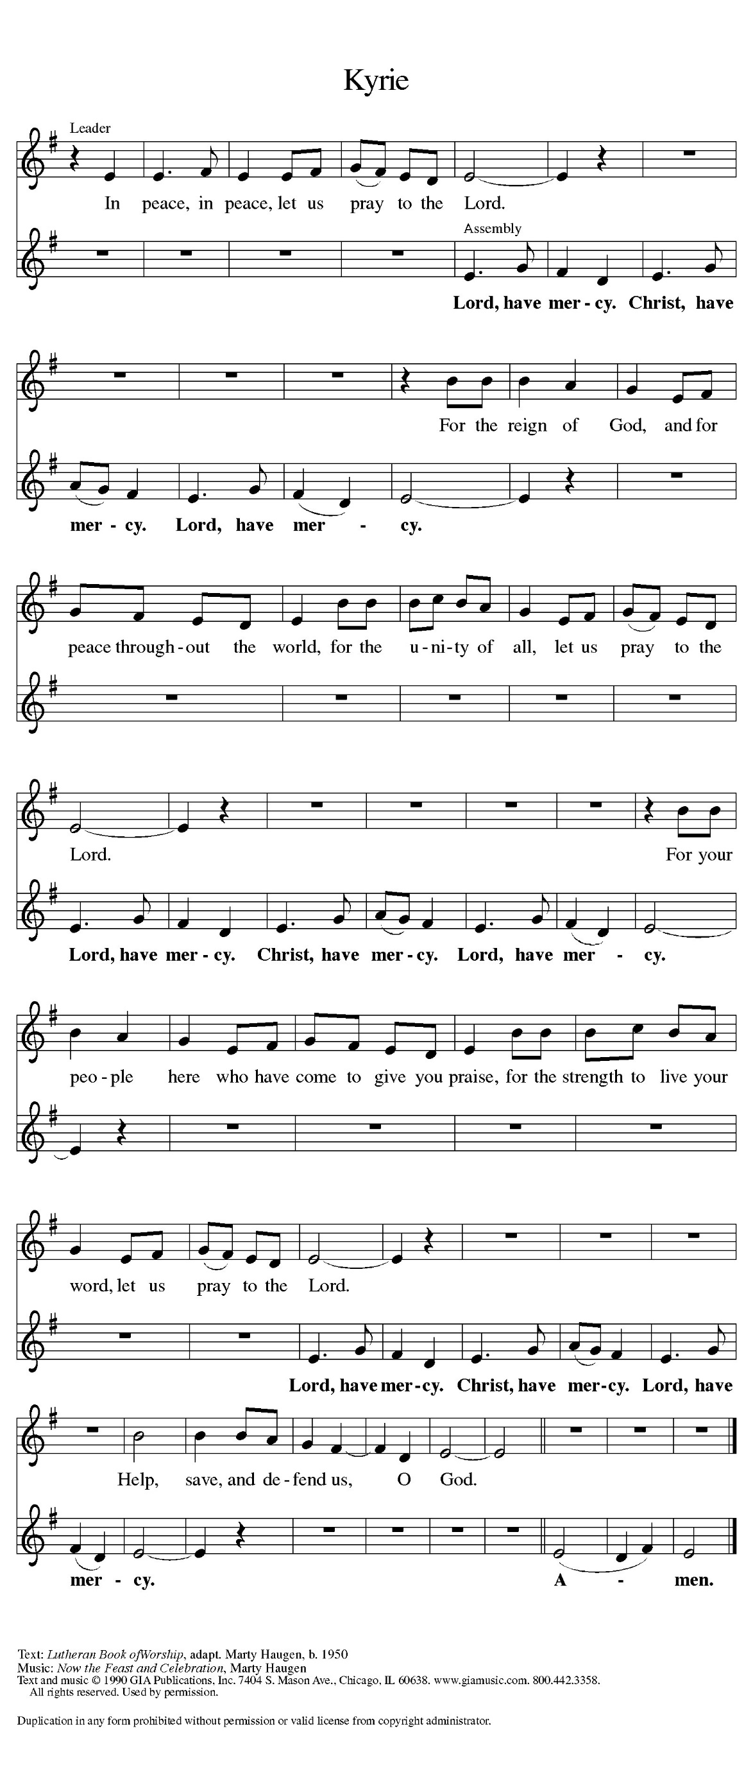
And also with you.

Prayer of the Day
Let us pray.
Stir up the wills of all who look to you, Lord God, and strengthen our faith in your coming, that, transformed by grace, we may walk in your way; through Jesus Christ, our Savior and Lord, who lives and reigns with you and the Holy Spirit, one God, now and forever.
Amen.
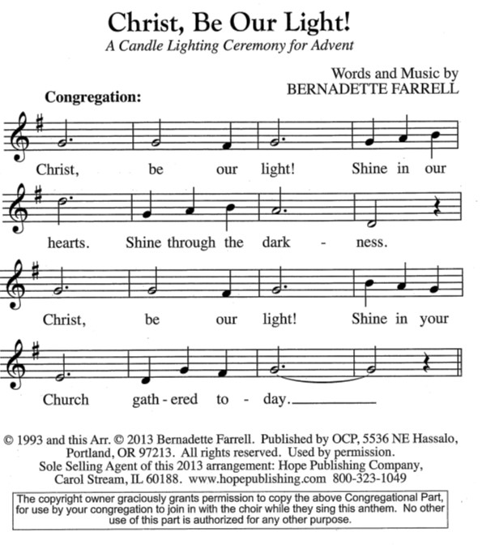
Advent Wreath Lighting

THIRD SUNDAY – Hope for Those Who Are Watching
Responsive Litany
Advent is a time to awaken our spiritual senses.
We stand in awe of your deeds, O Lord, repeat them in our day!
Grant us vision to behold your glory.
We stand in awe of your deeds, O Lord, repeat them in our day!
Quiet us so we may hear your still, soft voice.
We stand in awe of your deeds, O Lord, repeat them in our day!
Make us vessels of your mercy, compassion, and grace.
We stand in awe of your deeds, O Lord, repeat them in our day!
For all of us eagerly watching for your glory in our midst:
Grant that we might have the peace of Christ as we wait, the love of Christ as we act, and the grace of Christ as we speak.

Candle Lighting
Today we light three candles. The first candle reminds us of those who find themselves in a season of waiting, resting in hopeful anticipation for God to act. The second candle is for anyone feeling weakened and wearied by the circumstances of life. We echo the cry of scripture to renew their strength and increase their power. The third candle awakens our spiritual senses, challenging us to embrace the glory of God, as we await our Savior’s promised coming.

WORD
God speaks to us in scripture reading, preaching, and song.

First Reading: Isaiah 35:1-10
A reading from Isaiah.
¹ The wilderness and the dry land shall be glad;
the desert shall rejoice and blossom;
like the crocus ² it shall blossom abundantly
and rejoice with joy and shouting.
The glory of Lebanon shall be given to it,
the majesty of Carmel and Sharon.
They shall see the glory of the Lord,
the majesty of our God.]]
³ Strengthen the weak hands
and make firm the feeble knees.
⁴ Say to those who are of a fearful heart,
“Be strong, do not fear!
Here is your God.
He will come with vengeance,
with terrible recompense.
He will come and save you.”
⁵ Then the eyes of the blind shall be opened,
and the ears of the deaf shall be opened;
⁶ then the lame shall leap like a deer,
and the tongue of the speechless sing for joy.
For waters shall break forth in the wilderness
and streams in the desert;
⁷ the burning sand shall become a pool
and the thirsty ground springs of water;
the haunt of jackals shall become a swamp;
the grass shall become reeds and rushes.
⁸ A highway shall be there,
and it shall be called the Holy Way;
the unclean shall not travel on it,
but it shall be for God’s people;
no traveler, not even fools, shall go astray.
⁹ No lion shall be there,
nor shall any ravenous beast come up on it;
they shall not be found there,
but the redeemed shall walk there.
¹⁰ And the ransomed of the Lord shall return
and come to Zion with singing;
everlasting joy shall be upon their heads;
they shall obtain joy and gladness,
and sorrow and sighing shall flee away.
The word of the Lord.
Thanks be to God.

Psalm: Psalm 146:5-10
⁵ Happy are they who have the God of Jacob | for their help,
whose hope is in the | Lord their God;
⁶ who made heaven and earth, the seas, and all that | is in them;
who keeps promis- | es forever;
⁷ who gives justice to those who are oppressed, and food to | those who hunger.
The Lord sets the | captive free.
⁸ The Lord opens the eyes of the blind; the Lord lifts up those who | are bowed down;
the Lord | loves the righteous.
⁹ The Lord cares | for the stranger;
the Lord sustains the orphan and widow, but frustrates the way | of the wicked.
¹⁰ The Lord shall | reign forever,
your God, O Zion, throughout all generations. | Hallelujah!
Second Reading: James 5:7-10
A reading from James.
⁷ Be patient, therefore, brothers and sisters, until the coming of the Lord. The farmer waits for the precious crop from the earth, being patient with it until it receives the early and the late rains. ⁸ You also must be patient. Strengthen your hearts, for the coming of the Lord is near. ⁹ Brothers and sisters, do not grumble against one another, so that you may not be judged. See, the Judge is standing at the doors! ¹⁰ As an example of suffering and patience, brothers and sisters, take the prophets who spoke in the name of the Lord.
The word of the Lord.
Thanks be to God.
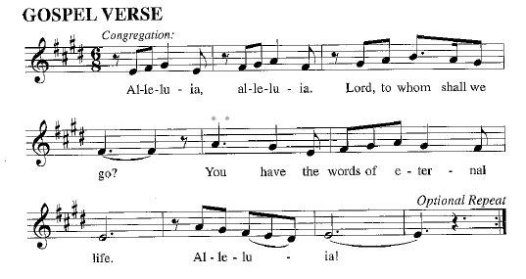
Gospel: Matthew 11:2-11
The holy gospel according to Matthew.
Glory to you, O Lord.
² When John heard in prison what the Messiah was doing, he sent word by his disciples ³ and said to him, “Are you the one who is to come, or are we to wait for another?” ⁴ Jesus answered them, “Go and tell John what you hear and see: ⁵ the blind receive their sight, the lame walk, those with a skin disease are cleansed, the deaf hear, the dead are raised, and the poor have good news brought to them. ⁶ And blessed is anyone who takes no offense at me.”
⁷ As they went away, Jesus began to speak to the crowds about John: “What did you go out into the wilderness to look at? A reed shaken by the wind? ⁸ What, then, did you go out to see? Someone dressed in soft robes? Look, those who wear soft robes are in royal palaces. ⁹ What, then, did you go out to see? A prophet? Yes, I tell you, and more than a prophet. ¹⁰ This is the one about whom it is written,
‘See, I am sending my messenger ahead of you,
who will prepare your way before you.’
¹¹ “Truly I tell you, among those born of women no one has arisen greater than John the Baptist, yet the least in the kingdom of heaven is greater than he.”
The gospel of the Lord.
Praise to you, O Christ.

Please be seated.
Children’s Message

Sermon
Hymn of the Day Prepare the Royal Highway ELW# 265

Apostles’ Creed
I believe in God, the Father almighty,
creator of heaven and earth.
I believe in Jesus Christ, God’s only Son, our Lord,
who was conceived by the Holy Spirit, born of the virgin Mary,
suffered under Pontius Pilate, was crucified, died, and was buried;
he descended to the dead. On the third day he rose again;
he ascended into heaven, he is seated at the right hand of the Father,
and he will come to judge the living and the dead.
I believe in the Holy Spirit, the holy catholic church,
the communion of saints, the forgiveness of sins,
the resurrection of the body,
and the life everlasting. Amen.

Prayers of Intercession
In our waiting and watching, we come to you in prayer, O God, trusting your promise to renew the church, the nations, and the whole creation.

God of power and mercy, we praise you for Jesus and his acts of healing and liberation. Lead us to proclaim the good news from generation to generation, that all may place their hope in you. God of grace,
hear our prayer.
When lands are parched and dry, bring rain and snow; where wilderness is barren, sow seeds of life. Fill the lands with trees that grow, plants that flower, and creatures that thrive, as nature proclaims the wonder of your works. God of grace,
hear our prayer.
When there is injustice or corruption among nations and leaders, root it out. Turn their attention to inequity and the cries of the poor. Instill a deeper sense of compassion and care in all who govern. God of grace,
hear our prayer.
When bodies weaken and hearts grow fearful, speak your blessing. (We pray especially for . . .) In uncertain times, remind us of the promise spoken to our ancestors in faith. God of grace,
hear our prayer.
When people are imprisoned or held captive, break the chains and offer release. Strengthen the work of the church in restorative justice, breaking cycles of poverty, and welcoming the immigrant (especially we pray for Global Refuge and Lutheran Social Services). God of grace,
hear our prayer.
As we await your coming, we give thanks for the faithful who have lived and died in faith (especially Mary, mother of Jesus, John of the Cross and . . .). May their boldness of faith inspire our witness and work. God of grace,
hear our prayer.
Draw near to us, O God, as we commend all for whom we pray, trusting in your mercy through Jesus Christ, Emmanuel.
Amen.

Peace
The peace of Christ be with you always.
And also with you.

Choir Anthem Joy of Longing Hearts

MEAL
God feeds us with the presence of Jesus Christ.

Please stand
Offertory Hymn As the Grains of Wheat ELW#465

Offering Prayer
Creator God,
You made the whole world,
even the farthest stars,
and you draw us near to feed us.
We praise you for these gifts of bread and wine.
Strengthen us with this food
that we may live in expectation
for the advent of your Son, Jesus Christ our Lord.
Amen.

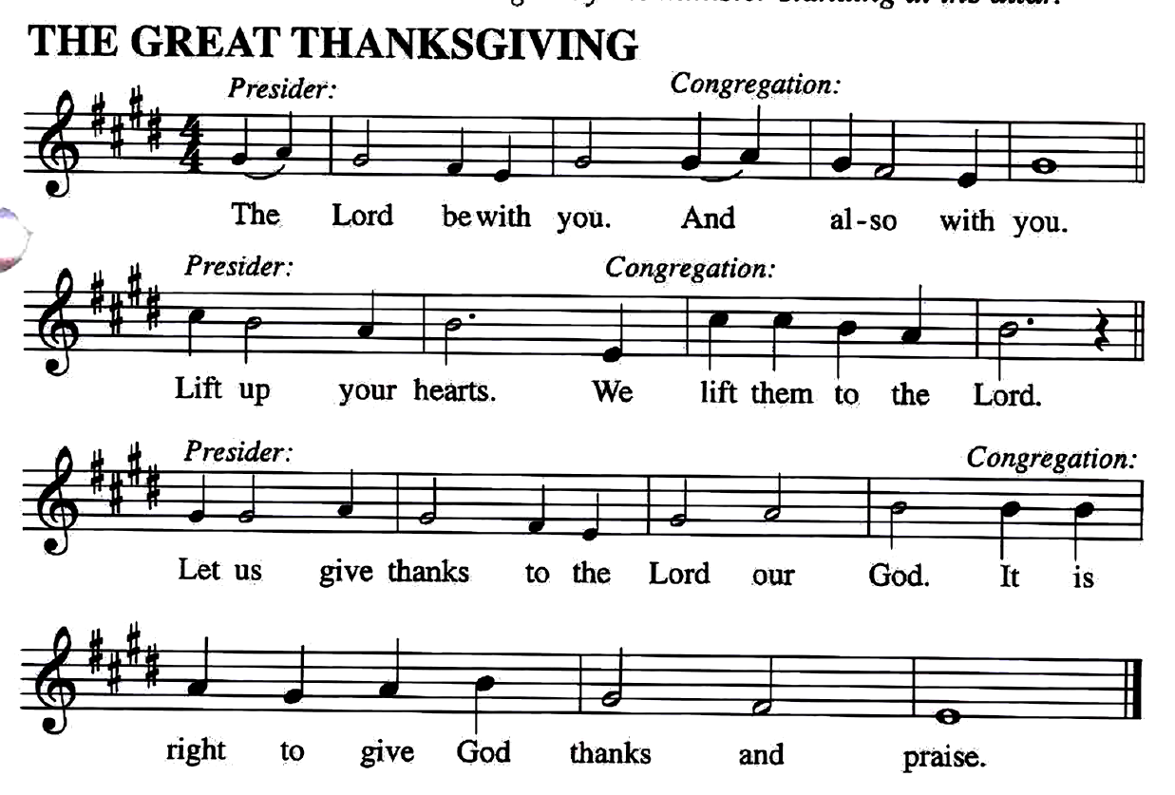
The Great Thanksgiving

Preface
It is our duty and delight... and so with the church on earth and the host of heaven we praise your name and join their unending hymn…

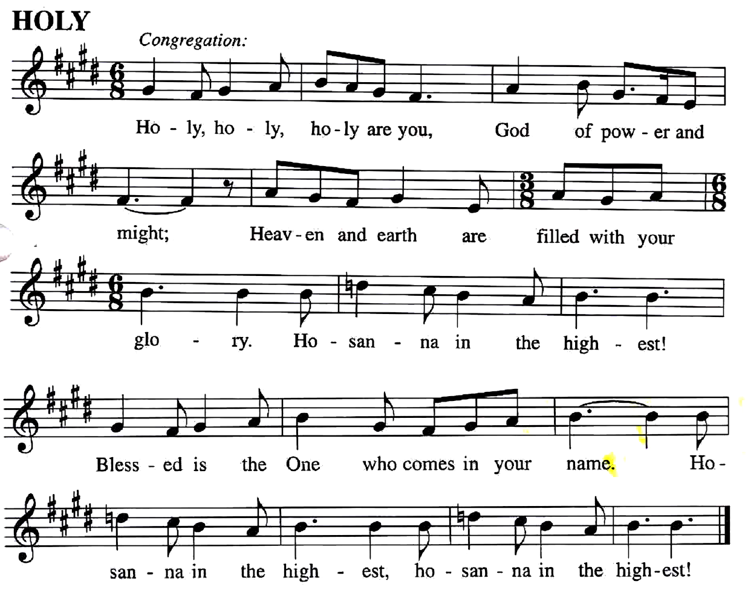

You are indeed holy… we pray for his coming again, as we cry:
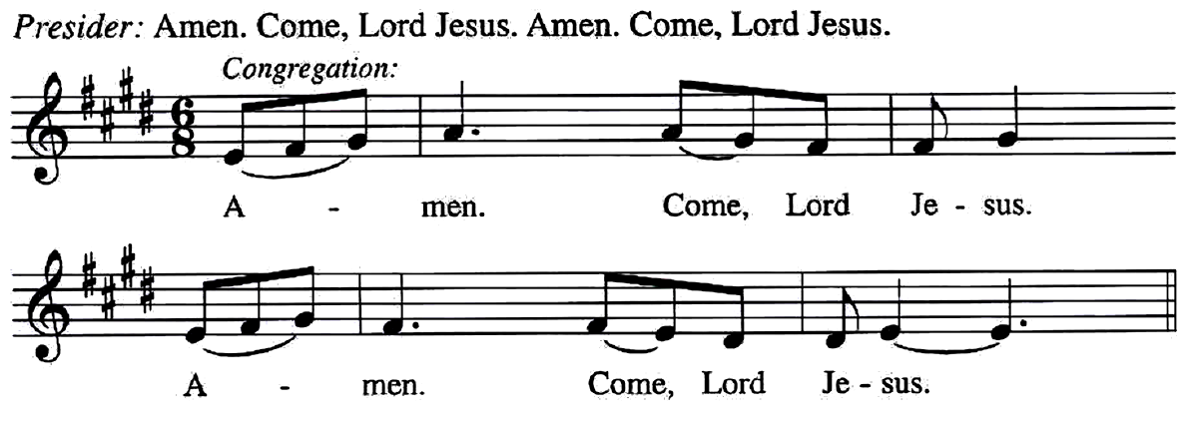

Send now, we pray, your Holy Spirit,
That all of your promises may come to us and your whole creation.
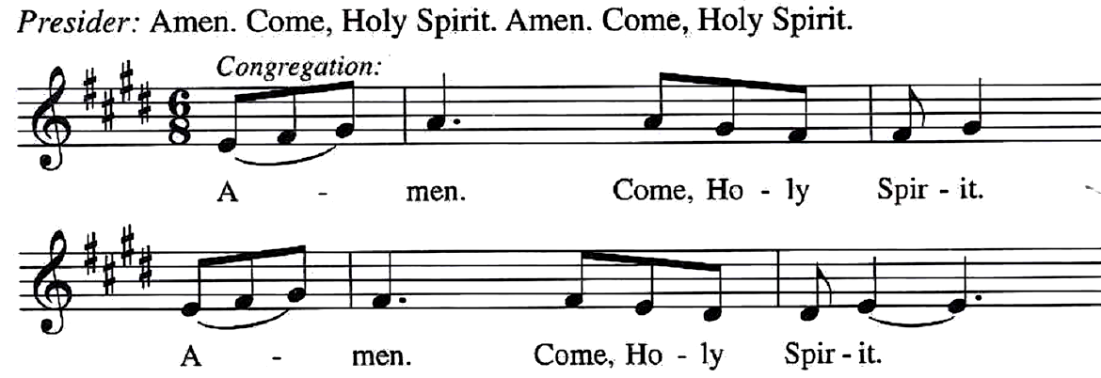

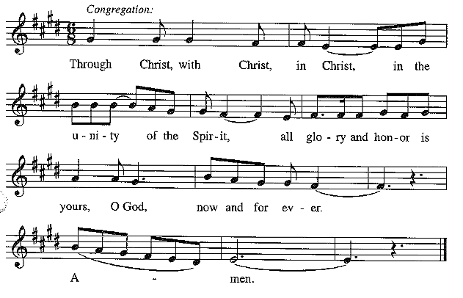
This we pray through Jesus Christ, our Savior and our friend.

Lord's Prayer
Our Father, who art in heaven,
hallowed be thy name,
thy kingdom come, thy will be done,
on earth as it is in heaven.
Give us this day our daily bread;
and forgive us our trespasses,
as we forgive those who trespass against us;
and lead us not into temptation but deliver us from evil.
For thine is the kingdom, and the power,
and the glory, forever and ever. Amen.

Invitation to Communion
God feed us with tender mercy.
Come to the table.

Lamb of God
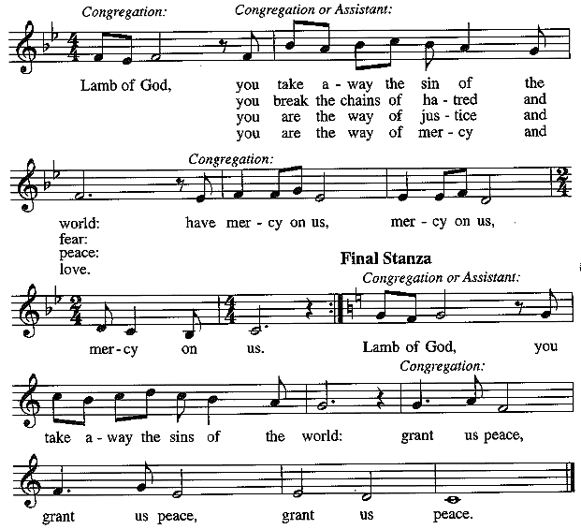

Communion Hymns Now the Heavens Start to Whisper ACS#901

He Comes to Us as One Unknown ELW#737
Prayer after Communion
Generous God,
We thank you for the gift of life,
for the bread of salvation.
We thank you for coming among us,
for leading us into peace
We thank you for showering us with mercy,
for sending us into the world.
Come, Lord Jesus, and go with us
as we feed the hungry in your name.
Amen.
God blesses us and sends us in mission to the world.
SENDING

Blessing
God of endings and beginnings,
God in the darkness and the light,
God, our hope for the journey,
☩ bless and keep you now and forever.
Amen.
Sending Song People, Look East ELW#248
Dismissal
Go in peace. Prepare the way for Emmanuel. Thanks be to God.

