
Worship Plan for Sunday, August 30, 2026
14th Sunday After Pentecost

The Holy Spirit calls us together as the people of God.
GATHERING

Prelude
Welcome/Announcements
Reflection - Preparing for Worship
Sing 3X

Please stand.
Confession and Forgiveness
All may make the sign of the cross, the sign that is marked at baptism, as the presiding minister begins.

Blessed be the holy Trinity,☩ one God,
whose compassion endures forever.
Amen.

Let us confess our sin to God.
Silence is kept for reflection.

Compassionate God,
we confess to you all our sins.
Our burden is heavy, and we cannot free ourselves.
In your mercy, call us back to you.
Your yoke is easy and your burden is light.
Restore us to dwell in your peace.
In Christ’s name we pray,
Amen.

Jesus says, “Come to me,
all you who are weary
and are carrying heavy burdens,
and I will give you rest.”
In the name of God,
Father, ☩ Son, and Holy Spirit,
your sins are forgiven.
Rest in God’s love.
Amen.

Gathering Song For the Beauty of the Earth ELW 879

Greeting
The grace of our Lord Jesus Christ, the love of God
and the communion of the Holy Spirit be with you all.
And also, with you.

Hymn of Praise
Prayer of the Day
Let us pray.
O God, we thank you for your Son, who chose the path of suffering for the sake of the world. Humble us by his example, point us to the path of obedience, and give us strength to follow your commands, through Jesus Christ, our Savior and Lord.
Amen.

Please be seated.
God speaks to us in scripture reading, preaching, and song.
WORD

First Reading: Jeremiah 15:15-21
A reading from Jeremiah.
¹⁵ O Lord, you know;
remember me and visit me,
and bring down retribution for me on my persecutors.
In your forbearance do not take me away;
know that on your account I suffer insult.
¹⁶ Your words were found, and I ate them,
and your words became to me a joy
and the delight of my heart,
for I am called by your name,
O Lord, God of hosts.
¹⁷ I did not sit in the company of merrymakers,
nor did I rejoice;
under the weight of your hand I sat alone,
for you had filled me with indignation.
¹⁸ Why is my pain unceasing,
my wound incurable,
refusing to be healed?
Truly, you are to me like a deceitful brook,
like waters that fail.
¹⁹ Therefore thus says the Lord:
If you turn back, I will take you back,
and you shall stand before me.
If you utter what is precious and not what is worthless,
you shall serve as my mouth.
It is they who will turn to you,
not you who will turn to them.
²⁰ And I will make you to this people
a fortified wall of bronze;
they will fight against you,
but they shall not prevail over you,
for I am with you
to save you and deliver you,
says the Lord.
²¹ I will deliver you out of the hand of the wicked
and redeem you from the grasp of the ruthless.
The word of the Lord.
Thanks be to God.

Psalm: Psalm 26:1-8
¹ Give judgment for me, O Lord, for I have lived | with integrity;
I have trusted in the Lord and | have not faltered.
² Test me, O | Lord, and try me;
examine my heart | and my mind.
³ For your steadfast love is be- | fore my eyes;
I have walked faithful- | ly with you.
⁴ I have not sat | with the worthless,
nor do I consort with | the deceitful. R
⁵ I have hated the company of | evildoers;
I will not sit down | with the wicked.
⁶ I will wash my hands in inno- | cence, O Lord,
that I may go in procession | round your altar,
⁷ singing aloud a song | of thanksgiving
and recounting all your won- | derful deeds.
⁸ Lord, I love the house in | which you dwell
and the place where your glo- | ry abides. R

Second Reading: Romans 12:9-21
A reading from Romans.
⁹ Let love be genuine; hate what is evil; hold fast to what is good; ¹⁰ love one another with mutual affection; outdo one another in showing honor. ¹¹ Do not lag in zeal; be ardent in spirit; serve the Lord. ¹² Rejoice in hope; be patient in affliction; persevere in prayer. ¹³ Contribute to the needs of the saints; pursue hospitality to strangers.
¹⁴ Bless those who persecute you; bless and do not curse them. ¹⁵ Rejoice with those who rejoice; weep with those who weep. ¹⁶ Live in harmony with one another; do not be arrogant, but associate with the lowly; do not claim to be wiser than you are. ¹⁷ Do not repay anyone evil for evil, but take thought for what is noble in the sight of all. ¹⁸ If it is possible, so far as it depends on you, live peaceably with all. ¹⁹ Beloved, never avenge yourselves, but leave room for the wrath of God, for it is written, “Vengeance is mine; I will repay, says the Lord.” ²⁰ Instead, “if your enemies are hungry, feed them; if they are thirsty, give them something to drink, for by doing this you will heap burning coals on their heads.” ²¹ Do not be overcome by evil, but overcome evil with good.
The word of the Lord.
Thanks be to God.
Please stand.
Gospel Acclamation
Gospel: Matthew 16:21-28
The holy gospel according to Matthew.
Glory to you, O Lord.
²¹ From that time on, [after Peter confessed that Jesus was the Messiah,] Jesus began to show his disciples that he must go to Jerusalem and undergo great suffering at the hands of the elders and chief priests and scribes and be killed and on the third day be raised. ²² And Peter took him aside and began to rebuke him, saying, “God forbid it, Lord! This must never happen to you.” ²³ But he turned and said to Peter, “Get behind me, Satan! You are a hindrance to me, for you are setting your mind not on divine things but on human things.”
²⁴ Then Jesus told his disciples, “If any wish to come after me, let them deny themselves and take up their cross and follow me. ²⁵ For those who want to save their life will lose it, and those who lose their life for my sake will find it. ²⁶ For what will it profit them if they gain the whole world but forfeit their life? Or what will they give in return for their life?
²⁷ “For the Son of Man is to come with his angels in the glory of his Father, and then he will repay everyone for what has been done. ²⁸ Truly I tell you, there are some standing here who will not taste death before they see the Son of Man coming in his kingdom.”
The gospel of the Lord.
Praise to you, O Christ.

Please be seated.
Children’s Message

Sermon

Please stand
Hymn of the Day Spirit, Open My Heart ACS 1043

Apostles’ Creed
Let us confess our faith to the words of the Apostles’ Creed
I believe in God, the Father almighty,
creator of heaven and earth.
I believe in Jesus Christ, God's only Son, our Lord,
who was conceived by the Holy Spirit,
born of the Virgin Mary,
suffered under Pontius Pilate,
was crucified, died, and was buried;
he descended to the dead.
On the third day he rose again;
he ascended into heaven,
he is seated at the right hand of the Father,
and he will come to judge the living and the dead.
I believe in the Holy Spirit,
the holy catholic Church,
the communion of saints,
the forgiveness of sins,
the resurrection of the body,
and the life everlasting. Amen

Please sit or kneel.
Prayers of Intercession
With bold trust in God’s unfailing provision, we pray for the church, those in need, and all of God’s creation.
For the church in every land, that its mission and ministry is anchored in the love of Christ. When threats or challenges arise, teach us to take up our cross and follow you in faith. Merciful God,
receive our prayer.
For the well-being of your creation, that all that lives and grows on the earth may thrive. Bring relief to areas ravaged by droughts, floods, fires, storms, and other disasters (especially). Merciful God,
receive our prayer.
For the nations and all in authority, that they seek to live in peace with one another. Bless the work of international and diplomatic organizations and all who work to bring peace to a world scarred by violence. Merciful God,
receive our prayer.
For all those in need, that they be satisfied. Ensure all your children have safe access to food, water, shelter, and medical care. Bring healing to all who bear wounds in body, mind, and spirit (especially). Merciful God,
receive our prayer.
For the congregation gathered here to serve you, that they remain strong in faith and united in purpose. Guide our committees, study groups, and other meetings toward honesty and humility, always seeking genuine love. Merciful God,
receive our prayer.
For the faithful departed, that their witness continues to strengthen and guide the church. Renew our hope in your promises in this life and the life to come. Merciful God,
receive our prayer.
Receive our prayers and answer, O God, as you have promised. All this we ask in the name of your Son, Jesus Christ our Lord. Amen.
Peace
The peace of Christ be with you always. And also, with you.

MEAL
God feeds us with the presence of Jesus Christ.

Please be seated.
Offering

Special Music Becky Spaulding

Please stand.
Offertory Hymn Here on Jesus Christ I will Stand ACS 1024

Offertory Prayer
Lord of the harvest,
we return to you a portion of what you have given to us.
Turn us to set our hope not on the uncertainty of riches,
but on you, who richly provides for us.
Multiply what we have gathered
to bless all who are suffering and in need,
through Jesus Christ our Lord.
Amen.

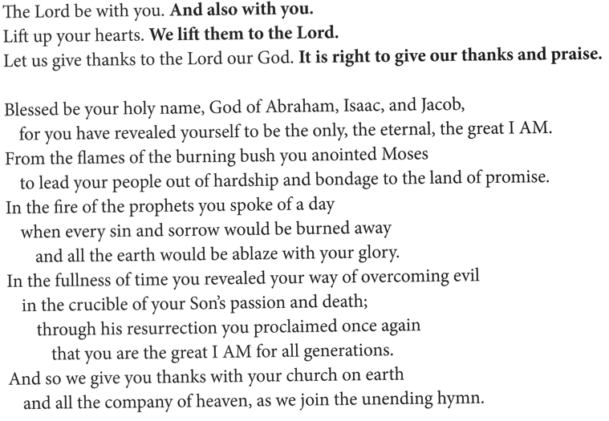
The Great Thanksgiving
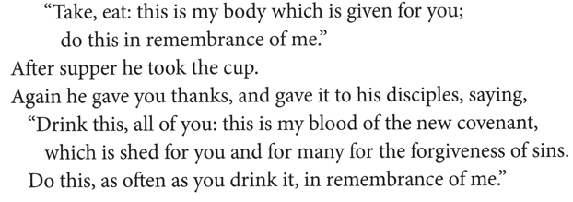
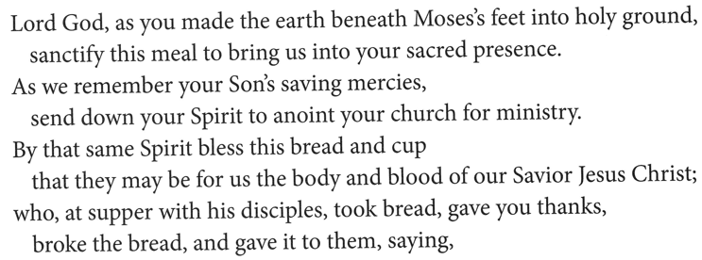
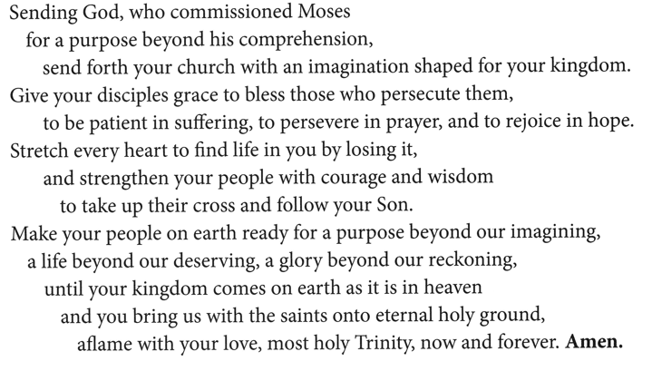

The Lord’s Prayer
Our Father, who art in heaven,
hallowed be thy name, thy kingdom come,
thy will be done, on earth as it is in heaven.
Give us this day our daily bread;
and forgive us our trespasses, as we forgive those who trespass against us;
and lead us not into temptation but deliver us from evil.
For thine is the kingdom,
and the power, and the glory, forever and ever.
Amen.

Invitation to Communion
Heaven has come near.
Come, share in the feast!

Please be seated.
Communion Hymns

Will You Come and Follow Me ELW 798
The Summons

Lord Jesus, You Shall Be My Song ELW 808
Prayer after Communion
Compassionate God,
through the gifts of bread and wine
our hearts are filled with the abundance of your love.
Strengthen us that we, through this holy meal,
may share your love freely, as you have shared with us.
We ask this in the name of Jesus,
through the Spirit nourishing us now and forever.
Amen.

God blesses us and sends us in mission to the world.
SENDING

Blessing
Creator, Redeemer, Sustainer,
☩ one God,
bless, heal, and hold you
today and always.
Amen.

Sending Song Lift High the Cross ELW 660

Dismissal
Heaven has come near. Go, share the good news!
Thanks be to God.

From sundaysandseasons.com.
Copyright © 2026 Augsburg Fortress. All rights reserved.

