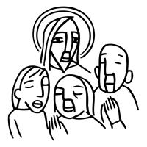
Worship Plan for Sunday, September 6, 2026
15th Sunday After Pentecost

The Holy Spirit calls us together as the people of God.
GATHERING

Prelude
Welcome/Announcements
Reflection - Preparing for Worship
Sing 3X

Please stand.
Confession and Forgiveness
All may make the sign of the cross, the sign that is marked at baptism, as the presiding minister begins.
Blessed be the holy Trinity, ☩ one God,
who pours love into our hearts
and healing upon the earth.
Amen.
Confident that God justifies us by grace through faith,
let us confess our sin.
Silence is kept for reflection.
Compassionate God,
we confess that we struggle to embody your goodness
in the world and in our own hearts.
Creation groans from overuse.
Jealousy and bitterness strain our relationships.
Indifference keeps us from seeking justice.
Divisions disrupt your call to show genuine love
to others.
Turn our hearts back to you.
Restore our world and reconcile us to one another.
Renew us to live as your holy people,
following the way of Jesus Christ.
Amen.
Hear this good news:
We have peace with God through ☩ Jesus Christ,
in whom there is no condemnation,
but only forgiveness and the promise of eternal life.
Receive freely this healing gift of grace.
Amen.

Gathering Song Awake, My Soul, and with the Sun ELW 466

Greeting
The grace of our Lord Jesus Christ, the love of God
and the communion of the Holy Spirit be with you all.
And also, with you.

Prayer of the Day
O Lord God, enliven and preserve your church with your perpetual mercy. Without your help, we mortals will fail; remove far from us everything that is harmful, and lead us toward all that gives life and salvation, through Jesus Christ, our Savior and Lord.
Amen.

Please be seated.
God speaks to us in scripture reading, preaching, and song.
WORD

First Reading: Ezekiel 33:7-11
A reading from Ezekiel.
⁷ So you, mortal, I have made a sentinel for the house of Israel; whenever you hear a word from my mouth, you shall give them warning from me. ⁸ If I say to the wicked, “O wicked ones, you shall surely die,” and you do not speak to warn the wicked to turn from their ways, the wicked shall die in their iniquity, but their blood I will require at your hand. ⁹ But if you warn the wicked to turn from their ways and they do not turn from their ways, the wicked shall die in their iniquity, but you will have saved your life.
¹⁰ Now you, mortal, say to the house of Israel: Thus you have said: “Our transgressions and our sins weigh upon us, and we waste away because of them; how then can we live?” ¹¹ Say to them: As I live, says the Lord God, I have no pleasure in the death of the wicked but that the wicked turn from their ways and live; turn back, turn back from your evil ways, for why will you die, O house of Israel?
The word of the Lord.
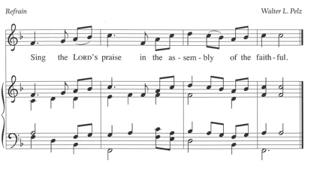
Thanks be to God.

Psalm: Psalm 119:33-40
³³ Teach me, O Lord, the way | of your statutes,
and I shall keep it | to the end.
³⁴ Give me understanding, and I shall | keep your teaching;
I shall keep it with | all my heart.
³⁵ Lead me in the path of | your commandments,
for that is | my desire.
³⁶ Incline my heart to | your decrees
and not to | unjust gain. R
³⁷ Turn my eyes from be- | holding falsehood;
give me life | in your way.
³⁸ Fulfill your promise | to your servant,
which is for | those who fear you.
³⁹ Turn away the reproach | that I dread,
because your judg- | ments are good.
⁴⁰ Behold, I long for | your commandments;
by your righteousness en- | liven me. R

Second Reading: Romans 13:8-14
A reading from Romans.
⁸ Owe no one anything, except to love one another, for the one who loves another has fulfilled the law. ⁹ The commandments, “You shall not commit adultery; you shall not murder; you shall not steal; you shall not covet,” and any other commandment, are summed up in this word, “You shall love your neighbor as yourself.” ¹⁰ Love does no wrong to a neighbor; therefore, love is the fulfilling of the law.
¹¹ Besides this, you know what time it is, how it is already the moment for you to wake from sleep. For salvation is nearer to us now than when we became believers; ¹² the night is far gone; the day is near. Let us then throw off the works of darkness and put on the armor of light; ¹³ let us walk decently as in the day, not in reveling and drunkenness, not in illicit sex and licentiousness, not in quarreling and jealousy. ¹⁴ Instead, put on the Lord Jesus Christ, and make no provision for the flesh, to gratify its desires.
The word of the Lord.
Thanks be to God.

Please stand.
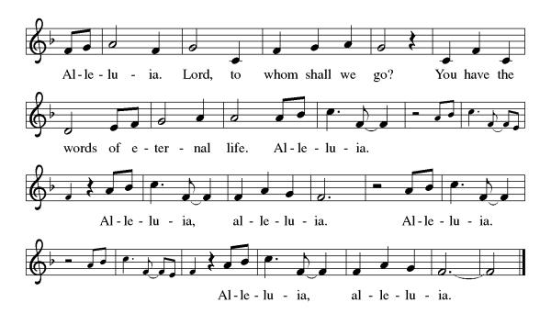
Gospel Acclamation

Gospel: Matthew 18:15-20
The holy gospel according to Matthew.
Glory to you, O Lord.
[Jesus said to the disciples:] ¹⁵ “If your brother or sister sins against you, go and point out the fault when the two of you are alone. If you are listened to, you have regained that one. ¹⁶ But if you are not listened to, take one or two others along with you, so that every word may be confirmed by the evidence of two or three witnesses. ¹⁷ If that person refuses to listen to them, tell it to the church, and if the offender refuses to listen even to the church, let such a one be to you as a gentile and a tax collector. ¹⁸ Truly I tell you, whatever you bind on earth will be bound in heaven, and whatever you loose on earth will be loosed in heaven. ¹⁹ Again, truly I tell you, if two of you agree on earth about anything you ask, it will be done for you by my Father in heaven. ²⁰ For where two or three are gathered in my name, I am there among them.”
The gospel of the Lord.
Praise to you, O Christ.

Please be seated.
Children’s Message

Sermon

Please stand
Hymn of the Day Awake, My Soul, and with the Sun ELW 557

Apostles’ Creed
Let us confess our faith to the words of the Apostles’ Creed
I believe in God, the Father almighty,
creator of heaven and earth.
I believe in Jesus Christ, God's only Son, our Lord,
who was conceived by the Holy Spirit,
born of the Virgin Mary,
suffered under Pontius Pilate,
was crucified, died, and was buried;
he descended to the dead.
On the third day he rose again;
he ascended into heaven,
he is seated at the right hand of the Father,
and he will come to judge the living and the dead.
I believe in the Holy Spirit,
the holy catholic Church,
the communion of saints,
the forgiveness of sins,
the resurrection of the body,
and the life everlasting. Amen

Please sit or kneel.
Prayers of Intercession
Reminded of God’s gracious and abundant love, we offer our prayers, confident that God hears us.
Proclaiming God, empower your church throughout the world to announce the words you give us. Open us to receive your word in unexpected ways. Hear us, O God.
Your mercy is great.
Forming God, renew the cycles of your creation that provide for the needs of all. Protect grasslands, marshes, swamps, and all places of transition. Heal communities crying out after disaster (especially). Hear us, O God.
Your mercy is great.
Governing God, turn all who create, enforce, or interpret legislation away from selfish gain and toward your promise of good for all, especially the good of all who labor. Hear us, O God.
Your mercy is great.
Attending God, wake us up to any around us who are in need. Restore broken relationships, failing health, frayed emotions, and the hurts we carry with us. (We pray especially for . . .) Hear us, O God.
Your mercy is great.
Gathering God, resolve conflicts in this community through your righteousness and grace. Reconcile us to each other, making your good news known even through our imperfections. Hear us, O God.
Your mercy is great.
Loving God, all who die in faith have life with you. We give you thanks for the nearness of your salvation for (name/s, and) all who have gone before us. Hear us, O God.
Your mercy is great.
Grant the prayers we have offered, what we have forgotten to ask, and whatever else you see that we need. We ask this in Jesus’ name.
Amen.

Peace
The peace of Christ be with you always. And also, with you.

MEAL
God feeds us with the presence of Jesus Christ.

Please be seated.
Offering

Choir Music ~ Come Jesus Come

Please stand.
Offertory Hymn Here on Jesus Christ I will Stand ACS 1024

Offertory Prayer
God of creation,
you send rain and the earth springs forth abundantly.
All blessings are from you;
make us generous with what we have.
Use our gifts, our abilities, and our hearts
in service to you and in love to our neighbors,
today and always.
Amen.

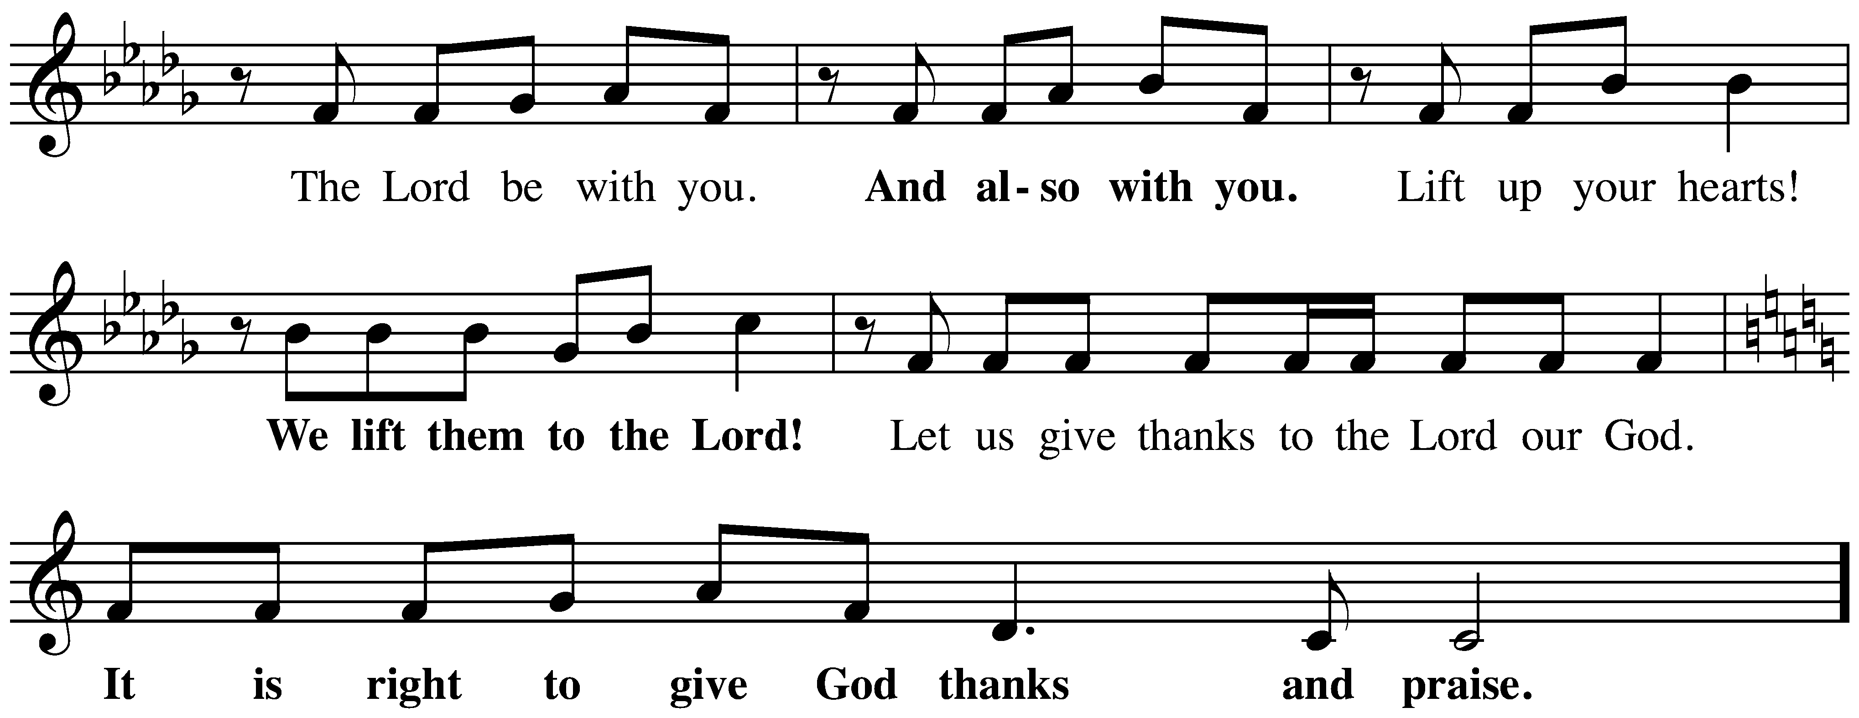
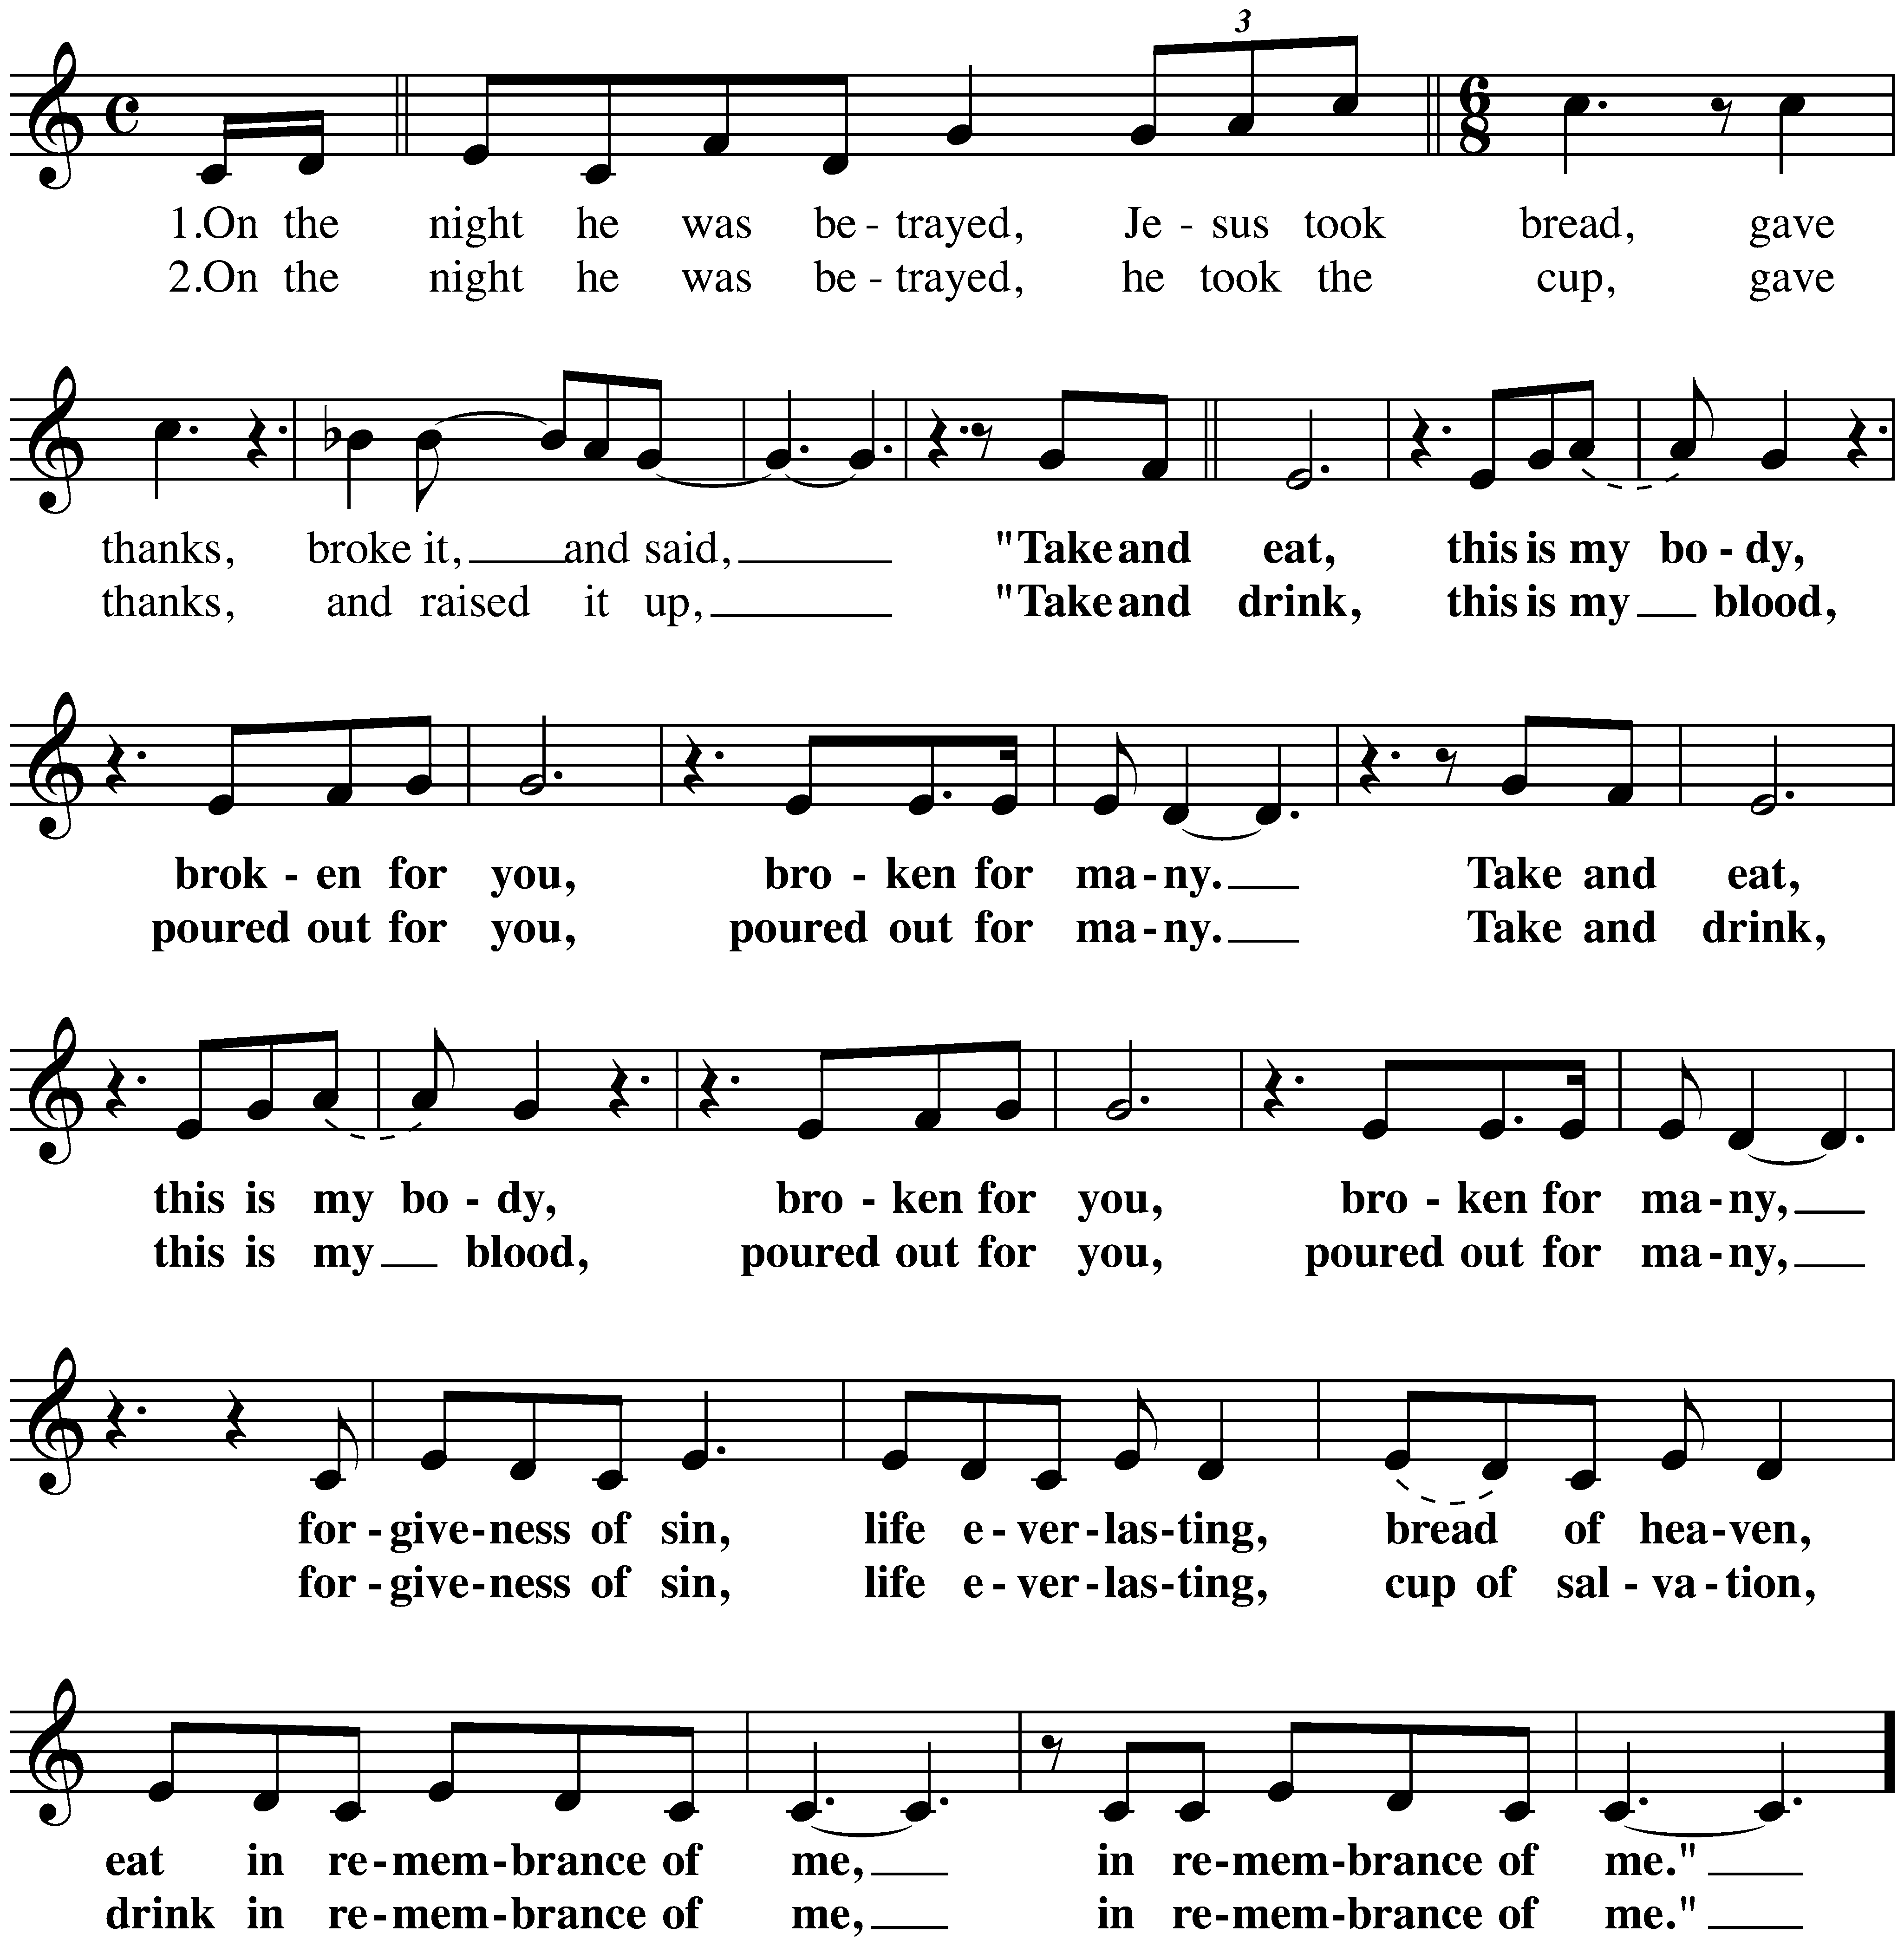
The Great Thanksgiving

The Lord’s Prayer
Our Father, who art in heaven,
hallowed be thy name, thy kingdom come,
thy will be done, on earth as it is in heaven.
Give us this day our daily bread;
and forgive us our trespasses, as we forgive those who trespass against us;
and lead us not into temptation but deliver us from evil.
For thine is the kingdom,
and the power, and the glory, forever and ever.
Amen.

Invitation to Communion
Christ invites you to this table.
All who are thirsty, all who are hungry, come!

Please be seated.
Communion Hymns
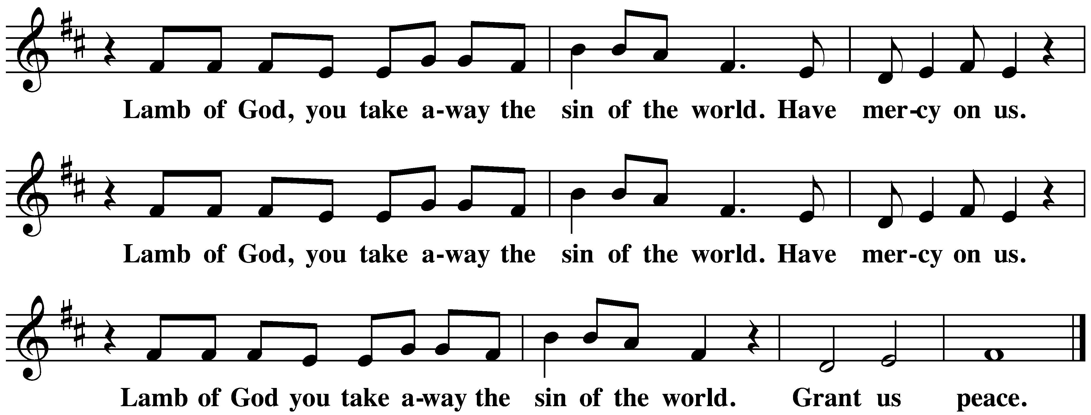
Draw Us in the Spirit’s Tether ELW 470

When We Are Living ELW 639

Prayer after Communion
Sustaining God,
with this bread and cup,
you nourish us with mercy and abundant life.
By your Spirit, send us from this table to serve a needy world.
Make us living signs of your liberation, healing, and love,
following the way of Jesus, in whose name we pray.
Amen.

God blesses us and sends us in mission to the world.
SENDING

Blessing
The God of love
draw you into full accord and one mind,
in the body of Christ Jesus.
Amen.
The God of hope
grant you strength and joy in all circumstances
through the interceding of the Spirit.
Amen.
The God of grace
☩ bless you now and forever.
Amen.

Sending Song Go, My Children, with My Blessing ELW 543

Dismissal
Go out in joy. Be led forth in peace.
Thanks be to God.

From sundaysandseasons.com.
Copyright © 2026 Augsburg Fortress. All rights reserved.

CCLI License 1553828

