
Worship Plan for Sunday, May 17, 2026
Seventh Sunday of Easter

The Holy Spirit calls us together as the people of God.
GATHERING
Welcome & Announcements
Prelude
Reflection – Preparing for Worship

Please stand.
Confession and Forgiveness
The assembly stands. All may make the sign of the cross, the sign that is marked at baptism, as the presiding minister begins.

In the name of the Father,
and of the ☩ Son,
and of the Holy Spirit.
Amen.

God of all mercy and consolation, come to the help of your people, turning us from our sin to live for you alone. Give us the power of your Holy Spirit that we may confess our sin, receive your forgiveness, and grow into the fullness of Jesus Christ, our Savior and Lord.
Amen.

Let us confess our sin in the presence of God and of one another.
The assembly kneels or stands. Silence is kept for reflection.

Most merciful God,
we confess that we are captive to sin and cannot free ourselves. We have sinned against you in thought, word, and deed, by what we have done and by what we have left undone. We have not loved you with our whole heart; we have not loved our neighbors as ourselves. For the sake of your Son, Jesus Christ, have mercy on us. Forgive us, renew us, and lead us, so that we may delight in your will and walk in your ways, to the glory of your holy name.
Amen.

In the mercy of almighty God, Jesus Christ was given to die for us, and for his sake God forgives us all our sins. As a called and ordained minister of the church of Christ, and by his authority, I therefore declare to you the entire forgiveness of all your sins, in the name of the Father, and of the ☩ Son, and of the Holy Spirit.
Amen.

Gathering Song Bind Us Together TFF 217

Greeting
The grace of our Lord Jesus Christ, the love of God,
and the communion of the Holy Spirit be with you all.
And also with you.

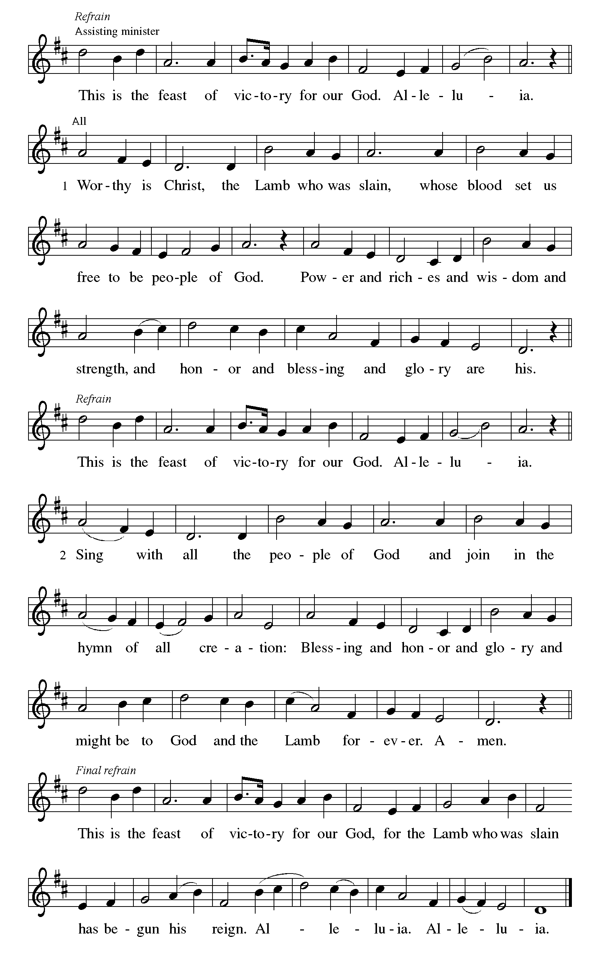
Canticle of Praise

Prayer of the Day
Let us pray.
O God of glory, your Son Jesus Christ suffered for us and ascended to your right hand. Unite us with Christ and each other in suffering and in joy, that all the world may be drawn into your bountiful presence, through Jesus Christ, our Savior and Lord, who lives and reigns with you and the Holy Spirit, one God, now and forever.
Amen.
God speaks to us in scripture reading, preaching, and song.
WORD

First Reading: Acts 1:6-14
A reading from Acts.
⁶ When [the apostles] had come together, they asked [Jesus], “Lord, is this the time when you will restore the kingdom to Israel?” ⁷ He replied, “It is not for you to know the times or periods that the Father has set by his own authority. ⁸ But you will receive power when the Holy Spirit has come upon you, and you will be my witnesses in Jerusalem, in all Judea and Samaria, and to the ends of the earth.” ⁹ When he had said this, as they were watching, he was lifted up, and a cloud took him out of their sight. ¹⁰ While he was going and they were gazing up toward heaven, suddenly two men in white robes stood by them. ¹¹ They said, “Men of Galilee, why do you stand looking up toward heaven? This Jesus, who has been taken up from you into heaven, will come in the same way as you saw him go into heaven.”
¹² Then they returned to Jerusalem from the mount called Olivet, which is near Jerusalem, a Sabbath day’s journey away. ¹³ When they had entered the city, they went to the room upstairs where they were staying: Peter, and John, and James, and Andrew, Philip and Thomas, Bartholomew and Matthew, James son of Alphaeus, and Simon the Zealot, and Judas son of James. ¹⁴ All these were constantly devoting themselves to prayer, together with certain women, including Mary the mother of Jesus, as well as his brothers.
The word of the Lord.
Thanks be to God.

Psalm: Psalm 68:1-10, 32-35
¹ Let God arise, and let God’s ene- | mies be scattered;
let those who | hate God flee.
² As smoke is driven away, so you should drive | them away;
as the wax melts before the fire, so let the wicked perish at the pres- | ence of God.
³ But let the righteous be glad and rejoice | before God;
let them also be mer- | ry and joyful.
⁴ Sing to God, sing praises to God’s name; exalt the one who | rides the clouds;
I Am is that name, rejoice | before God! R
⁵ In your holy habita- | tion, O God,
you are a father to orphans, defend- | er of widows;
⁶ you give the solitary a home and bring forth prisoners | into freedom;
but the rebels shall live in | desert places.
⁷ O God, when you went forth be- | fore your people,
when you marched | through the wilderness,
⁸ the earth quaked, and the skies poured down rain, at the presence of God, the | God of Sinai,
at the presence of God, the | God of Israel.
⁹ You sent a bountiful | rain, O God;
you restored your inheritance | when it languished.
¹⁰ Your people found their | home in it;
in your goodness, O God, you have made provision | for the poor. R
³² Sing to God, O kingdoms | of the earth;
sing praises | to the Lord.
³³ You ride in the heavens, O God, in the | ancient heavens;
you send forth your voice, your | mighty voice.
³⁴ Ascribe pow- | er to God,
whose majesty is over Israel; whose strength is | in the skies.
³⁵ How wonderful you are in your holy places, O | God of Israel,
giving strength and power to your people! | Blessed be God! R

Second Reading: 1 Peter 4:12-14; 5:6-11
A reading from 1 Peter.
¹² Beloved, do not be surprised at the fiery ordeal that is taking place among you to test you, as though something strange were happening to you. ¹³ But rejoice insofar as you are sharing Christ’s sufferings, so that you may also be glad and shout for joy when his glory is revealed. ¹⁴ If you are reviled for the name of Christ, you are blessed, because the spirit of glory, which is the Spirit of God, is resting on you.
^{5:6} Humble yourselves, therefore, under the mighty hand of God, so that he may exalt you in due time. ⁷ Cast all your anxiety on him, because he cares for you. ⁸ Discipline yourselves; keep alert. Like a roaring lion your adversary the devil prowls around, looking for someone to devour. ⁹ Resist him, steadfast in your faith, for you know that your brothers and sisters in all the world are undergoing the same kinds of suffering. ¹⁰ And after you have suffered for a little while, the God of all grace, who has called you to his eternal glory in Christ, will himself restore, support, strengthen, and establish you. ¹¹ To him be the power forever and ever. Amen.
The word of the Lord.
Thanks be to God.
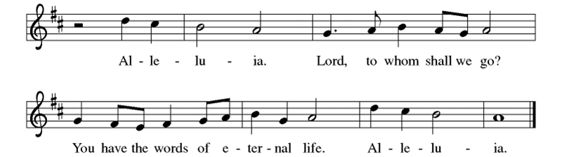

Gospel: John 17:1-11
The holy gospel according to John.
Glory to you, O Lord.
¹ After Jesus had spoken these words [to his disciples,] he looked up to heaven and said, “Father, the hour has come; glorify your Son so that the Son may glorify you, ² since you have given him authority over all people, to give eternal life to all whom you have given him. ³ And this is eternal life, that they may know you, the only true God, and Jesus Christ, whom you have sent. ⁴ I glorified you on earth by finishing the work that you gave me to do. ⁵ So now, Father, glorify me in your own presence with the glory that I had in your presence before the world existed.
⁶ “I have made your name known to those whom you gave me from the world. They were yours, and you gave them to me, and they have kept your word. ⁷ Now they know that everything you have given me is from you, ⁸ for the words that you gave to me I have given to them, and they have received them and know in truth that I came from you, and they have believed that you sent me. ⁹ I am asking on their behalf; I am not asking on behalf of the world but on behalf of those whom you gave me, because they are yours. ¹⁰ All mine are yours, and yours are mine, and I have been glorified in them. ¹¹ And now I am no longer in the world, but they are in the world, and I am coming to you. Holy Father, protect them in your name that you have given me, so that they may be one, as we are one.”
The gospel of the Lord.
Praise to you, O Christ.
Please be seated.
Children’s Message

Sermon

Hymn of the Day I Come With Joy ELW 482

Nicene Creed
A: Let us profess our faith to the words of the Nicene creed
We believe in one God,
the Father, the Almighty,
maker of heaven and earth,
of all that is, seen and unseen.
We believe in one Lord, Jesus Christ,
the only Son of God,
eternally begotten of the Father,
God from God, Light from Light,
true God from true God,
begotten, not made,
of one Being with the Father;
through him all things were made.
For us and for our salvation
he came down from heaven,
was incarnate of the Holy Spirit and the virgin Mary
and became truly human.
For our sake he was crucified under Pontius Pilate;
he suffered death and was buried.
On the third day he rose again
in accordance with the scriptures;
he ascended into heaven
and is seated at the right hand of the Father.
He will come again in glory to judge the living and the dead,
and his kingdom will have no end.
We believe in the Holy Spirit, the Lord, the giver of life,
who proceeds from the Father and the Son,*
who with the Father and the Son is worshiped and glorified,
who has spoken through the prophets.
We believe in one holy catholic and apostolic church.
We acknowledge one baptism for the forgiveness of sins.
We look for the resurrection of the dead,
and the life of the world to come. Amen.

Prayers of Intercession
Trusting in the power of Christ’s resurrection to heal and redeem our broken world, let us pray for the needs of all creation.
O God, your people sing praises throughout the church. By your Holy Spirit, inspire musicians, deacons, pastors, and bishops to proclaim the gospel of Jesus. Merciful God,
receive our prayer.
Your creative power fills the universe. Bring favorable weather, nurture plants and animals, protect us from natural disasters, and guide us to care for all you have made. Merciful God,
receive our prayer.
Your justice is exercised in society by those in authority. Instill in political leaders, business leaders, school administrators, and all who care for others a desire for peace and equity. Merciful God,
receive our prayer.
Your compassion and care come through the gifts of medicine and relationships. Soothe the anxious, protect widows and orphans, comfort those living with memory loss and their families, and heal the sick (especially). Merciful God,
receive our prayer.
Your love radiates from communities gathered in your name. Bless those experiencing significant transitions in life such as graduation, retirement, new employment (other transitions may be named), and accompany us in our prayers during these times. Merciful God,
receive our prayer.
O God, your promise of eternal life is certain and sure. Inspire us by the steadfast faith of those who have gone before us, so that we may be confident in the assurances you give. Merciful God,
receive our prayer.
God of resurrection power, use us and these prayers to proclaim the good news of new life to all the world, through Jesus Christ, our risen Savior.
Amen.

Peace
The peace of Christ be with you always. And also with you.

MEAL
God feeds us with the presence of Jesus Christ.

Choral Anthem – Goodness of God

Please stand.
Offertory Hymn Give Thanks

Offering Prayer
Merciful God,
accept the fruits of our labor, gathered to give you glory.
You have set a table before us, a glimpse of that great day
when we will hunger and thirst no more.
Nourish us with the body and blood of Jesus,
that goodness and mercy may follow us
and bless the world you love.
In the name of Jesus,
Amen.

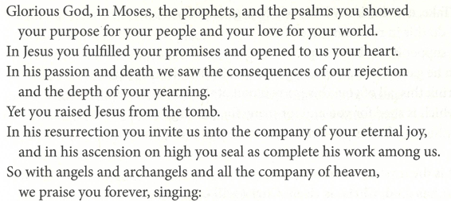
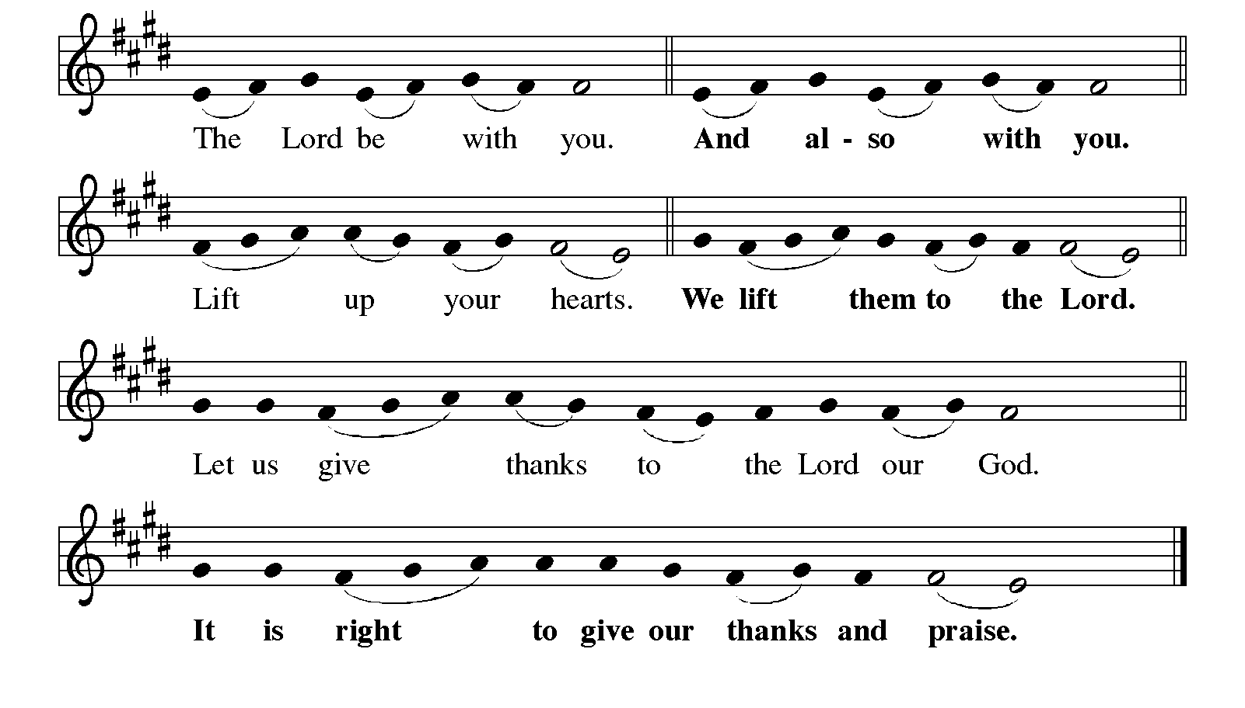
Great Thanksgiving

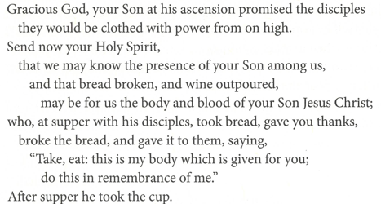
Eucharistic Prayer
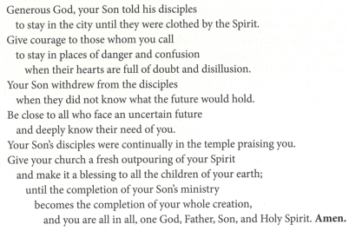
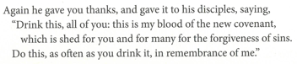

Lord’s Prayer
Our Father, who art in heaven,
hallowed be thy name, thy kingdom come,
thy will be done, on earth as it is in heaven.
Give us this day our daily bread;
and forgive us our trespasses, as we forgive those who trespass against us;
and lead us not into temptation but deliver us from evil.
For thine is the kingdom,
and the power, and the glory, forever and ever.
Amen.

Invitation to Communion
Come to the table of new life.
Receive the risen Lord.

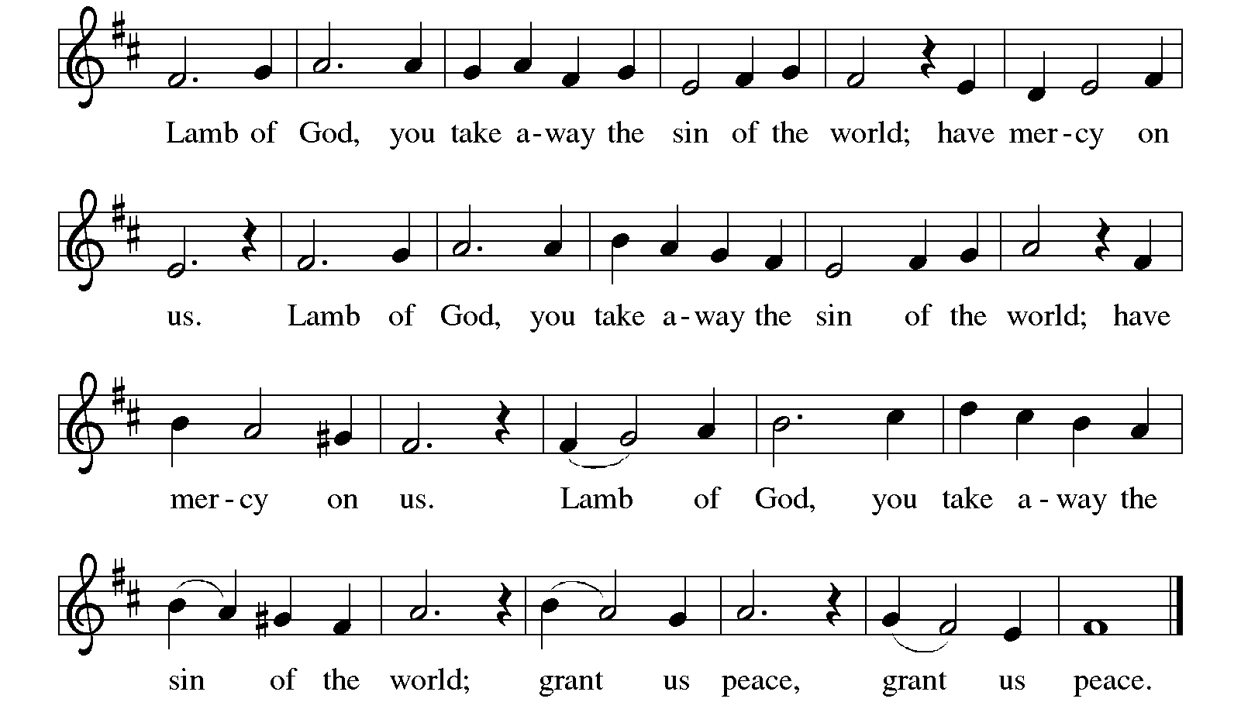
Communion

Communion Songs Let Us Break Bread Together ELW 471

Draw Us in the Spirit's Tether ELW 470

Prayer after Communion
Holy One,
through this meal you have made your home among us
and are making all things new.
Send us now to speak peace to anxious hearts,
to love our enemies,
and to bring your healing to the nations.
In the name of Jesus, Amen.

SENDING
God blesses us and sends us in mission to the world.

Blessing
God Almighty, who is the beginning and the end,
Jesus Christ, the firstborn of the dead,
and the Spirit, our advocate and peace,
☩ bless you now and forever.

Sending Song May the God of Hope Go with Us ACS 984
Dios de la Esperanza x 2

Dismissal
Go in peace. Serve the Lord.
Thanks be to God.

From sundaysandseasons.com.
Copyright © 2026 Augsburg Fortress. All rights reserved.

