
Worship Plan for Sunday, August 23, 2026
13th Sunday After Pentecost

The Holy Spirit calls us together as the people of God.
GATHERING

Prelude
Welcome/Announcements
Reflection - Preparing for Worship
Sing 3X

Please stand.
Confession and Forgiveness
All may make the sign of the cross, the sign that is marked at baptism, as the presiding minister begins.

Blessed be the holy Trinity,☩ one God,
whose compassion endures forever.
Amen.

Let us confess our sin to God.
Silence is kept for reflection.

Compassionate God,
we confess to you all our sins.
Our burden is heavy, and we cannot free ourselves.
In your mercy, call us back to you.
Your yoke is easy and your burden is light.
Restore us to dwell in your peace.
In Christ’s name we pray,
Amen.

Jesus says, “Come to me,
all you who are weary
and are carrying heavy burdens,
and I will give you rest.”
In the name of God,
Father, ☩ Son, and Holy Spirit,
your sins are forgiven.
Rest in God’s love.
Amen.

Gathering Song Making Their Way ACS 979

Greeting
The grace of our Lord Jesus Christ, the love of God
and the communion of the Holy Spirit be with you all.
And also, with you.

Hymn of Praise
Prayer of the Day
Let us pray.
O God, with all your faithful followers of every age, we praise you, the rock of our life. Be our strong foundation and form us into the body of your Son, that we may gladly minister to all the world, through Jesus Christ, our Savior and Lord.
Amen.

Please be seated.
God speaks to us in scripture reading, preaching, and song.
WORD

First Reading: Isaiah 51:1-6
A reading from Isaiah.
¹ Listen to me, you who pursue righteousness,
you who seek the Lord.
Look to the rock from which you were hewn
and to the quarry from which you were dug.
² Look to Abraham your father
and to Sarah, who bore you,
for he was but one when I called him,
but I blessed him and made him many.
³ For the Lord will comfort Zion;
he will comfort all her waste places
and will make her wilderness like Eden,
her desert like the garden of the Lord;
joy and gladness will be found in her,
thanksgiving and the voice of song.
⁴ Listen to me, my people,
and give heed to me, my nation,
for a teaching will go out from me
and my justice for a light to the peoples.
⁵ I will bring near my deliverance swiftly;
my salvation has gone out,
and my arms will rule the peoples;
the coastlands wait for me,
and for my arm they hope.
⁶ Lift up your eyes to the heavens
and look at the earth beneath,
for the heavens will vanish like smoke,
the earth will wear out like a garment,
and those who live on it will die like gnats,
but my salvation will be forever,
and my deliverance will never be ended.
The word of the Lord.
Thanks be to God.

Psalm: Psalm 138
¹ I will give thanks to you, O Lord, with | my whole heart;
before the gods I will | sing your praise.
² I will bow down toward your holy temple and praise your name, because of your steadfast | love and faithfulness;
for you have glorified your name and your word a- | bove all things.
³ When I called, you | answered me;
you increased my | strength within me.
⁴ All the rulers of the earth will praise | you, O Lord,
when they have heard the words | of your mouth. R
⁵ They will sing of the ways | of the Lord,
that great is the glory | of the Lord.
⁶ The Lord is high, yet cares | for the lowly,
perceiving the haughty | from afar.
⁷ Though I walk in the midst of trouble, you | keep me safe;
you stretch forth your hand against the fury of my enemies; your right | hand shall save me.
⁸ You will make good your pur- | pose for me;
O Lord, your steadfast love endures forever; do not abandon the works | of your hands. R

Second Reading: Romans 12:1-8
A reading from Romans.
¹ I appeal to you therefore, brothers and sisters, on the basis of God’s mercy, to present your bodies as a living sacrifice, holy and acceptable to God, which is your reasonable act of worship. ² Do not be conformed to this age, but be transformed by the renewing of the mind, so that you may discern what is the will of God—what is good and acceptable and perfect.
³ For by the grace given to me I say to everyone among you not to think of yourself more highly than you ought to think but to think with sober judgment, each according to the measure of faith that God has assigned. ⁴ For as in one body we have many members and not all the members have the same function, ⁵ so we, who are many, are one body in Christ, and individually we are members one of another. ⁶ We have gifts that differ according to the grace given to us: prophecy, in proportion to faith; ⁷ ministry, in ministering; the teacher, in teaching; ⁸ the encourager, in encouragement; the giver, in sincerity; the leader, in diligence; the compassionate, in cheerfulness.
The word of the Lord.
Thanks be to God.
Please stand.
Gospel Acclamation
Gospel: Matthew 16:13-20
The holy gospel according to Matthew.
Glory to you, O Lord.
¹³ Now when Jesus came into the district of Caesarea Philippi, he asked his disciples, “Who do people say that the Son of Man is?” ¹⁴ And they said, “Some say John the Baptist but others Elijah and still others Jeremiah or one of the prophets.” ¹⁵ He said to them, “But who do you say that I am?” ¹⁶ Simon Peter answered, “You are the Messiah, the Son of the living God.” ¹⁷ And Jesus answered him, “Blessed are you, Simon son of Jonah! For flesh and blood has not revealed this to you but my Father in heaven. ¹⁸ And I tell you, you are Peter, and on this rock I will build my church, and the gates of Hades will not prevail against it. ¹⁹ I will give you the keys of the kingdom of heaven, and whatever you bind on earth will be bound in heaven, and whatever you loose on earth will be loosed in heaven.” ²⁰ Then he sternly ordered the disciples not to tell anyone that he was the Messiah.
The gospel of the Lord.
Praise to you, O Christ.

Please be seated.
Children’s Message

Sermon

Please stand
Hymn of the Day My Hope is Built on Nothing Less ELW 596

Apostles’ Creed
Let us confess our faith to the words of the Apostles’ Creed
I believe in God, the Father almighty,
creator of heaven and earth.
I believe in Jesus Christ, God's only Son, our Lord,
who was conceived by the Holy Spirit,
born of the Virgin Mary,
suffered under Pontius Pilate,
was crucified, died, and was buried;
he descended to the dead.
On the third day he rose again;
he ascended into heaven,
he is seated at the right hand of the Father,
and he will come to judge the living and the dead.
I believe in the Holy Spirit,
the holy catholic Church,
the communion of saints,
the forgiveness of sins,
the resurrection of the body,
and the life everlasting. Amen

Please sit or kneel.
Prayers of Intercession
With bold trust in God’s unfailing provision, we pray for the church, those in need, and all of God’s creation.
God, our rock, you are the foundation on which the church is built. Strengthen and encourage your faithful people everywhere they gather, that they boldly proclaim your word of life to all the world. Merciful God,
receive our prayer.
You spoke and all creation came into being. Field and forest, wetland and wilderness—all reveal your glory. Sustain and nourish your creation (local areas of ecological concern may be named). Teach us to be wise stewards of all you have made. Merciful God,
receive our prayer.
You bring deliverance to nations and peoples. Come to the aid of nations experiencing war, conflict, disease, famine, and disaster (especially). Guide the work of relief agencies and peacemaking organizations. Merciful God,
receive our prayer.
You regard the lowly and hear us when we cry out to you. Be present among all who struggle with addiction, housing insecurity, incarceration, and mental illness, that they know they are not alone. Hear our prayers for all in need this day (especially). Merciful God,
receive our prayer.
You draw together people with differing gifts. Lift up the many and varied gifts and talents of this congregation and strengthen the bonds of fellowship that all may be united as the body of Christ. Merciful God,
receive our prayer.
Your steadfast love endures forever. We give thanks for the faithful who died in the hope of this promise. Strengthen us in faith until the day we join them at your eternal banquet. Merciful God,
receive our prayer.
Receive our prayers and answer, O God, as you have promised. All this we ask in the name of your Son, Jesus Christ our Lord.
Amen.

Peace
The peace of Christ be with you always. And also, with you.

MEAL
God feeds us with the presence of Jesus Christ.

Please be seated.
Offering

Special Music Alicia & Bob Massie-Legg

Please stand.
Offertory Hymn Here on Jesus Christ I will Stand ACS 1024

Offertory Prayer
Lord of the harvest,
we return to you a portion of what you have given to us.
Turn us to set our hope not on the uncertainty of riches,
but on you, who richly provides for us.
Multiply what we have gathered
to bless all who are suffering and in need,
through Jesus Christ our Lord.
Amen.

The Great Thanksgiving
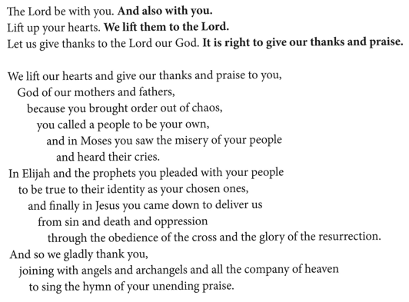

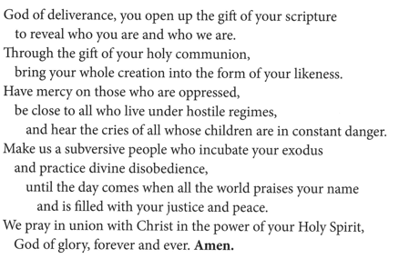
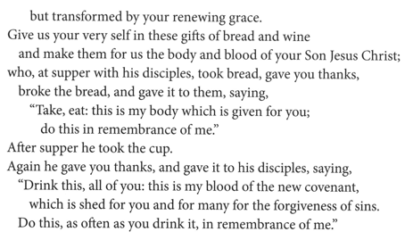
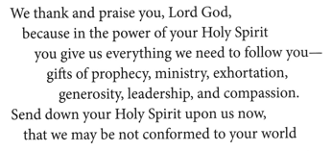

The Lord’s Prayer
Our Father, who art in heaven,
hallowed be thy name, thy kingdom come,
thy will be done, on earth as it is in heaven.
Give us this day our daily bread;
and forgive us our trespasses, as we forgive those who trespass against us;
and lead us not into temptation but deliver us from evil.
For thine is the kingdom,
and the power, and the glory, forever and ever.
Amen.

Invitation to Communion
Heaven has come near.
Come, share in the feast!

Please be seated.
Communion Hymns

Built on a Rock ELW 652

Blessed Assurance ELW 638

Prayer after Communion
Compassionate God,
through the gifts of bread and wine
our hearts are filled with the abundance of your love.
Strengthen us that we, through this holy meal,
may share your love freely, as you have shared with us.
We ask this in the name of Jesus,
through the Spirit nourishing us now and forever.
Amen.

God blesses us and sends us in mission to the world.
SENDING

Blessing
Creator, Redeemer, Sustainer,
☩ one God,
bless, heal, and hold you
today and always.
Amen.

Sending Song Faith of Our Fathers ELW 812

Dismissal
Heaven has come near. Go, share the good news!
Thanks be to God.

From sundaysandseasons.com.
Copyright © 2026 Augsburg Fortress. All rights reserved.

