
Worship Plan for Sunday, January 4, 2026
Second Sunday of Christmas

The Holy Spirit calls us together as the people of God.
GATHERING
Prelude
Welcome & Announcements
Jesus, What a Wonderful Child ELW#297
(Sing x 2)
Confession and Forgiveness
Blessed be the holy Trinity, ☩ one God,
Wonderful Counselor,
Mighty Savior,
Prince of Peace.
Amen.

Trusting in God’s steadfast love and faithfulness,
let us confess our sin.

Silence is kept for reflection.

Reconciling God,
we yearn for your presence to transform
our grief, pain, and despair.
We confess that we have not always prepared
room in our hearts for your love;
we have not always recognized
your presence among us;
we have not always embraced your message of peace.

We cry out, weary with the burden of violence,
oppression, and fear.
We confess our failure to make room
for those seeking refuge;
our participation in violent systems
that harm your innocent ones;
our reluctance to embody your good news.

Be born in us today
and teach us to sing the joyful song of your salvation.
Amen

God’s grace upon grace flows over you.
☩ Christ’s presence redeems the whole creation.
Your sins are forgiven. Let the earth rejoice and be glad!
A righteous branch springs forth:
it is Christ the Lord, our Savior,
in whom we have forgiveness, life, and mercy.
By the power of the Holy Spirit,
receive the grace and forgiveness of God
through ☩ Christ Jesus,
whose day draws near.
Amen.
Gathering Song The First Noel ELW#300

Greeting
The grace of our Lord Jesus Christ, the love of God,
and the communion of the Holy Spirit be with you all. And also with you.

Prayer of the Day
Let us pray.
Almighty God, you have filled all the earth with the light of your incarnate Word. By your grace empower us to reflect your light in all that we do, through Jesus Christ, our Savior and Lord, who lives and reigns with you and the Holy Spirit, one God, now and forever.
Amen.

WORD
God speaks to us in scripture reading, preaching, and song.
First Reading: Jeremiah 31:7-14
A reading from Jeremiah.
⁷ Thus says the Lord:
Sing aloud with gladness for Jacob,
and raise shouts for the chief of the nations;
proclaim, give praise, and say,
“Save, O Lord, your people,
the remnant of Israel.”
⁸ See, I am going to bring them from the land of the north
and gather them from the farthest parts of the earth,
among them the blind and the lame,
those with child and those in labor together;
a great company, they shall return here.
⁹ With weeping they shall come,
and with consolations I will lead them back;
I will let them walk by brooks of water,
in a straight path where they shall not stumble,
for I have become a father to Israel,
and Ephraim is my firstborn.
¹⁰ Hear the word of the Lord, O nations,
and declare it in the coastlands far away;
say, “He who scattered Israel will gather him
and will keep him as a shepherd does a flock.”
¹¹ For the Lord has ransomed Jacob
and has redeemed him from hands too strong for him.
¹² They shall come and sing aloud on the height of Zion,
and they shall be radiant over the goodness of the Lord,
over the grain, the wine, and the oil,
and over the young of the flock and the herd;
their life shall become like a watered garden,
and they shall never languish again.
¹³ Then shall the young women rejoice in the dance,
and the young men and the old shall be merry.
I will turn their mourning into joy;
I will comfort them and give them gladness for sorrow.
¹⁴ I will give the priests their fill of fatness,
and my people shall be satisfied with my bounty,
says the Lord.
The word of the Lord.
Thanks be to God.

Psalm: Psalm 147:12-20
¹² Worship the Lord, | O Jerusalem;
praise your | God, O Zion,
¹³ who has strengthened the bars | of your gates
and has blessed your chil- | dren within you.
¹⁴ God has established peace | on your borders
and satisfies you with the | finest wheat.
¹⁵ God sends out a command | to the earth,
a word that runs | very swiftly.
¹⁶ God gives | snow like wool,
scattering | frost like ashes.
¹⁷ God scatters | hail like bread crumbs.
Who can stand a- | gainst God’s cold?
¹⁸ The Lord sends forth the | word and melts them;
the wind blows, and the | waters flow.
¹⁹ God declares the | word to Jacob,
statutes and judg- | ments to Israel.
²⁰ The Lord has not done so to any | other nation;
they do not know God’s judgments. | Hallelujah!

Second Reading: Ephesians 1:3-14
A reading from Ephesians.
³ Blessed be the God and Father of our Lord Jesus Christ, who has blessed us in Christ with every spiritual blessing in the heavenly places, ⁴ just as he chose us in Christ before the foundation of the world to be holy and blameless before him in love. ⁵ He destined us for adoption as his children through Jesus Christ, according to the good pleasure of his will, ⁶ to the praise of his glorious grace that he freely bestowed on us in the Beloved. ⁷ In him we have redemption through his blood, the forgiveness of our trespasses, according to the riches of his grace ⁸ that he lavished on us. With all wisdom and insight ⁹ he has made known to us the mystery of his will, according to his good pleasure that he set forth in Christ, ¹⁰ as a plan for the fullness of time, to gather up all things in him, things in heaven and things on earth. ¹¹ In Christ we have also obtained an inheritance, having been destined according to the purpose of him who accomplishes all things according to his counsel and will, ¹² so that we, who were the first to set our hope on Christ, might live for the praise of his glory. ¹³ In him you also, when you had heard the word of truth, the gospel of your salvation, and had believed in him, were marked with the seal of the promised Holy Spirit; ¹⁴ this is the pledge of our inheritance toward redemption as God’s own people, to the praise of his glory.
The word of the Lord.
Thanks be to God.
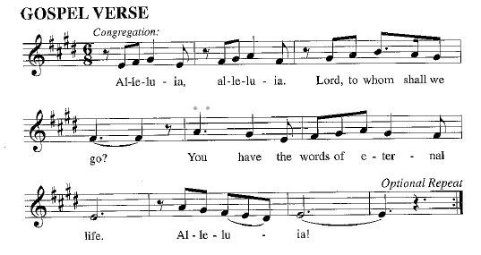

Gospel: John 1:[1-9] 10-18
The holy gospel according to John.
Glory to you, O Lord.
[¹ In the beginning was the Word, and the Word was with God, and the Word was God. ² He was in the beginning with God. ³ All things came into being through him, and without him not one thing came into being. What has come into being ⁴ in him was life, and the life was the light of all people. ⁵ The light shines in the darkness, and the darkness did not overtake it.
⁶ There was a man sent from God whose name was John. ⁷ He came as a witness to testify to the light, so that all might believe through him. ⁸ He himself was not the light, but he came to testify to the light. ⁹ The true light, which enlightens everyone, was coming into the world.]
¹⁰ He was in the world, and the world came into being through him, yet the world did not know him. ¹¹ He came to what was his own, and his own people did not accept him. ¹² But to all who received him, who believed in his name, he gave power to become children of God, ¹³ who were born, not of blood or of the will of the flesh or of the will of man, but of God.
¹⁴ And the Word became flesh and lived among us, and we have seen his glory, the glory as of a father’s only son, full of grace and truth. ¹⁵ (John testified to him and cried out, “This was he of whom I said, ‘He who comes after me ranks ahead of me because he was before me.’ ”) ¹⁶ From his fullness we have all received, grace upon grace. ¹⁷ The law indeed was given through Moses; grace and truth came through Jesus Christ. ¹⁸ No one has ever seen God. It is the only Son, himself God, who is close to the Father’s heart, who has made him known.
The gospel of the Lord.
Praise to you, O Christ.

Please be seated.
Children’s Message

Sermon
Hymn of the Day Let Our Gladness Have No End ELW# 291

Apostles’ Creed
I believe in God, the Father almighty,
creator of heaven and earth.
I believe in Jesus Christ, God’s only Son, our Lord,
who was conceived by the Holy Spirit, born of the virgin Mary,
suffered under Pontius Pilate, was crucified, died, and was buried;
he descended to the dead. On the third day he rose again;
he ascended into heaven, he is seated at the right hand of the Father,
and he will come to judge the living and the dead.
I believe in the Holy Spirit, the holy catholic church,
the communion of saints, the forgiveness of sins,
the resurrection of the body,
and the life everlasting. Amen.

Prayers of Intercession
Empowered by the news of Christ’s birth, let us pray boldly for the church, creation, and all who are in need.
O God, you reveal yourself wherever two or three are gathered in your name. Be with us now, not only in the infant Jesus and resurrected Christ, but in the beloved people of this assembly. Hear us, O God.
Your mercy is great.
You reveal yourself in the waters of the womb; in brooks, ponds, and oceans; and in the waters of baptism. Grant us wisdom to tenderly care for the earth as a garden watered by your grace. Hear us, O God.
Your mercy is great.
You reveal yourself in blessed diversity. Help us to look for you in people near and far, in bodies of all kinds, and in kindred young and old. Let us seek you in many places, praising you in many tongues. Hear us, O God.
Your mercy is great.
You reveal yourself in new life. Support those beginning a new job, a new relationship, or a new living situation, especially those displaced because of tragedy or loss. Be with all others who need your life-giving touch this day (especially). Hear us, O God.
Your mercy is great.
You reveal yourself in holy communion. Sustain all who provide food and fellowship in this congregation and in the wider community. Make our tables signs of your welcoming presence among us. Hear us, O God.
Your mercy is great.
You promise to turn mourning into joy and to comfort those who weep. We remember those who have died and look to being united with them in your glory. Hear us, O God.
Your mercy is great.
With the joy of Christ’s birth in our hearts, we commend our prayers to you, O God, trusting in your boundless mercy and eternal love; through Jesus Christ our Savior.
Amen.

Peace
The peace of Christ be with you always.
And also with you.

Choir Anthem Dona Nobis Pacem

MEAL
God feeds us with the presence of Jesus Christ.

Please stand
Offertory Hymn As the Grains of Wheat ELW#465

Offering Prayer
God of glory,
great are your wonders among us
and many are the blessings you bestow.
Use us and these your gifts for the needs of the world,
that all the ends of the earth may rejoice in your saving grace,
through Christ our Savior.
Amen.

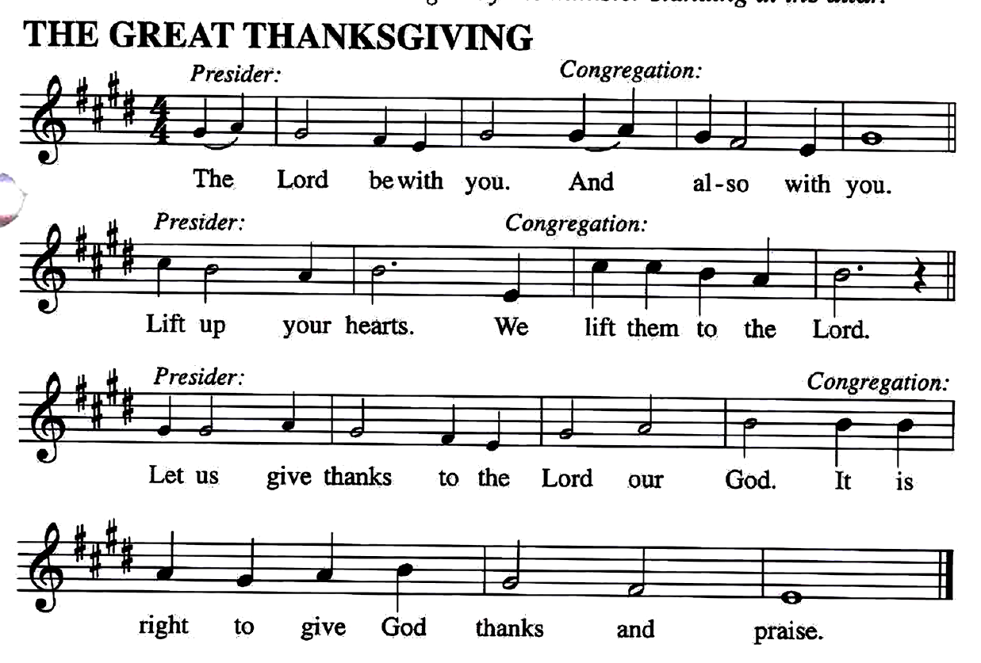
The Great Thanksgiving

Preface
It is our duty and delight... and so with the church on earth and the host of heaven we praise your name and join their unending hymn…

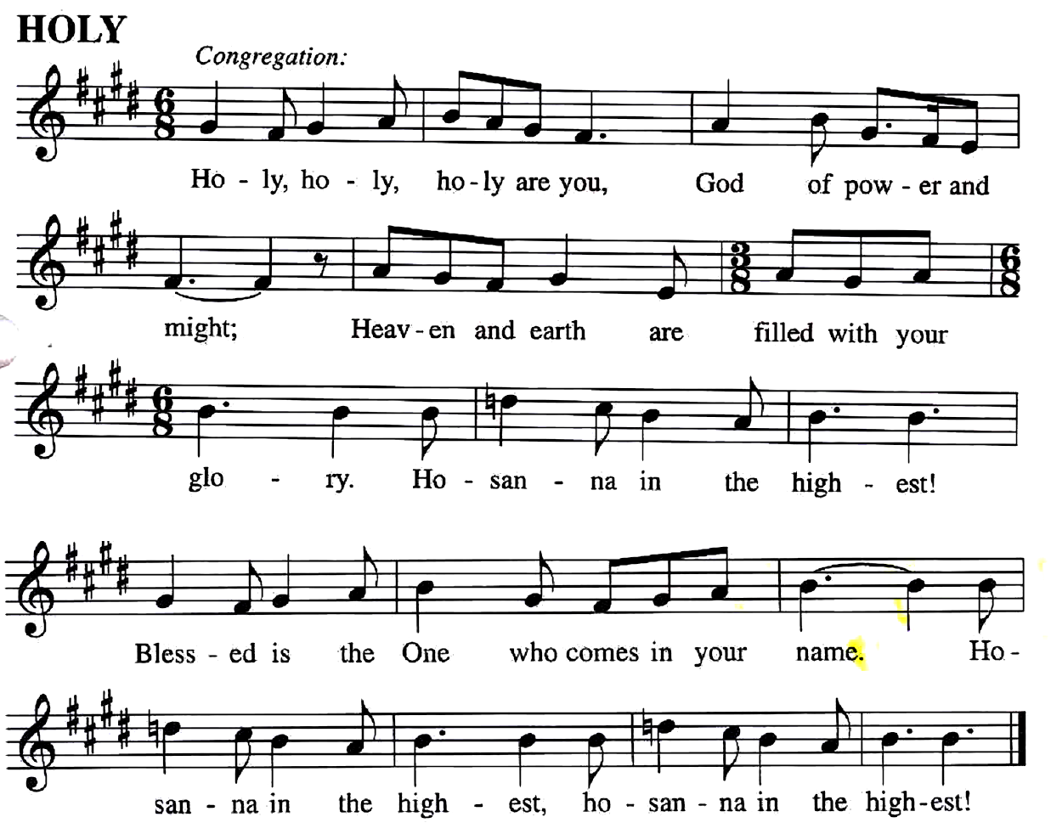

You are indeed holy… we pray for his coming again, as we cry:
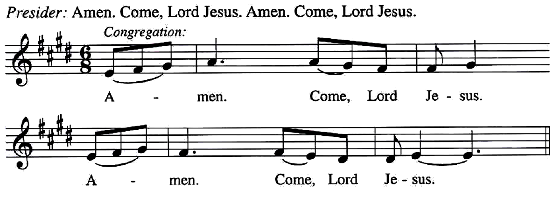

Send now, we pray, your Holy Spirit,
That all of your promises may come to us and your whole creation.
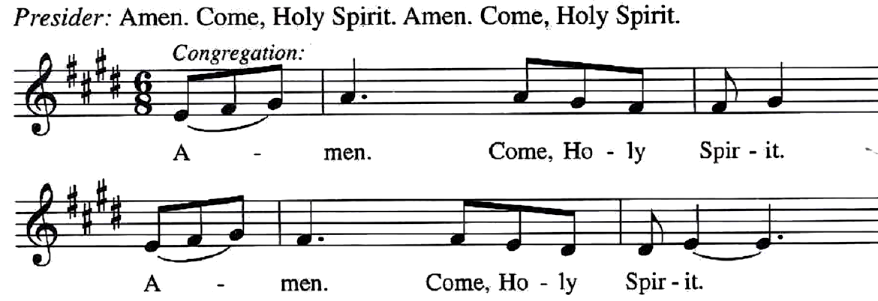

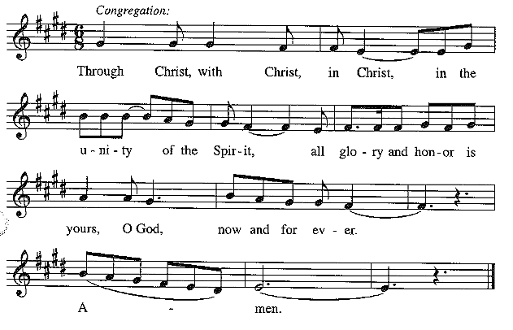
This we pray through Jesus Christ, our Savior and our friend.

Lord's Prayer
Our Father, who art in heaven,
hallowed be thy name,
thy kingdom come, thy will be done,
on earth as it is in heaven.
Give us this day our daily bread;
and forgive us our trespasses,
as we forgive those who trespass against us;
and lead us not into temptation but deliver us from evil.
For thine is the kingdom, and the power,
and the glory, forever and ever. Amen.

Invitation to Communion
God is now in flesh appearing.
Come to the feast of joy!

Lamb of God
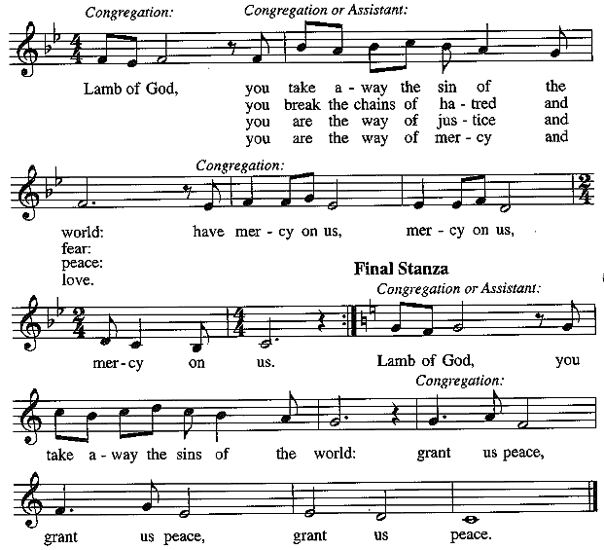

Communion Hymns Love Has Come ELW#292

Lo, How a Rose E’er Blooming ELW#272

Prayer after Communion
Incarnate God, you are among us at this table.
May we treasure this gift and ponder in our hearts
the mystery of your presence.
Move us to discover the wonders of your love
in the everyday moments of our lives,
through Christ born in us.
Amen.
God blesses us and sends us in mission to the world.
SENDING

Blessing
The triune God,
glorious Mystery,
holy Incarnate One,
abiding Comforter,
☩ bless you with endless grace, peace, and joy.
Amen.
Sending Song That Boy-Child of Mary ELW#293

Dismissal
Glory to God in the highest!
And peace to God’s people on earth!
Go in joy. Embody God’s redeeming grace.
Thanks be to God.

