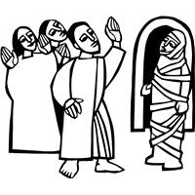
Worship Plan for Sunday, March 22, 2026
Fifth Sunday in Lent

The Holy Spirit calls us together as the people of God.
GATHERING

Prelude
Welcome/Announcements
Reflection - Preparing for Worship
Sing 2x

Please stand.
Confession and Forgiveness
All make the sign of the cross, the sign that is marked at baptism, as the presiding minister begins.
Blessed be the holy Trinity, ☩ one God,
who forgives all our sin,
whose mercy endures forever.
Amen.

Let us return to God, confessing our sin in the assurance of God’s abiding love.
Silence is kept for reflection.

Compassionate One,
you are slow to anger and abounding in steadfast love,
but our lives do not always reflect you
and your love for the world.
We do not show others the tender compassion
you have shown to us.
We do not welcome others with the radical hospitality
you grant to all people.
We oppress others,
even though you have set us free again and again.
We squander the abundant gifts of the earth.
Transform our lives
and guide us again in the way of the cross.
Amen.

Beloved in Christ,
God’s arms are always stretched open wide
to welcome the wandering ones home.
In ☩ Christ your sins are forgiven.
You have a place in God’s house forever.
Amen.

Gathering Song Down at the Cross TFF 72

Greeting
The grace of our Lord Jesus Christ, the love of God
and the communion of the Holy Spirit be with you all.
And also, with you.

Kyrie

Your Heart, O God is Grieved

Prayer of the Day
Let us pray.
Almighty God, your Son came into the world to free us all from sin and death. Breathe upon us the power of your Spirit, that we may be raised to new life in Christ and serve you in righteousness all our days, through Jesus Christ, our Savior and Lord, who lives and reigns with you and the Holy Spirit, one God, now and forever.
Amen.
Please be seated.
God speaks to us in scripture reading, preaching, and song.
WORD

First Reading: Ezekiel 37:1-14
A reading from Ezekiel.
¹ The hand of the Lord came upon me, and he brought me out by the spirit of the Lord and set me down in the middle of a valley; it was full of bones. ² He led me all around them; there were very many lying in the valley, and they were very dry. ³ He said to me, “Mortal, can these bones live?” I answered, “O Lord God, you know.” ⁴ Then he said to me, “Prophesy to these bones and say to them: O dry bones, hear the word of the Lord. ⁵ Thus says the Lord God to these bones: I will cause breath to enter you, and you shall live. ⁶ I will lay sinews on you and will cause flesh to come upon you and cover you with skin and put breath in you, and you shall live, and you shall know that I am the Lord.”
⁷ So I prophesied as I had been commanded, and as I prophesied, suddenly there was a noise, a rattling, and the bones came together, bone to its bone. ⁸ I looked, and there were sinews on them, and flesh had come upon them, and skin had covered them, but there was no breath in them. ⁹ Then he said to me, “Prophesy to the breath, prophesy, mortal, and say to the breath: Thus says the Lord God: Come from the four winds, O breath, and breathe upon these slain, that they may live.” ¹⁰ I prophesied as he commanded me, and the breath came into them, and they lived and stood on their feet, a vast multitude.
¹¹ Then he said to me, “Mortal, these bones are the whole house of Israel. They say, ‘Our bones are dried up, and our hope is lost; we are cut off completely.’ ¹² Therefore prophesy and say to them: Thus says the Lord God: I am going to open your graves and bring you up from your graves, O my people, and I will bring you back to the land of Israel. ¹³ And you shall know that I am the Lord when I open your graves and bring you up from your graves, O my people. ¹⁴ I will put my spirit within you, and you shall live, and I will place you on your own soil; then you shall know that I, the Lord, have spoken and will act, says the Lord.”
The word of the Lord.
Thanks be to God.

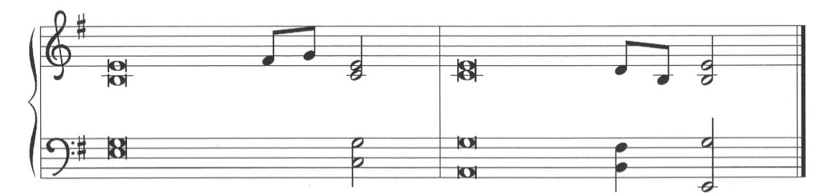
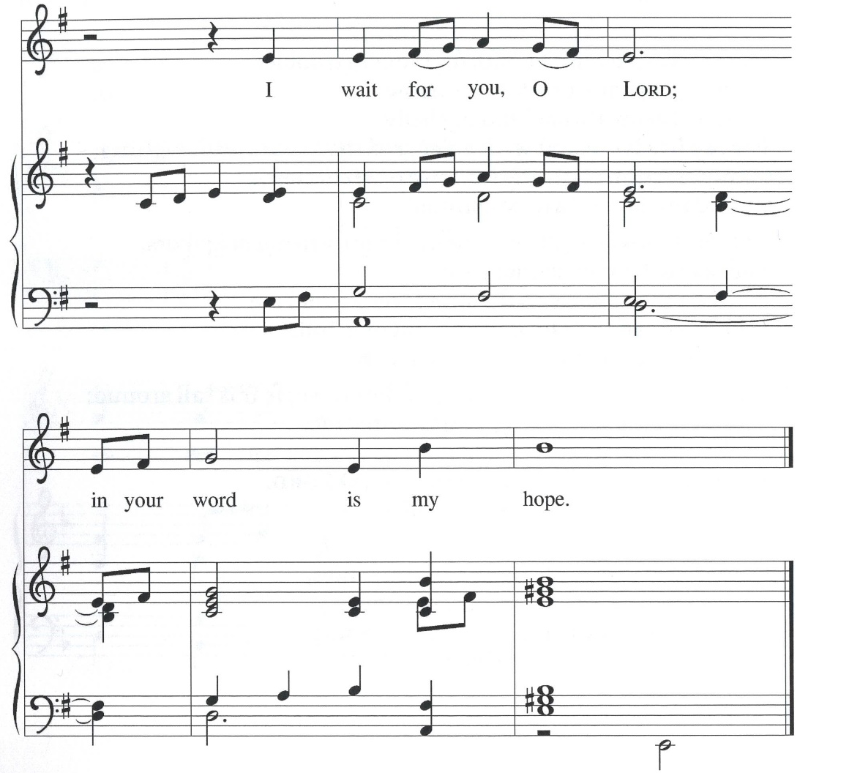
Psalm: Psalm 130
¹ Out | of the depths
I cry to | you, O Lord;
² O Lord, | hear my voice!
Let your ears be attentive to the voice of my | supplication.
³ If you were to keep watch | over sins,
O Lord, | who could stand?
⁴ Yet with you | is forgiveness,
in order that you | may be feared. R
⁵ I wait for you, O Lord; | my soul waits;
in your word | is my hope.
⁶ My soul waits for the Lord more than those who keep watch | for the morning,
more than those who keep watch | for the morning.
⁷ O Israel, wait for the Lord, for with the Lord there is | steadfast love;
with the Lord there is plen- | teous redemption.
⁸ For the Lord shall | redeem Israel
from | all their sins. R

Second Reading: Romans 8:6-11
A reading from Romans.
⁶ To set the mind on the flesh is death, but to set the mind on the Spirit is life and peace. ⁷ For this reason the mind that is set on the flesh is hostile to God; it does not submit to God’s law—indeed, it cannot, ⁸ and those who are in the flesh cannot please God.
⁹ But you are not in the flesh; you are in the Spirit, since the Spirit of God dwells in you. Anyone who does not have the Spirit of Christ does not belong to him. ¹⁰ But if Christ is in you, then the body is dead because of sin, but the Spirit is life because of righteousness. ¹¹ If the Spirit of him who raised Jesus from the dead dwells in you, he who raised Christ Jesus from the dead will give life to your mortal bodies also through his Spirit that dwells in you.
The word of the Lord.
Thanks be to God.
Please stand.
Gospel: John 11:1-45
The holy gospel according to John.
Glory to you, O Lord.
¹ Now a certain man was ill, Lazarus of Bethany, the village of Mary and her sister Martha. ² Mary was the one who anointed the Lord with perfume and wiped his feet with her hair; her brother Lazarus was ill. ³ So the sisters sent a message to Jesus, “Lord, he whom you love is ill.” ⁴ But when Jesus heard it, he said, “This illness does not lead to death; rather, it is for God’s glory, so that the Son of God may be glorified through it.” ⁵ Accordingly, though Jesus loved Martha and her sister and Lazarus, ⁶ after having heard that Lazarus was ill, he stayed two days longer in the place where he was.
⁷ Then after this he said to the disciples, “Let us go to Judea again.” ⁸ The disciples said to him, “Rabbi, the Jews were just now trying to stone you, and are you going there again?” ⁹ Jesus answered, “Are there not twelve hours of daylight? Those who walk during the day do not stumble because they see the light of this world. ¹⁰ But those who walk at night stumble because the light is not in them.” ¹¹ After saying this, he told them, “Our friend Lazarus has fallen asleep, but I am going there to awaken him.” ¹² The disciples said to him, “Lord, if he has fallen asleep, he will be all right.” ¹³ Jesus, however, had been speaking about his death, but they thought that he was referring merely to sleep. ¹⁴ Then Jesus told them plainly, “Lazarus is dead. ¹⁵ For your sake I am glad I was not there, so that you may believe. But let us go to him.” ¹⁶ Thomas, who was called the Twin, said to his fellow disciples, “Let us also go, that we may die with him.”
¹⁷ When Jesus arrived, he found that Lazarus had already been in the tomb four days. ¹⁸ Now Bethany was near Jerusalem, some two miles away, ¹⁹ and many of the Jews had come to Martha and Mary to console them about their brother. ²⁰ When Martha heard that Jesus was coming, she went and met him, while Mary stayed at home. ²¹ Martha said to Jesus, “Lord, if you had been here, my brother would not have died. ²² But even now I know that God will give you whatever you ask of him.” ²³ Jesus said to her, “Your brother will rise again.” ²⁴ Martha said to him, “I know that he will rise again in the resurrection on the last day.” ²⁵ Jesus said to her, “I am the resurrection and the life. Those who believe in me, even though they die, will live, ²⁶ and everyone who lives and believes in me will never die. Do you believe this?” ²⁷ She said to him, “Yes, Lord, I believe that you are the Messiah, the Son of God, the one coming into the world.”
²⁸ When she had said this, she went back and called her sister Mary and told her privately, “The Teacher is here and is calling for you.” ²⁹ And when she heard it, she got up quickly and went to him. ³⁰ Now Jesus had not yet come to the village but was still at the place where Martha had met him. ³¹ The Jews who were with her in the house consoling her saw Mary get up quickly and go out. They followed her because they thought that she was going to the tomb to weep there. ³² When Mary came where Jesus was and saw him, she knelt at his feet and said to him, “Lord, if you had been here, my brother would not have died.” ³³ When Jesus saw her weeping and the Jews who came with her also weeping, he was greatly disturbed in spirit and deeply moved. ³⁴ He said, “Where have you laid him?” They said to him, “Lord, come and see.” ³⁵ Jesus began to weep. ³⁶ So the Jews said, “See how he loved him!” ³⁷ But some of them said, “Could not he who opened the eyes of the blind man have kept this man from dying?”
³⁸ Then Jesus, again greatly disturbed, came to the tomb. It was a cave, and a stone was lying against it. ³⁹ Jesus said, “Take away the stone.” Martha, the sister of the dead man, said to him, “Lord, already there is a stench because he has been dead four days.” ⁴⁰ Jesus said to her, “Did I not tell you that if you believed you would see the glory of God?” ⁴¹ So they took away the stone. And Jesus looked upward and said, “Father, I thank you for having heard me. ⁴² I knew that you always hear me, but I have said this for the sake of the crowd standing here, so that they may believe that you sent me.” ⁴³ When he had said this, he cried with a loud voice, “Lazarus, come out!” ⁴⁴ The dead man came out, his hands and feet bound with strips of cloth and his face wrapped in a cloth. Jesus said to them, “Unbind him, and let him go.”
⁴⁵ Many of the Jews, therefore, who had come with Mary and had seen what Jesus did believed in him.
The gospel of the Lord.
Praise to you, O Christ.
Please be seated.
Children’s Message

Sermon

Please stand
Hymn of the Day Jesus Is a Rock in a Weary Land ELW 333

Apostles’ Creed
Let us confess our faith to the words of the Apostles’ Creed
I believe in God, the Father almighty,
creator of heaven and earth.
I believe in Jesus Christ, God’s only Son, our Lord,
who was conceived by the Holy Spirit,
born of the virgin Mary,
suffered under Pontius Pilate,
was crucified, died, and was buried;
he descended to the dead.*
On the third day he rose again;
he ascended into heaven,
he is seated at the right hand of the Father,
and he will come to judge the living and the dead.
I believe in the Holy Spirit,
the holy catholic church,
the communion of saints,
the forgiveness of sins,
the resurrection of the body,
and the life everlasting. Amen.

Please sit or kneel.
Prayers of Intercession
Reconciled by God’s mercy and sustained by God’s presence, let us pray for the world and its needs.
We pray for the church. Grant life and peace to all who gather in your name. Breathe into us so that we may share your message of forgiveness, hope, and love. Hear us, O God.
Your mercy is great.
We pray for creation. Renew landscapes that have dried up, prosper the work of those who restore homes and habitats after natural disasters, and sustain places where biodiversity thrives (local places in nature may be named). Hear us, O God.
Your mercy is great.
We pray for the nations. Unbind leaders trapped by fear to act boldly for justice, free all who live in places of war and violence, and guide refugees and asylum seekers to safety. Hear us, O God.
Your mercy is great.
We pray for all people in need. Take away the stone of poverty that weighs down so many. Console any who weep and heal all who are sick (especially). Hear us, O God.
Your mercy is great.
We pray for this assembly. Ready the hearts and spirits of all preparing to be baptized (especially). Deepen our wonder at the mystery of your resurrection and life. Hear us, O God.
Your mercy is great.
We offer our thanksgiving for (Jonathan Edwards and ) all people who have died in faith. Give us faith to trust in your power to redeem and save, and bring us up from our graves to life in you. Hear us, O God.
Your mercy is great.
Receive our prayers, O God, through Jesus Christ, our strength and salvation.
Amen.

Peace
The peace of Christ be with you always.
And also, with you.

God feeds us with the presence of Jesus Christ.
MEAL

Please be seated.
Offering

Choir – Softly and Tenderly

Please stand.
Offertory Hymn Come, Bring Your Burdens ACS 1009

Offertory Prayer
Let us pray
Gracious Provider,
you set your immense treasures among us,
opening your heart to the world.
As we prepare to feast on your bountiful love,
deepen our commitment to sharing those
treasures with others,
through our Savior, Jesus Christ.
Amen.

The Great Thanksgiving

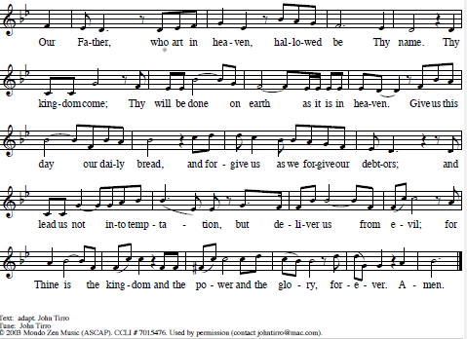
The Lord’s Prayer

Invitation to Communion
All who are hungry, come!
The feast of grace is spread.
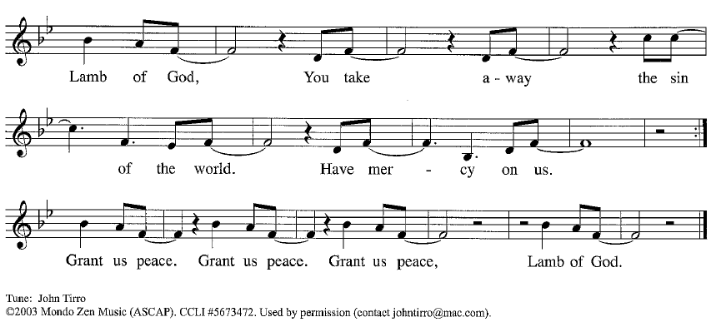
Please be seated
Communion Hymns I Am the Bread of Life ELW 485

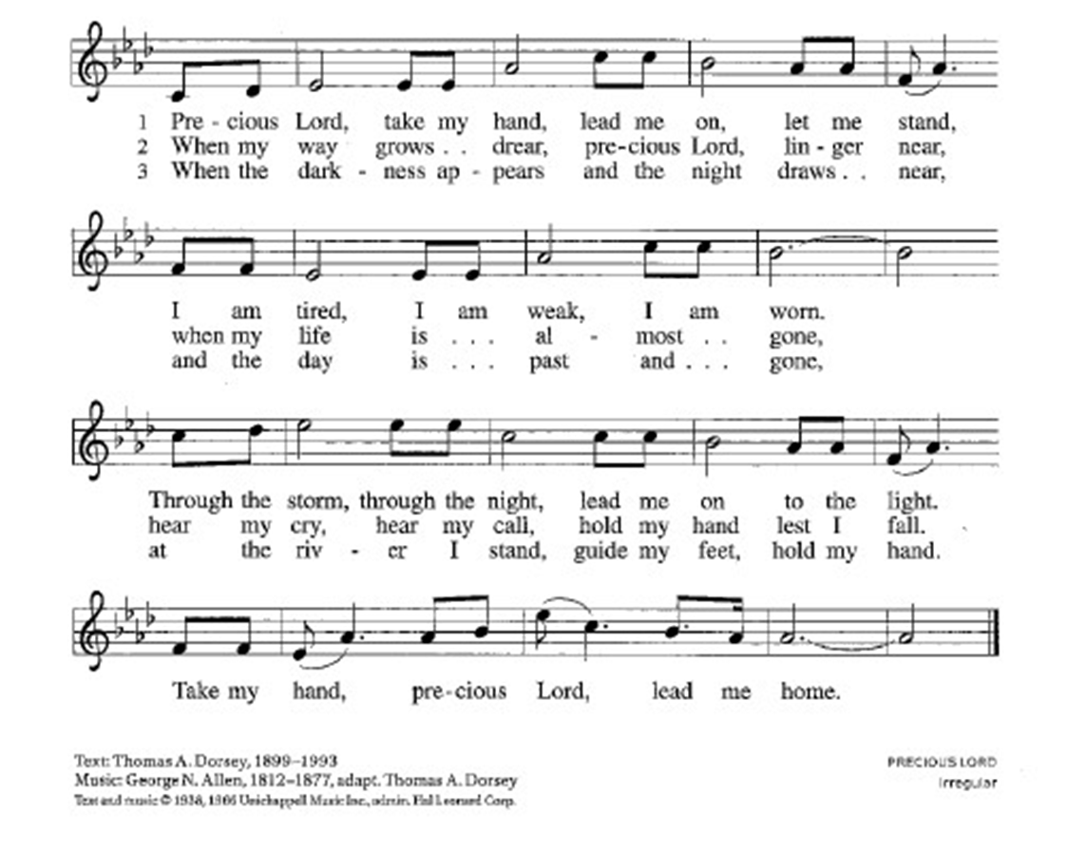
Precious Lord, Take My Hand ELW 773
Prayer After Communion
Generous Host,
you have shared your feast with us and made us new.
Send us now to set tables of love and grace in our communities,
that your liberating love might nourish the world into freedom,
in the name of the crucified one, Jesus Christ our Lord. Amen.

God blesses us and sends us in mission to the world.
SENDING

Blessing
God our tender parent,
God the crucified one,
God the reconciling Spirit,
☩ bless you now and forever. Amen.

Sending Song You Are the Way ELW 758

Dismissal
Go in peace. Care for others as God cares for you.
Thanks be to God.

