
Worship Plan for Sunday, October 11, 2026
20th Sunday After Pentecost
Women’s Sunday

The Holy Spirit calls us together as the people of God.
GATHERING

Prelude
Welcome/Announcements
Handbells ~ Inception
Reflection - Preparing for Worship
Sing 2x

Please stand.
Confession and Forgiveness
All may make the sign of the cross, the sign that is marked at baptism, as the presiding minister begins.

Blessed be the holy Trinity,☩ one God,
whose compassion endures forever.
Amen.

Let us confess our sin to God.
Silence is kept for reflection.

Compassionate God,
we confess to you all our sins.
Our burden is heavy, and we cannot free ourselves.
In your mercy, call us back to you.
Your yoke is easy and your burden is light.
Restore us to dwell in your peace.
In Christ’s name we pray,
Amen.

Jesus says, “Come to me,
all you who are weary
and are carrying heavy burdens,
and I will give you rest.”
In the name of God,
Father, ☩ Son, and Holy Spirit,
your sins are forgiven.
Rest in God’s love.
Amen.

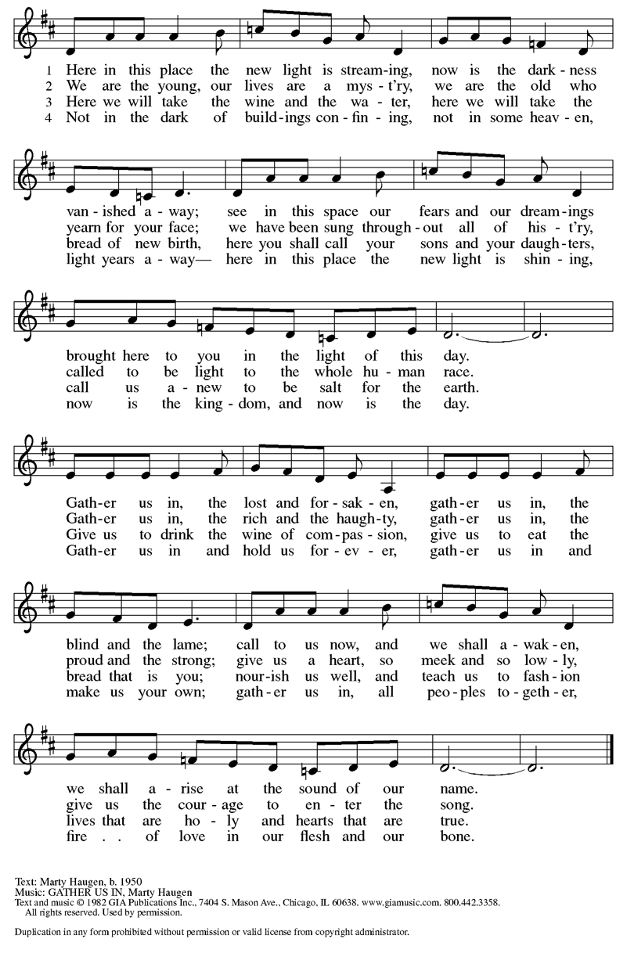
Gathering Song Gather Us In ELW 532
Greeting
The grace of our Lord Jesus Christ, the love of God
and the communion of the Holy Spirit be with you all.
And also, with you.

Prayer of the Day
Let us pray.
Lord of the feast, you have prepared a table before all peoples and poured out your life with abundance. Call us again to your banquet. Strengthen us by what is honorable, just, and pure, and transform us into a people of righteousness and peace, through Jesus Christ, our Savior and Lord.
Amen.

Please be seated.
God speaks to us in scripture reading, preaching, and song.
WORD

First Reading: Isaiah 25:1-9
A reading from Isaiah.
¹ O Lord, you are my God;
I will exalt you; I will praise your name,
for you have done wonderful things,
plans formed of old, faithful and sure.
² For you have made the city a heap,
the fortified city a ruin;
the palace of foreigners is a city no more;
it will never be rebuilt.
³ Therefore strong peoples will glorify you;
cities of ruthless nations will fear you.
⁴ For you have been a refuge to the poor,
a refuge to the needy in their distress,
a shelter from the rainstorm and a shade from the heat.
When the blast of the ruthless was like a winter rainstorm,
⁵ the noise of foreigners like heat in a dry place,
you subdued the heat with the shade of clouds;
the song of the ruthless was stilled.
⁶ On this mountain the Lord of hosts will make for all peoples
a feast of rich food, a feast of well-aged wines,
of rich food filled with marrow, of well-aged wines strained clear.
⁷ And he will destroy on this mountain
the shroud that is cast over all peoples,
the covering that is spread over all nations;
⁸ he will swallow up death forever.
Then the Lord God will wipe away the tears from all faces,
and the disgrace of his people he will take away from all the earth,
for the Lord has spoken.
⁹ It will be said on that day,
“See, this is our God; we have waited for him, so that he might save us.
This is the Lord for whom we have waited;
let us be glad and rejoice in his salvation.”
The word of the Lord.
Thanks be to God.

Psalm: Psalm 121
¹ I lift up my eyes | to the hills;
from where is my | help to come?
² My help comes | from the Lord,
the maker of heav- | en and earth. R
³ The Lord will not let your | foot be moved
nor will the one who watches over you | fall asleep.
⁴ Behold, the keep- | er of Israel
will neither slum- | ber nor sleep; R
⁵ the Lord watches | over you;
the Lord is your shade at | your right hand;
⁶ the sun will not strike | you by day,
nor the | moon by night. R
⁷ The Lord will preserve you | from all evil
and will | keep your life.
⁸ The Lord will watch over your going out and your | coming in,
from this time forth for- | evermore. R

Second Reading: Philippians 4:1-9
A reading from Philippians.
¹ My brothers and sisters, whom I love and long for, my joy and crown, stand firm in the Lord in this way, my beloved.
² I urge Euodia and I urge Syntyche to be of the same mind in the Lord. ³ Yes, and I ask you also, my loyal companion, help these women, for they have struggled beside me in the work of the gospel, together with Clement and the rest of my coworkers, whose names are in the book of life.
⁴ Rejoice in the Lord always; again I will say, Rejoice. ⁵ Let your gentleness be known to everyone. The Lord is near. ⁶ Do not be anxious about anything, but in everything by prayer and supplication with thanksgiving let your requests be made known to God. ⁷ And the peace of God, which surpasses all understanding, will guard your hearts and your minds in Christ Jesus.
⁸ Finally, brothers and sisters, whatever is true, whatever is honorable, whatever is just, whatever is pure, whatever is pleasing, whatever is commendable, if there is any excellence and if there is anything worthy of praise, think about these things. ⁹ As for the things that you have learned and received and heard and noticed in me, do them, and the God of peace will be with you.
The word of the Lord.
Thanks be to God.
Please stand.
Gospel Acclamation
Gospel: Matthew 22:1-14
The holy gospel according to Matthew.
Glory to you, O Lord.
¹ Once more Jesus spoke to them in parables, saying: ² “The kingdom of heaven may be compared to a king who gave a wedding banquet for his son. ³ He sent his slaves to call those who had been invited to the wedding banquet, but they would not come. ⁴ Again he sent other slaves, saying, ‘Tell those who have been invited: Look, I have prepared my dinner, my oxen and my fat calves have been slaughtered, and everything is ready; come to the wedding banquet.’ ⁵ But they made light of it and went away, one to his farm, another to his business, ⁶ while the rest seized his slaves, mistreated them, and killed them. ⁷ The king was enraged. He sent his troops, destroyed those murderers, and burned their city. ⁸ Then he said to his slaves, ‘The wedding is ready, but those invited were not worthy. ⁹ Go therefore into the main streets, and invite everyone you find to the wedding banquet.’ ¹⁰ Those slaves went out into the streets and gathered all whom they found, both good and bad, so the wedding hall was filled with guests.
¹¹ “But when the king came in to see the guests, he noticed a man there who was not wearing a wedding robe, ¹² and he said to him, ‘Friend, how did you get in here without a wedding robe?’ And he was speechless. ¹³ Then the king said to the attendants, ‘Bind him hand and foot, and throw him into the outer darkness, where there will be weeping and gnashing of teeth.’ ¹⁴ For many are called, but few are chosen.”
The gospel of the Lord.
Praise to you, O Christ.

Please be seated.
Children’s Message
Sermon
Please stand
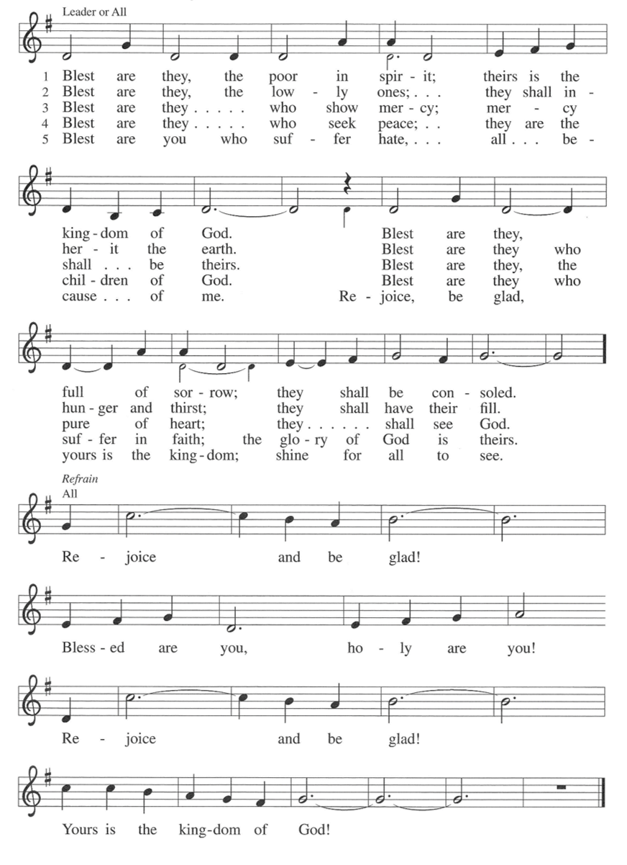
Hymn of the Day Blest are They ELW 728

Apostles’ Creed
Let us confess our faith to the words of the Apostles’ Creed
I believe in God, the Father almighty,
creator of heaven and earth.
I believe in Jesus Christ, God's only Son, our Lord,
who was conceived by the Holy Spirit,
born of the Virgin Mary,
suffered under Pontius Pilate,
was crucified, died, and was buried;
he descended to the dead.
On the third day he rose again;
he ascended into heaven,
he is seated at the right hand of the Father,
and he will come to judge the living and the dead.
I believe in the Holy Spirit,
the holy catholic Church,
the communion of saints,
the forgiveness of sins,
the resurrection of the body,
and the life everlasting. Amen

Please sit or kneel.
Prayers of Intercession
Seeking the Spirit of God who makes all things new, we pray for the church and the world.
Holy God, we remember your promise of unity on your holy mountain. Empower the World Council of Churches and all those working across religious difference, that the world may know your undivided love. Hear us, O God.
Your mercy is great.
We remember your promise of green pastures and quiet waters. Preserve all places of natural beauty and restore our relationship with the land. Hear us, O God.
Your mercy is great.
We remember your promise to not abandon us amid storm and disaster. Renew all communities facing disasters (regions in crisis may be named) and give your courage to those leading relief efforts. Hear us, O God.
Your mercy is great.
We remember your promise to wipe away every tear. Heal and console all who are sick or suffering (especially). Hear us, O God.
Your mercy is great.
We remember your promise of a banquet open to all people. Challenge this congregation to open wide our doors and welcome everyone to the table. Hear us, O God.
Your mercy is great.
We remember your promise to swallow up death forever. We give thanks for those who have gone before us. Hear us, O God.
Your mercy is great.
Trusting in your boundless grace, O God, we lift up these spoken prayers and those in our hearts; through Jesus Christ our Lord.
Amen.

Peace
The peace of Christ be with you always. And also, with you.

MEAL
God feeds us with the presence of Jesus Christ.

Please be seated.
Offering

Choir ~ One World, One Communion

Please stand.
Offertory Hymn Come, Bring Your Burdens to God ACS 1009
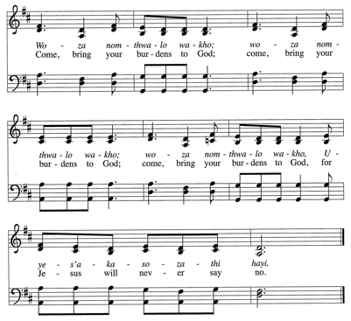
Sing 2x
Offertory Prayer
Lord of the harvest,
we return to you a portion of what you have given to us.
Turn us to set our hope not on the uncertainty of riches,
but on you, who richly provides for us.
Multiply what we have gathered
to bless all who are suffering and in need,
through Jesus Christ our Lord.
Amen.

The Great Thanksgiving

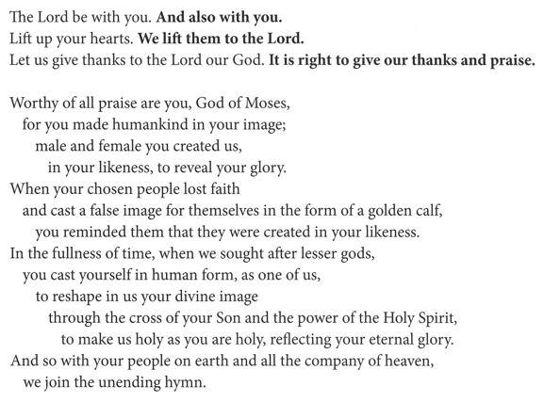

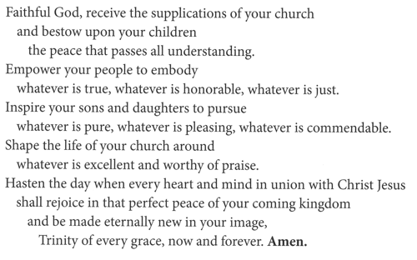
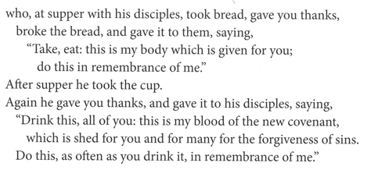
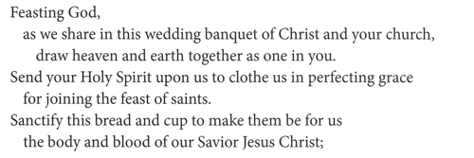
The Lord’s Prayer
Our Father, who art in heaven,
hallowed be thy name, thy kingdom come,
thy will be done, on earth as it is in heaven.
Give us this day our daily bread;
and forgive us our trespasses, as we forgive those who trespass against us;
and lead us not into temptation but deliver us from evil.
For thine is the kingdom,
and the power, and the glory, forever and ever.
Amen.

Invitation to Communion
Heaven has come near.
Come, share in the feast!

Please be seated.
Communion Hymns

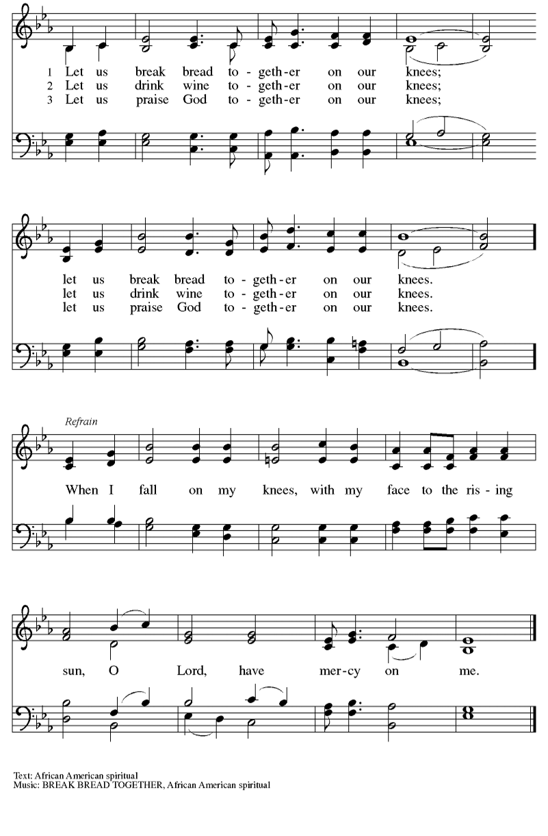
Let Us Break Bread Together ELW 471

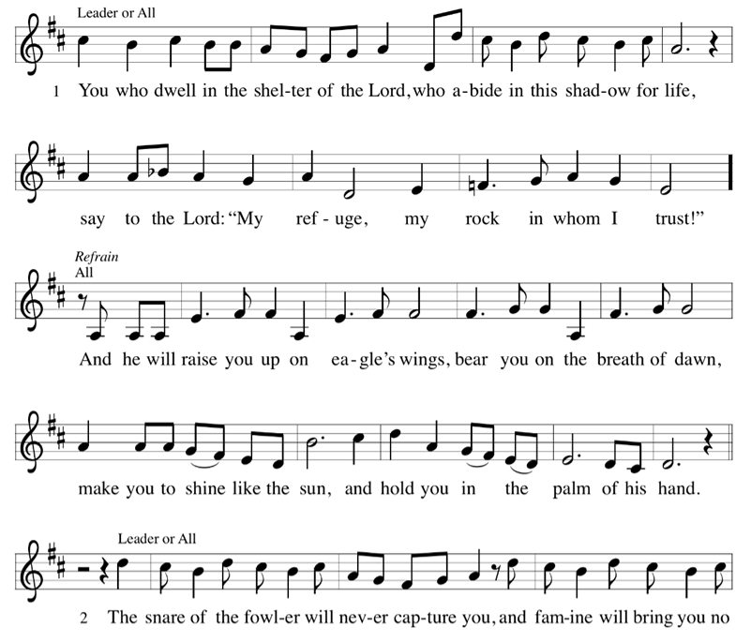
On Eagles Wings ELW 787
(continued on next page)

Prayer after Communion
Compassionate God,
through the gifts of bread and wine
our hearts are filled with the abundance of your love.
Strengthen us that we, through this holy meal,
may share your love freely, as you have shared with us.
We ask this in the name of Jesus,
through the Spirit nourishing us now and forever.
Amen.

God blesses us and sends us in mission to the world.
SENDING

Blessing
Creator, Redeemer, Sustainer,
☩ one God,
bless, heal, and hold you
today and always.
Amen.

SENDING SONG Rejoice, Ye Pure in Heart! ELW 873

Dismissal
Heaven has come near. Go, share the good news!
Thanks be to God.

From sundaysandseasons.com.
Copyright © 2026 Augsburg Fortress. All rights reserved.

