
Worship Plan for Sunday, June 21, 2026
4th Sunday After Pentecost

The Holy Spirit calls us together as the people of God.
GATHERING

Prelude
Welcome/Announcements
Reflection - Preparing for Worship
Sing 2X

Please stand.
Confession and Forgiveness
All may make the sign of the cross, the sign that is marked at baptism, as the presiding minister begins.

Blessed be the holy Trinity,☩ one God,
whose compassion endures forever.
Amen.

Let us confess our sin to God.
Silence is kept for reflection.

Compassionate God,
we confess to you all our sins.
Our burden is heavy, and we cannot free ourselves.
In your mercy, call us back to you.
Your yoke is easy and your burden is light.
Restore us to dwell in your peace.
In Christ’s name we pray,
Amen.

Jesus says, “Come to me,
all you who are weary
and are carrying heavy burdens,
and I will give you rest.”
In the name of God,
Father, ☩ Son, and Holy Spirit,
your sins are forgiven.
Rest in God’s love.
Amen.

Gathering Song This is My Father’s World ELW 824

Greeting
The grace of our Lord Jesus Christ, the love of God
and the communion of the Holy Spirit be with you all.
And also, with you.

Hymn of Praise

Prayer of the Day
Let us pray.
Teach us, good Lord God, to serve you as you deserve, to give and not to count the cost, to fight and not to heed the wounds, to toil and not to seek for rest, to labor and not to ask for reward, except that of knowing that we do your will, through Jesus Christ, our Savior and Lord.
Amen.

Please be seated.
God speaks to us in scripture reading, preaching, and song.
WORD

First Reading: Jeremiah 20:7-13
A reading from Jeremiah.
⁷ O Lord, you have enticed me,
and I was enticed;
you have overpowered me,
and you have prevailed.
I have become a laughingstock all day long;
everyone mocks me.
⁸ For whenever I speak, I must cry out;
I must shout, “Violence and destruction!”
For the word of the Lord has become for me
a reproach and derision all day long.
⁹ If I say, “I will not mention him
or speak any more in his name,”
then within me there is something like a burning fire
shut up in my bones;
I am weary with holding it in,
and I cannot.
¹⁰ For I hear many whispering:
“Terror is all around!
Denounce him! Let us denounce him!”
All my close friends
are watching for me to stumble.
“Perhaps he can be enticed,
and we can prevail against him
and take our revenge on him.”
¹¹ But the Lord is with me like a terrifying warrior;
therefore my persecutors will stumble,
and they will not prevail.
They will be greatly shamed,
for they will not succeed.
Their eternal dishonor
will never be forgotten.
¹² O Lord of hosts, you test the righteous;
you see the heart and the mind;
let me see your retribution upon them,
for to you I have committed my cause.
¹³ Sing to the Lord;
praise the Lord!
For he has delivered the life of the needy
from the hands of evildoers.
The word of the Lord.
Thanks be to God.

Psalm: Psalm 69:7-10 [11-15] 16-18
⁷ Surely, for your sake I have suf- | fered reproach,
and shame has cov- | ered my face.
⁸ I have become a stranger to | my own kindred,
an alien to my | mother’s children.
⁹ Zeal for your house has eat- | en me up;
the scorn of those who scorn you has fall- | en upon me.
¹⁰ I humbled my- | self with fasting,
but that was turned to | my reproach. R
¹⁶ Answer me, O Lord, for your | love is kind;
in your great compassion, | turn to me.
¹⁷ Hide not your face | from your servant;
be swift and answer me, for I am | in distress.
¹⁸ Draw near to me | and redeem me;
because of my enemies de- | liver me. R

Second Reading: Romans 6:1b-11
A reading from Romans.
^{1b} Should we continue in sin in order that grace may increase? ² By no means! How can we who died to sin go on living in it? ³ Do you not know that all of us who were baptized into Christ Jesus were baptized into his death? ⁴ Therefore we were buried with him by baptism into death, so that, just as Christ was raised from the dead by the glory of the Father, so we also might walk in newness of life.
⁵ For if we have been united with him in a death like his, we will certainly be united with him in a resurrection like his. ⁶ We know that our old self was crucified with him so that the body of sin might be destroyed, so we might no longer be enslaved to sin. ⁷ For whoever has died is freed from sin. ⁸ But if we died with Christ, we believe that we will also live with him. ⁹ We know that Christ, being raised from the dead, will never die again; death no longer has dominion over him. ¹⁰ The death he died, he died to sin once for all, but the life he lives, he lives to God. ¹¹ So you also must consider yourselves dead to sin and alive to God in Christ Jesus.
The word of the Lord.
Thanks be to God.
Please stand.
Gospel Acclamation

Gospel: Matthew 10:24-39
The holy gospel according to Matthew.
Glory to you, O Lord.
[Jesus said to the twelve:] ²⁴ “A disciple is not above the teacher nor a slave above the master; ²⁵ it is enough for the disciple to be like the teacher and the slave like the master. If they have called the master of the house Beelzebul, how much more will they malign those of his household!
²⁶ “So have no fear of them, for nothing is covered up that will not be uncovered and nothing secret that will not become known. ²⁷ What I say to you in the dark, tell in the light, and what you hear whispered, proclaim from the housetops. ²⁸ Do not fear those who kill the body but cannot kill the soul; rather, fear the one who can destroy both soul and body in hell. ²⁹ Are not two sparrows sold for a penny? Yet not one of them will fall to the ground apart from your Father. ³⁰ And even the hairs of your head are all counted. ³¹ So do not be afraid; you are of more value than many sparrows.
³² “Everyone, therefore, who acknowledges me before others, I also will acknowledge before my Father in heaven, ³³ but whoever denies me before others, I also will deny before my Father in heaven.
³⁴ “Do not think that I have come to bring peace to the earth; I have not come to bring peace but a sword.
³⁵ For I have come to set a man against his father,
and a daughter against her mother,
and a daughter-in-law against her mother-in-law,
³⁶ and one’s foes will be members of one’s own household.
³⁷ “Whoever loves father or mother more than me is not worthy of me, and whoever loves son or daughter more than me is not worthy of me, ³⁸ and whoever does not take up the cross and follow me is not worthy of me. ³⁹ Those who find their life will lose it, and those who lose their life for my sake will find it.”
The gospel of the Lord.
Praise to you, O Christ.

Please be seated.
Children’s Message

Sermon

Please stand.

Hymn of the Day How Firm a Foundation ELW 796

Apostles’ Creed
Let us confess our faith to the words of the Apostles’ Creed
I believe in God, the Father almighty,
creator of heaven and earth.
I believe in Jesus Christ, God's only Son, our Lord,
who was conceived by the Holy Spirit,
born of the Virgin Mary,
suffered under Pontius Pilate,
was crucified, died, and was buried;
he descended to the dead.
On the third day he rose again;
he ascended into heaven,
he is seated at the right hand of the Father,
and he will come to judge the living and the dead.
I believe in the Holy Spirit,
the holy catholic Church,
the communion of saints,
the forgiveness of sins,
the resurrection of the body,
and the life everlasting. Amen

Please sit or kneel.
Prayers of Intercession
Gathered together by the Holy Spirit, let us pray for the church and the needs of the world.
Life-giving God, you have called your people to lose their lives for Jesus’ sake. Strengthen your church to follow you in the face of difficulty. God of grace,
hear our prayer.
Creator God, you know every sparrow that falls to the ground. Protect migrating birds, endangered species, and their natural habitats. Empower us to care for your creation. God of grace,
hear our prayer.
Sovereign God, you call us to act justly and love mercy. Protect those with marginalized identities to whom we have not shown the abounding love of Jesus. Bring an end to oppression and bigotry in all forms. God of grace,
hear our prayer.
Sustaining God, you promise to provide for us. Help those living with disability. Comfort those experiencing any sort of illness or suffering (especially). God of grace,
hear our prayer.
Empowering God, strengthen us to live out our diverse callings. We pray especially for fathers and father figures, that they show your compassion and care. We pray for all for whom this day is difficult or painful. God of grace,
hear our prayer.
Faithful God, we give thanks for saints (like Onesimos Nesib) who have claimed their baptismal promises. May we follow their example of faith and service. God of grace,
hear our prayer.
Trusting you receive all our prayers, we commend our spoken and unspoken prayers to you, O God, through Jesus our Savior.
Amen.
Peace
The peace of Christ be with you always. And also, with you.

MEAL
God feeds us with the presence of Jesus Christ.
Please be seated.
Offering

Special Music Jake Turnmire

Please stand.
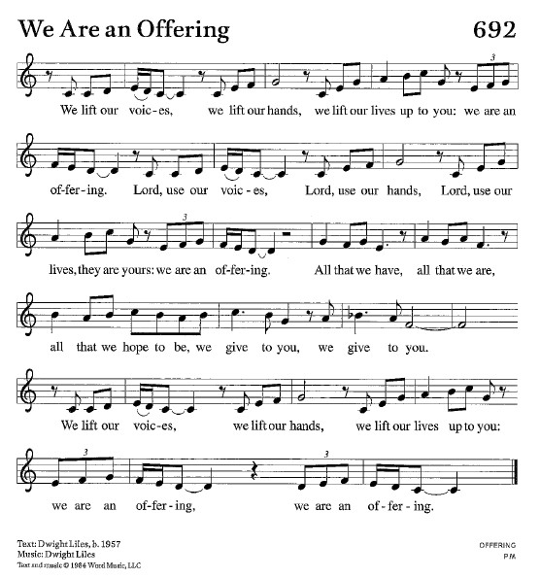
Offertory Hymn We Are An Offering ELW 692
Offertory Prayer
Lord of the harvest,
we return to you a portion of what you have given to us.
Turn us to set our hope not on the uncertainty of riches,
but on you, who richly provides for us.
Multiply what we have gathered
to bless all who are suffering and in need,
through Jesus Christ our Lord.
Amen.

The Great Thanksgiving
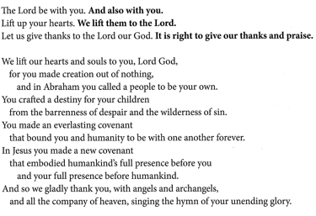
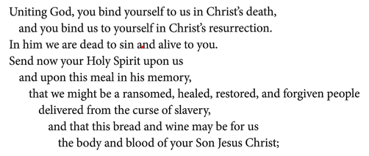
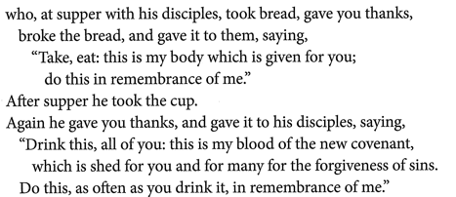
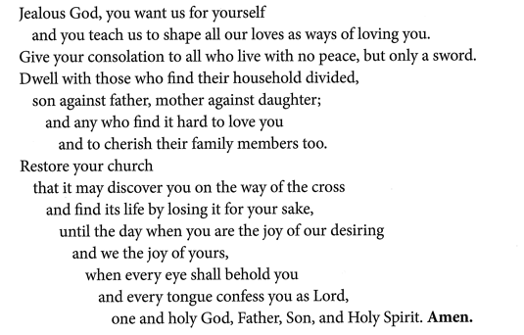
The Lord’s Prayer
Our Father, who art in heaven,
hallowed be thy name, thy kingdom come,
thy will be done, on earth as it is in heaven.
Give us this day our daily bread;
and forgive us our trespasses, as we forgive those who trespass against us;
and lead us not into temptation but deliver us from evil.
For thine is the kingdom,
and the power, and the glory, forever and ever.
Amen.

Invitation to Communion
Heaven has come near.
Come, share in the feast!

Please be seated.
Communion Hymns

Borning Cry ELW 732

Day by Day ELW 790

Prayer after Communion
Compassionate God,
through the gifts of bread and wine
our hearts are filled with the abundance of your love.
Strengthen us that we, through this holy meal,
may share your love freely, as you have shared with us.
We ask this in the name of Jesus,
through the Spirit nourishing us now and forever.
Amen.

God blesses us and sends us in mission to the world.
SENDING

Blessing
Creator, Redeemer, Sustainer,
☩ one God,
bless, heal, and hold you
today and always.
Amen.

Sending Song On Our Way Rejoicing ELW 537
Dismissal
Heaven has come near. Go, share the good news!
Thanks be to God.
Copyright © 2026 Augsburg Fortress. All rights reserved.

