
Worship Plan for Sunday, March 1, 2026
Second Sunday in Lent

The Holy Spirit calls us together as the people of God.
GATHERING

Prelude
Welcome/Announcements
Handbells - Nearer My God To Thee
Reflection - Preparing for Worship
Sing 2x

Please stand.
Confession and Forgiveness
All make the sign of the cross, the sign that is marked at baptism, as the presiding minister begins.
Blessed be the holy Trinity, ☩ one God,
who forgives all our sin,
whose mercy endures forever.
Amen.

Let us return to God, confessing our sin in the assurance of God’s abiding love.
Silence is kept for reflection.

Compassionate One,
you are slow to anger and abounding in steadfast love,
but our lives do not always reflect you
and your love for the world.
We do not show others the tender compassion
you have shown to us.
We do not welcome others with the radical hospitality
you grant to all people.
We oppress others,
even though you have set us free again and again.
We squander the abundant gifts of the earth.
Transform our lives
and guide us again in the way of the cross.
Amen.

Beloved in Christ,
God’s arms are always stretched open wide
to welcome the wandering ones home.
In ☩ Christ your sins are forgiven.
You have a place in God’s house forever.
Amen.

Gathering Song What Wondrous Love Is This ELW 666

Greeting
The grace of our Lord Jesus Christ, the love of God
and the communion of the Holy Spirit be with you all.
And also, with you.

Kyrie

Your Heart, O God is Grieved

Prayer of the Day
Let us pray.
O God, our leader and guide, in the waters of baptism you bring us to new birth to live as your children. Strengthen our faith in your promises, that by your Spirit we may lift up your life to all the world through your Son, Jesus Christ, our Savior and Lord, who lives and reigns with you and the Holy Spirit, one God, now and forever.
Amen.

Please be seated.
God speaks to us in scripture reading, preaching, and song.
WORD

First Reading: Genesis 12:1-4a
A reading from Genesis.
¹ The Lord said to Abram, “Go from your country and your kindred and your father’s house to the land that I will show you. ² I will make of you a great nation, and I will bless you and make your name great, so that you will be a blessing. ³ I will bless those who bless you, and the one who curses you I will curse, and in you all the families of the earth shall be blessed.”
^{4a} So Abram went, as the Lord had told him, and Lot went with him.
The word of the Lord.
Thanks be to God.

Psalm: Psalm 121
¹ I lift up my eyes | to the hills;
from where is my | help to come?
² My help comes | from the Lord,
the maker of heav- | en and earth.
³ The Lord will not let your | foot be moved
nor will the one who watches over you | fall asleep.
⁴ Behold, the keep- | er of Israel
will neither slum- | ber nor sleep; R
⁵ the Lord watches | over you;
the Lord is your shade at | your right hand;
⁶ the sun will not strike | you by day,
nor the | moon by night.
⁷ The Lord will preserve you | from all evil
and will | keep your life.
⁸ The Lord will watch over your going out and your | coming in,
from this time forth for- | evermore. R

Second Reading: Romans 4:1-5, 13-17
A reading from Romans.
¹ What then are we to say was gained by Abraham, our ancestor according to the flesh? ² For if Abraham was justified by works, he has something to boast about, but not before God. ³ For what does the scripture say? “Abraham believed God, and it was reckoned to him as righteousness.” ⁴ Now to one who works, wages are not reckoned as a gift but as something due. ⁵ But to one who does not work but trusts him who justifies the ungodly, such faith is reckoned as righteousness.
¹³ For the promise that he would inherit the world did not come to Abraham or to his descendants through the law but through the righteousness of faith. ¹⁴ For if it is the adherents of the law who are to be the heirs, faith is null and the promise is void. ¹⁵ For the law brings wrath, but where there is no law, neither is there transgression.
¹⁶ For this reason the promise depends on faith, in order that it may rest on grace, so that it may be guaranteed to all his descendants, not only to the adherents of the law but also to those who share the faith of Abraham (who is the father of all of us, ¹⁷ as it is written, “I have made you the father of many nations”), in the presence of the God in whom he believed, who gives life to the dead and calls into existence the things that do not exist.
The word of the Lord.
Thanks be to God.
Please stand.

Gospel: John 3:1-17
The holy gospel according to John.
Glory to you, O Lord.
¹ Now there was a Pharisee named Nicodemus, a leader of the Jews. ² He came to Jesus by night and said to him, “Rabbi, we know that you are a teacher who has come from God, for no one can do these signs that you do unless God is with that person.” ³ Jesus answered him, “Very truly, I tell you, no one can see the kingdom of God without being born from above.” ⁴ Nicodemus said to him, “How can anyone be born after having grown old? Can one enter a second time into the mother’s womb and be born?” ⁵ Jesus answered, “Very truly, I tell you, no one can enter the kingdom of God without being born of water and Spirit. ⁶ What is born of the flesh is flesh, and what is born of the Spirit is spirit. ⁷ Do not be astonished that I said to you, ‘You must be born from above.’ ⁸ The wind blows where it chooses, and you hear the sound of it, but you do not know where it comes from or where it goes. So it is with everyone who is born of the Spirit.” ⁹ Nicodemus said to him, “How can these things be?” ¹⁰ Jesus answered him, “Are you the teacher of Israel, and yet you do not understand these things?
¹¹ “Very truly, I tell you, we speak of what we know and testify to what we have seen, yet you do not receive our testimony. ¹² If I have told you about earthly things and you do not believe, how can you believe if I tell you about heavenly things? ¹³ No one has ascended into heaven except the one who descended from heaven, the Son of Man. ¹⁴ And just as Moses lifted up the serpent in the wilderness, so must the Son of Man be lifted up, ¹⁵ that whoever believes in him may have eternal life.
¹⁶ “For God so loved the world that he gave his only Son, so that everyone who believes in him may not perish but may have eternal life.
¹⁷ “Indeed, God did not send the Son into the world to condemn the world but in order that the world might be saved through him.”
The gospel of the Lord.
Praise to you, O Christ.

Please be seated.

Children’s Message

Sermon

Please stand.
Hymn of the Day God Loved the World ELW 323

Apostles’ Creed
Let us confess our faith to the words of the Apostles’ Creed
I believe in God, the Father almighty,
creator of heaven and earth.
I believe in Jesus Christ, God’s only Son, our Lord,
who was conceived by the Holy Spirit,
born of the virgin Mary,
suffered under Pontius Pilate,
was crucified, died, and was buried;
he descended to the dead.*
On the third day he rose again;
he ascended into heaven,
he is seated at the right hand of the Father,
and he will come to judge the living and the dead.
I believe in the Holy Spirit,
the holy catholic church,
the communion of saints,
the forgiveness of sins,
the resurrection of the body,
and the life everlasting. Amen.

Please sit or kneel.
Prayers of Intercession
Reconciled by God’s mercy and sustained by God’s presence, let us pray for the world and its needs.
Faithful One, you renew us by grace. As you have inspired faith through the work of church artists and hymnwriters throughout the ages (like George Herbert whom the church remembers today), give your church the means to praise your beauty today. Hear us, O God.
Your mercy is great.
Living One, you delight in this world. The sun and moon, the wind and the water declare your goodness. Preserve this earth, and protect conservationists, scientists, and all who labor in service to creation. Hear us, O God.
Your mercy is great.
Ruling One, you bless us to be a blessing. Open the hearts of all leaders to seek the flourishing of every person and lend your help to all who wait for justice, deliverance, and peace. Hear us, O God.
Your mercy is great.
Compassionate One, you send your Son to save. Declare your word of acceptance to any who feel condemned and lift up any brought low by hatred and exclusion. Tend to all who are struggling with illness or loss (especially). Hear us, O God.
Your mercy is great.
Guiding One, you watch over our going out and coming in. Bless newcomers and new members in this assembly (especially) and accompany those who have recently left this community to journey elsewhere (especially). Hear us, O God.
Your mercy is great.
Eternal One, you neither slumber nor sleep. Be our keeper in life and in death. Thank you for our beloved who have died, and for your promise which saves this whole world by your love. Hear us, O God.
Your mercy is great.
Receive our prayers, O God, through Jesus Christ, our strength and salvation.
Amen.

Peace
The peace of Christ be with you always.
And also, with you.

God feeds us with the presence of Jesus Christ.
MEAL

Please be seated.
Offering

Choir – Prayer of Communion

Please stand.
Offertory Hymn Come, Bring Your Burdens ACS 1009

Offertory Prayer
Let us pray
Gracious Provider,
you set your immense treasures among us,
opening your heart to the world.
As we prepare to feast on your bountiful love,
deepen our commitment to sharing those
treasures with others,
through our Savior, Jesus Christ.
Amen.

The Great Thanksgiving

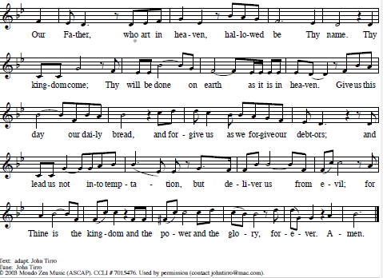
The Lord’s Prayer

Invitation to Communion
All who are hungry, come!
The feast of grace is spread.
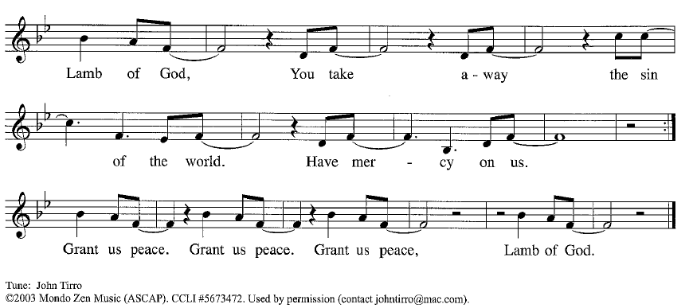
Please be seated.
Communion Hymns We Are Baptized in Christ Jesus ELW 451

Christ Is the Life ACS 927

Prayer After Communion
Generous Host,
you have shared your feast with us and made us new.
Send us now to set tables of love and grace in our communities,
that your liberating love might nourish the world into freedom,
in the name of the crucified one, Jesus Christ our Lord. Amen.

God blesses us and sends us in mission to the world.
SENDING

Blessing
God our tender parent,
God the crucified one,
God the reconciling Spirit,
☩ bless you now and forever. Amen.

Sending Song When I Survey the Wondrous Cross ELW 803

Dismissal
Go in peace. Care for others as God cares for you.
Thanks be to God.

