
Worship Plan for Sunday, April 5, 2026
Resurrection of Our Lord: Easter Day

The Holy Spirit calls us together as the people of God.
GATHERING
Welcome & Announcements
Prelude -Hand bells – All Creatures of Our God and King

Thanksgiving
Alleluia! Christ is risen.
Christ is risen indeed. Alleluia!

Just as God’s work of creation never ends,
so the gifts received in baptism are renewed every day.
Let us give thanks together for the life given in baptism.
We give you thanks, O God, for the waters of life:
for water to bathe in, water to drink,
for waters to play in and waters that inspire wonder,
for water that gives life to our planet.
We give you thanks, O God, for the waters of life.

We give you thanks, O God, for the waters of this place:
for water from our tap, for rain [and snow],
for [local water sources may be named].
We give you thanks, O God, for the waters of this place.

We give you thanks for your salvation through water:
for delivering Noah and his family through the floodwaters,
for leading your people Israel through the sea into freedom,
for preserving your prophet Elijah through the time of drought,
for guiding your people across the Jordan into a new land,
for quenching the Samaritan woman’s thirst with living water.
We give you thanks for your salvation through water.

We give you thanks for the life of all the baptized,
and for all who gather here;
for godparents and baptismal sponsors,
for children and grandchildren, for our brothers and sisters in Christ whom we have never seen but to whom we are bound.
We give you thanks for the life of all the baptized.

We give you thanks for life in Christ through your Holy Spirit:
for our entry into Jesus’ death through these waters,
for our new birth into a life of freedom and service,
for our calling to be your people, sent out for the life of the world.
We give you thanks, blessed and holy Trinity, now and forever. Amen.

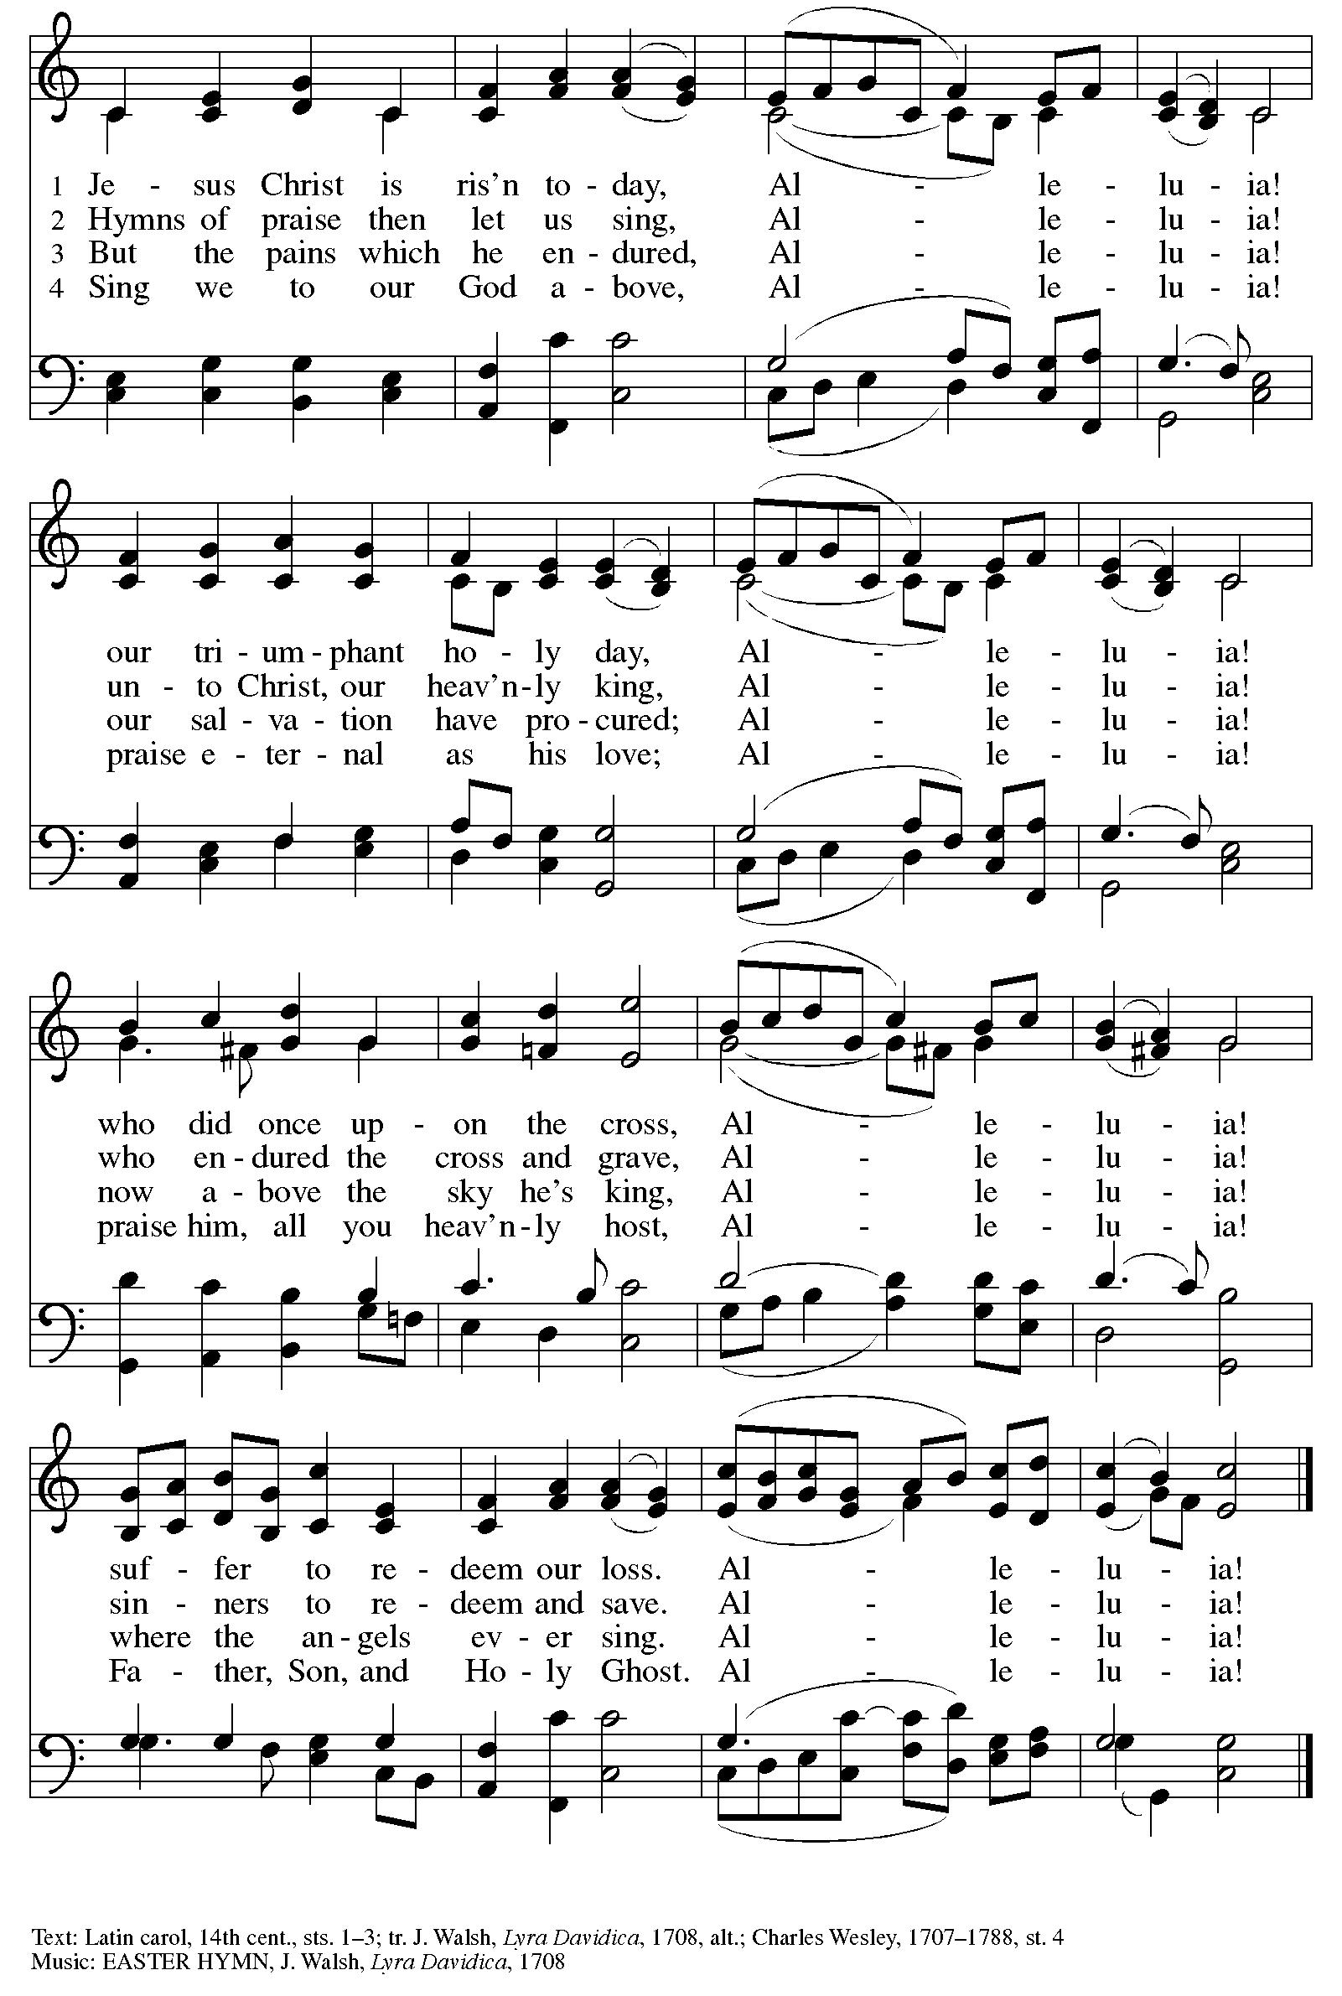
Gathering Song Jesus Christ Is Risen Today ELW 365
Greeting
The grace of our Lord Jesus Christ, the love of God,
and the communion of the Holy Spirit be with you all.
And also with you.

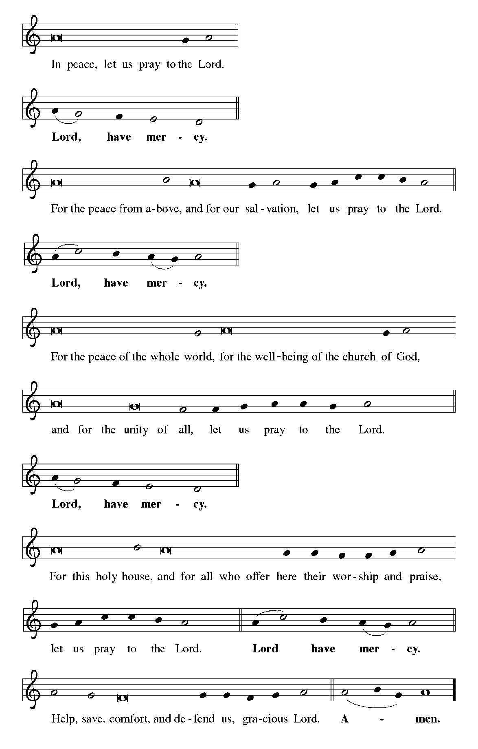
Kyrie

Canticle of Praise
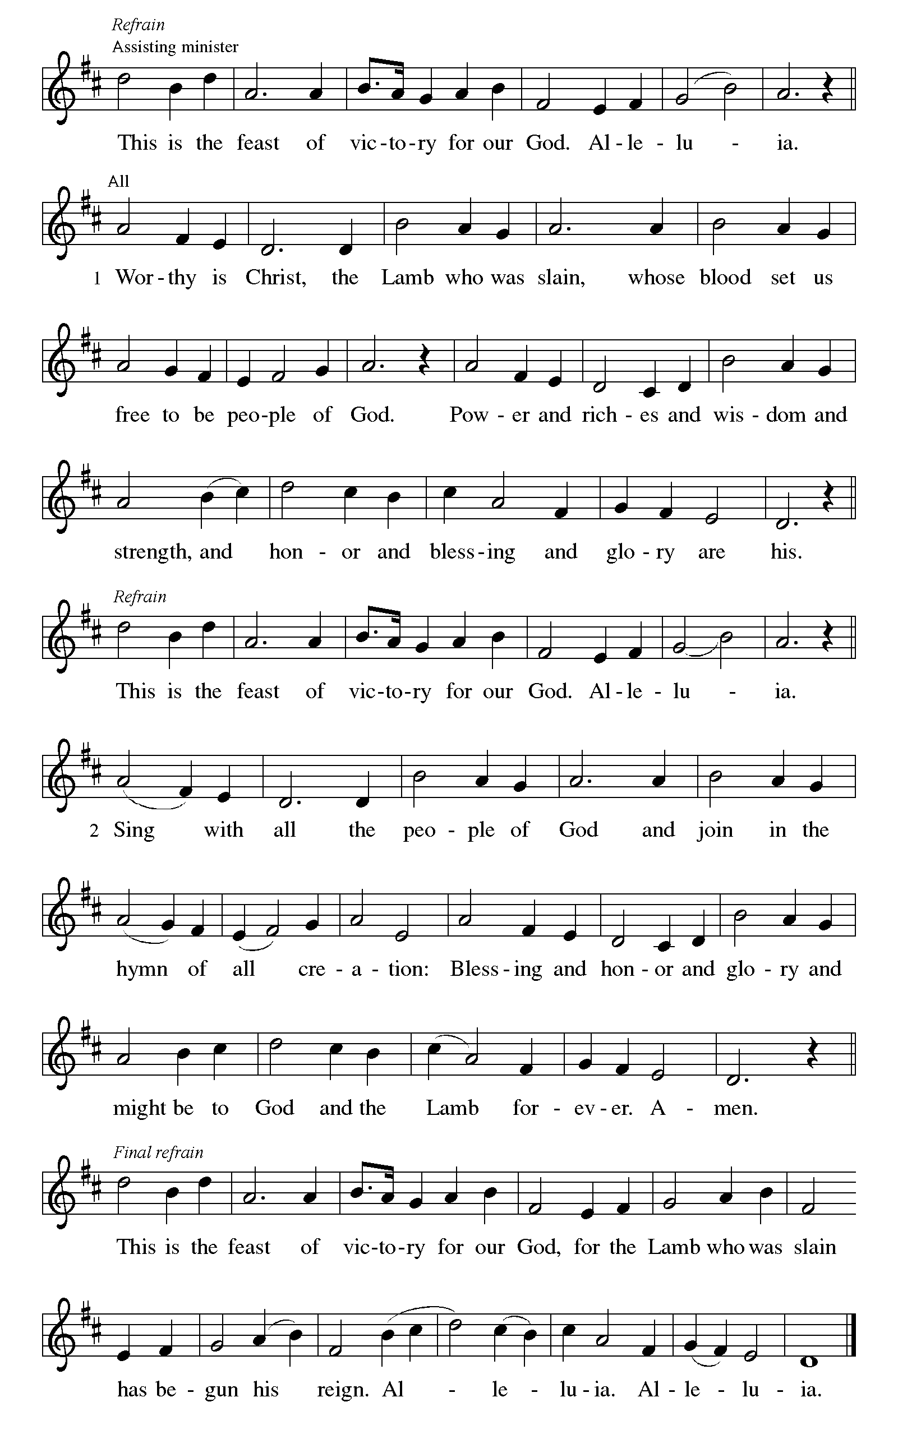

Prayer of the Day
Let us pray.
O God, you gave your only Son to suffer death on the cross for our redemption, and by his glorious resurrection you delivered us from the power of death. Make us die every day to sin, that we may live with him forever in the joy of the resurrection, through your Son, Jesus Christ our Lord, who lives and reigns with you and the Holy Spirit, one God, now and forever.
Amen.
God speaks to us in scripture reading, preaching, and song.
WORD
First Reading: Acts 10:34-43
A reading from Acts.
³⁴ Peter began to speak to [Cornelius and his household]: “I truly understand that God shows no partiality, ³⁵ but in every people anyone who fears him and practices righteousness is acceptable to him. ³⁶ You know the message he sent to the people of Israel, preaching peace by Jesus Christ—he is Lord of all. ³⁷ That message spread throughout Judea, beginning in Galilee after the baptism that John announced: ³⁸ how God anointed Jesus of Nazareth with the Holy Spirit and with power; how he went about doing good and healing all who were oppressed by the devil, for God was with him. ³⁹ We are witnesses to all that he did both in Judea and in Jerusalem. They put him to death by hanging him on a tree, ⁴⁰ but God raised him on the third day and allowed him to appear, ⁴¹ not to all the people but to us who were chosen by God as witnesses and who ate and drank with him after he rose from the dead. ⁴² He commanded us to preach to the people and to testify that he is the one ordained by God as judge of the living and the dead. ⁴³ All the prophets testify about him that everyone who believes in him receives forgiveness of sins through his name.”
The word of the Lord.
Thanks be to God.

Psalm: Psalm 118:1-2, 14-24
¹ Give thanks to the Lord, for the | Lord is good;
God’s mercy en- | dures forever.
² Let Israel | now declare,
“God’s mercy en- | dures forever.”
¹⁴ The Lord is my strength | and my song,
and has become | my salvation.
¹⁵ Shouts of rejoicing and salvation echo in the tents | of the righteous:
“The right hand of the | Lord acts valiantly!
¹⁶ The right hand of the Lord | is exalted!
The right hand of the | Lord acts valiantly!”
¹⁷ I shall not | die, but live,
and declare the works | of the Lord. R
¹⁸ The Lord indeed pun- | ished me sorely,
but did not hand me o- | ver to death.
¹⁹ Open for me the | gates of righteousness;
I will enter them and give thanks | to the Lord.
²⁰ “This is the gate | of the Lord;
here the righ- | teous may enter.”
²¹ I give thanks to you, for you have | answered me
and you have become | my salvation. R
²² The stone that the build- | ers rejected
has become the chief | cornerstone.
²³ By the Lord has | this been done;
it is marvelous | in our eyes.
²⁴ This is the day that the | Lord has made;
let us rejoice and be | glad in it. R

Second Reading: Colossians 3:1-4
A reading from Colossians.
¹ If you have been raised with Christ, seek the things that are above, where Christ is, seated at the right hand of God. ² Set your minds on the things that are above, not on the things that are on earth, ³ for you have died, and your life is hidden with Christ in God. ⁴ When Christ who is your life is revealed, then you also will be revealed with him in glory.
The word of the Lord.
Thanks be to God.

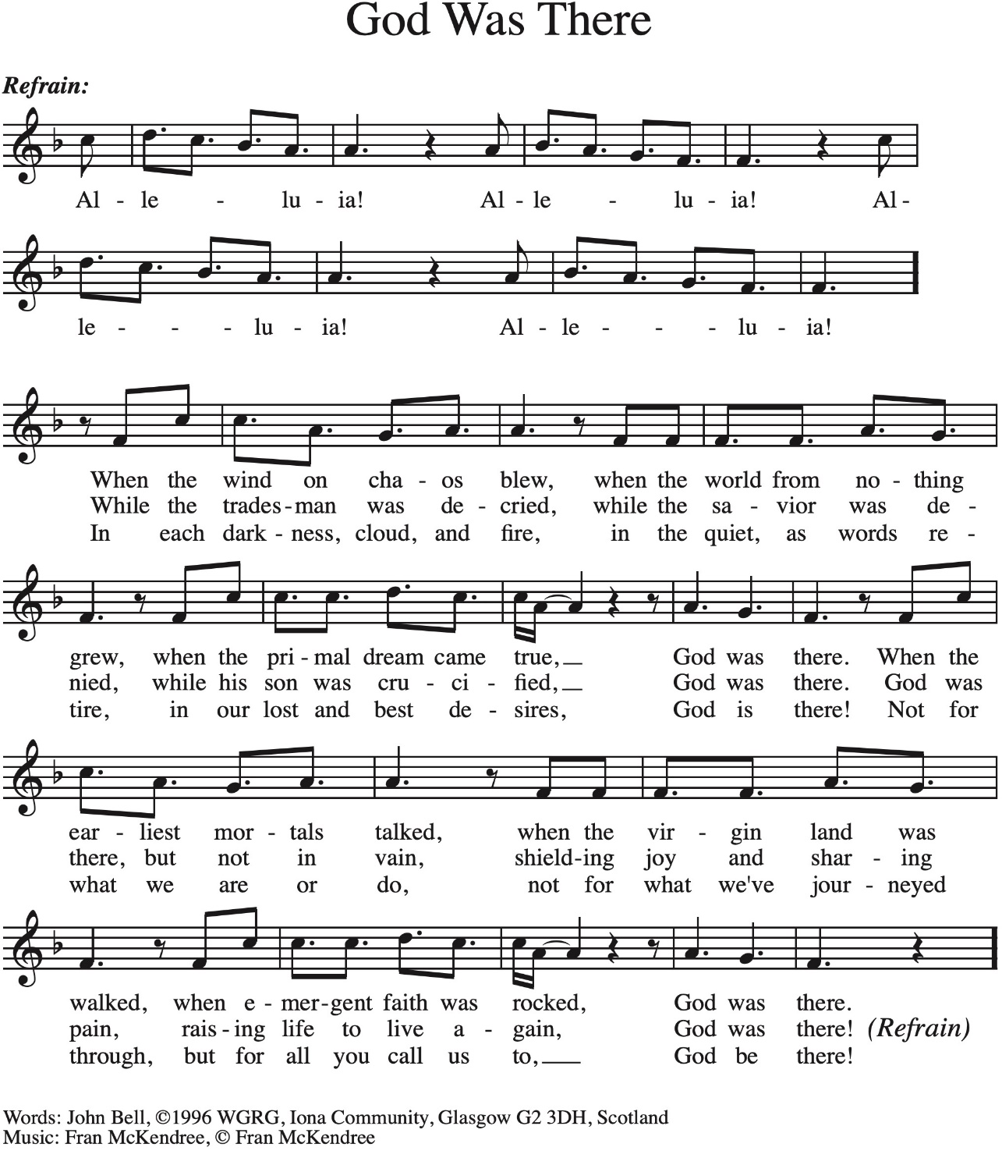
Gospel Processional God Was There Vs 1-2

Gospel: Matthew 28:1-10
The holy gospel according to Matthew.
Glory to you, O Lord.
¹ After the Sabbath, as the first day of the week was dawning, Mary Magdalene and the other Mary went to see the tomb. ² And suddenly there was a great earthquake, for an angel of the Lord, descending from heaven, came and rolled back the stone and sat on it. ³ His appearance was like lightning and his clothing white as snow. ⁴ For fear of him the guards shook and became like dead men. ⁵ But the angel said to the women, “Do not be afraid, for I know that you are looking for Jesus who was crucified. ⁶ He is not here, for he has been raised, as he said. Come, see the place where he lay. ⁷ Then go quickly and tell his disciples, ‘He has been raised from the dead, and indeed he is going ahead of you to Galilee; there you will see him.’ This is my message for you.” ⁸ So they left the tomb quickly with fear and great joy and ran to tell his disciples. ⁹ Suddenly Jesus met them and said, “Greetings!” And they came to him, took hold of his feet, and worshiped him. ¹⁰ Then Jesus said to them, “Do not be afraid; go and tell my brothers and sisters to go to Galilee; there they will see me.”
The gospel of the Lord.
Praise to you, O Christ.

Gospel Processional God Was There Vs 3

Please be seated.
Children’s Message

Sermon
Hymn of the Day Christ Is Risen! Alleluia! ELW 382

Nicene Creed
A: Let us profess our faith to the words of the Nicene creed
We believe in one God,
the Father, the Almighty,
maker of heaven and earth,
of all that is, seen and unseen.
We believe in one Lord, Jesus Christ,
the only Son of God,
eternally begotten of the Father,
God from God, Light from Light,
true God from true God,
begotten, not made,
of one Being with the Father;
through him all things were made.
For us and for our salvation
he came down from heaven,
was incarnate of the Holy Spirit and the virgin Mary
and became truly human.
For our sake he was crucified under Pontius Pilate;
he suffered death and was buried.
On the third day he rose again
in accordance with the scriptures;
he ascended into heaven
and is seated at the right hand of the Father.
He will come again in glory to judge the living and the dead,
and his kingdom will have no end.
We believe in the Holy Spirit, the Lord, the giver of life,
who proceeds from the Father and the Son,*
who with the Father and the Son is worshiped and glorified,
who has spoken through the prophets.
We believe in one holy catholic and apostolic church.
We acknowledge one baptism for the forgiveness of sins.
We look for the resurrection of the dead,
and the life of the world to come. Amen.

Prayers of Intercession
Trusting in the power of Christ’s resurrection to heal and redeem our broken world, let us pray for the needs of all creation.
Risen Savior, you have conquered death and opened the gates of everlasting life. Dispel our doubts and fears and renew our faith and hope in you. Merciful God,
receive our prayer.
Life-giving God, the created world rejoices in Christ’s victory over death. May all the earth be renewed by the light of Jesus’ resurrection, and may we be faithful stewards of all you have made. Merciful God,
receive our prayer.
Sovereign God, let the nations acknowledge your reign of justice and truth. Where violence, oppression, and corruption hold sway, pour out your holy and life-giving Spirit to transform and redeem. Merciful God,
receive our prayer.
Gentle Shepherd, like the women at the empty tomb, many grieve or feel lost and afraid. Draw near to those who are ill or in pain (especially). Reveal yourself to them as the Risen One. Merciful God,
receive our prayer.
Faithful God, we thank you for the living hope you give us through Christ’s resurrection. Bless this community, that we may boldly proclaim Christ’s victory over death in word and deed. Merciful God,
receive our prayer.
Eternal One, we give thanks for all who have died and now share in the joy of your resurrection. Bring us, with them, to the unending feast of your victory. Merciful God,
receive our prayer.
God of resurrection power, use us and these prayers to proclaim the good news of new life to all the world, through Jesus Christ, our risen Savior.
Amen.

Peace
The peace of Christ be with you always. And also with you.

MEAL
God feeds us with the presence of Jesus Christ.

Choral Anthem – Risen Alleluia!

Please stand.
Offertory Hymn Give Thanks

Offering Prayer
A: Let us pray
Gracious Provider,
You set your immense treasures among us,
opening your heart to the world.
As we prepare to feast on your beautiful love,
deepen our commitment to sharing those
treasures with others,
through our Savior, Jesus Christ.
Amen.

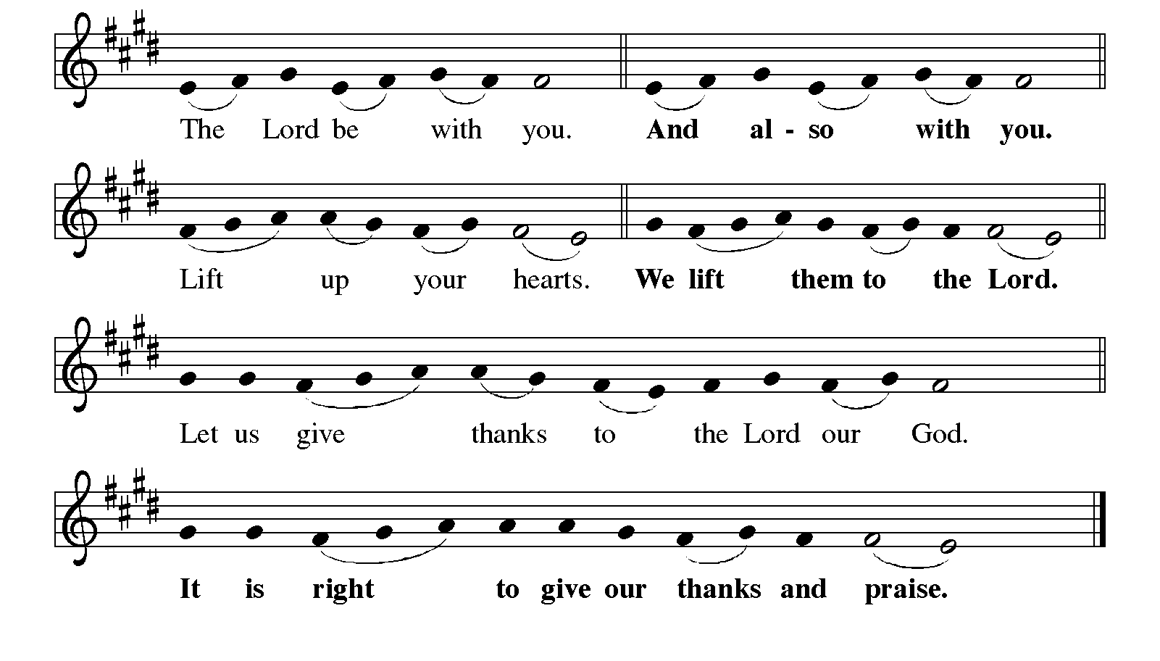
Great Thanksgiving

It is indeed right, our duty and our joy,
that we should at all times and in all places
give thanks and praise to you, almighty and merciful God,
for the glorious resurrection of our Savior Jesus Christ,
the true Paschal Lamb who gave himself to take away our sin;
who in dying has destroyed death,
and in rising has brought us to eternal life.
And so, with Mary Magdalene and Peter and all the witnesses of the resurrection,
with earth and sea and all their creatures,
and with angels and archangels, cherubim and seraphim,
we praise your name and join their unending hymn:
Eucharistic Prayer
Holy, living, and loving God,
we praise you for creating the heavens and the earth.
We bless you for bringing Noah and his family through the waters of the flood,
for freeing your people Israel from the bonds of slavery,
and for sending your Son to be our Redeemer.
We give you thanks for Jesus
who, living among us, healed the sick, fed the hungry,
and with a love stronger than death, gave his life for others.
In the night in which he was betrayed,
our Lord Jesus took bread, and gave thanks;
broke it, and gave it to his disciples, saying:
Take and eat; this is my body, given for you.
Do this for the remembrance of me.

Again, after supper, he took the cup, gave thanks,
and gave it for all to drink, saying:
This cup is the new covenant in my blood,
shed for you and for all people for the forgiveness of sin.
Do this for the remembrance of me.
Remembering, therefore,
his life-giving death and glorious resurrection,
we await your promised life for all this dying world.
Breathe your Spirit on us and on this bread and cup:
carry us in your arms from death to life,
that we may live as your chosen ones,
clothed in the righteousness of Christ.
Through him all glory and honor is yours,
Almighty Father, with the Holy Spirit,
in your holy Church,
both now and forever.
Amen

Lord’s Prayer
Our Father, who art in heaven,
hallowed be thy name, thy kingdom come,
thy will be done, on earth as it is in heaven.
Give us this day our daily bread;
and forgive us our trespasses, as we forgive those who trespass against us;
and lead us not into temptation but deliver us from evil.
For thine is the kingdom,
and the power, and the glory, forever and ever.
Amen.

Invitation to Communion
Jesus Christ, risen from the dead,
gives everyone a place at the welcome table.
Alleluia! Come to the feast.

Communion
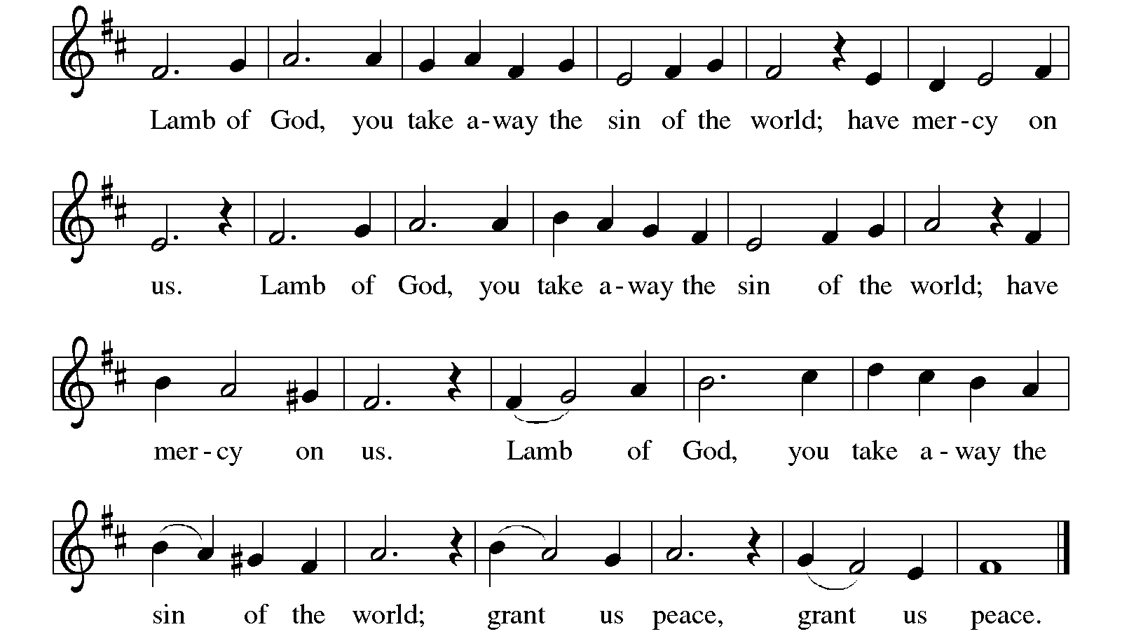

Communion Songs Christ Has Arisen, Alleluia ELW 364

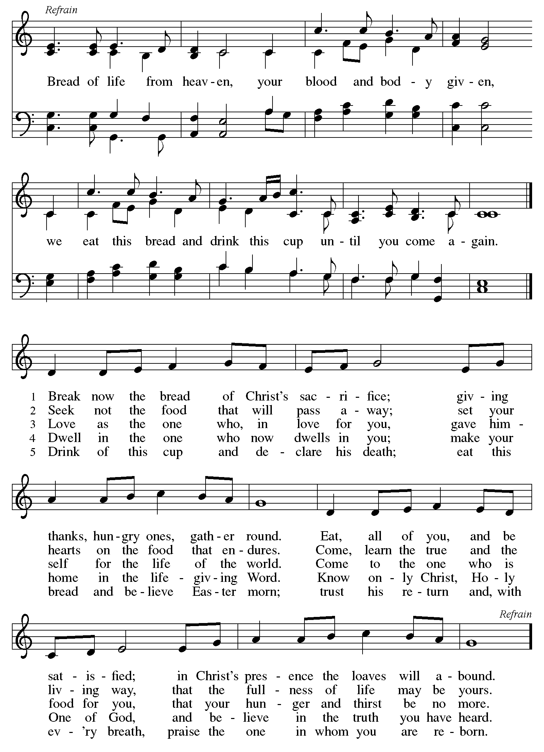
Bread of Life from Heaven ELW 474

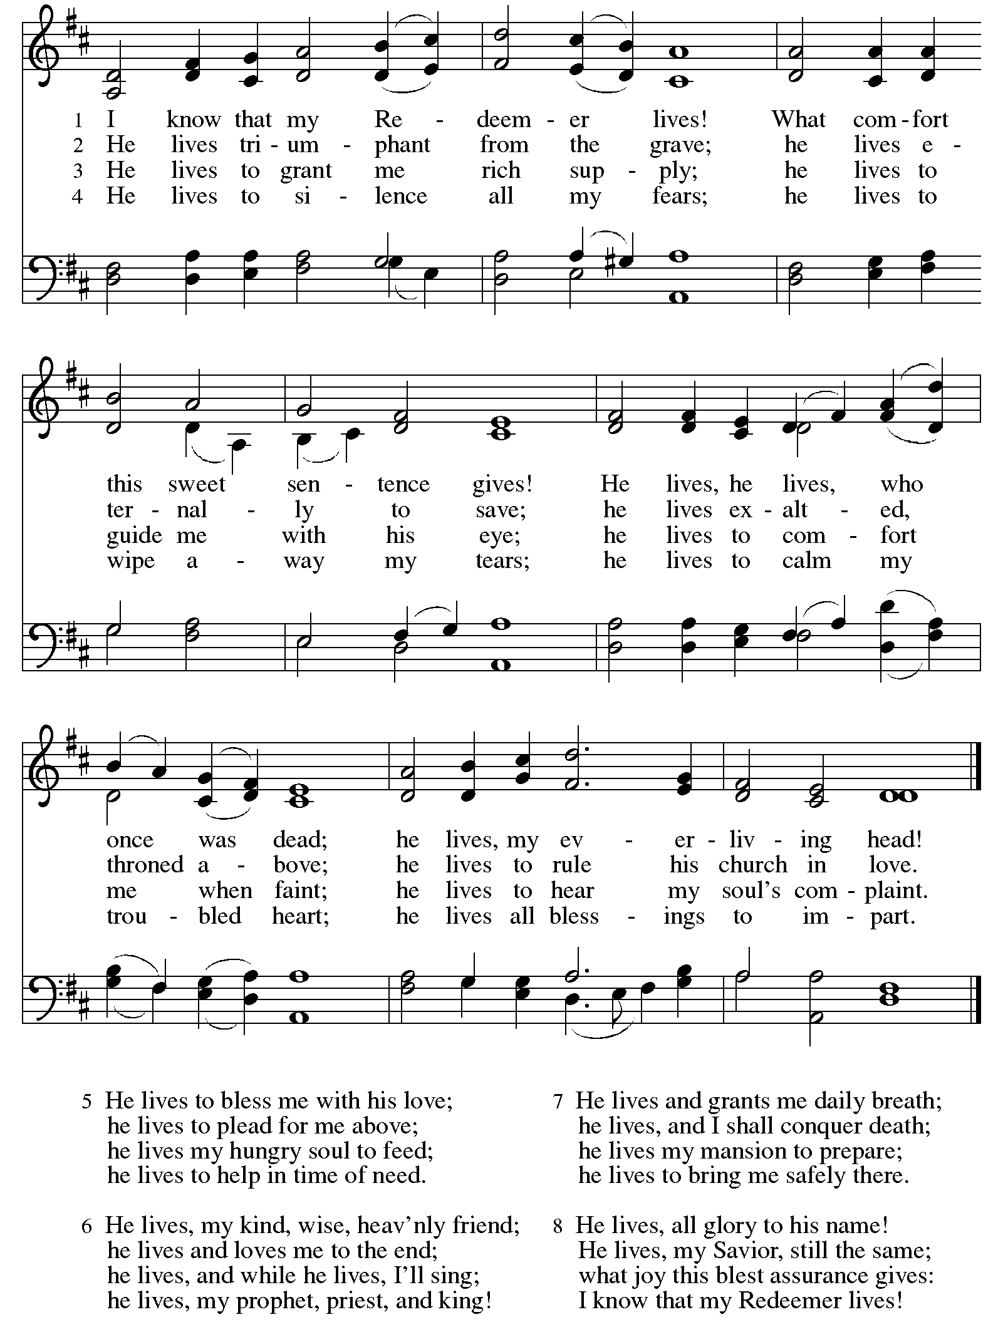
I Know that My Redeemer Lives! ELW 619

Prayer after Communion
A: Living One,
In this feast you have made yourself known to us.
Send us now to tell of your wonders,
sing of your glory,
and proclaim your risen life
to a wounded and weary world.
Amen.

SENDING
God blesses us and sends us in mission to the world.

Blessing
Triune God,
Who was, who is and who is to come,
Sovereign, ☩ Savior, and Spirit,
Light your way with resurrection dawn,
Now and always. Amen.

Sending Song Thine Is the Glory ELW 376
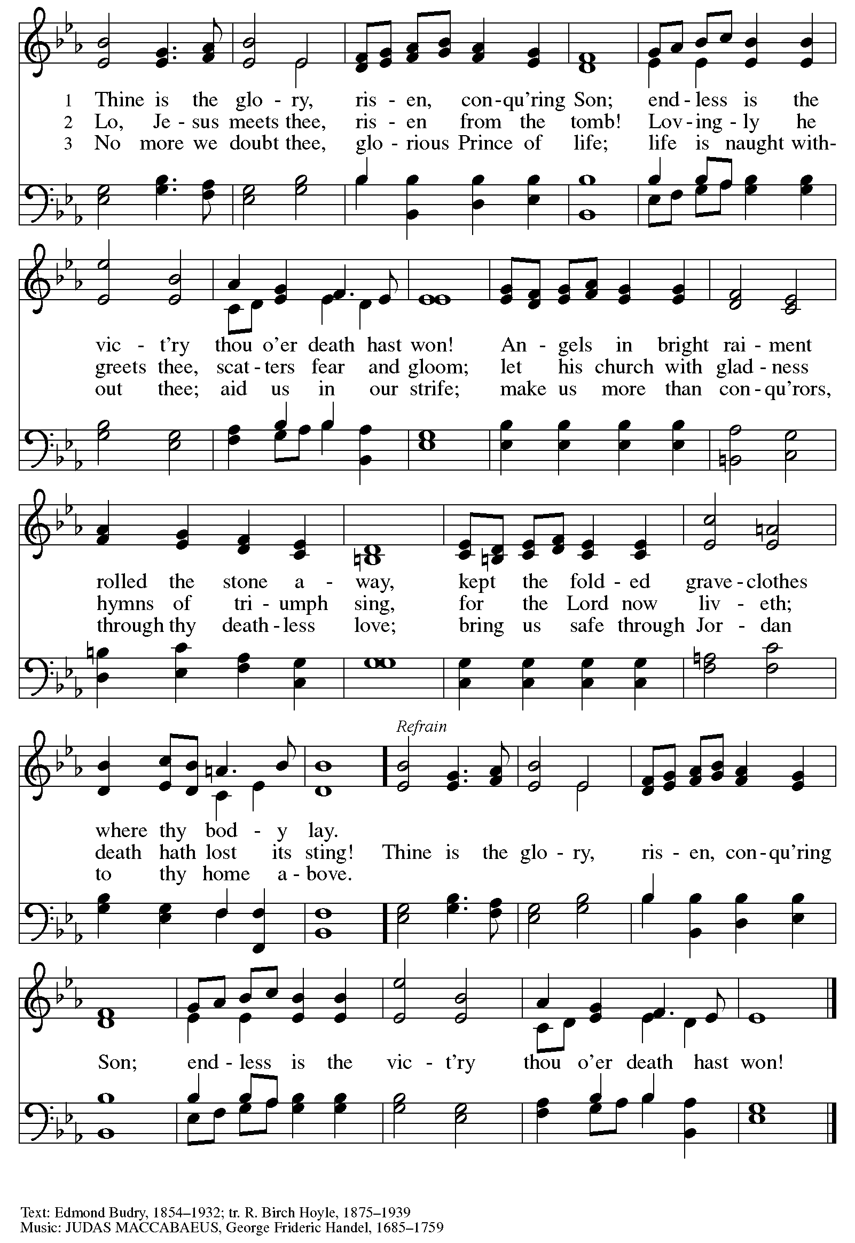
Dismissal
Alleluia. Christ is risen.
Christ is risen indeed. Alleluia.
Go in peace. In Christ you are made new. Alleluia! Alleluia!
Thanks be to God. Alleluia! Alleluia!

From sundaysandseasons.com. Copyright © 2026 Augsburg Fortress. All rights reserved.

