Worship Plan for Sunday, December 7, 2025
Second Sunday of Advent

The Holy Spirit calls us together as the people of God.
GATHERING
Handbells
Prelude
Welcome & Announcements

We Are Waiting for Jesus ACS#905
Confession and Forgiveness
Blessed be the holy Trinity, ☩ one God,
alive in the world,
reviving creation,
arriving soon.
Amen.

Let us confess our sin in the presence of God
and of one another

Silence is kept for reflection.

God of mercy,
we confess that we have sinned.
We trust earthly powers and human authority alone.
We grow fearful. We cling to false comforts.

God of might,
we confess that we have sinned.
We have turned away from our neighbors.
We have trusted false promises.

God in our midst,
we confess that we have sinned.
We plead; come to us.
Bring your mercy to birth in us.

A righteous branch springs forth:
it is Christ the Lord, our Savior,
in whom we have forgiveness, life, and mercy.
By the power of the Holy Spirit,
receive the grace and forgiveness of God
through ☩ Christ Jesus,
whose day draws near.
Amen.

Gathering Song Hark, the Glad Sound! ELW#239

Greeting
The grace of our Lord Jesus Christ, the love of God,
and the communion of the Holy Spirit be with you all.
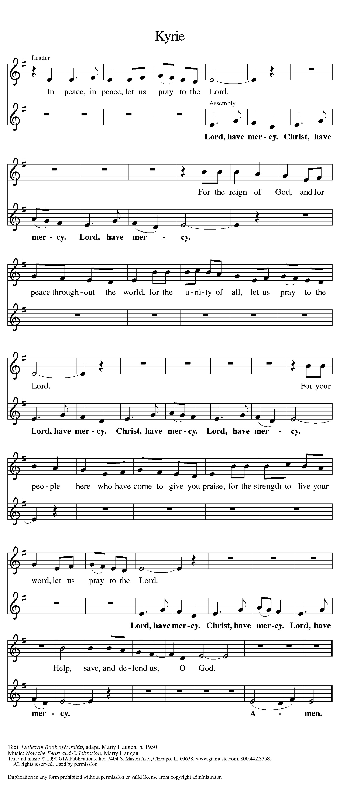
And also with you.

Prayer of the Day
Let us pray.
Stir up our hearts, Lord God, to prepare the way of your only Son. By his coming nurture our growth as people of repentance and peace; through Jesus Christ, our Savior and Lord, who lives and reigns with you and the Holy Spirit, one God, now and forever.
Amen.
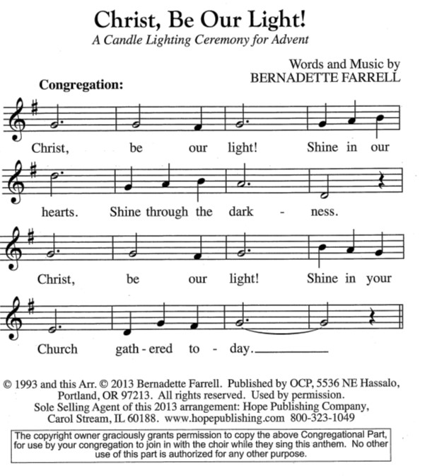
Advent Wreath Lighting

SECOND SUNDAY – Hope for Those Who Are Weary
Responsive Litany
The Light shines in the darkness,
but the darkness has not overcome it.
During Advent our weary souls seek God’s daily strength.
The Lord gives strength to the weary and increases the power of the week.
We grow weary when fear overshadows faith.
The Lord gives strength to the weary and increases the power of the week.
We grow weary when destructive actions erupt in the world around us.
The Lord gives strength to the weary and increases the power of the week.
For all of us feeling weary this Advent season:
Grant that we might have the peace of Christ as we wait, the love of Christ as we act, and the grace of Christ as we speak.

Candle Lighting
Today we light two candles. The first candle illuminates patience in the areas of our lives where God has called us to wait. The second candle extends the promise of strength to all who feel weary and weak in the shadows of this world. As we continue our Advent journey, may our hope be kindled as the light grows brighter.

WORD
God speaks to us in scripture reading, preaching, and song.

First Reading: Isaiah 11:1-10
A reading from Isaiah.
¹ A shoot shall come out from the stump of Jesse,
and a branch shall grow out of his roots.
² The spirit of the Lord shall rest on him,
the spirit of wisdom and understanding,
the spirit of counsel and might,
the spirit of knowledge and the fear of the Lord.
³ His delight shall be in the fear of the Lord.
He shall not judge by what his eyes see
or decide by what his ears hear,
⁴ but with righteousness he shall judge for the poor
and decide with equity for the oppressed of the earth;
he shall strike the earth with the rod of his mouth,
and with the breath of his lips he shall kill the wicked.
⁵ Righteousness shall be the belt around his waist
and faithfulness the belt around his loins.
⁶ The wolf shall live with the lamb;
the leopard shall lie down with the kid;
the calf and the lion will feed together,
and a little child shall lead them.
⁷ The cow and the bear shall graze;
their young shall lie down together;
and the lion shall eat straw like the ox.
⁸ The nursing child shall play over the hole of the asp,
and the weaned child shall put its hand on the adder’s den.
⁹ They will not hurt or destroy
on all my holy mountain,
for the earth will be full of the knowledge of the Lord
as the waters cover the sea.
¹⁰ On that day the root of Jesse shall stand as a signal to the peoples; the nations shall inquire of him, and his dwelling shall be glorious.
The word of the Lord.
Thanks be to God.

Psalm: Psalm 72:1-7, 18-19
¹ Give the king your jus- | tice, O God,
and your righteousness to | the king’s son;
² that he may rule your | people righteously
and the | poor with justice;
³ that the mountains may bring prosperity | to the people,
and the | hills, in righteousness.
⁴ Let him defend the needy a- | mong the people,
rescue the poor, and crush | the oppressor.
⁵ May he live as long as the sun and | moon endure,
from one generation | to another.
⁶ Let him come down like rain upon | the mown field,
like showers that wa- | ter the earth.
⁷ In his time may the | righteous flourish;
and let there be an abundance of peace till the moon shall | be no more.
¹⁸ Blessed are you, Lord God, the | God of Israel;
you alone do | wondrous deeds!
¹⁹ And blessed be your glorious | name forever,
and may all the earth be filled with your glory. A- | men. Amen.
Second Reading: Romans 15:4-13
A reading from Romans.
⁴ Whatever was written in former days was written for our instruction, so that by steadfastness and by the encouragement of the scriptures we might have hope. ⁵ May the God of steadfastness and encouragement grant you to live in harmony with one another, in accordance with Christ Jesus, ⁶ so that together you may with one voice glorify the God and Father of our Lord Jesus Christ.
⁷ Welcome one another, therefore, just as Christ has welcomed you, for the glory of God. ⁸ For I tell you that Christ has become a servant of the circumcised on behalf of the truth of God in order that he might confirm the promises given to the ancestors ⁹ and that the gentiles might glorify God for his mercy. As it is written,
“Therefore I will confess you among the gentiles
and sing praises to your name”;
¹⁰ and again he says,
“Rejoice, O gentiles, with his people”;
¹¹ and again,
“Praise the Lord, all you gentiles,
and let all the peoples praise him”;
¹² and again Isaiah says,
“The root of Jesse shall come,
the one who rises to rule the gentiles;
in him the gentiles shall hope.”
¹³ May the God of hope fill you with all joy and peace in believing, so that you may abound in hope by the power of the Holy Spirit.
The word of the Lord.
Thanks be to God.
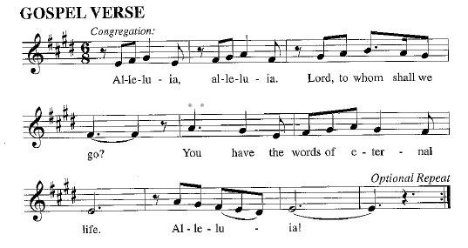
Gospel: Matthew 3:1-12
The holy gospel according to Matthew.
Glory to you, O Lord.
¹ In those days John the Baptist appeared in the wilderness of Judea, proclaiming, ² “Repent, for the kingdom of heaven has come near.” ³ This is the one of whom the prophet Isaiah spoke when he said,
“The voice of one crying out in the wilderness:
‘Prepare the way of the Lord;
make his paths straight.’ ”
⁴ Now John wore clothing of camel’s hair with a leather belt around his waist, and his food was locusts and wild honey. ⁵ Then Jerusalem and all Judea and all the region around the Jordan were going out to him, ⁶ and they were baptized by him in the River Jordan, confessing their sins.
⁷ But when he saw many of the Pharisees and Sadducees coming for his baptism, he said to them, “You brood of vipers! Who warned you to flee from the coming wrath? ⁸ Therefore, bear fruit worthy of repentance, ⁹ and do not presume to say to yourselves, ‘We have Abraham as our ancestor,’ for I tell you, God is able from these stones to raise up children to Abraham. ¹⁰ Even now the ax is lying at the root of the trees; therefore every tree that does not bear good fruit will be cut down and thrown into the fire.
¹¹ “I baptize you with water for repentance, but the one who is coming after me is more powerful than I, and I am not worthy to carry his sandals. He will baptize you with the Holy Spirit and fire. ¹² His winnowing fork is in his hand, and he will clear his threshing floor and will gather his wheat into the granary, but the chaff he will burn with unquenchable fire.”
The gospel of the Lord
Praise to you, O Christ.

Please be seated.
Children’s Message

Sermon
Hymn of the Day On Jordan’s Bank the Baptist’s Cry ELW# 249

Apostles’ Creed
I believe in God, the Father almighty,
creator of heaven and earth.
I believe in Jesus Christ, God’s only Son, our Lord,
who was conceived by the Holy Spirit, born of the virgin Mary,
suffered under Pontius Pilate, was crucified, died, and was buried;
he descended to the dead. On the third day he rose again;
he ascended into heaven, he is seated at the right hand of the Father,
and he will come to judge the living and the dead.
I believe in the Holy Spirit, the holy catholic church,
the communion of saints, the forgiveness of sins,
the resurrection of the body,
and the life everlasting. Amen.

Prayers of Intercession
In our waiting and watching, we come to you in prayer, O God, trusting your promise to renew the church, the nations, and the whole creation.
With wisdom and understanding, inspire the faithful around the world. Unite hearts and minds in work to address poverty, access to housing, and equity among peoples. God of grace,
hear our prayer.
With counsel and might, move us to care for creation. As we dream of the day when all creatures will flourish alongside one another, guide us in ways humanity and all creation will mutually thrive. God of grace,
hear our prayer.
With righteousness and faithfulness, encourage nations to live in harmony with one another. We pray for international student and teacher exchanges, for our partner churches, and for the shared mission of Lutheran World Relief and Lutheran Disaster Response. God of grace,
hear our prayer.
With steadfastness and encouragement, strengthen those who have lost hope in the face of grief, depression, or disease (especially). Renew the spirits of those recovering from surgery and medical procedures. God of grace,
hear our prayer.
With welcome and hospitality, embolden us in our shared ministry to overcome all that divides. In acts of repentance, reconciliation, and reparation, may we serve in the way of Christ. God of grace,
hear our prayer.
With joy and peace, we remember our ancestors in the faith (especially Ambrose, Bishop of Milan, whom we commemorate today). Fill us with the hope of the Holy Spirit now and into the ages of ages. God of grace,
hear our prayer.
Draw near to us, O God, as we commend all for whom we pray, trusting in your mercy through Jesus Christ, Emmanuel.
Amen.

Peace
The peace of Christ be with you always.
And also with you.

Choir Anthem Let Every Heart Prepare Him Room

MEAL
God feeds us with the presence of Jesus Christ.

Please stand
Offertory Hymn As the Grains of Wheat ELW#465

Offering Prayer
Creator God,
You made the whole world,
even the farthest stars,
and you draw us near to feed us.
We praise you for these gifts of bread and wine.
Strengthen us with this food
that we may live in expectation
for the advent of your Son, Jesus Christ our Lord.
Amen.

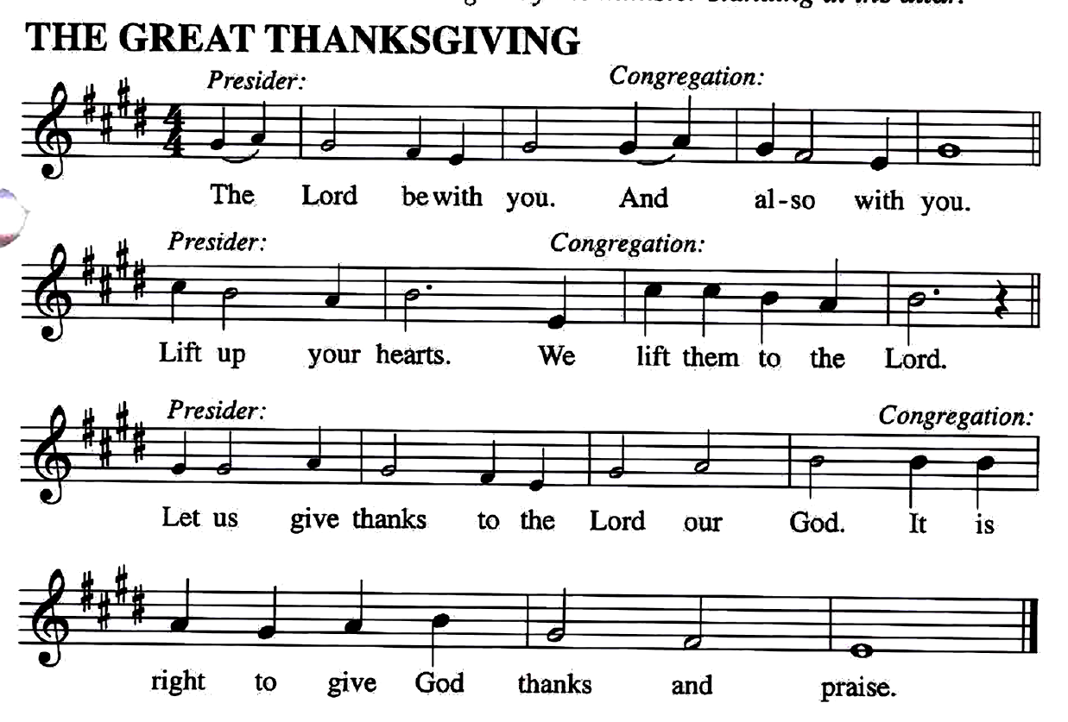
The Great Thanksgiving

Preface
It is our duty and delight... and so with the church on earth and the host of heaven we praise your name and join their unending hymn…

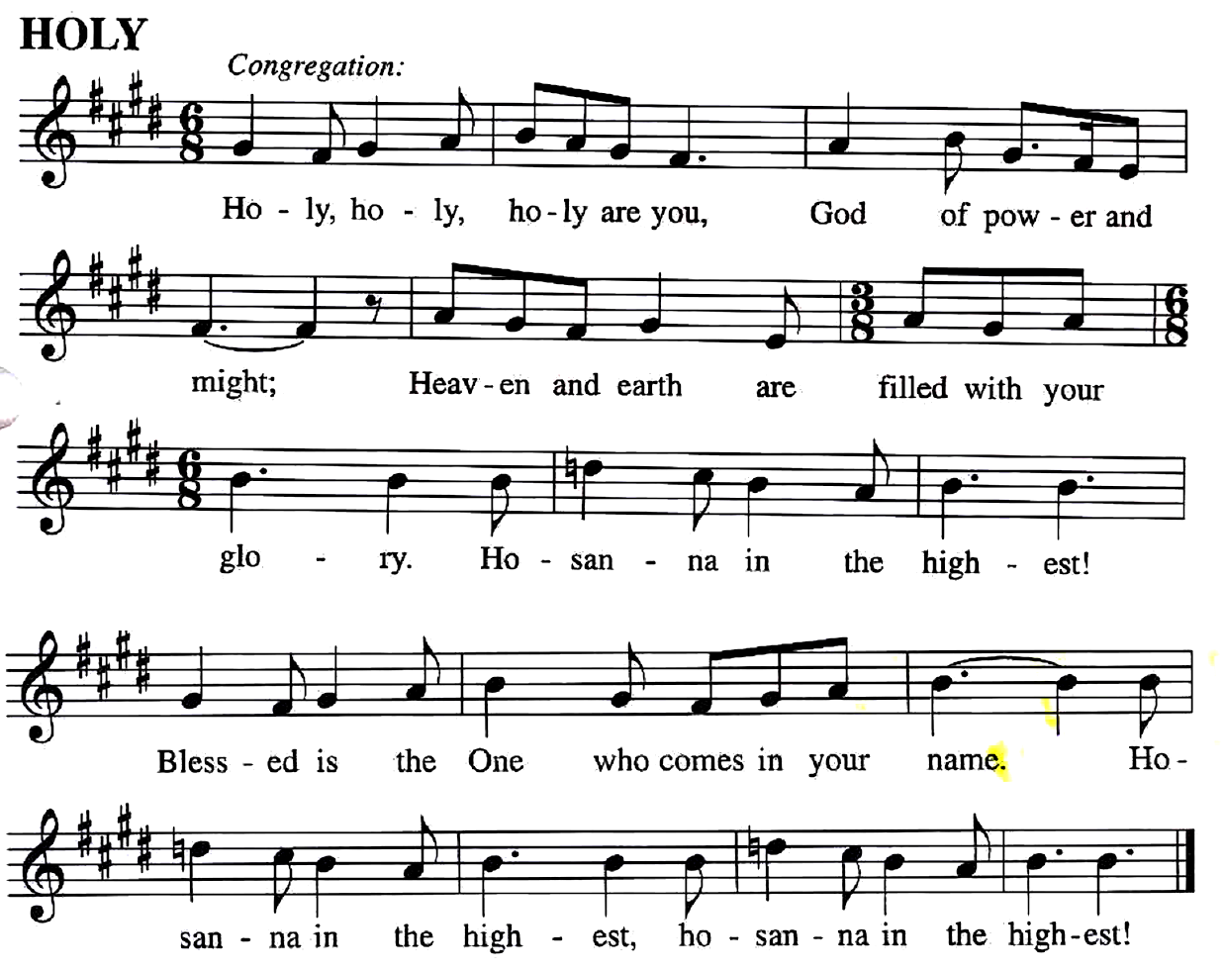

You are indeed holy… we pray for his coming again, as we cry:

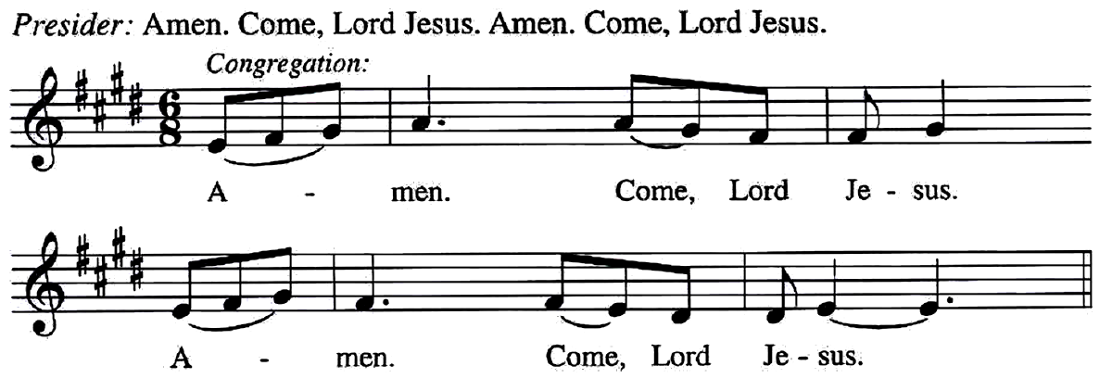

Send now, we pray, your Holy Spirit,
That all of your promises may come to us and your whole creation.
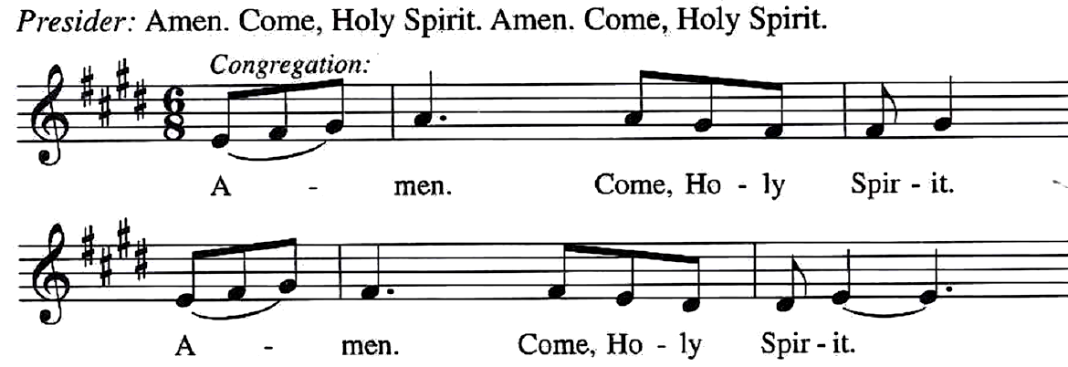

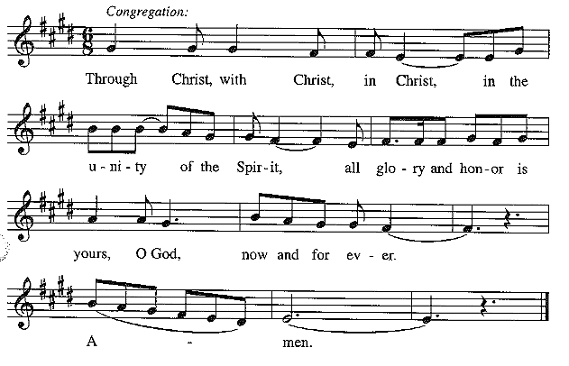
This we pray through Jesus Christ, our Savior and our friend.

Lord's Prayer
Our Father, who art in heaven,
hallowed be thy name,
thy kingdom come, thy will be done,
on earth as it is in heaven.
Give us this day our daily bread;
and forgive us our trespasses,
as we forgive those who trespass against us;
and lead us not into temptation but deliver us from evil.
For thine is the kingdom, and the power,
and the glory, forever and ever. Amen.

Invitation to Communion
God feed us with tender mercy.
Come to the table.

Lamb of God
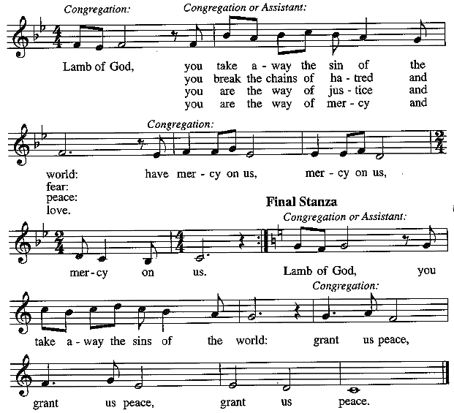
Communion Hymns All Earth Is Hopeful ELW#266

Come, Thou Long-Expected Jesus ELW#254

Comfort, Comfort Now My People ELW#256

Prayer after Communion
Generous God,
We thank you for the gift of life,
for the bread of salvation.
We thank you for coming among us,
for leading us into peace
We thank you for showering us with mercy,
for sending us into the world.
Come, Lord Jesus, and go with us
as we feed the hungry in your name.
Amen.
God blesses us and sends us in mission to the world.
SENDING

Blessing
God of endings and beginnings,
God in the darkness and the light,
God, our hope for the journey,
☩ bless and keep you now and forever.
Amen.

Sending Song The King Shall Come ELW#260

Dismissal
Go in peace. Prepare the way for Emmanuel. Thanks be to God.

