Worship Plan for Sunday, October 18, 2026
21th Sunday After Pentecost

The Holy Spirit calls us together as the people of God.
GATHERING

Prelude
Welcome/Announcements
Reflection - Preparing for Worship
Sing 2x

Please stand.
Confession and Forgiveness
All may make the sign of the cross, the sign that is marked at baptism, as the presiding minister begins.
Blessed be the holy Trinity, ☩ one God,
who pours love into our hearts
and healing upon the earth.
Amen.
Confident that God justifies us by grace through faith,
let us confess our sin.
Silence is kept for reflection.
Compassionate God,
we confess that we struggle to embody your goodness
in the world and in our own hearts.
Creation groans from overuse.
Jealousy and bitterness strain our relationships.
Indifference keeps us from seeking justice.
Divisions disrupt your call to show genuine love
to others.
Turn our hearts back to you.
Restore our world and reconcile us to one another.
Renew us to live as your holy people,
following the way of Jesus Christ.
Amen.
Hear this good news:
We have peace with God through ☩ Jesus Christ,
in whom there is no condemnation,
but only forgiveness and the promise of eternal life.
Receive freely this healing gift of grace.
Amen.

Gathering Song You Servants of God ELW 825

Greeting
The grace of our Lord Jesus Christ, the love of God
and the communion of the Holy Spirit be with you all.
And also, with you.

Prayer of the Day
Let us pray.
Sovereign God, raise your throne in our hearts. Created by you, let us live in your image; created for you, let us act for your glory; redeemed by you, let us give you what is yours, through Jesus Christ, our Savior and Lord.
Amen.

Please be seated.
God speaks to us in scripture reading, preaching, and song.
WORD

First Reading: Isaiah 45:1-7
A reading from Isaiah.
¹ Thus says the Lord to his anointed, to Cyrus,
whose right hand I have grasped
to subdue nations before him
and to strip kings of their robes,
to open doors before him—
and the gates shall not be closed:
² I will go before you
and level the mountains;
I will break in pieces the doors of bronze
and cut through the bars of iron;
³ I will give you the treasures of darkness
and riches hidden in secret places,
so that you may know that it is I, the Lord,
the God of Israel, who call you by your name.
⁴ For the sake of my servant Jacob
and Israel my chosen,
I call you by your name;
I give you a title, though you do not know me.
⁵ I am the Lord, and there is no other;
besides me there is no god.
I arm you, though you do not know me,
⁶ so that they may know, from the rising of the sun
and from the west, that there is no one besides me;
I am the Lord, and there is no other.
⁷ I form light and create darkness,
I make weal and create woe;
I the Lord do all these things.
The word of the Lord.
Thanks be to God.

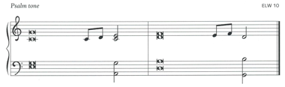
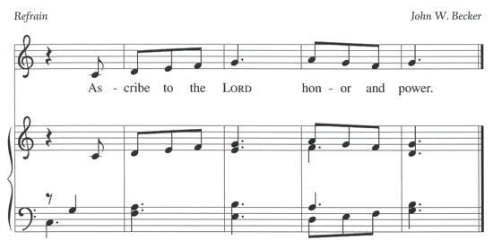

Psalm: Psalm 96:1-9 [10-13]
¹ Sing to the Lord | a new song;
sing to the Lord, | all the earth.
² Sing to the Lord, bless the name | of the Lord;
proclaim God’s salvation from | day to day.
³ Declare God’s glory a- | mong the nations
and God’s wonders a- | mong all peoples.
⁴ For great is the Lord and greatly | to be praised,
more to be feared | than all gods. R
⁵ As for all the gods of the nations, they | are but idols;
but you, O Lord, have | made the heavens.
⁶ Majesty and magnificence are | in your presence;
power and splendor are in your | sanctuary.
⁷ Ascribe to the Lord, you families | of the peoples,
ascribe to the Lord hon- | or and power.
⁸ Ascribe to the Lord the honor due the | holy name;
bring offerings and enter the courts | of the Lord.
⁹ Worship the Lord in the beau- | ty of holiness;
tremble before the Lord, | all the earth. R

Second Reading: 1 Thessalonians 1:1-10
A reading from 1 Thessalonians.
¹ Paul, Silvanus, and Timothy,
To the church of the Thessalonians in God the Father and the Lord Jesus Christ:
Grace to you and peace.
² We always give thanks to God for all of you and mention you in our prayers, constantly ³ remembering before our God and Father your work of faith and labor of love and steadfastness of hope in our Lord Jesus Christ. ⁴ For we know, brothers and sisters beloved by God, that he has chosen you, ⁵ because our message of the gospel came to you not in word only but also in power and in the Holy Spirit and with full conviction; just as you know what kind of persons we proved to be among you for your sake. ⁶ And you became imitators of us and of the Lord, for in spite of persecution you received the word with joy from the Holy Spirit, ⁷ so that you became an example to all the believers in Macedonia and in Achaia. ⁸ For the word of the Lord has sounded forth from you not only in Macedonia and Achaia but in every place your faith in God has become known, so that we have no need to speak about it. ⁹ For they report about us what kind of welcome we had among you and how you turned to God from idols to serve a living and true God ¹⁰ and to wait for his Son from heaven, whom he raised from the dead—Jesus, who rescues us from the coming wrath.
The word of the Lord. Thanks be to God.
Please stand.
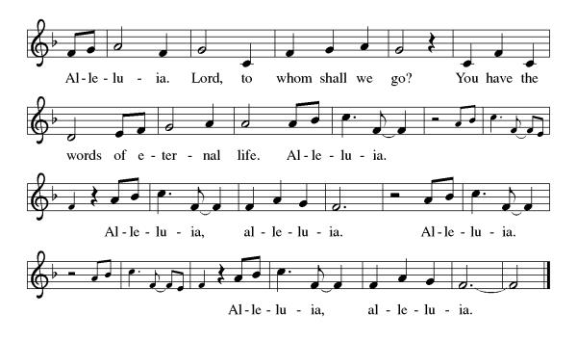
Gospel Acclamation
Gospel: Matthew 22:15-22
The holy gospel according to Matthew.
Glory to you, O Lord.
¹⁵ The Pharisees went and plotted to entrap [Jesus] in what he said. ¹⁶ So they sent their disciples to him, along with the Herodians, saying, “Teacher, we know that you are sincere, and teach the way of God in accordance with truth, and show deference to no one, for you do not regard people with partiality. ¹⁷ Tell us, then, what you think. Is it lawful to pay taxes to Caesar or not?” ¹⁸ But Jesus, aware of their malice, said, “Why are you putting me to the test, you hypocrites? ¹⁹ Show me the coin used for the tax.” And they brought him a denarius. ²⁰ Then he said to them, “Whose head is this and whose title?” ²¹ They answered, “Caesar’s.” Then he said to them, “Give therefore to Caesar the things that are Caesar’s and to God the things that are God’s.” ²² When they heard this, they were amazed, and they left him and went away.
The gospel of the Lord.
Praise to you, O Christ.

Please be seated.
Children’s Message
Sermon
Please stand
Hymn of the Day Lift Every Voice and Sing ELW 841
(continued on next page)
Apostles’ Creed
Let us confess our faith to the words of the Apostles’ Creed
I believe in God, the Father almighty,
creator of heaven and earth.
I believe in Jesus Christ, God's only Son, our Lord,
who was conceived by the Holy Spirit,
born of the Virgin Mary,
suffered under Pontius Pilate,
was crucified, died, and was buried;
he descended to the dead.
On the third day he rose again;
he ascended into heaven,
he is seated at the right hand of the Father,
and he will come to judge the living and the dead.
I believe in the Holy Spirit,
the holy catholic Church,
the communion of saints,
the forgiveness of sins,
the resurrection of the body,
and the life everlasting. Amen
Please sit or kneel.
Prayers of Intercession
Seeking the Spirit of God who makes all things new, we pray for the church and the world.
Living and true God, you inspire us to share the message of the gospel. Give your spirit of love to seminarians and those beginning their lives in ordained ministry (local seminarians or newly called ministers may be named). Hear us, O God.
Your mercy is great.
We give you thanks for the majesty of our oceans. Protect the abundant life within them and sustain all those who work to preserve them. Hear us, O God.
Your mercy is great.
We seek your wisdom in all things. Direct all who hold positions of authority around the world, that they act with compassion, seeking the good of all. Hear us, O God.
Your mercy is great.
We pray for all people who work in dangerous or degrading environments. Grant them safety and courage, and heal all those who are injured, sick, or suffering (especially). Hear us, O God.
Your mercy is great.
We ask your blessing on those who do the quiet, unseen work of the church (congregational ministries may be named). Encourage them in their work of faith and labor of love. Hear us, O God.
Your mercy is great.
We thank you for our ancestors who have been called home to you (especially). Hear us, O God.
Your mercy is great.
Trusting in your boundless grace, O God, we lift up these spoken prayers and those in our hearts; through Jesus Christ our Lord.
Amen.

Peace
The peace of Christ be with you always. And also, with you.

MEAL
God feeds us with the presence of Jesus Christ.

Please be seated.
Offering

Choir Music ~ Everlasting God

Please stand.
Offertory Hymn Come, Bring Your Burdens to God ACS 1009
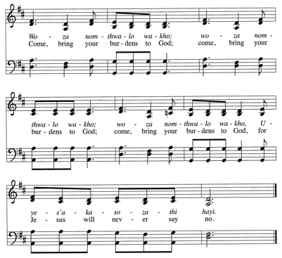
2x
Offertory Prayer
God of creation,
you send rain and the earth springs forth abundantly.
All blessings are from you;
make us generous with what we have.
Use our gifts, our abilities, and our hearts
in service to you and in love to our neighbors,
today and always.
Amen.

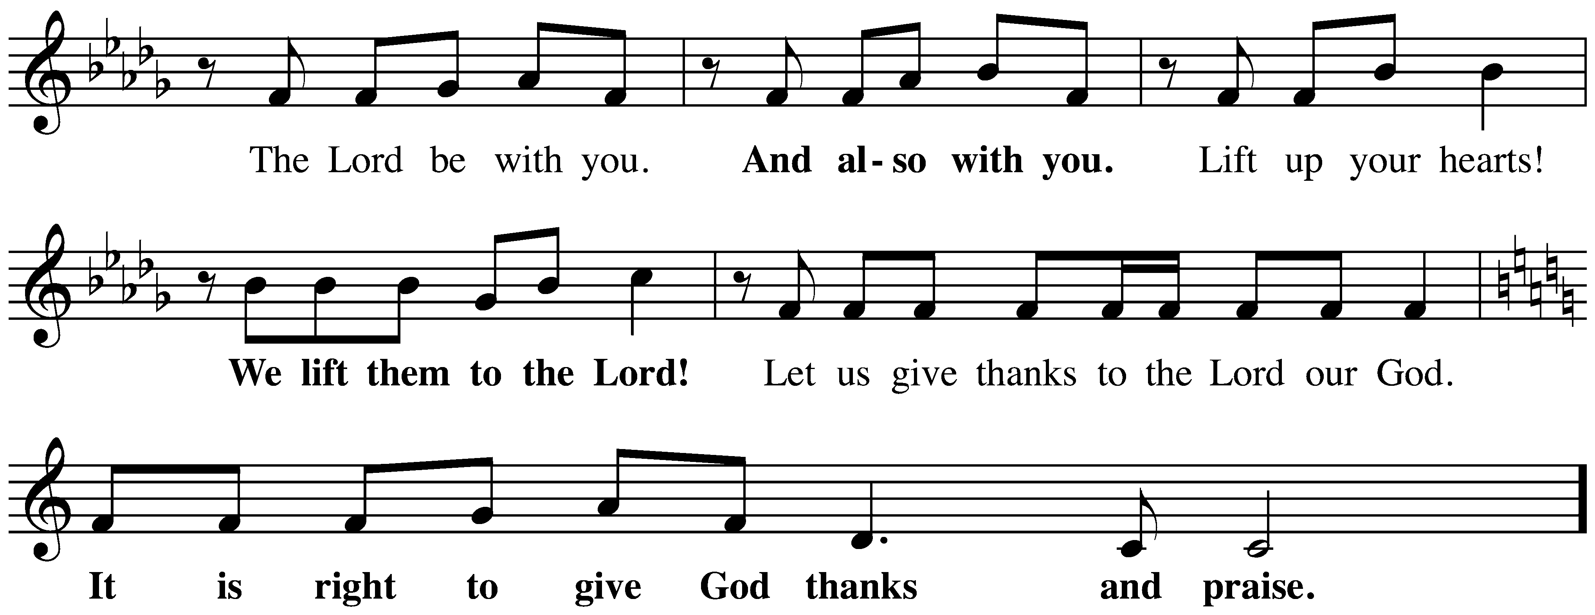
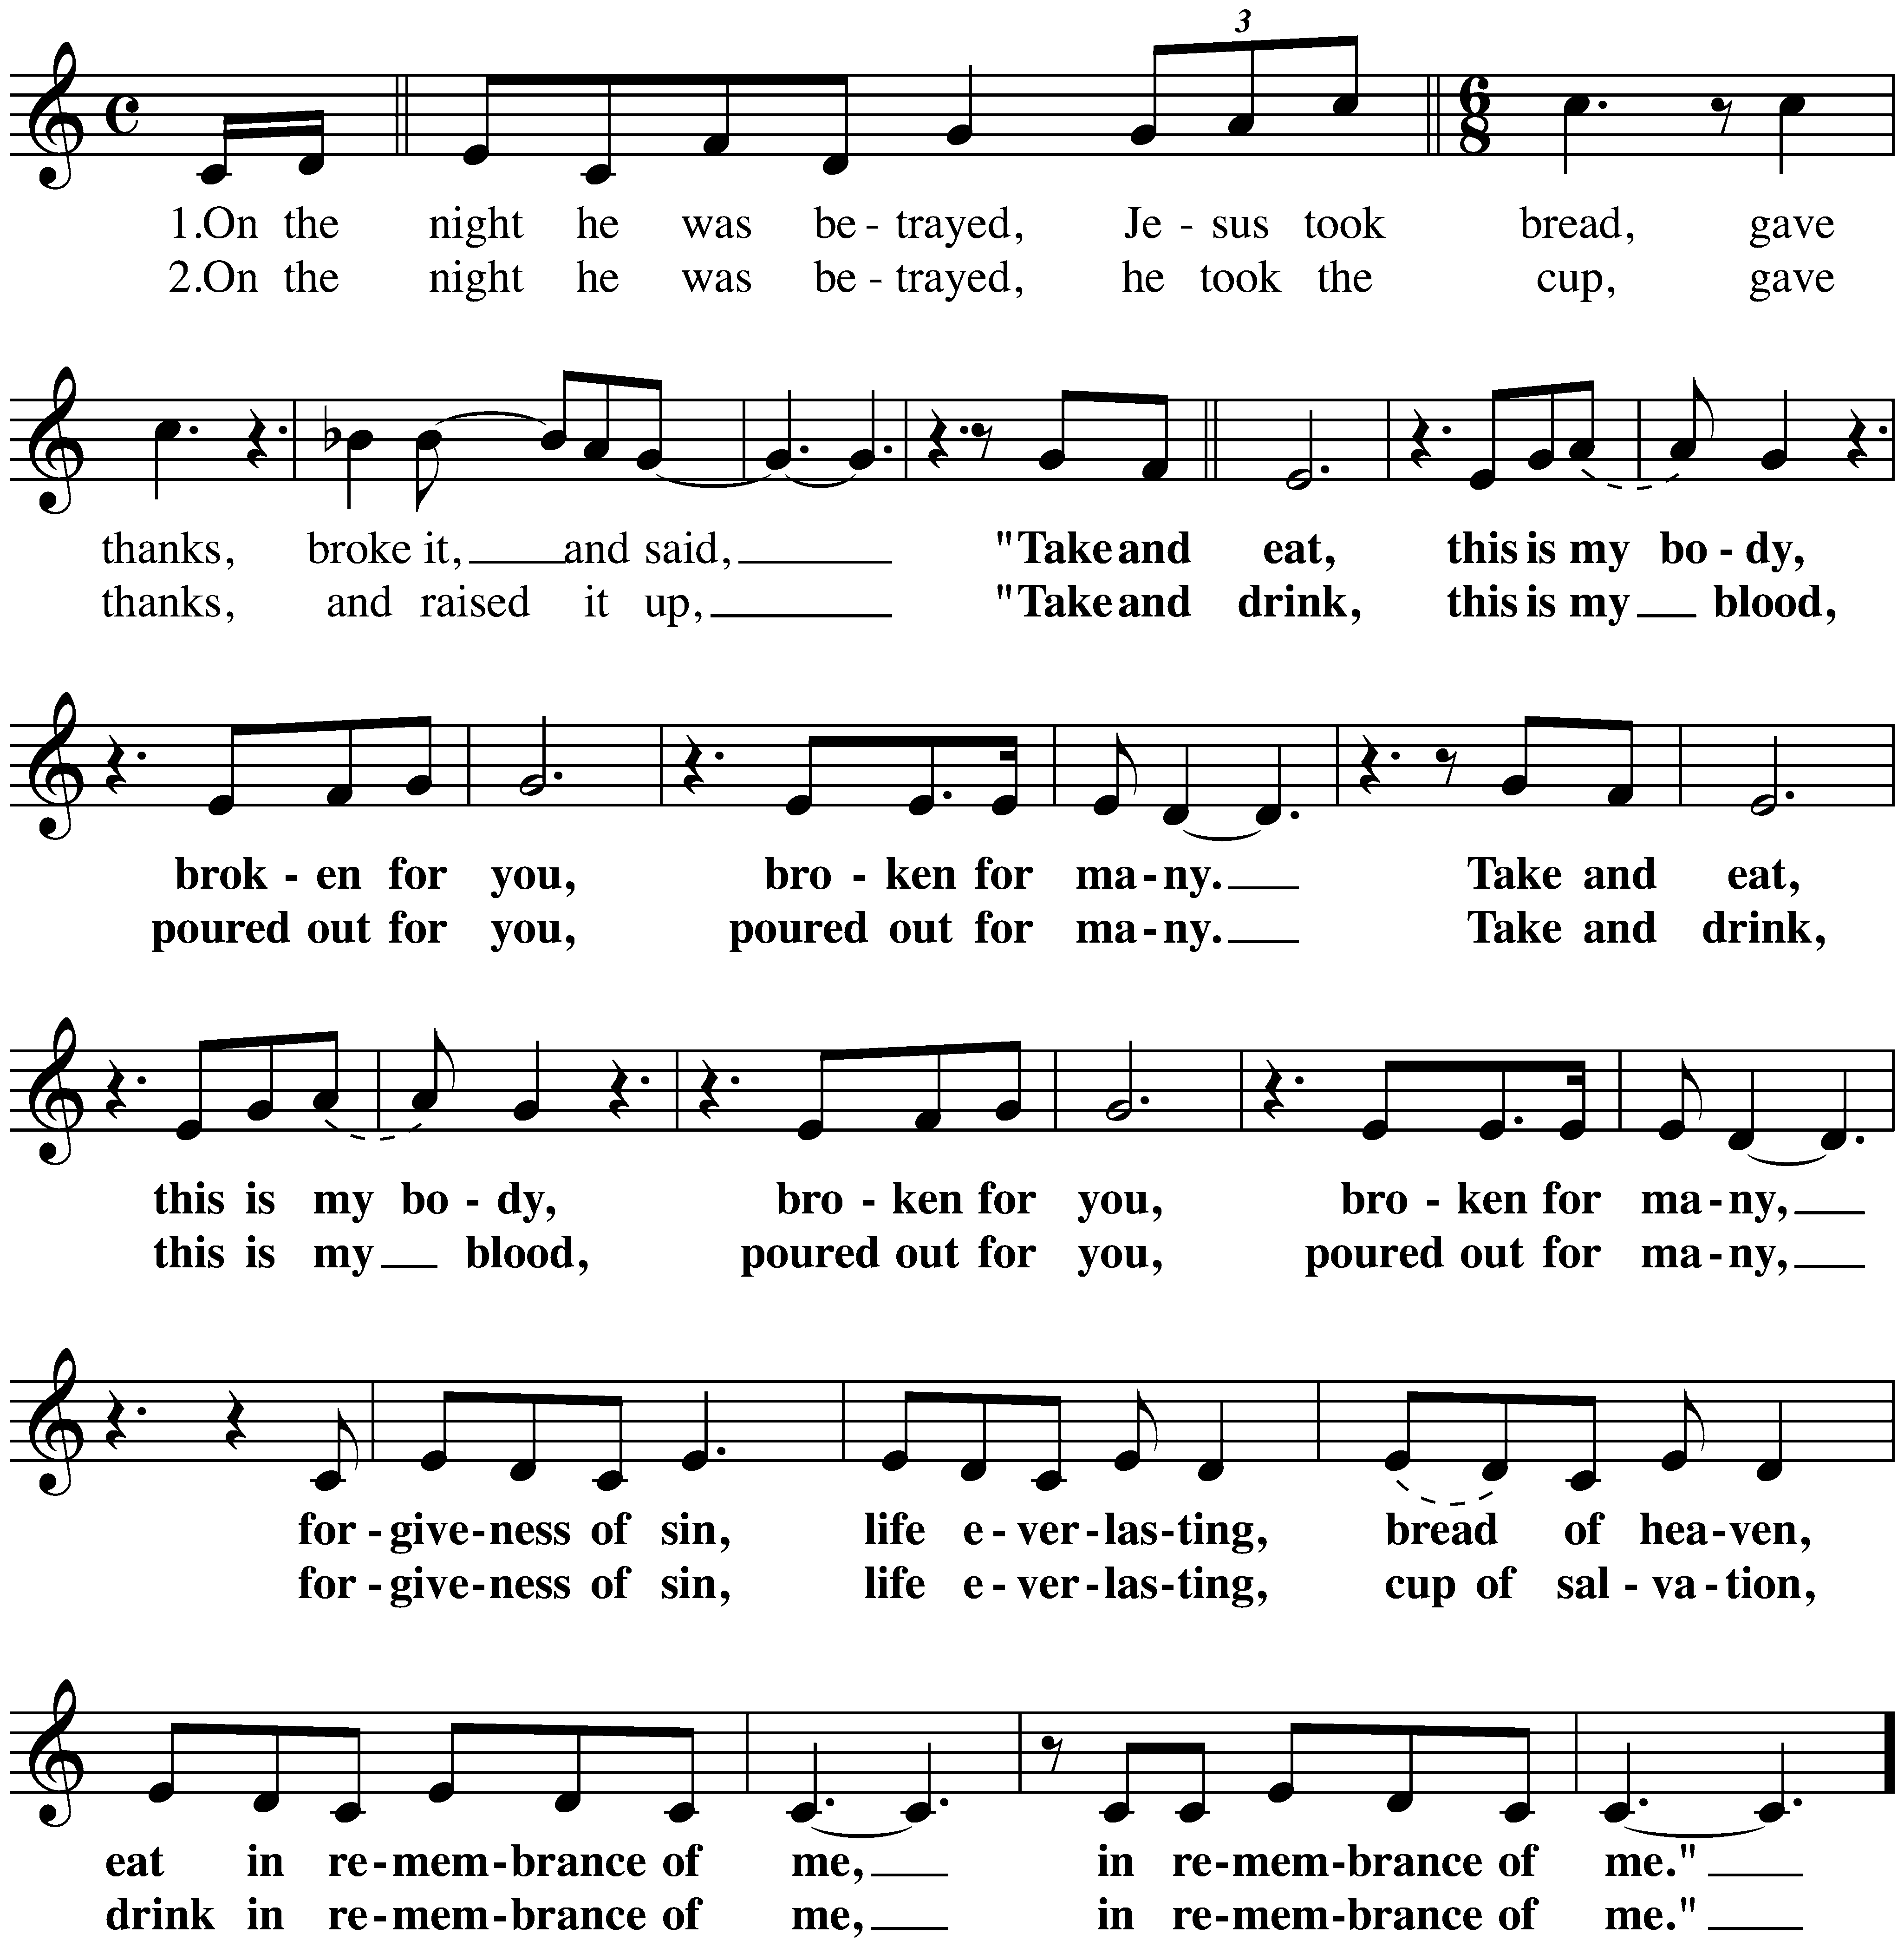
The Great Thanksgiving

The Lord’s Prayer
Our Father, who art in heaven,
hallowed be thy name, thy kingdom come,
thy will be done, on earth as it is in heaven.
Give us this day our daily bread;
and forgive us our trespasses, as we forgive those who trespass against us;
and lead us not into temptation but deliver us from evil.
For thine is the kingdom,
and the power, and the glory, forever and ever.
Amen.

Invitation to Communion
Christ invites you to this table.
All who are thirsty, all who are hungry, come!

Please be seated.
Communion Hymns
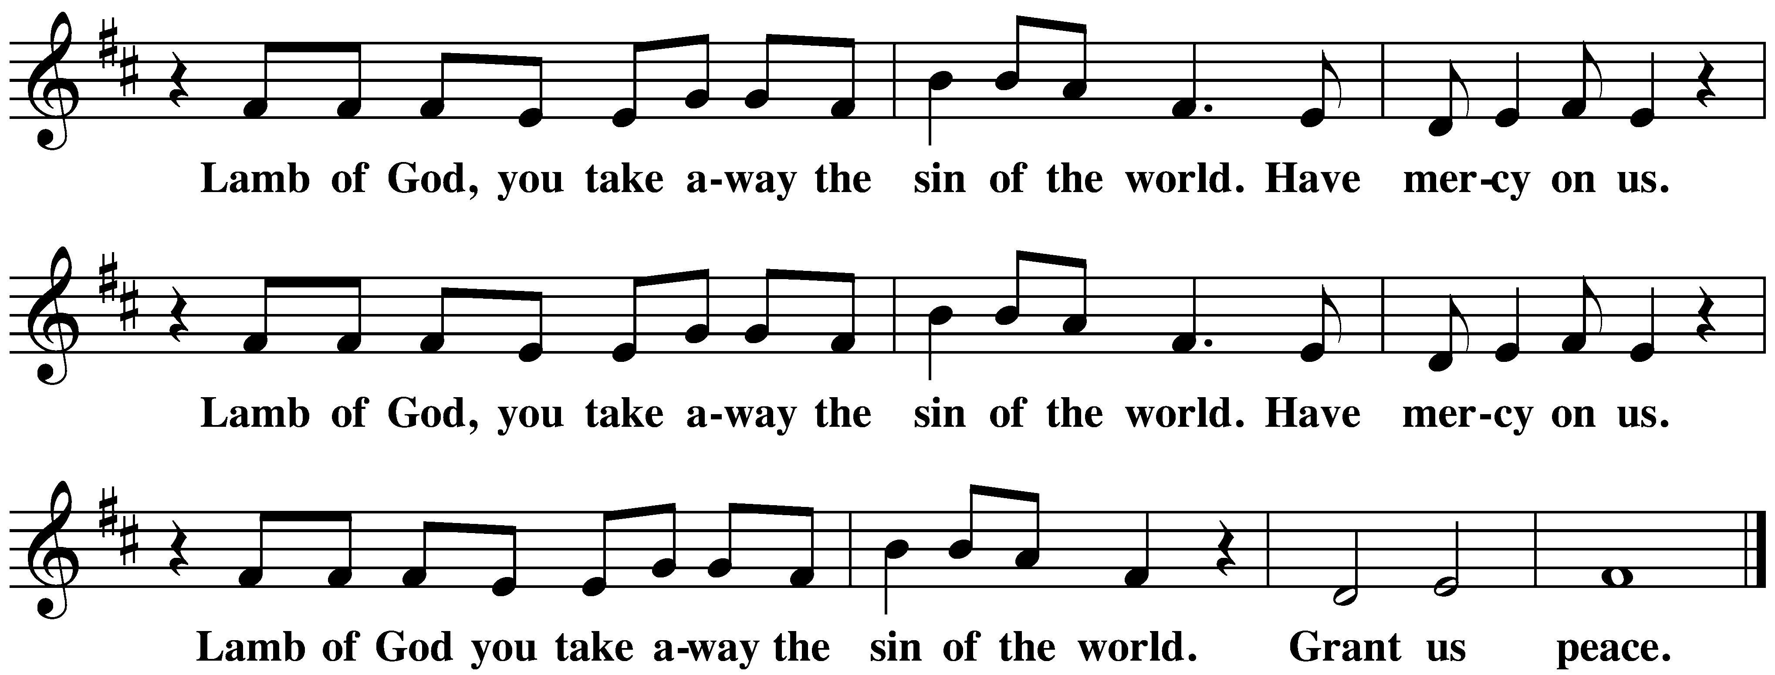
We Give Thee but Thine Own ELW 686

O God, You Search Me ACS 1082
Prayer after Communion
Sustaining God,
with this bread and cup,
you nourish us with mercy and abundant life.
By your Spirit, send us from this table to serve a needy world.
Make us living signs of your liberation, healing, and love,
following the way of Jesus, in whose name we pray.
Amen.
God blesses us and sends us in mission to the world.
SENDING

Blessing
The God of love
draw you into full accord and one mind,
in the body of Christ Jesus. Amen.
The God of hope
grant you strength and joy in all circumstances
through the interceding of the Spirit. Amen.
The God of grace
☩ bless you now and forever. Amen.

Sending Song God of Grace and God of Glory ELW 705

Dismissal
Go out in joy. Be led forth in peace.
Thanks be to God.

From sundaysandseasons.com.
Copyright © 2026 Augsburg Fortress. All rights reserved.
CCLI License 1553828

