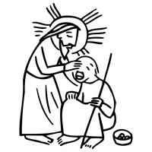
Worship Plan for Sunday, March 15, 2026
Fourth Sunday in Lent

The Holy Spirit calls us together as the people of God.
GATHERING

Prelude
Welcome/Announcements
Reflection - Preparing for Worship
Sing 2x

Please stand.
Confession and Forgiveness
All make the sign of the cross, the sign that is marked at baptism, as the presiding minister begins.
Blessed be the holy Trinity, ☩ one God,
who forgives all our sin,
whose mercy endures forever.
Amen.

Let us return to God, confessing our sin in the assurance of God’s abiding love.
Silence is kept for reflection.

Compassionate One,
you are slow to anger and abounding in steadfast love,
but our lives do not always reflect you
and your love for the world.
We do not show others the tender compassion
you have shown to us.
We do not welcome others with the radical hospitality
you grant to all people.
We oppress others,
even though you have set us free again and again.
We squander the abundant gifts of the earth.
Transform our lives
and guide us again in the way of the cross.
Amen.

Beloved in Christ,
God’s arms are always stretched open wide
to welcome the wandering ones home.
In ☩ Christ your sins are forgiven.
You have a place in God’s house forever.
Amen.

Gathering Song There Is a Balm in Gilead ELW 614

Greeting
The grace of our Lord Jesus Christ, the love of God
and the communion of the Holy Spirit be with you all.
And also, with you.

Kyrie

Your Heart, O God is Grieved

Prayer of the Day
Let us pray.
Bend your ear to our prayers, Lord Christ, and come among us. By your gracious life and death for us, bring light into the darkness of our hearts, and anoint us with your Spirit, for you live and reign with the Father and the Holy Spirit, one God, now and forever.
Amen.
Please be seated.
God speaks to us in scripture reading, preaching, and song.
WORD

First Reading: 1 Samuel 16:1-13
A reading from 1 Samuel.
¹ The Lord said to Samuel, “How long will you grieve over Saul? I have rejected him from being king over Israel. Fill your horn with oil and set out; I will send you to Jesse the Bethlehemite, for I have provided for myself a king among his sons.” ² Samuel said, “How can I go? If Saul hears of it, he will kill me.” And the Lord said, “Take a heifer with you and say, ‘I have come to sacrifice to the Lord.’ ³ Invite Jesse to the sacrifice, and I will show you what you shall do, and you shall anoint for me the one whom I name to you.” ⁴ Samuel did what the Lord commanded and came to Bethlehem. The elders of the city came to meet him trembling and said, “Do you come peaceably?” ⁵ He said, “Peaceably. I have come to sacrifice to the Lord; sanctify yourselves and come with me to the sacrifice.” And he sanctified Jesse and his sons and invited them to the sacrifice.
⁶ When they came, he looked on Eliab and thought, “Surely his anointed is now before the Lord.” ⁷ But the Lord said to Samuel, “Do not look on his appearance or on the height of his stature, because I have rejected him, for the Lord does not see as mortals see; they look on the outward appearance, but the Lord looks on the heart.” ⁸ Then Jesse called Abinadab and made him pass before Samuel. He said, “Neither has the Lord chosen this one.” ⁹ Then Jesse made Shammah pass by. And he said, “Neither has the Lord chosen this one.” ¹⁰ Jesse made seven of his sons pass before Samuel, and Samuel said to Jesse, “The Lord has not chosen any of these.” ¹¹ Samuel said to Jesse, “Are all your sons here?” And he said, “There remains yet the youngest, but he is keeping the sheep.” And Samuel said to Jesse, “Send and bring him, for we will not sit down until he comes here.” ¹² He sent and brought him in. Now he was ruddy and had beautiful eyes and was handsome. The Lord said, “Rise and anoint him, for this is the one.” ¹³ Then Samuel took the horn of oil and anointed him in the presence of his brothers, and the spirit of the Lord came mightily upon David from that day forward. Samuel then set out and went to Ramah.
The word of the Lord.
Thanks be to God.

Psalm: Psalm 23
¹ The Lord | is my shepherd;
I shall not | be in want.
² The Lord makes me lie down | in green pastures
and leads me be- | side still waters.
³ You restore my | soul, O Lord,
and guide me along right pathways | for your name’s sake.
⁴ Though I walk through the valley of the shadow of death, I shall | fear no evil;
for you are with me; your rod and your staff, they | comfort me. R
⁵ You prepare a table before me in the presence | of my enemies;
you anoint my head with oil, and my cup is | running over.
⁶ Surely goodness and mercy shall follow me all the days | of my life,
and I will dwell in the house of the | Lord forever. R

Second Reading: Ephesians 5:8-14
A reading from Ephesians.
⁸ Once you were darkness, but now in the Lord you are light. Walk as children of light, ⁹ for the fruit of the light is found in all that is good and right and true. ¹⁰ Try to find out what is pleasing to the Lord. ¹¹ Take no part in the unfruitful works of darkness; rather, expose them. ¹² For it is shameful even to mention what such people do secretly, ¹³ but everything exposed by the light becomes visible, ¹⁴ for everything that becomes visible is light. Therefore it says,
“Sleeper, awake!
Rise from the dead,
and Christ will shine on you.”
The word of the Lord.
Thanks be to God.
Please stand.
Gospel: John 9:1-41
The holy gospel according to John.
Glory to you, O Lord.
¹ As [Jesus] walked along, he saw a man blind from birth. ² His disciples asked him, “Rabbi, who sinned, this man or his parents, that he was born blind?” ³ Jesus answered, “Neither this man nor his parents sinned; he was born blind so that God’s works might be revealed in him. ⁴ We must work the works of him who sent me while it is day; night is coming, when no one can work. ⁵ As long as I am in the world, I am the light of the world.” ⁶ When he had said this, he spat on the ground and made mud with the saliva and spread the mud on the man’s eyes, ⁷ saying to him, “Go, wash in the pool of Siloam” (which means Sent). Then he went and washed and came back able to see. ⁸ The neighbors and those who had seen him before as a beggar began to ask, “Is this not the man who used to sit and beg?” ⁹ Some were saying, “It is he.” Others were saying, “No, but it is someone like him.” He kept saying, “I am he.” ¹⁰ But they kept asking him, “Then how were your eyes opened?” ¹¹ He answered, “The man called Jesus made mud, spread it on my eyes, and said to me, ‘Go to Siloam and wash.’ Then I went and washed and received my sight.” ¹² They said to him, “Where is he?” He said, “I do not know.”
¹³ They brought to the Pharisees the man who had formerly been blind. ¹⁴ Now it was a Sabbath day when Jesus made the mud and opened his eyes. ¹⁵ Then the Pharisees also began to ask him how he had received his sight. He said to them, “He put mud on my eyes. Then I washed, and now I see.” ¹⁶ Some of the Pharisees said, “This man is not from God, for he does not observe the Sabbath.” Others said, “How can a man who is a sinner perform such signs?” And they were divided. ¹⁷ So they said again to the blind man, “What do you say about him? It was your eyes he opened.” He said, “He is a prophet.”
¹⁸ The Jews did not believe that he had been blind and had received his sight until they called the parents of the man who had received his sight ¹⁹ and asked them, “Is this your son, who you say was born blind? How then does he now see?” ²⁰ His parents answered, “We know that this is our son and that he was born blind, ²¹ but we do not know how it is that now he sees, nor do we know who opened his eyes. Ask him; he is of age. He will speak for himself.” ²² His parents said this because they were afraid of the Jews, for the Jews had already agreed that anyone who confessed Jesus to be the Messiah would be put out of the synagogue. ²³ Therefore his parents said, “He is of age; ask him.”
²⁴ So for the second time they called the man who had been blind, and they said to him, “Give glory to God! We know that this man is a sinner.” ²⁵ He answered, “I do not know whether he is a sinner. One thing I do know, that though I was blind, now I see.” ²⁶ They said to him, “What did he do to you? How did he open your eyes?” ²⁷ He answered them, “I have told you already, and you would not listen. Why do you want to hear it again? Do you also want to become his disciples?” ²⁸ Then they reviled him, saying, “You are his disciple, but we are disciples of Moses. ²⁹ We know that God has spoken to Moses, but as for this man, we do not know where he comes from.” ³⁰ The man answered, “Here is an astonishing thing! You do not know where he comes from, yet he opened my eyes. ³¹ We know that God does not listen to sinners, but he does listen to one who worships him and obeys his will. ³² Never since the world began has it been heard that anyone opened the eyes of a person born blind. ³³ If this man were not from God, he could do nothing.” ³⁴ They answered him, “You were born entirely in sins, and are you trying to teach us?” And they drove him out.
³⁵ Jesus heard that they had driven him out, and when he found him he said, “Do you believe in the Son of Man?” ³⁶ He answered, “And who is he, sir? Tell me, so that I may believe in him.” ³⁷ Jesus said to him, “You have seen him, and the one speaking with you is he.” ³⁸ He said, “Lord, I believe.” And he worshiped him. ³⁹ Jesus said, “I came into this world for judgment, so that those who do not see may see and those who do see may become blind.” ⁴⁰ Some of the Pharisees who were with him heard this and said to him, “Surely we are not blind, are we?” ⁴¹ Jesus said to them, “If you were blind, you would not have sin. But now that you say, ‘We see,’ your sin remains.”
The gospel of the Lord.
Praise to you, O Christ.
Please be seated.
Children’s Message

Sermon

Please stand
Hymn of the Day Amazing Grace, How Sweet the Sound ELW 779

Apostles’ Creed
Let us confess our faith to the words of the Apostles’ Creed
I believe in God, the Father almighty,
creator of heaven and earth.
I believe in Jesus Christ, God’s only Son, our Lord,
who was conceived by the Holy Spirit,
born of the virgin Mary,
suffered under Pontius Pilate,
was crucified, died, and was buried;
he descended to the dead.*
On the third day he rose again;
he ascended into heaven,
he is seated at the right hand of the Father,
and he will come to judge the living and the dead.
I believe in the Holy Spirit,
the holy catholic church,
the communion of saints,
the forgiveness of sins,
the resurrection of the body,
and the life everlasting. Amen.

Please sit or kneel.
Prayers of Intercession
Reconciled by God’s mercy and sustained by God’s presence, let us pray for the world and its needs.
God, our shepherd, we pray that you guide the church. Lead Christians in our community (here local congregations may be named) and across the globe (here international companion churches and synods may be named) in right paths for your name’s sake. Hear us, O God.
Your mercy is great.
God our provider, we cry out for this planet and the life it holds. Rescue endangered animals and plants, preserve threatened ecosystems, and save creatures from natural disasters. Hear us, O God.
Your mercy is great.
God our sovereign, we plead for your peace on earth. Bring an end to war and violence, and raise up leaders in governments, courts, businesses, schools, and community organizations who seek goodness and mercy. Hear us, O God.
Your mercy is great.
God our healer, we call to you in our need. Uplift all who are made to feel unimportant, and transform the hearts of all infected by bigotry and prejudice. Care for all in special need this day (especially). Hear us, O God.
Your mercy is great.
God our friend, we praise you for the diversity of people among us. Awaken us to share and receive the gifts we each possess, and stir up a spirit of understanding, celebration, and welcome for all. Hear us, O God.
Your mercy is great.
God our home, we thank you for all who have died and completed their baptismal journeys. Grant us faith to live until we too dwell in your house forever. Hear us, O God.
Your mercy is great.
Receive our prayers, O God, through Jesus Christ, our strength and salvation.
Amen.

Peace
The peace of Christ be with you always.
And also, with you.

God feeds us with the presence of Jesus Christ.
MEAL

Please be seated.
Offering

Choir – Heal Me, O Lord

Please stand.
Offertory Hymn Come, Bring Your Burdens ACS 1009

Offertory Prayer
Let us pray
Gracious Provider,
you set your immense treasures among us,
opening your heart to the world.
As we prepare to feast on your bountiful love,
deepen our commitment to sharing those
treasures with others,
through our Savior, Jesus Christ.
Amen.

The Great Thanksgiving

The Lord be with you. And also with you.
Lift up your hearts. We lift them to the Lord.
Let us give thanks to the Lord our God. It is right to give our thanks and praise.

Praise upon praise belongs to you, God of David
for through the length of days your goodness faileth never.
You created a world of verdant pastures
and streams of living water where we should nothing lack.
Out of the house of Jesse
you named a shepherd son to be your people’s king.
With rod and staff you walked with your children
through the shadow of slavery and the valley of exile
and every kind of evil.
When your sheep strayed in sin, you sent your own Son
to be our shepherd king and to restore our souls.
He came to lay each one of us across his shoulders
and bring us home to you.
He set a table in the face of his enemies
and laid down his life that you might take it up again in glory.
And because you promise goodness and mercy to follow us all our days,
we give our thanks with all who dwell in your house forever,
with angels and archangels and all the company of heaven
as we join the unending hymn.

Anointing God, Samuel poured oil on the head of David,
and your Spirit came mightily upon him.
Send your Holy Spirit upon your church to make us faithful disciples
and, with your same Spirit, anoint these gifts of bread and wine
that they may be for us the body and blood of our Lord Jesus Christ;
Who, at supper with his disciples, took bread, gave you thanks,
broke the bread, and gave it to them, saying
“Take, eat: this is my body which is given for you;
do this in remembrance of me.”
After supper he took the cup.
Again he gave you thanks, and gave it to his disciples, saying,
“Drink this, all of you: this is my blood of the new covenant,
which is shed for you and for many for the forgiveness of sins.
Do this, as often as you drink it, in remembrance of me.”

Searching God, you along give your followers eyes of faith.
Teach your church to see as you see,
And set its sights on your kingdom.
In the face of evil, lift the burden of fear.
In the shadow of death, give comfort.
In the company of enemies, spread your welcome table
until that day when every cup runneth over
and your children look upon one everlasting banquet,
and all are made on around your heavenly feast,
as faith shall at last be made sight;
through your Son, Jesus Christ our Lord,
in the power of the Holy Spirit, with all honor and glory,
one God, now and forever. Amen

The Lord’s Prayer
Our Father, who art in heaven,
hallowed be thy name,
thy kingdom come,
thy will be done,
on earth as it is in heaven.
Give us this day our daily bread;
and forgive us our trespasses,
as we forgive those
who trespass against us;
and lead us not into temptation,
but deliver us from evil.
For thine is the kingdom,
and the power, and the glory,
forever and ever. Amen.

Invitation to Communion
All who are hungry, come!
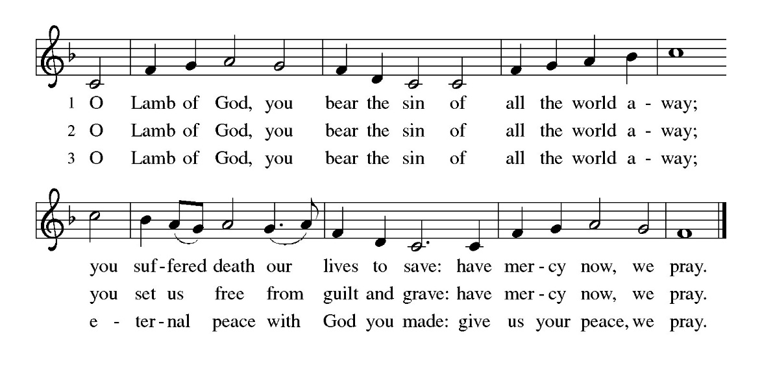
The feast of grace is spread.

Please be seated
Communion Hymns Be Thou My Vision ELW 793

Shepherd Me, O God ELW 780
Prayer After Communion
Generous Host,
you have shared your feast with us and made us new.
Send us now to set tables of love and grace in our communities,
that your liberating love might nourish the world into freedom,
in the name of the crucified one, Jesus Christ our Lord. Amen.

God blesses us and sends us in mission to the world.
SENDING

Blessing
God our tender parent,
God the crucified one,
God the reconciling Spirit,
☩ bless you now and forever. Amen.

Sending Song In the Cross of Christ I Glory ELW 324

Dismissal
Go in peace. Care for others as God cares for you.
Thanks be to God.

