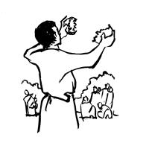
Worship Plan for Sunday, August 2, 2026
10th Sunday After Pentecost

The Holy Spirit calls us together as the people of God.
GATHERING

Prelude
Welcome/Announcements
Reflection - Preparing for Worship
Sing 3X

Please stand.
Confession and Forgiveness
All may make the sign of the cross, the sign that is marked at baptism, as the presiding minister begins.

Blessed be the holy Trinity,☩ one God,
whose compassion endures forever.
Amen.

Let us confess our sin to God.
Silence is kept for reflection.

Compassionate God,
we confess to you all our sins.
Our burden is heavy, and we cannot free ourselves.
In your mercy, call us back to you.
Your yoke is easy and your burden is light.
Restore us to dwell in your peace.
In Christ’s name we pray,
Amen.

Jesus says, “Come to me,
all you who are weary
and are carrying heavy burdens,
and I will give you rest.”
In the name of God,
Father, ☩ Son, and Holy Spirit,
your sins are forgiven.
Rest in God’s love.
Amen.

Gathering Song O Jesus, Joy of Loving Hearts (ELW 658

Greeting
The grace of our Lord Jesus Christ, the love of God
and the communion of the Holy Spirit be with you all.
And also, with you.

Hymn of Praise
Prayer of the Day
Let us pray.
Glorious God, your generosity waters the world with goodness, and you cover creation with abundance. Awaken in us a hunger for the food that satisfies both body and spirit, and with this food fill all the starving world; through your Son, Jesus Christ, our Savior and Lord.
Amen.
Please be seated.
God speaks to us in scripture reading, preaching, and song.
WORD

First Reading: Isaiah 55:1-5
A reading from Isaiah.
¹ Hear, everyone who thirsts;
come to the waters;
and you who have no money,
come, buy and eat!
Come, buy wine and milk
without money and without price.
² Why do you spend your money for that which is not bread
and your earnings for that which does not satisfy?
Listen carefully to me, and eat what is good,
and delight yourselves in rich food.
³ Incline your ear, and come to me;
listen, so that you may live.
I will make with you an everlasting covenant,
my steadfast, sure love for David.
⁴ See, I made him a witness to the peoples,
a leader and commander for the peoples.
⁵ Now you shall call nations that you do not know,
and nations that do not know you shall run to you,
because of the Lord your God, the Holy One of Israel,
for he has glorified you.
The word of the Lord.
Thanks be to God.

Psalm: Psalm 145:8-9, 14-21
⁸ The Lord is gracious and full | of compassion,
slow to anger and abounding in | steadfast love.
⁹ Lord, you are | good to all,
and your compassion is over | all your works. R
¹⁴ The Lord upholds all | those who fall
and lifts up those who | are bowed down.
¹⁵ The eyes of all wait upon | you, O Lord,
and you give them their food | in due season.
¹⁶ You open | wide your hand
and satisfy the desire of every | living thing.
¹⁷ You are righteous in | all your ways
and loving in | all your works. R
¹⁸ You are near to all who | call upon you,
to all who call up- | on you faithfully.
¹⁹ You fulfill the desire of | those who fear you;
you hear their | cry and save them.
²⁰ You watch over all | those who love you,
but all the wicked you | shall destroy.
²¹ My mouth shall speak the praise | of the Lord;
let all flesh bless God’s holy name forev- | er and ever. R

Second Reading: Romans 9:1-5
A reading from Romans.
¹ I am speaking the truth in Christ—I am not lying; my conscience confirms it by the Holy Spirit—² I have great sorrow and unceasing anguish in my heart. ³ For I could wish that I myself were accursed and cut off from Christ for the sake of my own brothers and sisters, my own flesh and blood. ⁴ They are Israelites, and to them belong the adoption, the glory, the covenants, the giving of the law, the worship, and the promises; ⁵ to them belong the patriarchs, and from them, according to the flesh, comes the Christ, who is over all, God blessed forever. Amen.
The word of the Lord.
Thanks be to God.
Please stand.
Gospel Acclamation
Gospel: Matthew 14:13-21
The holy gospel according to Matthew.
Glory to you, O Lord.
¹³ Now when Jesus heard [about the beheading of John the Baptist,] he withdrew from there in a boat to a deserted place by himself. But when the crowds heard it, they followed him on foot from the towns. ¹⁴ When he went ashore, he saw a great crowd, and he had compassion for them and cured their sick. ¹⁵ When it was evening, the disciples came to him and said, “This is a deserted place, and the hour is now late; send the crowds away so that they may go into the villages and buy food for themselves.” ¹⁶ Jesus said to them, “They need not go away; you give them something to eat.” ¹⁷ They replied, “We have nothing here but five loaves and two fish.” ¹⁸ And he said, “Bring them here to me.” ¹⁹ Then he ordered the crowds to sit down on the grass. Taking the five loaves and the two fish, he looked up to heaven and blessed and broke the loaves and gave them to the disciples, and the disciples gave them to the crowds. ²⁰ And all ate and were filled, and they took up what was left over of the broken pieces, twelve baskets full. ²¹ And those who ate were about five thousand men, besides women and children.
The gospel of the Lord.
Praise to you, O Christ.

Please be seated.
Children’s Message

Sermon

Please stand
Hymn of the Day Loves Were Broken, Words Were Spoken ACS 966

Apostles’ Creed
Let us confess our faith to the words of the Apostles’ Creed
I believe in God, the Father almighty,
creator of heaven and earth.
I believe in Jesus Christ, God's only Son, our Lord,
who was conceived by the Holy Spirit,
born of the Virgin Mary,
suffered under Pontius Pilate,
was crucified, died, and was buried;
he descended to the dead.
On the third day he rose again;
he ascended into heaven,
he is seated at the right hand of the Father,
and he will come to judge the living and the dead.
I believe in the Holy Spirit,
the holy catholic Church,
the communion of saints,
the forgiveness of sins,
the resurrection of the body,
and the life everlasting. Amen

Please sit or kneel.
Prayers of Intercession
With bold trust in God’s unfailing provision, we pray for the church, those in need, and all of God’s creation.
For your church in every place, that it satisfies those who hunger for your word. Bless the ministry of readers, translators, Bible study leaders, and writers, that God’s word is broken open and shared with all. Merciful God,
receive our prayer.
For your wondrous creation and all the bounty it provides, that your creatures are fed and nourished. Bless the work of farmers, farmworkers, those who fish, and all whose labor brings your abundance to our tables. Merciful God,
receive our prayer.
For your children in every nation, that they learn to love justice and live in harmony. As this week we remember the atomic bombings of Hiroshima and Nagasaki, keep us mindful of the horrors of war; draw our hearts instead toward your reign of love, hope, and peace. Merciful God,
receive our prayer.
For all who cry out with great sorrow and unceasing anguish, that they are comforted. Feed all who struggle with food insecurity; have mercy on all who are suffering in body, mind, and spirit (especially). Merciful God,
receive our prayer.
For this congregation, that it bears faithful witness to the abundance and joy of life in you. Bless all your faithful people gathered here, that they may become blessings for this community. Merciful God,
receive our prayer.
With thanksgiving for the faithful who now rest in your mercy, that their witness continues to inspire the church. By their example, may we trust your promises in life and in death. Merciful God,
receive our prayer.
Receive our prayers and answer, O God, as you have promised. All this we ask in the name of your Son, Jesus Christ our Lord.
Amen.

Peace
The peace of Christ be with you always. And also, with you.

MEAL
God feeds us with the presence of Jesus Christ.

Please be seated.
Offering

Special Music Becky Spaulding/Teena Rundle

Please stand.
Offertory Hymn Here on Jesus Christ I will Stand ACS 1024

Offertory Prayer
Lord of the harvest,
we return to you a portion of what you have given to us.
Turn us to set our hope not on the uncertainty of riches,
but on you, who richly provides for us.
Multiply what we have gathered
to bless all who are suffering and in need,
through Jesus Christ our Lord.
Amen.

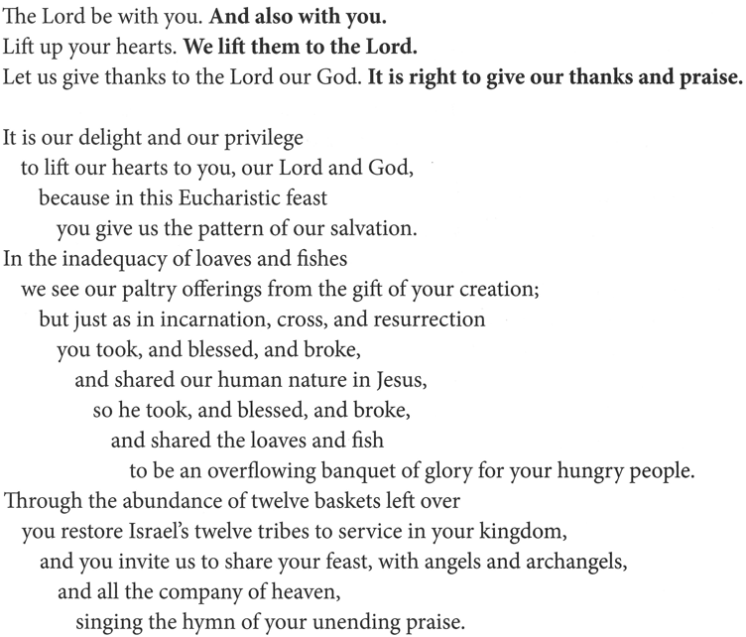
The Great Thanksgiving

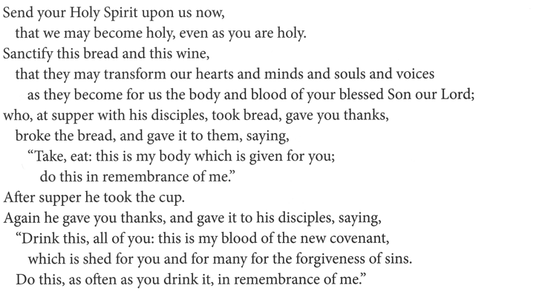


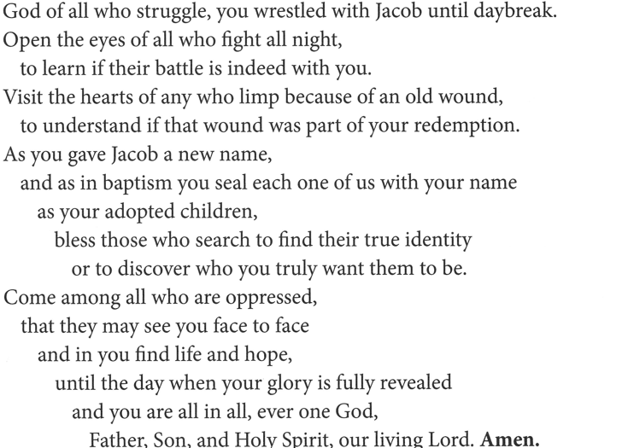
The Lord’s Prayer
Our Father, who art in heaven,
hallowed be thy name, thy kingdom come,
thy will be done, on earth as it is in heaven.
Give us this day our daily bread;
and forgive us our trespasses, as we forgive those who trespass against us;
and lead us not into temptation but deliver us from evil.
For thine is the kingdom,
and the power, and the glory, forever and ever.
Amen.

Invitation to Communion
Heaven has come near.
Come, share in the feast!

Please be seated.
Communion Hymns

Come, Let Us Eat ELW 491

You Satisfy the Hungry Heart; ELW 484
Gift of Finest Wheat

Prayer after Communion
Compassionate God,
through the gifts of bread and wine
our hearts are filled with the abundance of your love.
Strengthen us that we, through this holy meal,
may share your love freely, as you have shared with us.
We ask this in the name of Jesus,
through the Spirit nourishing us now and forever.
Amen.

God blesses us and sends us in mission to the world.
SENDING

Blessing
Creator, Redeemer, Sustainer,
☩ one God,
bless, heal, and hold you
today and always.
Amen.

Sending Song Let Us Talents and Tounges Employ ELW 674

Dismissal
Heaven has come near. Go, share the good news!
Thanks be to God.

From sundaysandseasons.com.
Copyright © 2026 Augsburg Fortress. All rights reserved.

